
SCHOOLS CELEBRATION OF WORLD INTERFAITH HARMONY WEEK 2019
February 1 – 7, 2019
Venue: Campuses of each schools

The Department of Education, as one of the supportive and leading partners for the celebration of the World Interfaith Harmony Week, motivates the schools under their supervision to laud the spirit of harmony and peace. As part of their initiative, each schools conducted activities in line with the celebration.
Each activity aimed to give a concrete message to the student leaders of each schools, on the essence of the World Interfaith Harmony Week. Some schools held seminar workshops engaged by the students. On these seminar workshops, students were asked to give illustrations on the current situation of the society. Hence, they were also asked to think of a solution that they can possibly do in their own little way. These seminar workshops gave an opportunity to each students to be more actively taking part on the society to lessen violent extremism and foster harmonious community.
Other schools held competitions wherein the student leaders showcase their talents. Using the art of theatre, dancing, singing, poetry, painting and speaking. In this way, the student leaders were on the zone of projecting the spirit of World Interfaith Harmony Week celebration. This is a true image of young people who were passionate in taking part on building peace and harmony in the society.
With the undying support of each school heads, the outcome of the activities made a huge impact to every participating student leader. Those activities would continue to inspire them and give them the light that despite the continuous effort of bad elements to uphold extremism, they have the abilities and capabilities to emancipate their community from such violence.

PHOTOS FROM EACH ACTIVITIES OF SCHOOLS
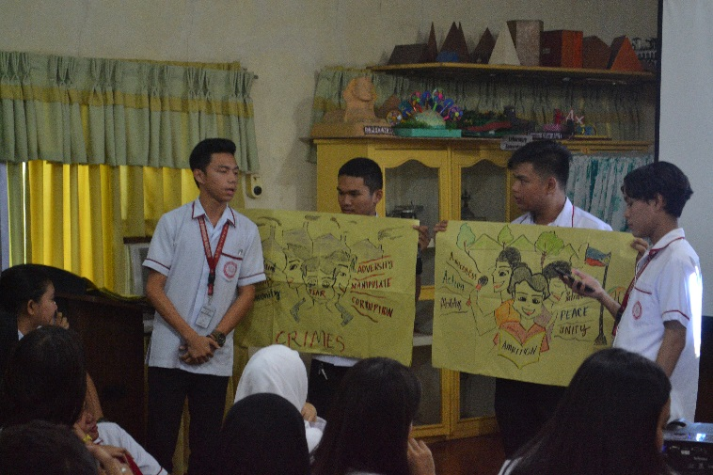
SEMINAR WORKSHOP. The student leaders Baliwasan Senior High School presented their illustrations of the current happenings in the society. In addition, they also showed solutions and possible actions that would address status quo.

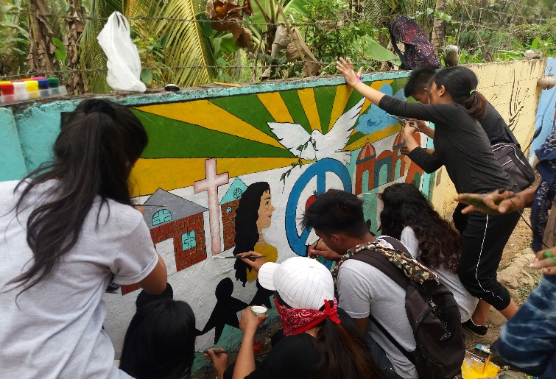
MURAL PAINTING. With passion and talent, the student leaders of Tictapul National High School took an initiative to design their school wall by painting an image which symbolizes the World Interfaith Harmony Week celebration.

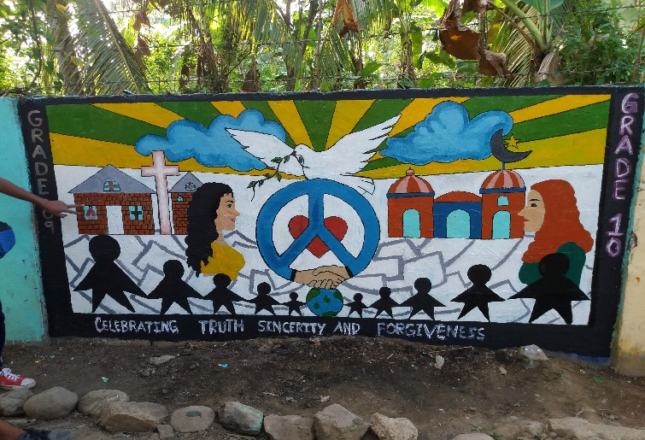

THE PAINTING. This is the finish mural painting of the student leaders of Tictapul National High School.

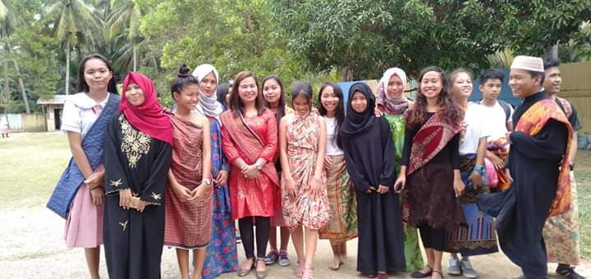
CULTURAL SHOW. Student leaders made an initiative to make a cultural show in their school. This activity aimed to represent the diverse culture of Zamboanga.

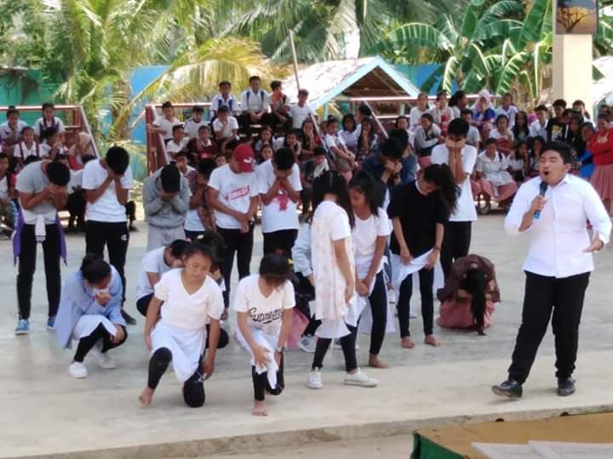
THEATRE PLAY. One of the areas wherein these student leaders excel is through portraying the spirit of the World Interfaith Harmony Week in the art of theatre. Their creativity simply tells us that these student leaders were capable of bringing the essence of the celebration.

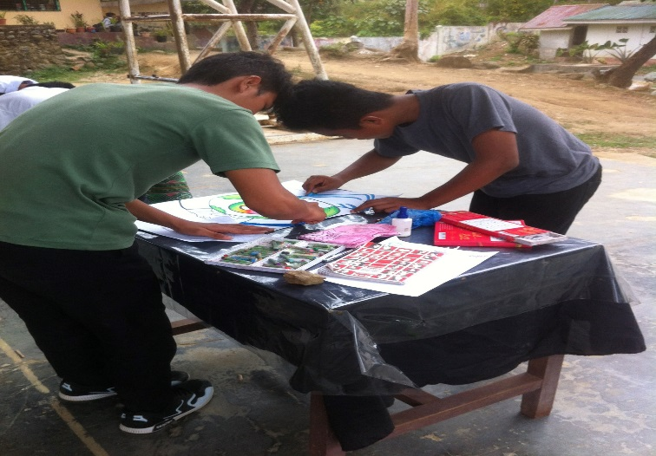
POSTER MAKING. In here, the student leaders also have another initiative to convey the message of the World Interfaith Harmony Week celebration.

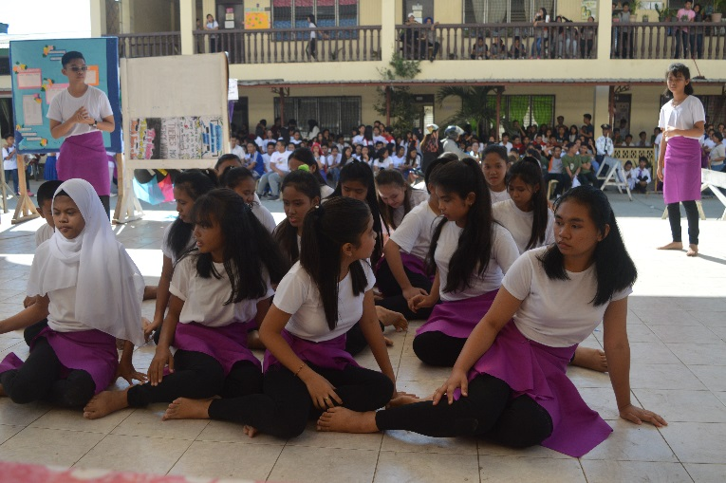
INTERPRETATIVE DANCE. With the spirit of celebration of World Interfaith Harmony Week as their inspiration, the student leaders of Zamboanga City High School Main perform an interpretative dance as their way of conveying the message of the celebration.

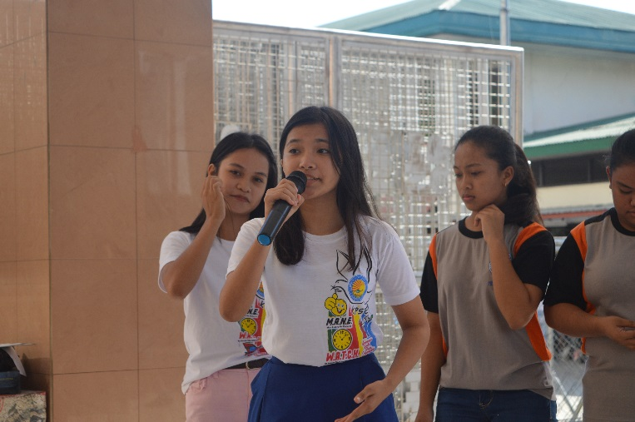
SPOKEN POETRY. One of the unique way of showcasing their young talents, the student leaders conducted a spoken poetry contest in line with the theme of the World Interfaith Harmony Week.

