CONGREGATION PRAYER FOR MUSLIMS
Friday Khutbah Prayer
February 1, 2019
Malagutay, Zamboanga City

As one of the religions of peace, Muslim leaders has always been part of the celebration of the World Interfaith Harmony Week. With the initiative of Silsilah Dialogue Movement, a congregation prayer for Muslims were being held annual as part of the celebration. It is usually held every Friday within the week, as part of Friday Khutbah Prayer. The initiative was to share to the world the message of our Muslim brothers and sisters with their participation on the World Interfaith Harmony Week.

Imam Jay Jikiri, a Muslim leader and one of the Silsilah Staff, gave the crowd of Muslim brothers and sisters a khutbah on a Friday prayer. On his khutbah, he mentioned the essence of being a Muslim and a believer of Allah. He said that as one Muslim, it does not end in believing only in oneness of Allah, but loving all the creation that He made. Imam Jay also gave emphasis on the role of Muslims as keepers of peace and harmony in this world. He also did mention that despite all the efforts of those bad elements to bring the name of Islam to dirt, a true Muslim must not lose hope in sharing the real goodness in an Islamic perspective.

On the latter part of his khutbah, he reminded everyone that with the celebration of the World Interfaith Harmony Week, it is an opportunity for them to take an initiative or a single step to start the journey together with Silsilah Dialogue Movement.

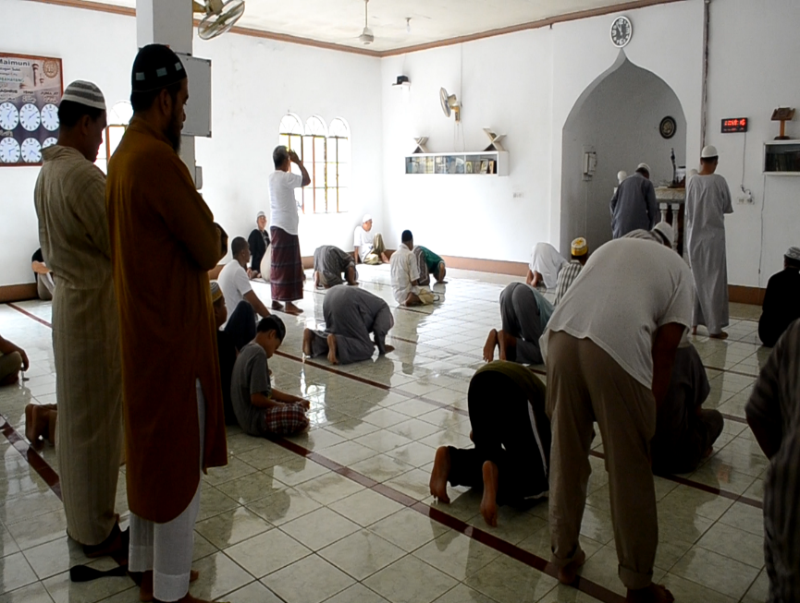
FRIDAY PRAYER. While waiting for the Uztadz to give the khutbah, our Muslim brothers performs salah (prayer) as they enter the Masjid. The prayer symbolizes as giving thanks to Allah for letting them reach His house of worship.

Note: After the recent bombing incident in one of the masjids in Zamboanga, our Muslim brothers and sisters asked a favor to the documentor not to take a lot of photos and videos for security measures.

