World Interfaith Harmony Week
Forum with the Tricycle Operators and Drivers

Sponsored by: Silsilah Dialogue Movement and RUEDA
Small conference Room, Centro Pastoral | 10:00-12nn

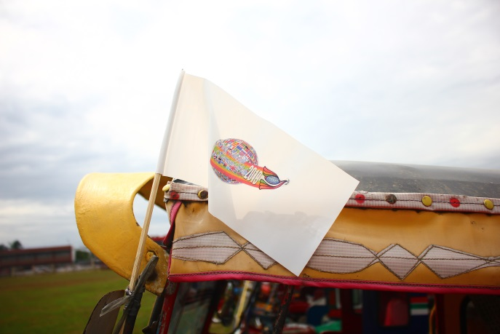
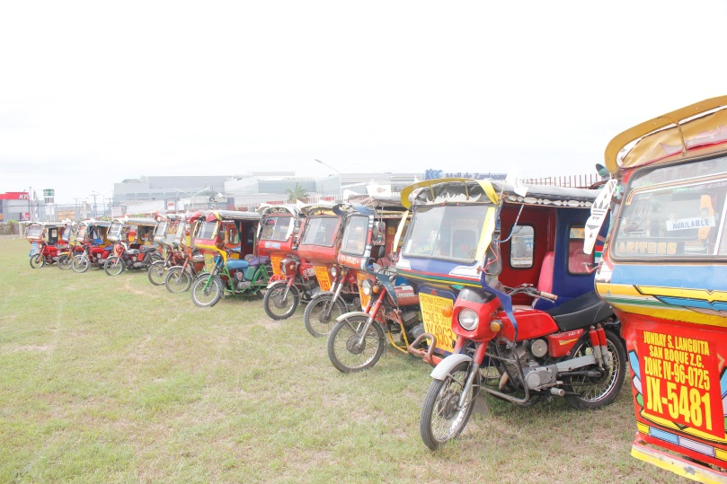
One hundred fifteen Tricycle drivers from different associations gathered to participate the annual, “Forum with the Tricycle Operators and Drivers “. The activity started with the hanging of the symbolic flag let which symbolizes, Peace to all people of sincere hearts, who believed that peace is possible and in spite of the current issues that affects the Muslim and Christian relation, them as tricycle drivers can be instrument and catalyst to spread the message of peace to their passengers and other people living in our society. The flag lets where placed at the front of the mirror side of the tricycle to be in solidarity with other groups in prayer. The activity aimed to encourage the drivers to spread the essence of Interfaith Harmony to the respective passengers and individuals in their daily routinely activity. The forum includes the basic matters and concerns of the Tricycle drivers among passengers and others. This activity inspired the tricycle drivers that harmony and peace begins with yourself and it is like a chain relation where you can share it to others especially to passengers and from passengers to their families and friends.

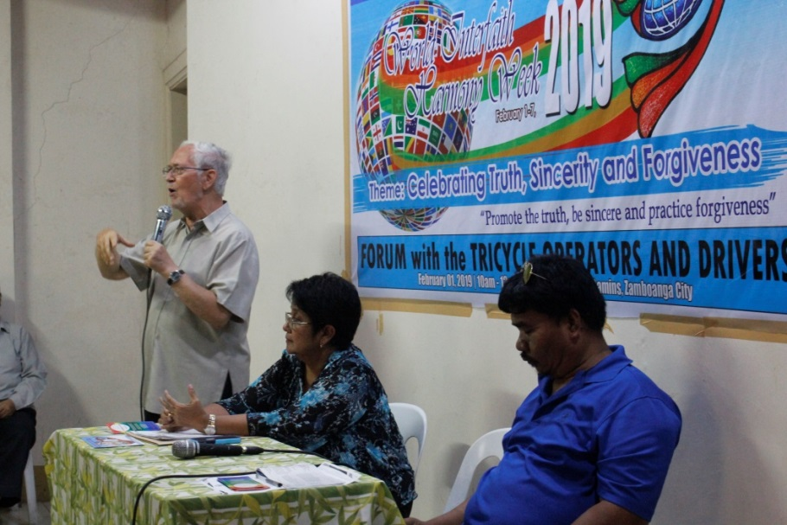
Ms. Erlinda Mandi from the tricycle Adjudication Board and Mr. Hermogenes Awid, the President of Tricycle Operators and Drivers of Zamboanga City were present to clarified and justified some problems and issues which gave satisfaction to all drivers including the operators.
Fr. Sebastiano D’Ambra, the founder of Silsilah gave the closing message and he promoted the Harmony prayer to the Tricycle drivers, he said that the essence of Interfaith Harmony can be shared to their passengers. This activity promotes peace and harmony not only to Religious leaders but also to Tricycle drivers where they have more interaction to ordinary people and have the greater chance to spread the spirit of Interfaith Harmony in their own simple way. These tricycle drivers can earn for a living and at the same time they could share the essence of compassion of mercy to their passengers along the way.
