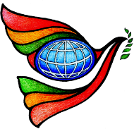
World Interfaith Harmony Week
Neighbors in Harmony- Bolong
Sponsored by: Emmaus Dialogue Movement

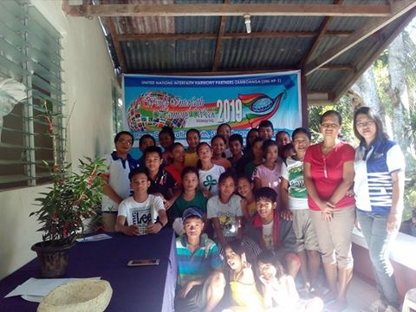
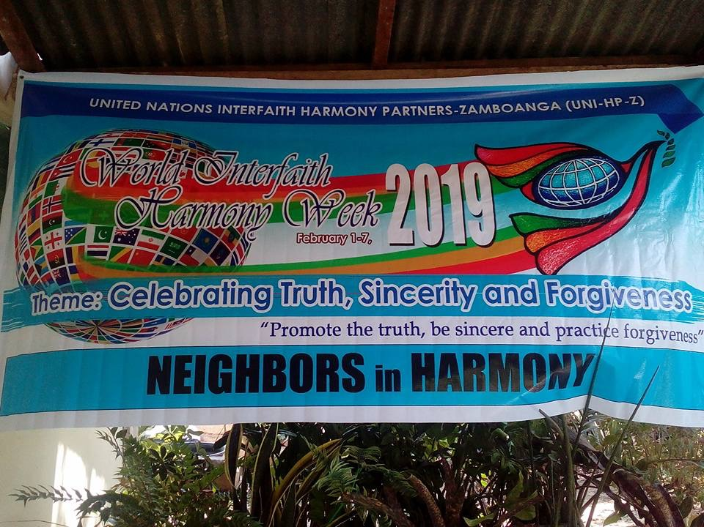
For the past consecutive years, the Emmaus Dialogue Movement is conducting the activity called “Neighbors in Harmony” every February in line with the celebration of the World Interfaith Harmony Week. The activity aims to gather people in the community to share o how each one can be instruments of peace and to have harmony among themselves and to reflect on any feeling or situation that affect their relationship as neighbors and lastly, to learn how to forgive and learn from the challenges that they faced every day. The Emmaus Circle members also take this occasion to introduce the “Harmony Prayer” to the community. They have also reflected that each one should know and understand that God loves us regardless of our religion, race, beliefs, and status in life. We should to embrace and respect each ones’ personality because we are Authentic in our own way.

World Interfaith Harmony Week
Harmony in Life, Words and Music
Sponsored by: Emmaus Dialogue Movement

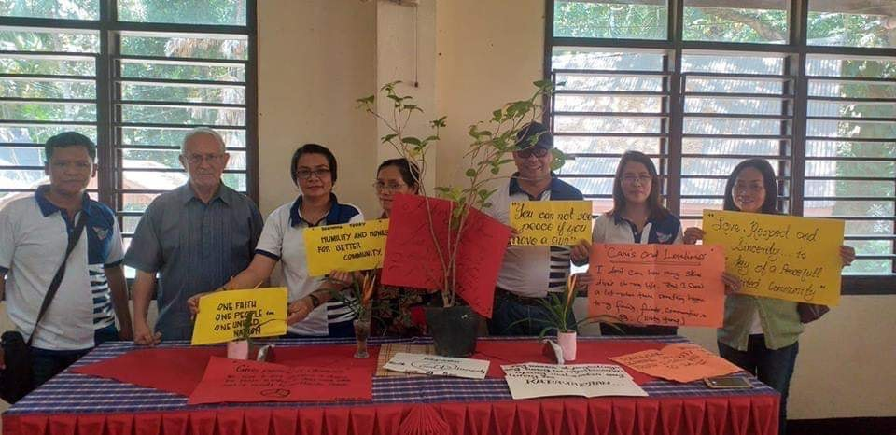

The activity aims to widen the imagination and creativity of the participants to challenge them to express and manifest harmony through music and words.
At the end, Emmaus members are “listening to the voice of the Jesus through the poor and those who suffer.”

