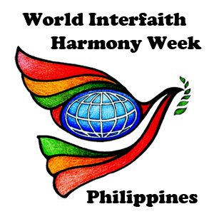

**LEADERSHIP AND HARMONY YOUTH TRAINING SEMINAR**

***Filipino-Turkish Tolerance School, Sinunuc, Zamboanga City***

FEBRUARY 7, 2019

**WORLD INTERFAITH HARMONY WEEK 2019**

**ZAMBOANGA**

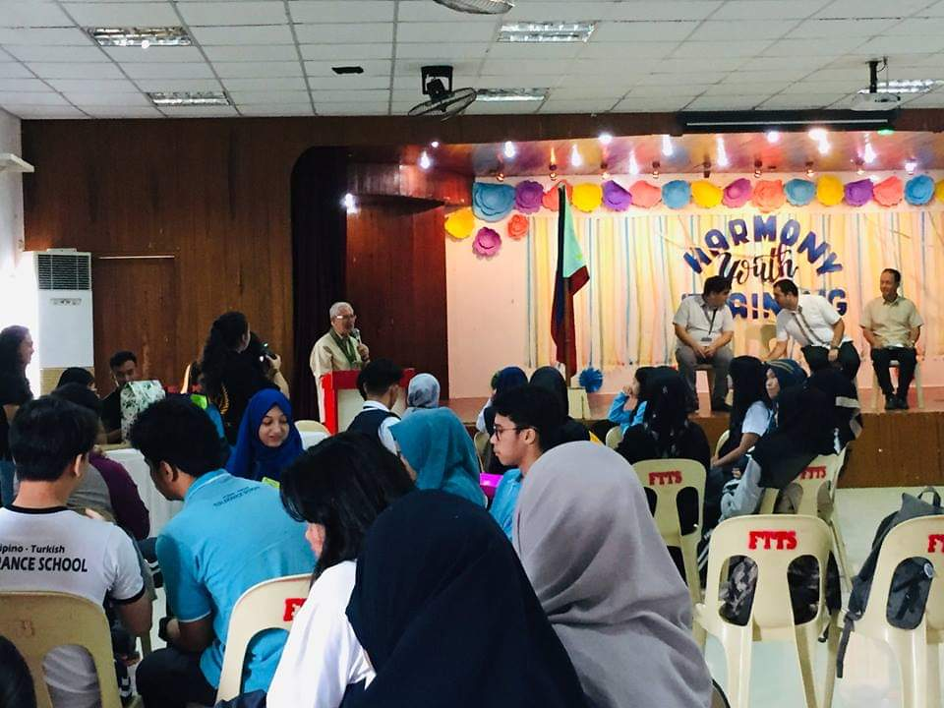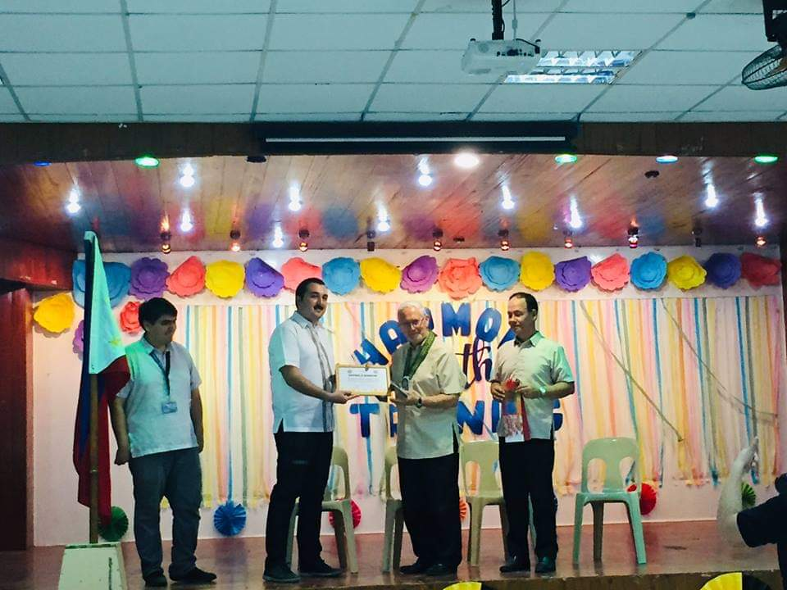

**Fr. Sebastiano D’Ambra, PIME** was invited to share the message of World Interfaith Harmony Week in the Filipino-Turkish Tolerance School. With the Spirit of World Interfaith Harmony Week, this school celebrated the activity with the youth.

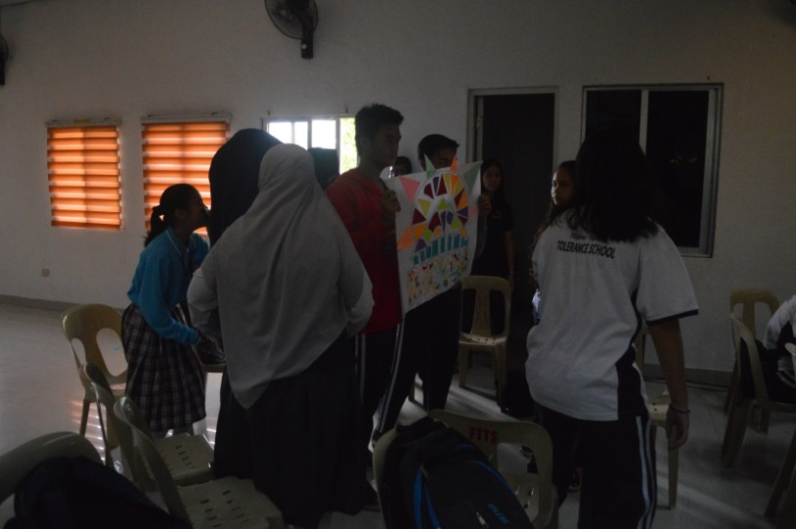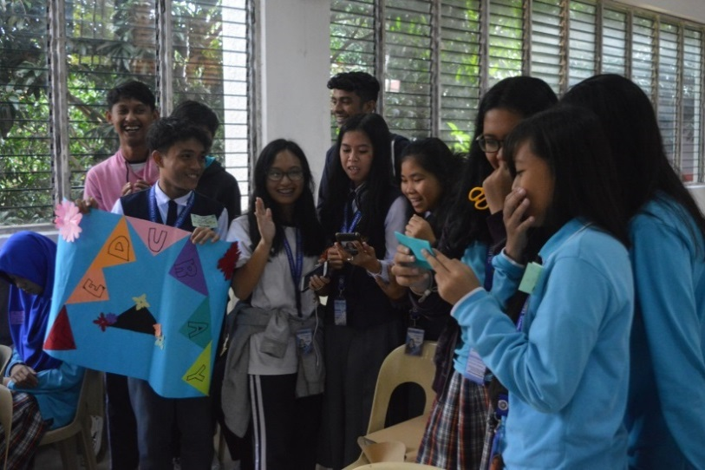

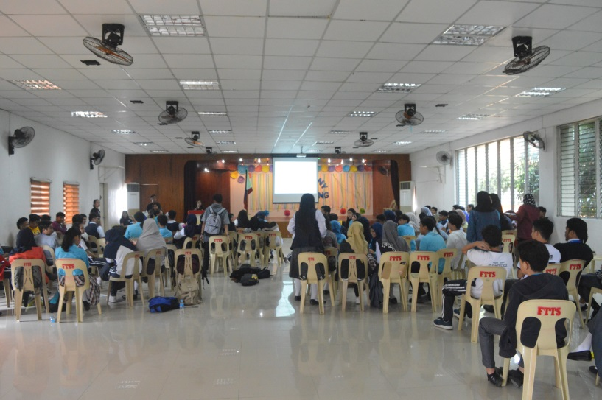

The youth of the Filipino-Turkish Tolerance School started the day with the banner making. This banner was made earlier and was used to represent the groups’ name and yells. With full enthusiasm, the activity started with the loud yells and cheers from the students. The banner was creatively designed by the students themselves with the different tribal names of each group. The event was organized by FTTS Faculty and the Student Government of the school.

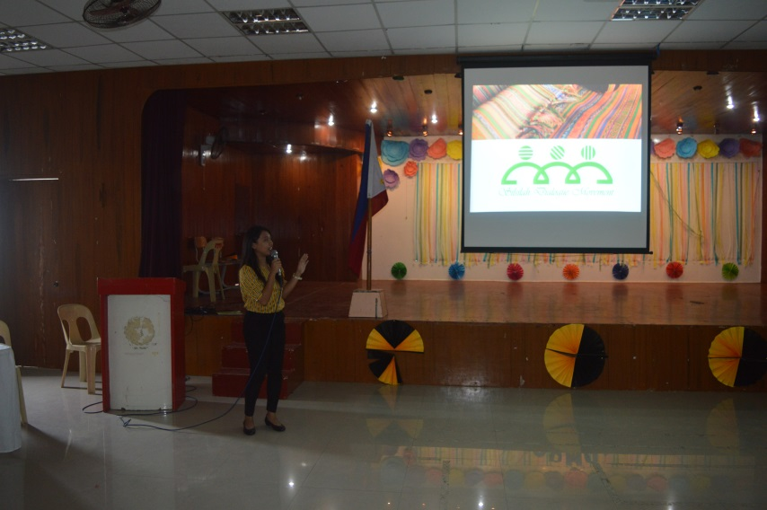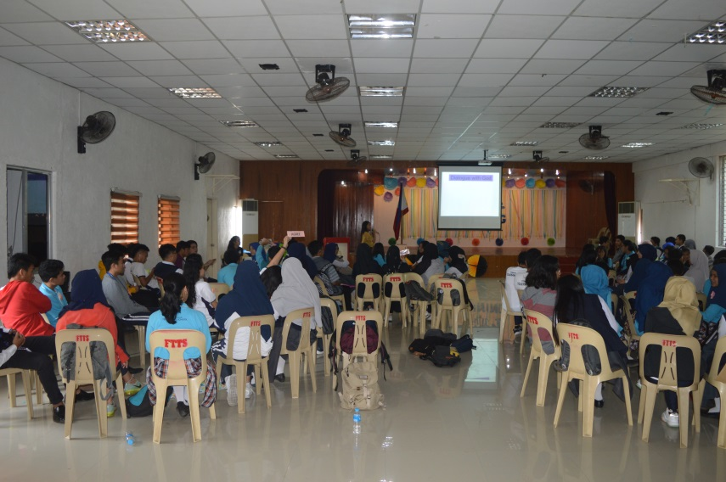

**Ms. Venus E. Montebon** - **Silsilah staff** was the first speaker of the activity. She focused her topic on Culture of Dialogue and the four pillars of Dialogue. Silsilah long reflected on this dialogue and the mission to promote Dialogue and Peace to youths, young professionals and different groups or institutions through seminars and formations.

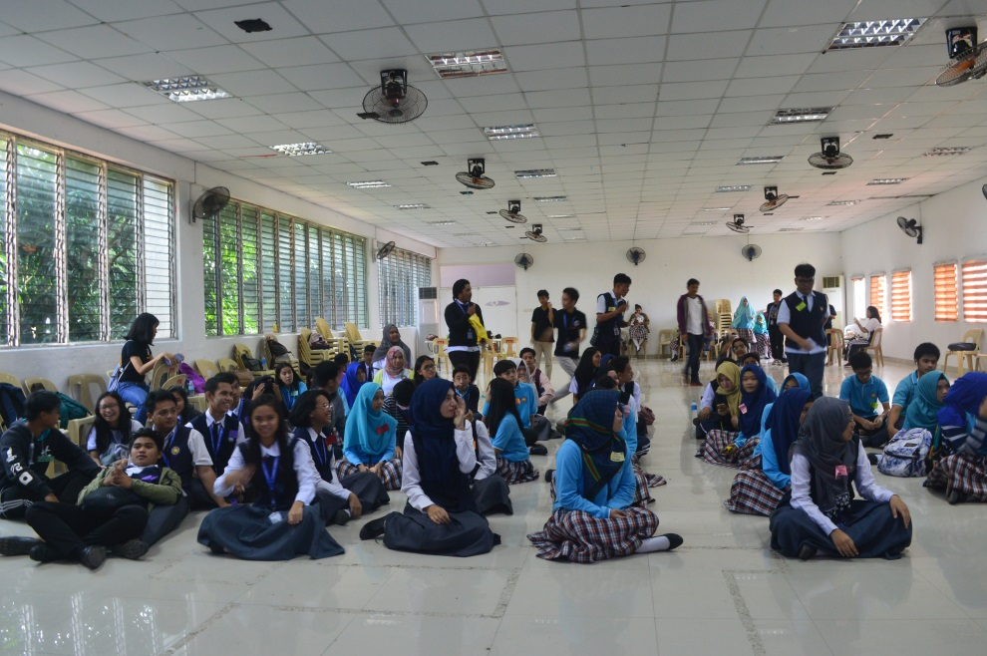

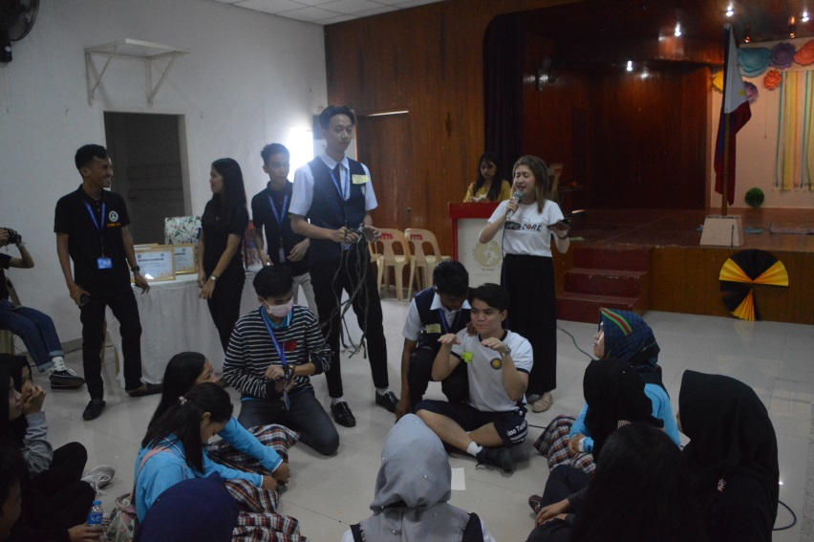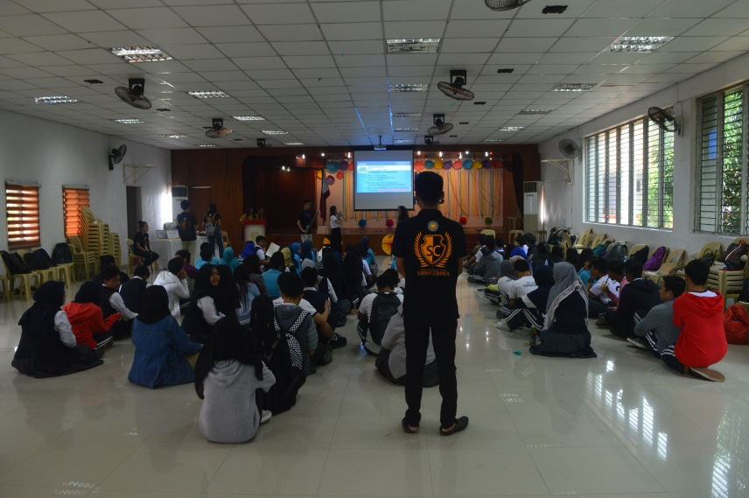

**Ms. Lady Anne Sheena Macero - Silsilah staff, World Interfaith Harmony Week Coordinator** was the second speaker of this activity. She started her talk with an activity which required creativity and teamwork. Her topic focused on Culture of Dialogue: Social Transformation. The youth participated with the activity in full enthusiasm and energy aiming to win every round of the activity given to them.

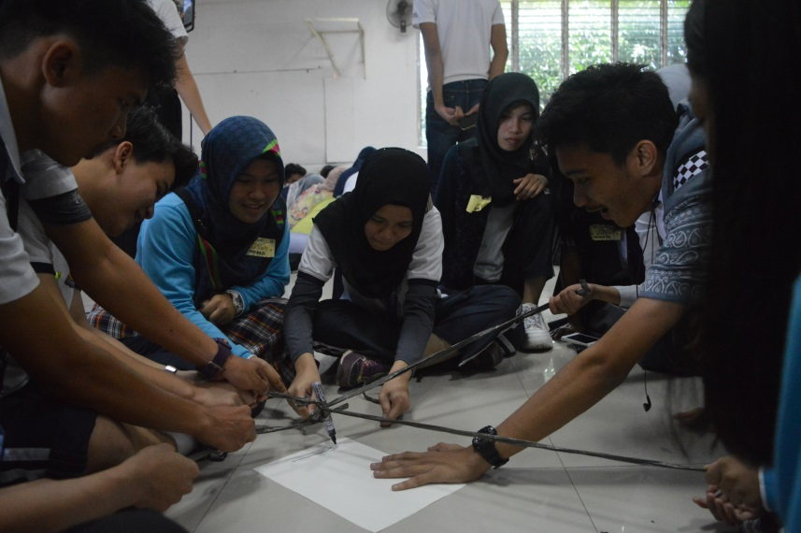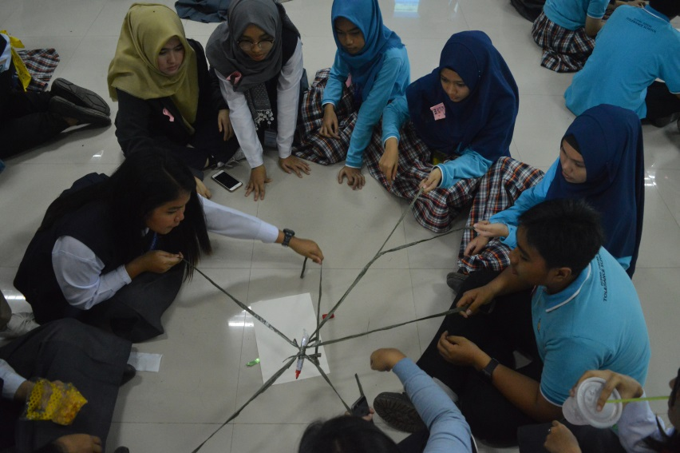

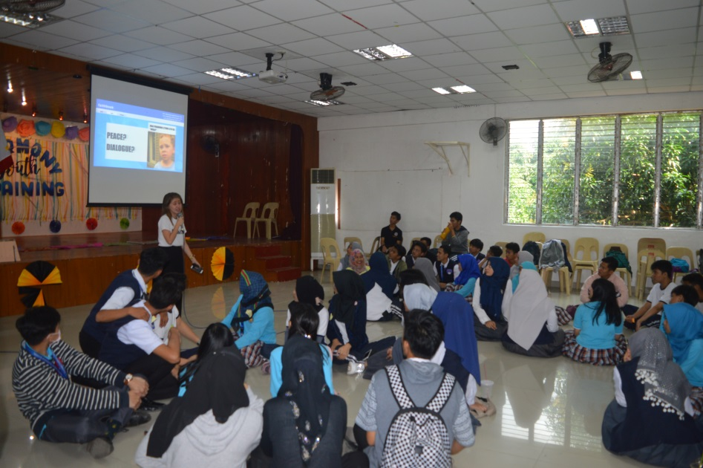

Sets of activity were thoroughly prepared by the speaker and the students were attentively listening to the instructions of the speaker. At the end of the activity, the students learned about the importance of social transformation especially the Pillar of Dialogue which is the “Dialogue with Others”.

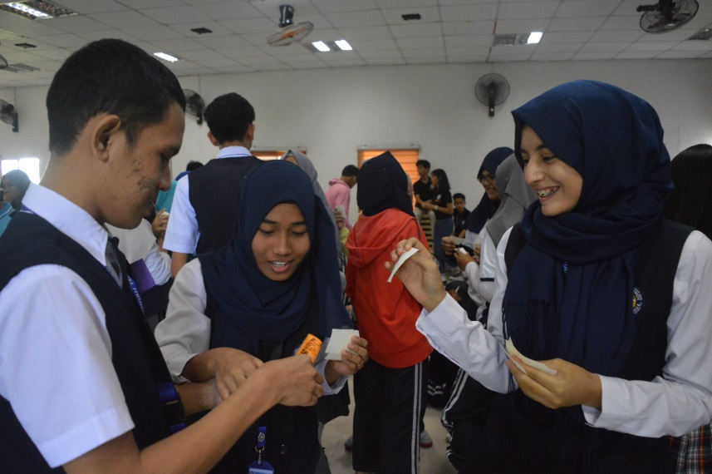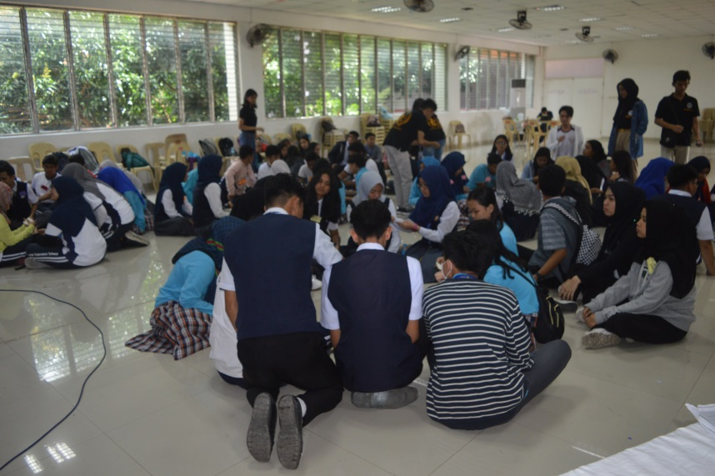

The joy of dialogue and learning at the same time is very commendable to the youth to develop proper behavior and reminded by the SSS values, Sincerity, Sensitivity and Solidarity.

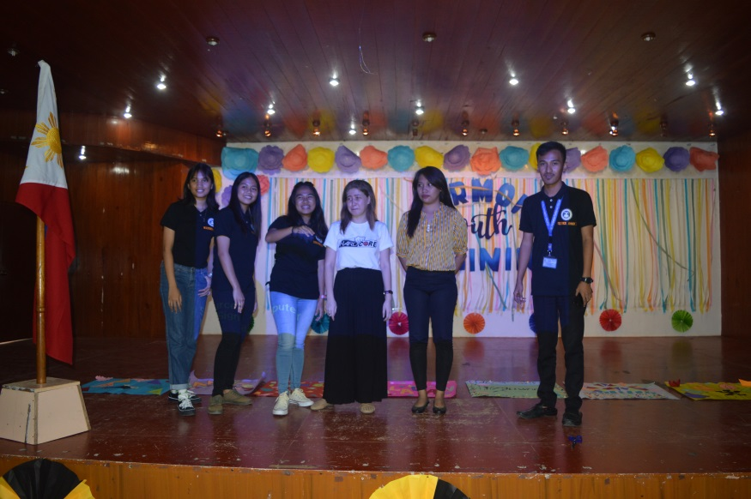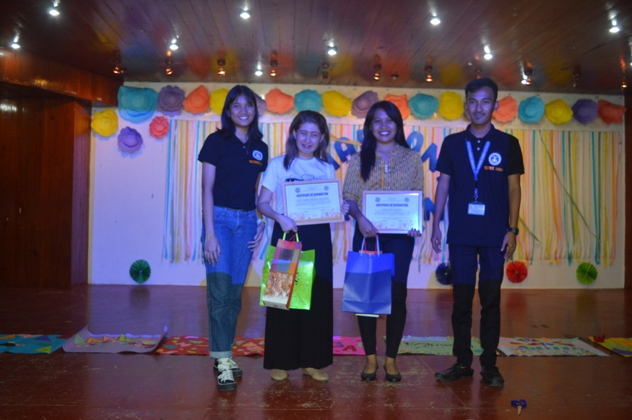

*The speakers of the activity received a certificate of recognition.*

Peace is a way of being and a way of living. The Celebration of the World Interfaith Harmony Week has been always promoting peace and harmony for the common good. This activity of the youth is not only to train them to lead but also to learn interreligious dialogue. It is the time to activate the youth of the world. This kind of activity really helps the millennial to be recognizing not only on academics but also to acquire the proper values to have a harmonious society.

To educate and enlighten the youths about social services and also promote goodness in the community, to reconnect people with a common goal, which is to build a better community. The opportunity to have a space for the youth, in the spirit of World Interfaith Harmony Week, is good but it must be done more often. To teach the youth the essence of acceptance, tolerance, interreligious dialogue and love for humanity is very essential. Advocating dialogue with the youth can develop their ideals and hopefully one day, the youth can change the world for the common good.