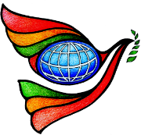
World Interfaith Harmony Week 2019
Freedom of Speech
Normal Rd. Baliwasan, Zamboanga City
February 5, 2019 1:00 pm- 5:00 pm
Sponsored by: Commission on Human Rights and Western Mindanao State University

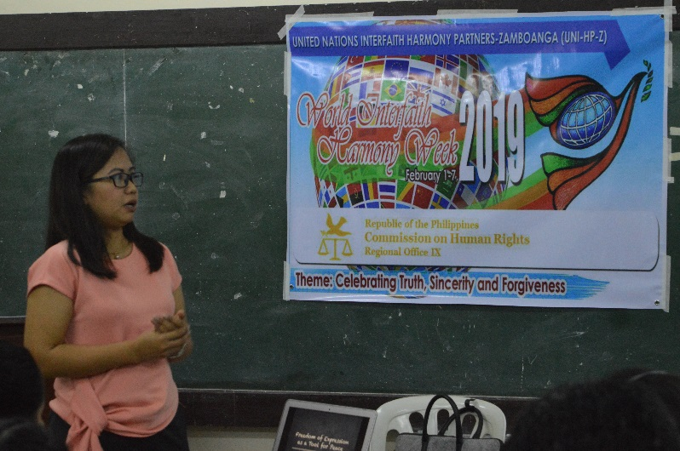
The Commission on Human Rights and Western Mindanao State University made their effort to gather Fourth year Mass Communication students at the College of Liberal Arts to lend their time to participate in the Freedom of Speech forum for them to also gain information that can be used in their respective fields. In recognizing current issues, the media plays a vital role in the dissemination of information to contribute in giving light to situations and challenges that our society is facing.
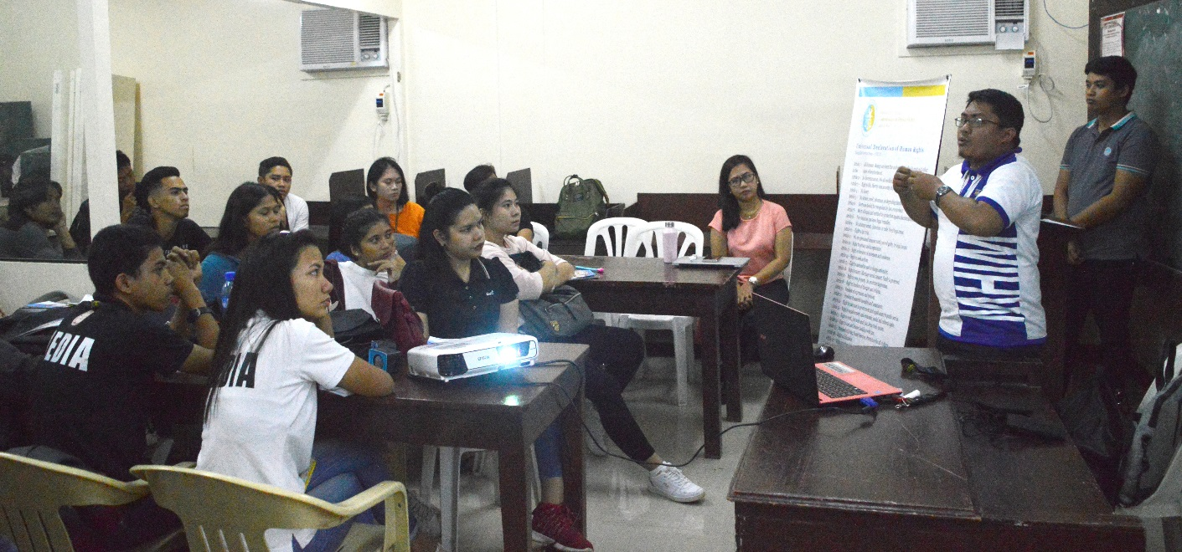
In connection with the Celebration of the World Interfaith Harmony Week 2019, our freedom of speech should be done to build a connection with people and the society rather than to destroy the people and our society. We must be dialogical in every way that we can. We must also speak the truth with sincerity in spreading factual information that can help in creating solutions than making additional problems that could be detrimental to humanity and the society.

At the end of the day, the activity helped us realized that the things that we do must always be linked to our Almighty God so we can do what is best for ourselves, others and our society. Part of what makes us better persons is doing things or uttering a word that comes from the bottom of our hearts and Truth, Sincerity and Forgiveness should be practiced even after this weeklong celebration.

