WORLD INTERFAITH HARMONY WEEK
13TH HARMONY DAY
FEBRUARY 2, 2019
SILSILAH AUDITORIUM, HARMONY VILLAGE, ZAMBOANGA CITY

For 13 consecutive years, it has been an annual tradition to celebrate the Harmony Youth Day. In this year’s collaborative celebration with the World Interfaith Harmony Week, the working committee together with the link moderators of different schools, communities and youth sectors gathered to have a concrete plan on the possible activities for the special event. After a simple yet productive meeting, the team came out with line of activities which includes the Broadway and the first ever “A Path to Harmony Project Runway”.

Given the current situation within the city’s vicinity, the supposed motorcade before the program proper of the 13th Harmony Youth Day was cancelled. However, the participants were advised to went directly to Harmony Village as venue of the program. They were also advised that a call time of 6:30AM to 8:00AM should be strictly followed in order to have an earlier time in ending the program.

The Silpeace Youth Program gave the crowd an extravagant performance with the concept of “Flash Mob” which caught the crowd in surprise and awe. An electrifying energy was brought by performers as the crowd witnessed them. Together with them are the “A Path to Harmony Project Runway” candidates as part of their production number. The loudest cheers from the crowd made the opening salvo an extra ordinary one.

After such, Fr. Sebastiano D’Ambra, convener of the World Interfaith Harmony Week and the founder of the Silsilah Dialogue Movement gave his warm welcoming remarks to the crowd. He introduced the World Interfaith Harmony Week and its history to the crowd as well as the history of the Harmony Youth Day.

Right after Fr. Seb’s message, the candidates for the first ever “A Path to Harmony Project Runway” which aimed to showcase the beauty of creativity and ideas of young talents in relation to the theme of the World Interfaith Harmony Week celebration. Along with their specialized costumes made from recyclable materials, the candidates confidently displayed their state-of-the-art dresses. There were 10 candidates came from 10 different participating schools who took the opportunity to exhibit their extra – ordinary talents. Each of them were given 2 minutes to give their speeches in line as well to theme of the celebration.

Another highlight of the 13th Harmony Youth Day was the Broadway presentation of 9 participating schools showcasing their creativity in conveying message through this form of art. Each has unique story line in connection with the spirit of the celebration of the World Interfaith Harmony Week. The presentation brought a roller coaster to the emotions and feelings of the crowd. Each presentation lasted for 10 minutes.

In the middle of the Broadway presentation, the working committee of the 13th Harmony Youth Day select some participants from the crowd to have an interview. They have shared their insights and reflections on their experience on the Harmony Youth Day. Some of them also shared on what would be the impact of this kind of special event to the youth leaders of different areas.

On the latter part of the program, after all the Broadway presentation, certificates were awarded to the participants as part of gratitude on their invaluable support and effort in joining the celebration of this special event. Winners on the first ever Project Runway were also awarded.

After the awarding of certificates, Ms. Aminda E. Saño, EDC, president of the Silsilah Dialogue Movement gave her closing remarks. In her speech, she congratulated the working committee as well as the facilitators of the event for a job well done. She also expressed her greatest gratitude, in behalf of Silsilah, to the participants who came a long way to join the celebration.

On the last part of the program, the crowd were introduced to “Yesterday’s Dream”, which was translated in various local dialects and languages, as the community singing. They sang all together as they close this special event. As the program officially came to an end, all the participants took the opportunity to have some photo ops together with Fr. Seb and Ms. Aminda as a remembrance on their unforgettable experience with the 13th Harmony Youth Day.

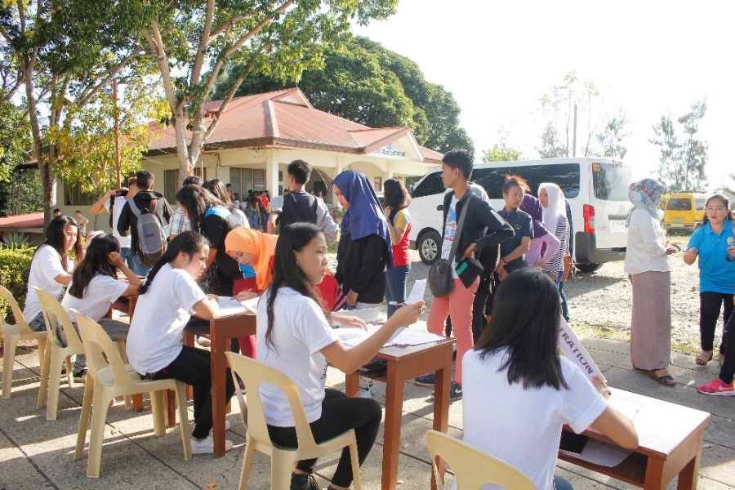
ARRIVAL OF THE PARTICIPANTS. Participants from different schools, communities and youth sectors arrived at the Harmony Village early in the morning. They were assisted immediately by the facilitators, which are members of Silpeace Youth Program, in the registration area and gave short briefing about the special event.

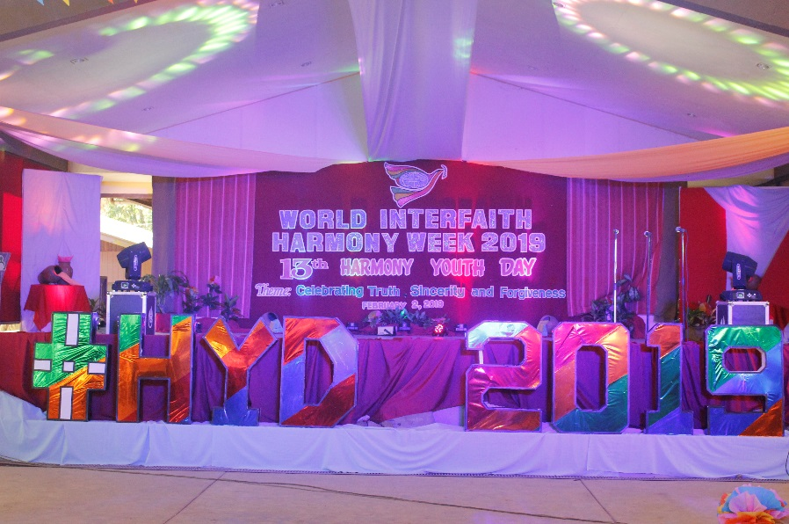
THE STAGE IS SET. With the concept of the working committee of the Harmony Youth Day working committee and the help of the members of the Silpeace Youth Program, the stage was designed with extravagant theme suited for the celebration for the youth. Its vibrant colors reflect the much energy and enthusiasm of every youth leader in celebrating the World Interfaith Harmony Week.

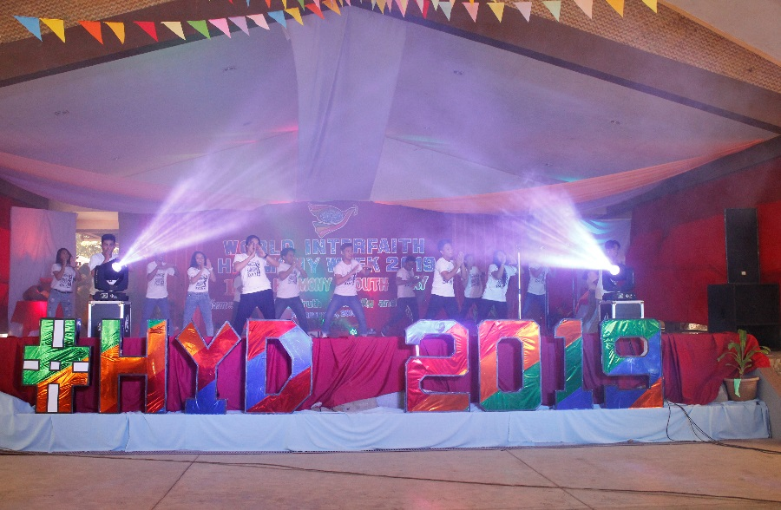

OPENING SALVO. The active members of the Silpeace Youth Program, once again gave their annual trademark as part of the Harmony Youth Day tradition. Their electrifying performance caught the crowd in surprise and awe.

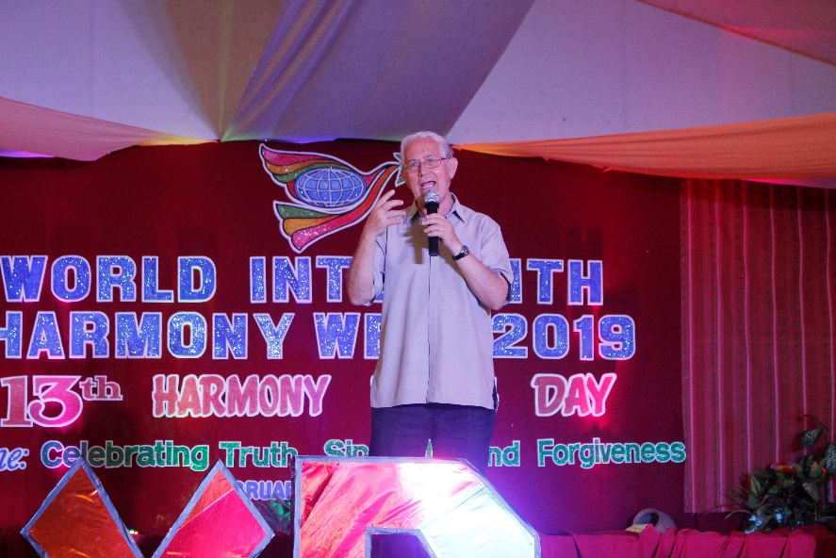
WELCOMING REMARKS. Fr. Sebastiano D’Ambra, the convener of the World Interfaith Harmony Week, gave his warmest welcoming message to the youth as they celebrate the 13th Harmony Youth Day. He delivered to them the essence of the celebration and its history that will surely inspire the generations to come.

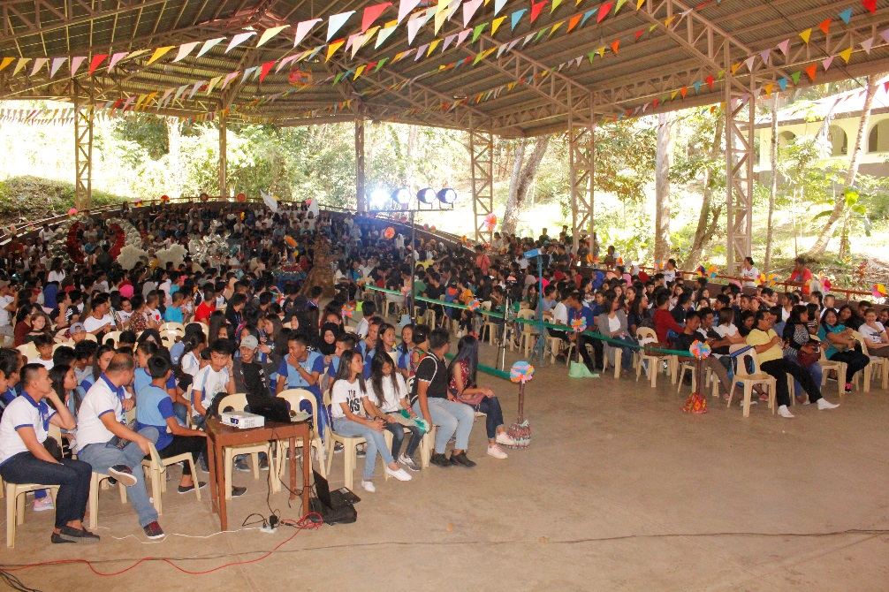
THE CROWD. With 735 participants coming from different schools, communities, and youth sectors, the 13th Harmony Youth Day became more lively hearing the loudest cheers from this sea of youth leaders as they prepare themselves to witness the showcasing of the “A Path to Harmony Project Runway” candidates with their unique costumes.

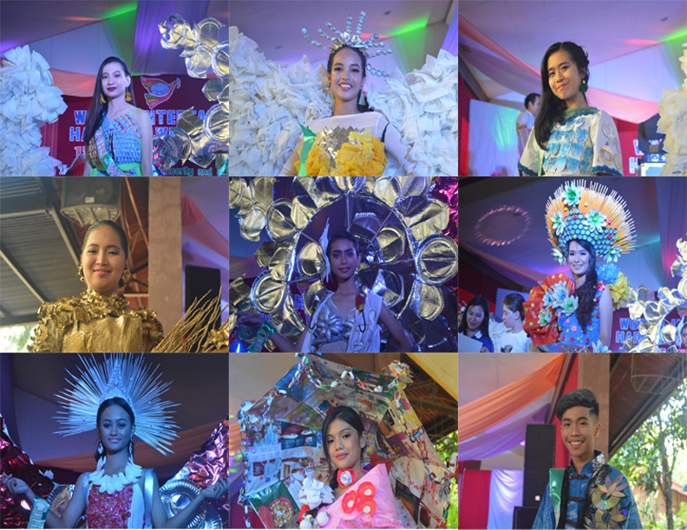

A PATH TO HARMONY PROJECT RUNWAY. The candidates of the first ever project runway of the Harmony Youth Day wearing their best dresses and gowns made out of recyclable materials inspired by the theme of the World Interfaith Harmony Week celebration. Each of them represent their active school participation towards the celebration.

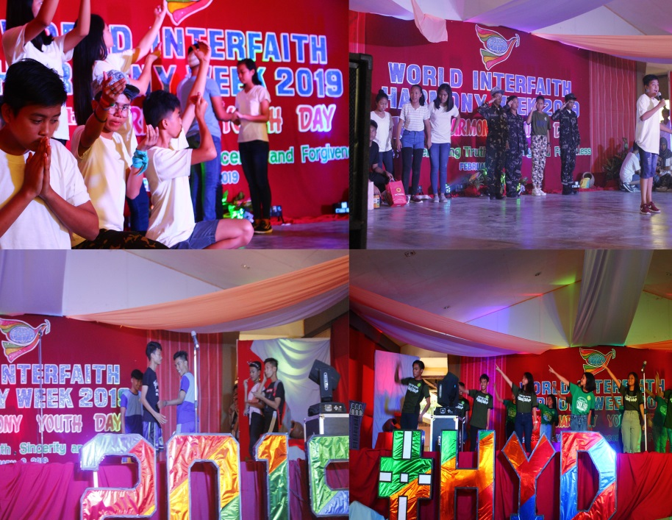
THE BROADWAY. One of the highlight of the 13th Harmony Youth Day, the broadway presentation of some of the participating schools in relation with the theme of the celebration of the World Interfaith Harmony Week. Here, the young talents showcase their skills and creativity through presenting an extra – ordinary broadway presentation.

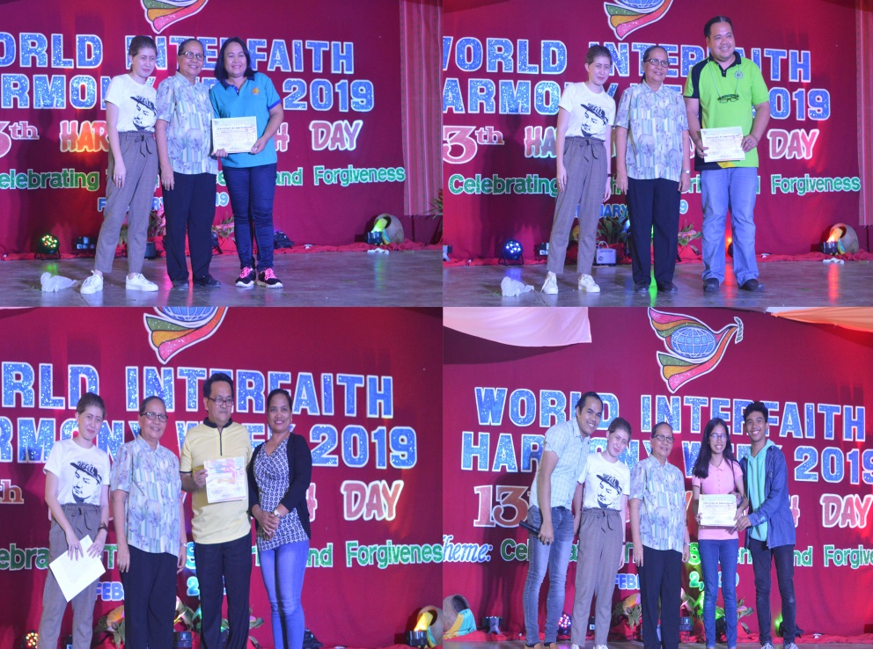

AWARDING OF CERTIFICATES. As part of appreciation for the participation of every schools, communities and youth sectors, the working committee of the World Interfaith Harmony Week awarded certificates as recognition to their invaluable support and efforts.

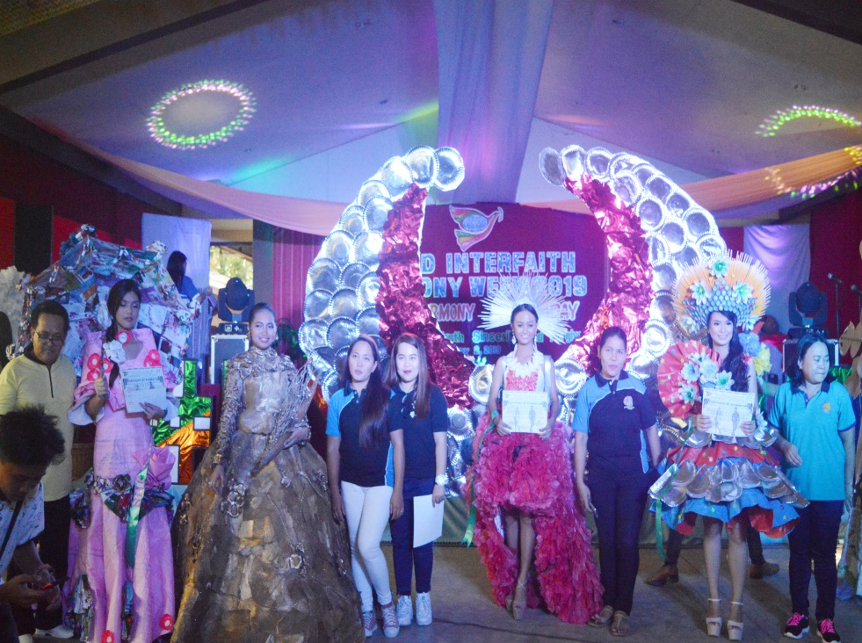

AWARDING OF WINNERS. With the first ever “A Path to Harmony Project Runway”, the candidates took a pose for photo ops together with their peace link moderators. Certificates and prizes were given to the 3 winners of the said contest.

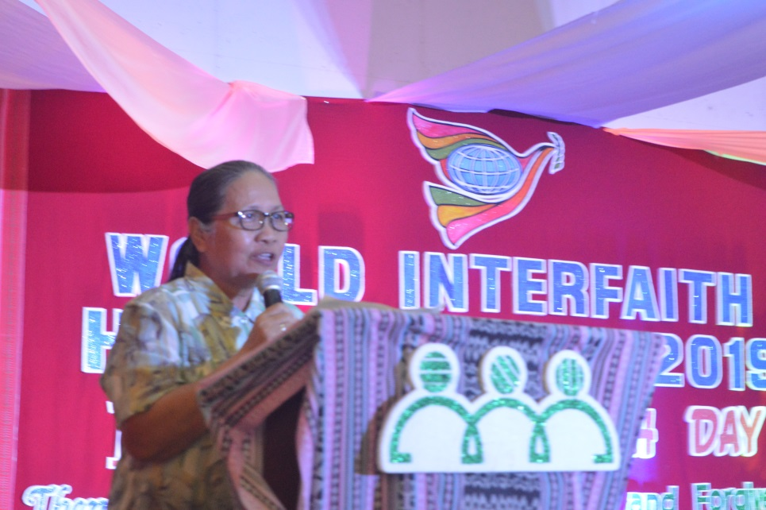
CLOSING REMARKS. Ms. Aminda E. Saño, EDC, president of the Silsilah Dialogue Movement, gave her warmest congratulations and gratitude to the working committee of the 13th Harmony Youth Day as well as the participants coming from different schools, communities and youth sectors.

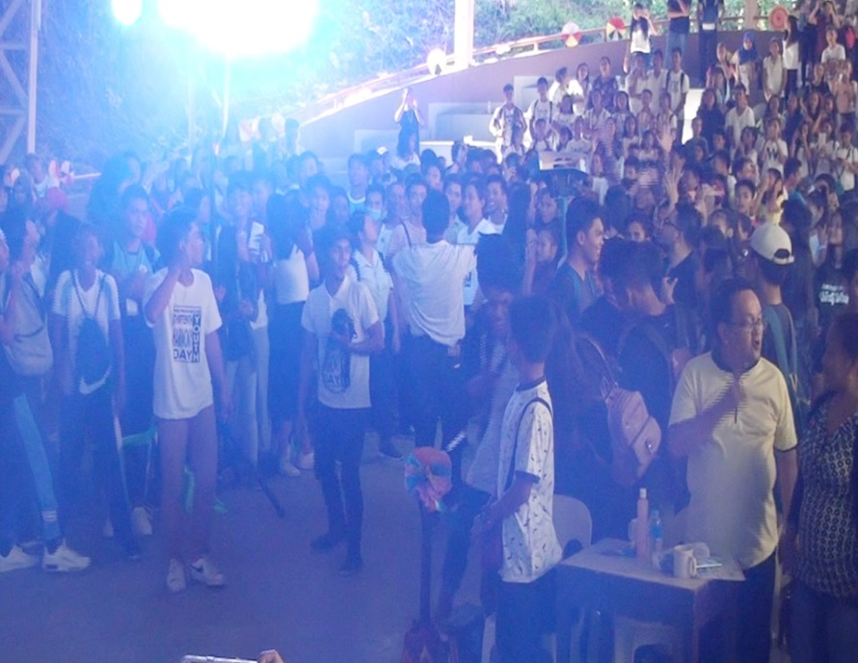

COMMUNITY SINGING. As the 13th Harmony Youth Day came to an end, the participants gathered at the center of the Silsilah Auditorium as they sing together the “Yesterday’s Dream” which was translated in various local dialects and languages.

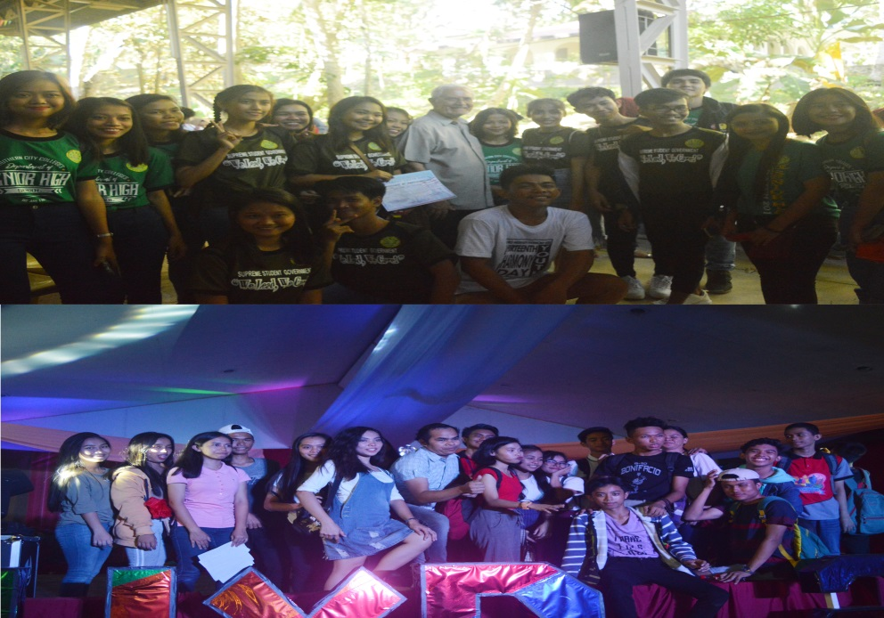
PHOTO OPS. After the program proper, the participants took the opportunity to have some photographs with Fr. Seb as part of their remembrance of their unforgettable experience during the 13th Harmony Youth Day.

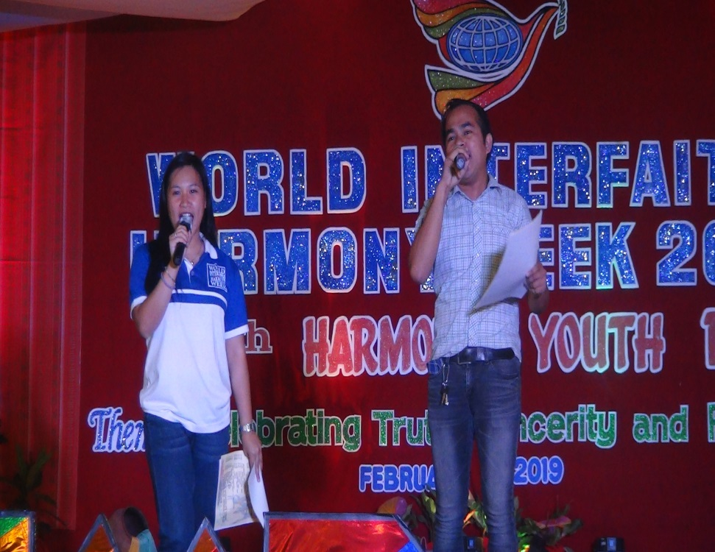
MASTERS OF CEREMONY. Ms. Kimberly Villaflores, an active member of Silpeace Youth Program and the current SK Chairwoman of the Sta. Catalina, together with Mr. Jupiter Montero, an active peace link moderator from one of the DepEd schools, gave their highest energy on being the emcees of this special event.

