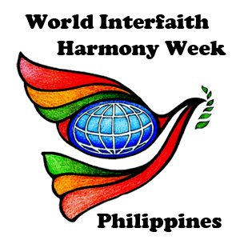

**FIRST NCMF ZAMBOANGA PENINSULA CULTURAL SUMMIT**

***Harmony village, Pitogo Sinunuc, Zamboanga City***

FEBRUARY 3, 2019

**WORLD INTERFAITH HARMONY WEEK 2019**

**ZAMBOANGA**

World Interfaith Harmony Week 2019 continues its celebration on the third day of February, despite the heightened security in the city. On this special occasion, the National Commission of Muslim Filipinos (NCMF) conducted their first Cultural Summit in Zamboanga City coinciding with the WIHW celebration. In relation with this, the NCMF Regional Director Dr. Zulkifar Abantas, collaborated with the Silsilah Dialogue Movement and decided to visit and conduct a short program in Silsilah, Harmony Village, Sinunuc. A good number of delegates arrived in Harmony Village with Police and Military for security and order. Among the 70 visitors, half of them were delegates from Indonesia and Malaysia who express their deepest gratitude and happiness for an earnest welcome from Silsilah.

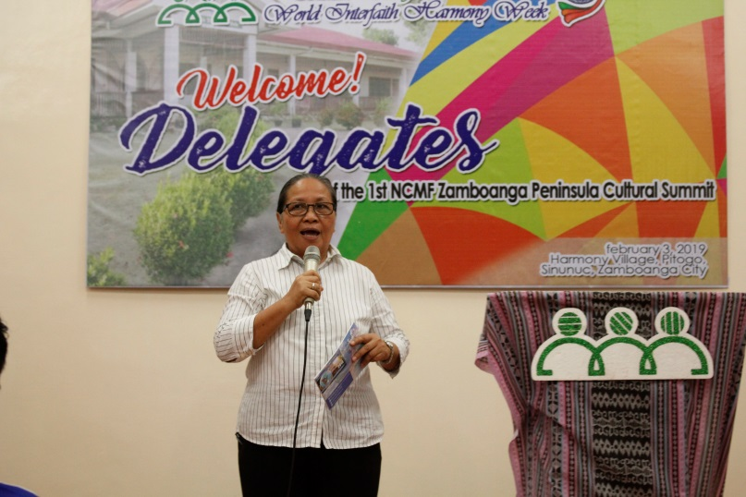

**Ms. Aminda E. Saño, EDC – President, Silsilah Dialogue Movement** acknowledged the visitors. She also expressed her happiness meeting people from different countries. This special program was also a special way to introduce the Silsilah Dialogue Movement and its mission to a group of Muslims. Silsilah has long reflected Muslim-Christian Dialogue through formations and this kind of activity is really a great opportunity to know more each other.

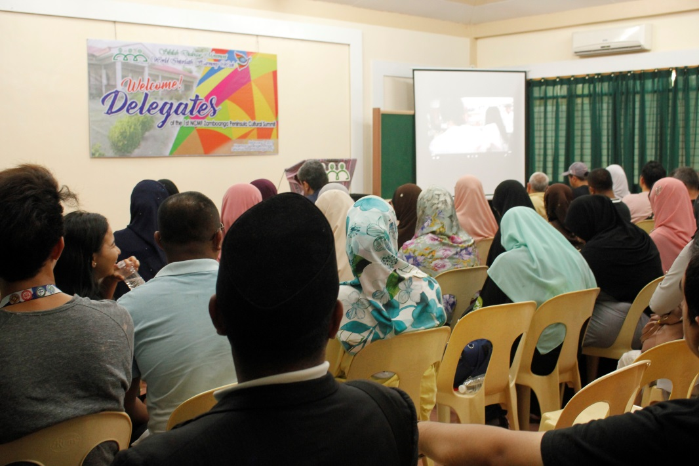

The documentary of Silsilah was viewed by the delegates. This documentary introduces the Mission and Vision of Silsilah. It also includes the programs of Silsilah with the four Pillars of Dialogue: Dialogue with God, Self, Others and Creation. With full attention, they watched the presentation and were motivated to know more about the Movement.

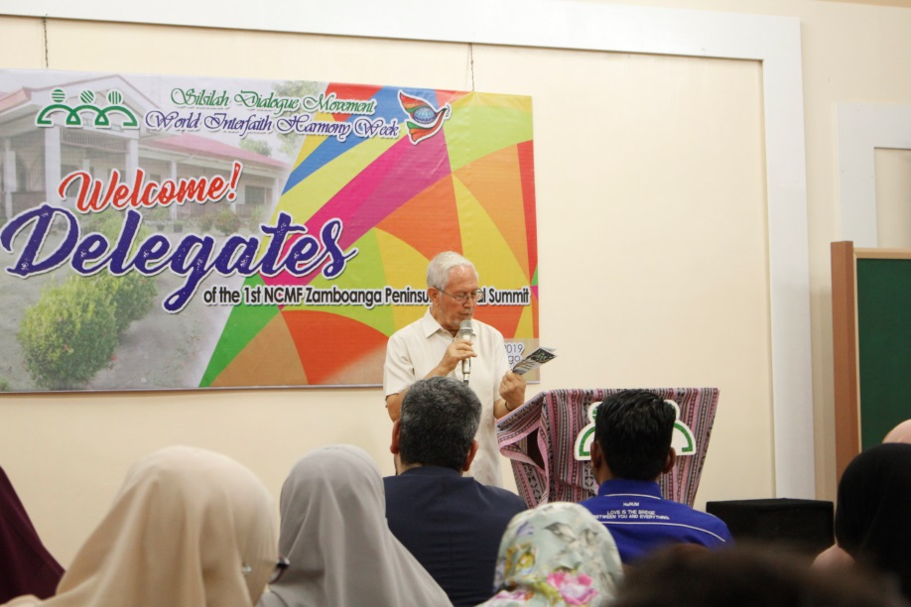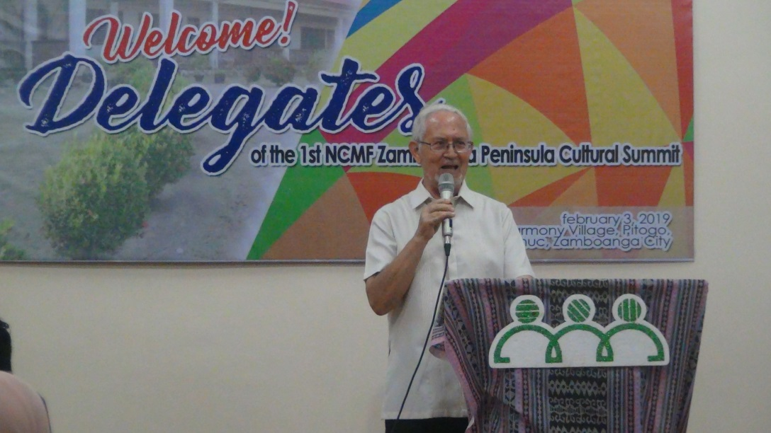

**Fr. Sebastiano D’Ambra, PIME Founder – Silsilah Dialogue Movement** shared the inspiring message of the World Interfaith Harmony Week and how this celebration was spearheaded by the Silsilah Dialogue Movement. He also shared his mission in the Philippines and how he decided to stay in Mindanao despite his age and the situation in the area.

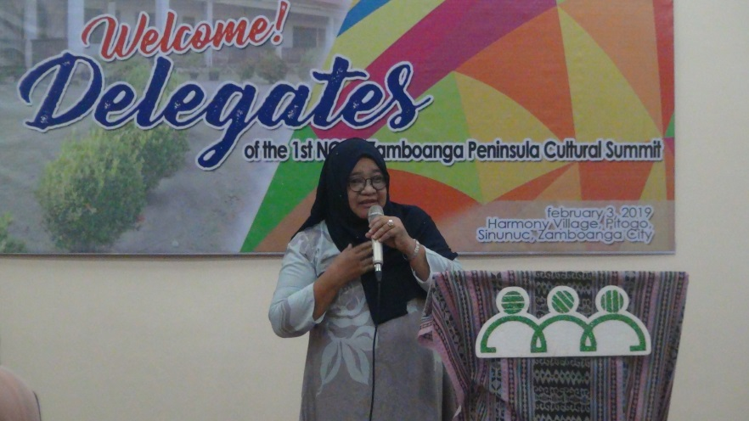

**Mrs. Sarah L. Handang, MEP-ALIVE**, shared her inspiring experiences during her stay with Silsilah Dialogue Movement. Mrs. Handang believes that Silsilah feels like home to her. Despite the differences in beliefs and culture, she is a family to the movement moving for the same aspirations which is to achieve peace. Islam is a religion of Peace and Christianity is a religion of love.

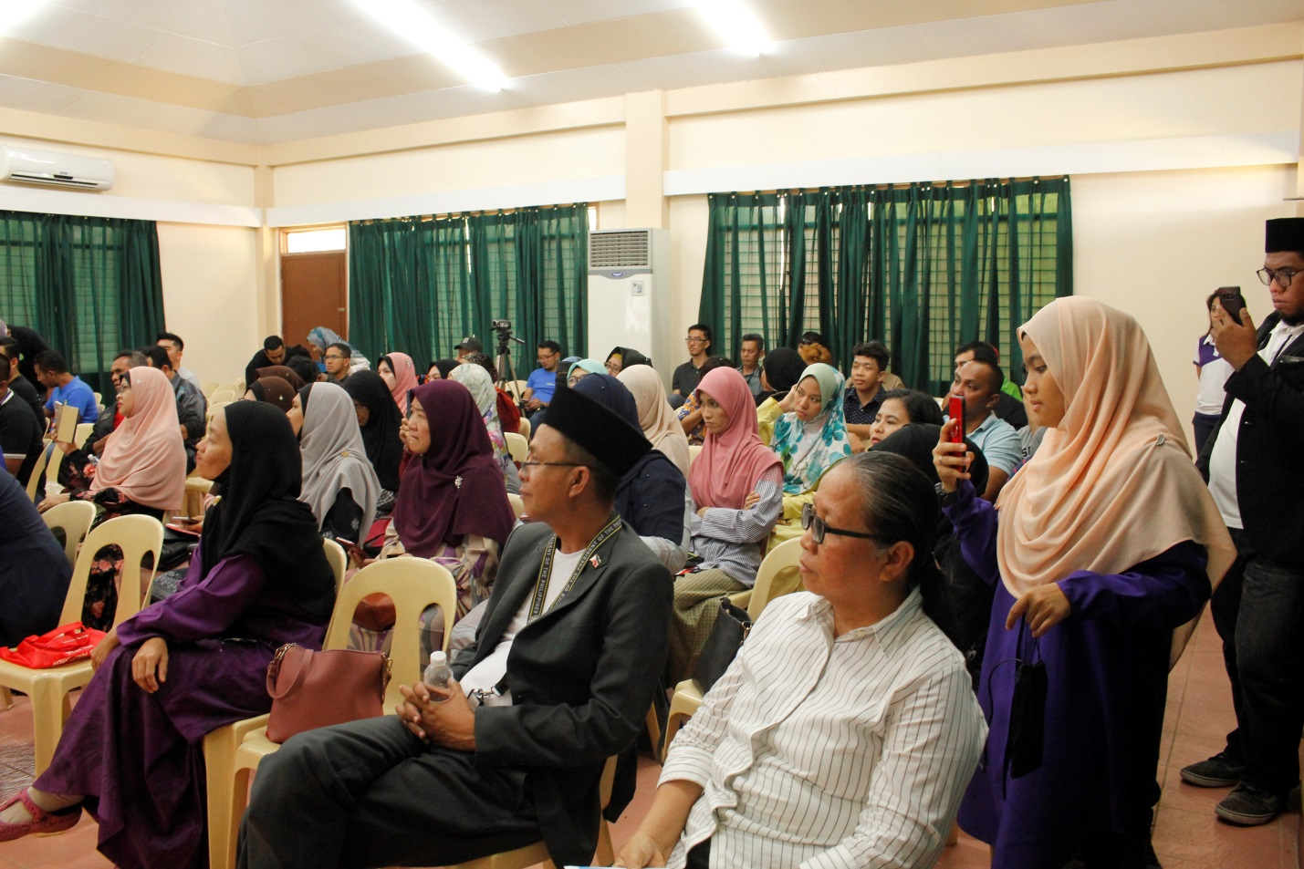

The delegates viewed the presentation of the HARUM-Malaysia. The presentation is about the famous author *Rumi* where his book was entitled “*Book of love*”. They distributed booklets which introduces Rumi and his works to the Silsilah Dialogue Movement.

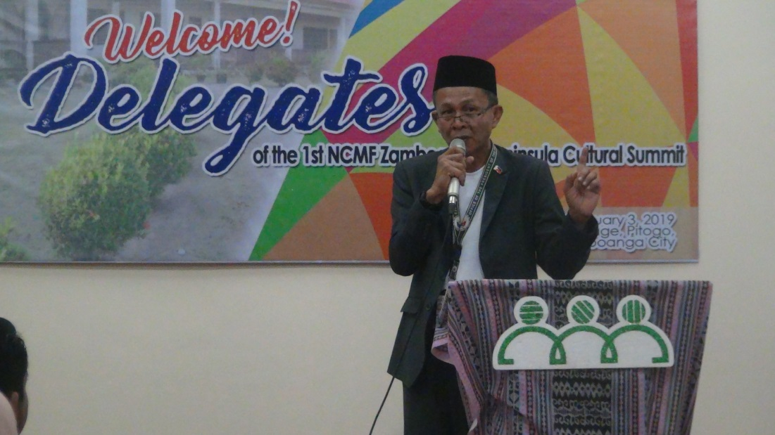

**Dr. Zulkifar Abantas, NCMF Regional Director** shared his gratitude and happiness for having this opportunity. To visit the Silsilah in this essential occasion make him feel fulfilled. He thanked Fr. Sebastiano D’Ambra for granting his request and spending time together with the Indonesian, Malaysian and National Commission of Muslim Filipinos delegates.

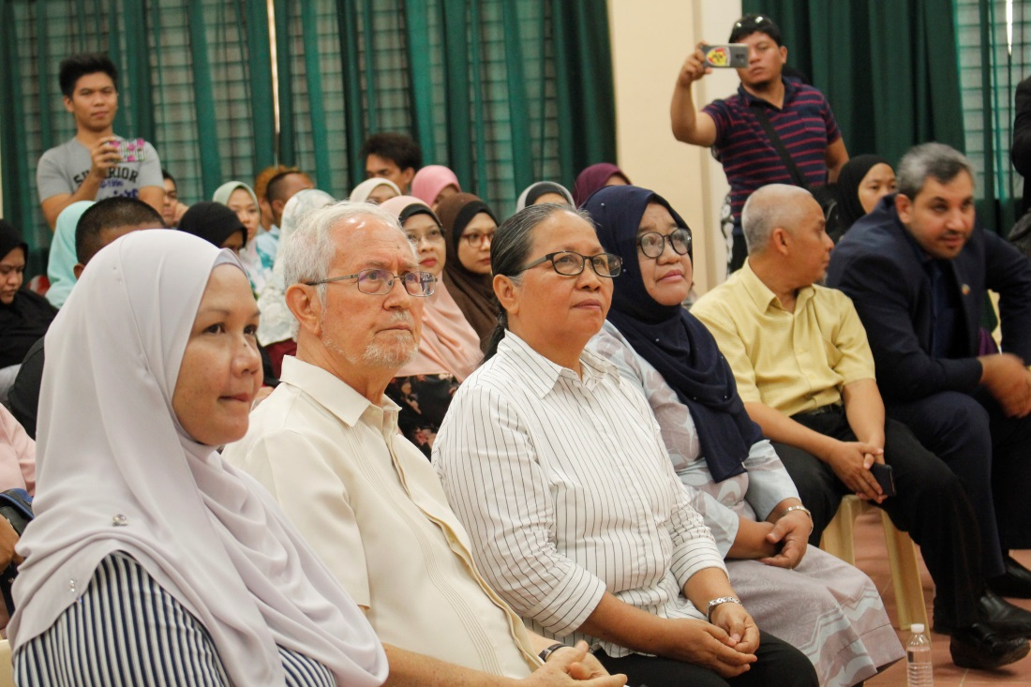

Fr. Sebastiano D’Ambra, PIME and Ms. Aminda E. Saño, EDC together with the NCMF delegates. Muslims and Christians, gathered together with acceptance and respect. A true image of Dialogue motivated by the belief that we can be in Peace, if we believe in it.

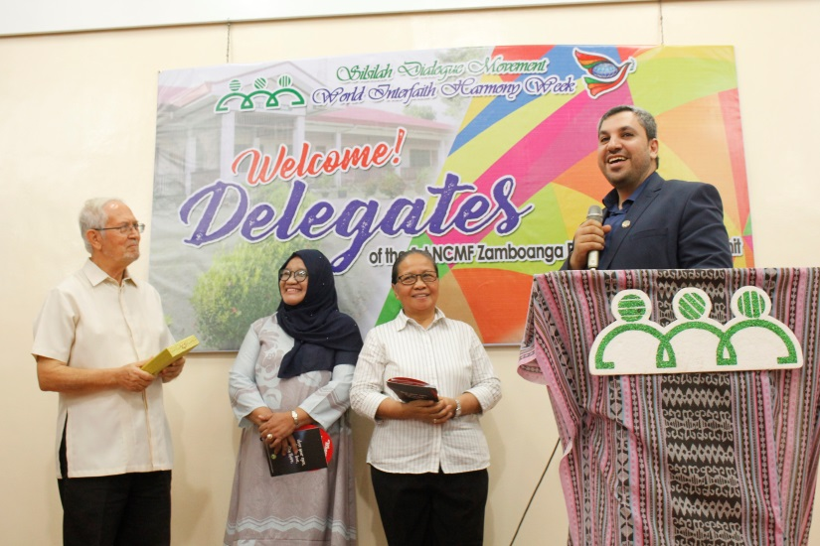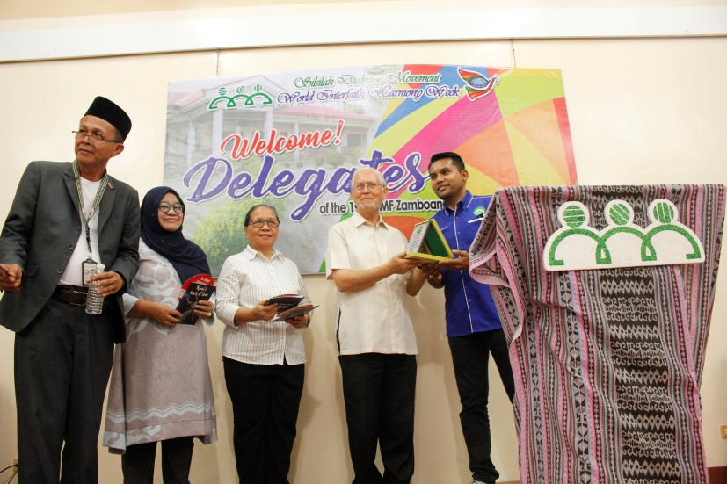

Silsilah receives an award for the event and for sharing the good message of World Interfaith Harmony Week.

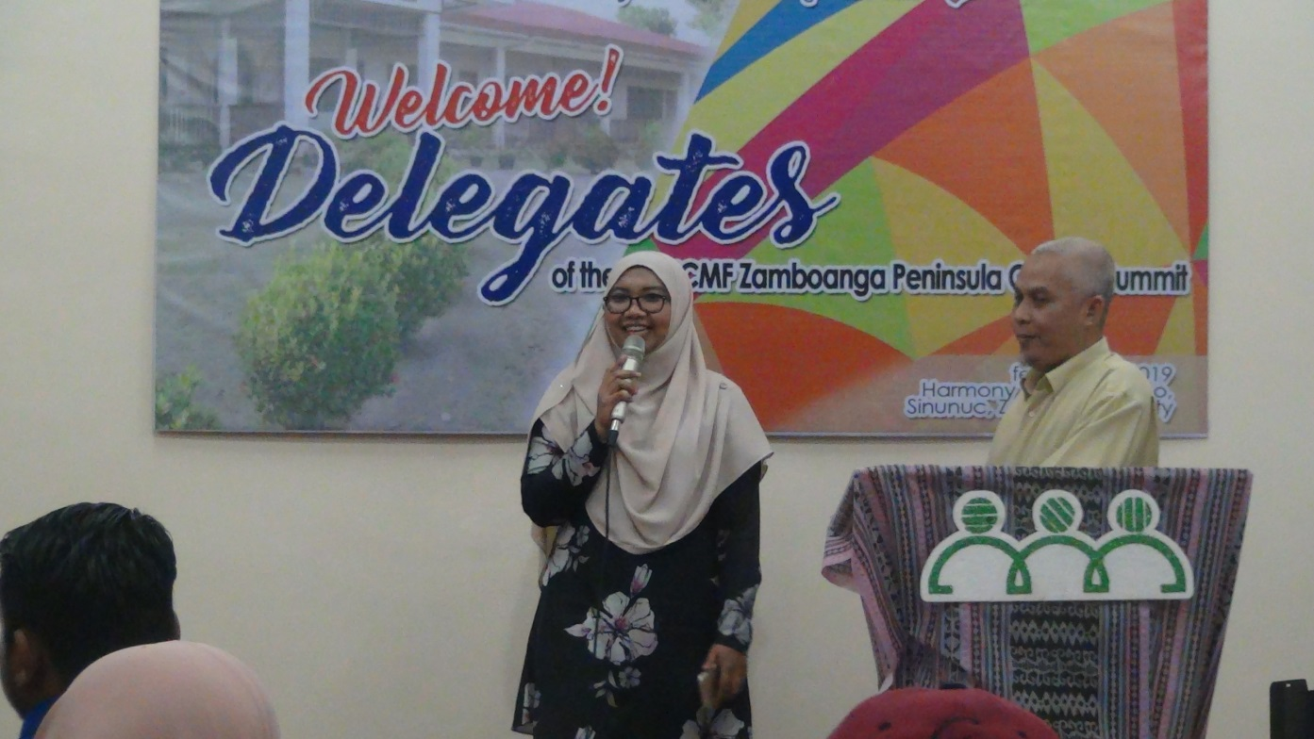

A song “Deen Assalam” was dedicated to Fr. Sebastiano D’Ambra, PIME. The meaning of the song is Islam as a religion for Peace and how our Brothers and Sisters of different faiths longed for it. The dream of love is benevolent and the goal for Peace is challenging especially in Mindanao but Silsilah will always be a sign of hope.

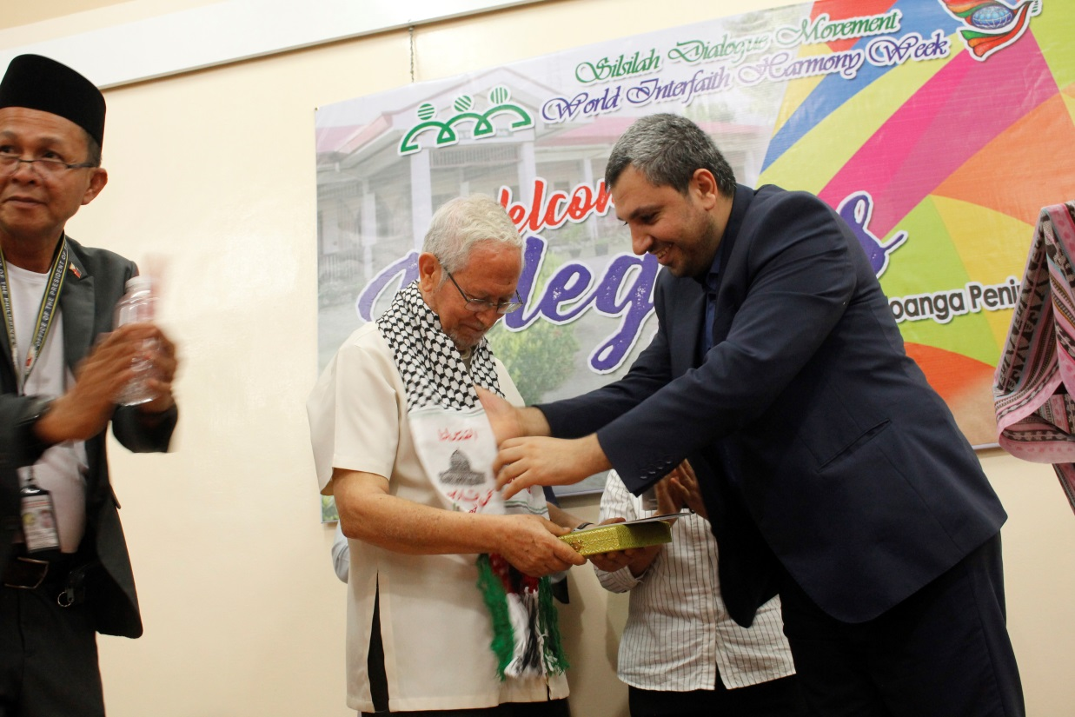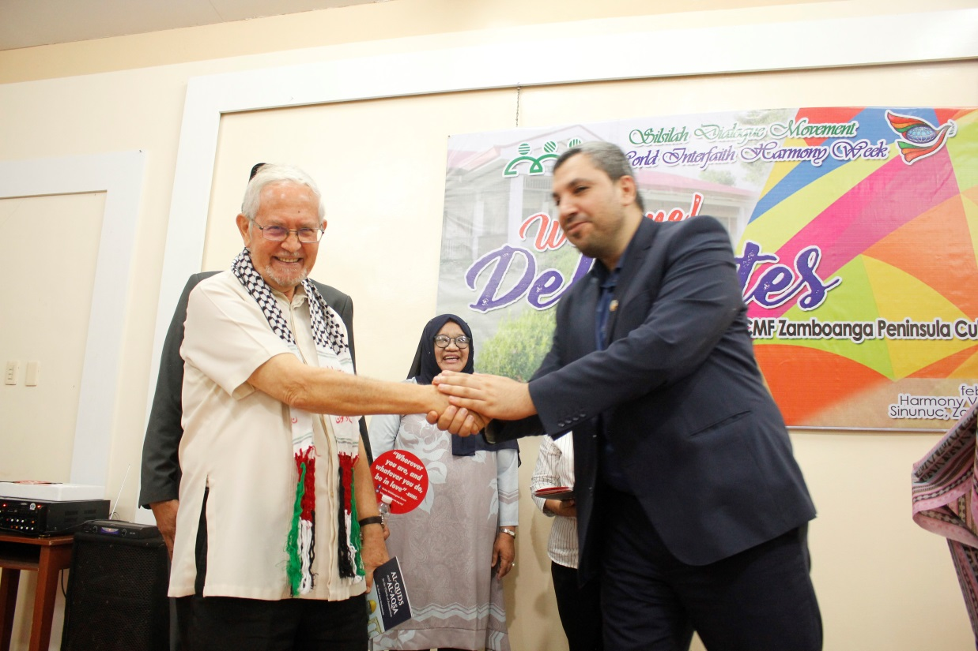

Fr. Sebastiano D’Ambra, PIME received a symbolic Shawl as a sign of friendship with the Indonesian delegates. Fr. Sebastiano D’Ambra, PIME was challenged to dream more and to continue his mission for Dialogue and Peace in Mindanao and in Philippines.

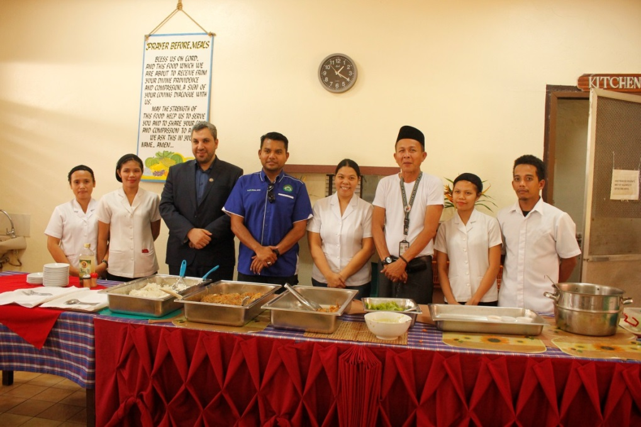

After the program, the delegates had their lunch and happily ate together. This activity was very significant giving the delegates a very essential experience.

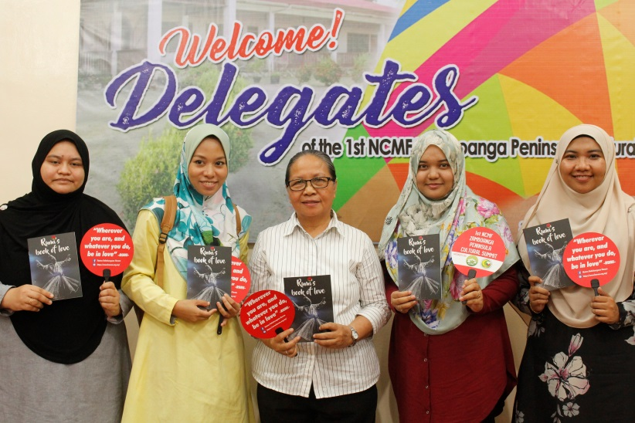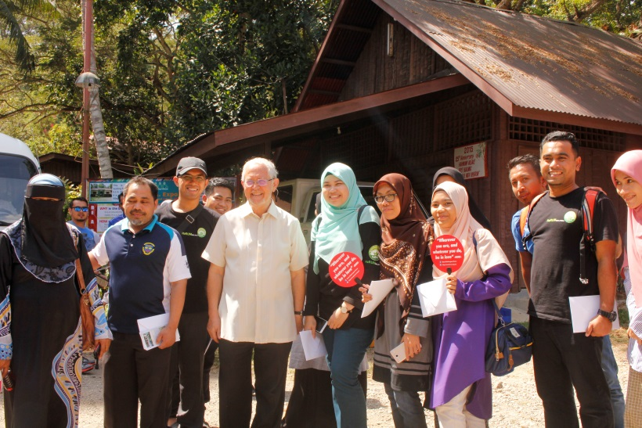

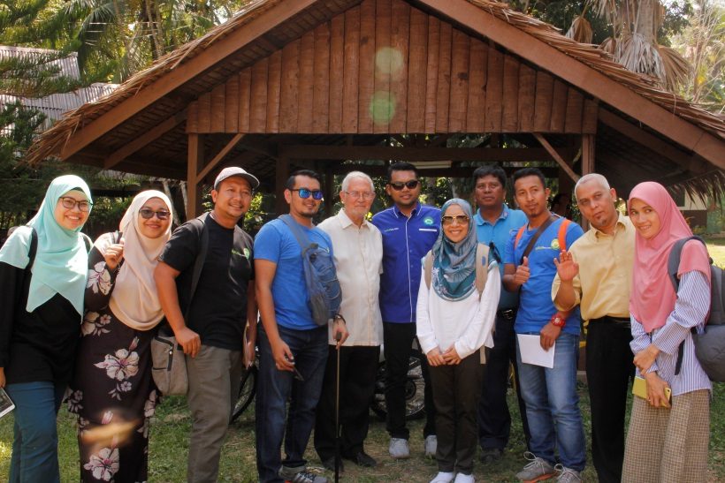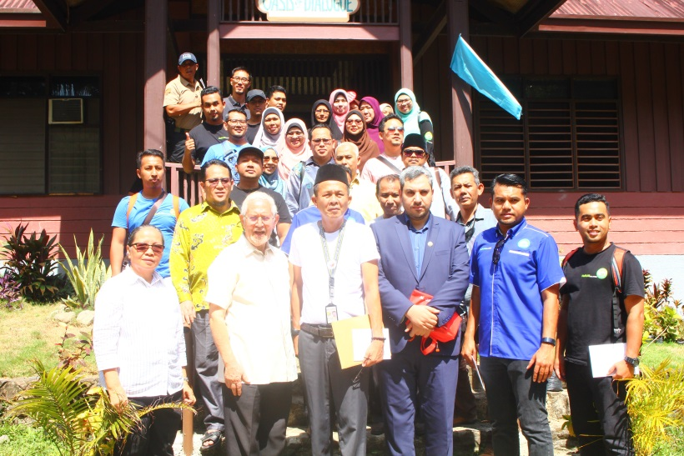

Truly, the differences of people can be accepted, if we learn to respect and know them more. Peace is very challenging in Mindanao. It is as if yesterday we made two steps towards peace but in just one act of terrorism, it feels like we were pulled a hundred steps away from peace. However, people with genuine heart and intentions will work to achieve it no matter how tough it will be. Peace will be achieved, if people will never lose the idea of love in their hearts. We are hoping for more symbolic activity of Muslim-Christian Dialogue and to inspire people to thrive more to have a better world and society with restored humanity.