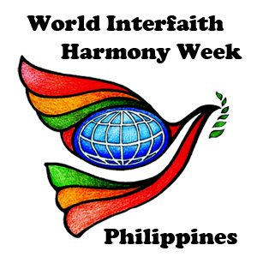

**FORUM ON EARLY DETECTION OF BREAST CANCER**

***MBCSEA Clinic, Production and Training Center for Women,***

***Sta. Maria., Zamboanga City***

FEBRUARY 9, 2019

**WORLD INTERFAITH HARMONY WEEK 2019**

**ZAMBOANGA**

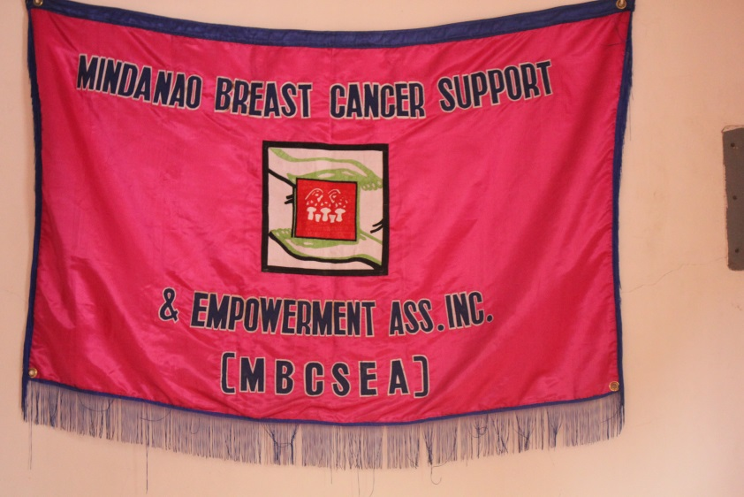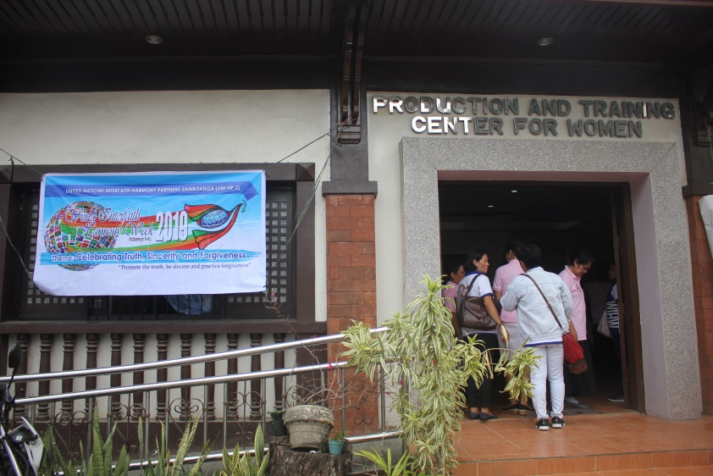

Breast Cancer is a form of cancer which has started affecting hundreds of women and few men around the world. Awareness campaigns like forums and sessions of different organizations are doing their best to inform people about the symptoms and preventions of this illness. With the spirit of World Interfaith Harmony Week, the Mindanao Breast Cancer Support and Empowerment Association, Inc. held their Breast Cancer forum for the women from the different Barangays of Sinunuc, Zamboanga City. Silsilah helped the MBCSEA organize this event. The activity aims to increase awareness about breast cancer and to give hope to people by informing them that early detection of this disease can help the patient have a better quality of life.

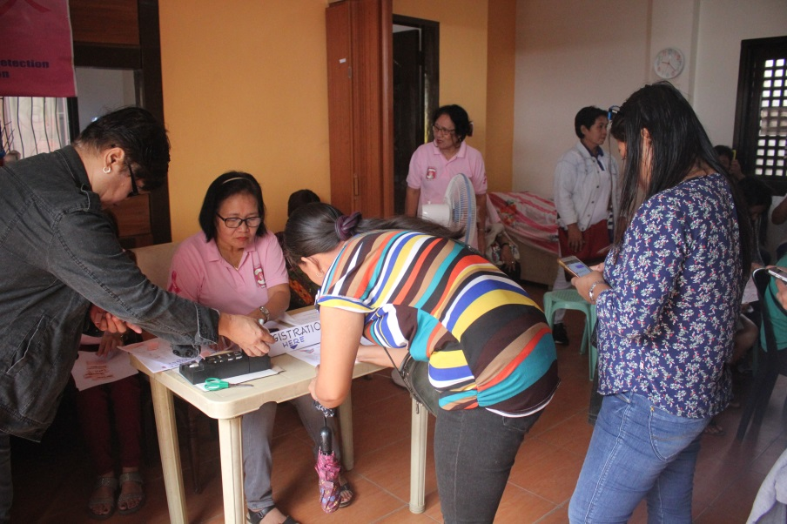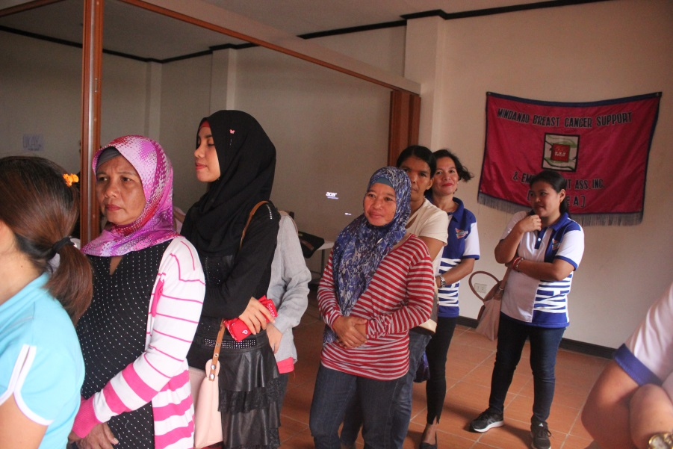

Women from Sinunuc Barangay and Silsilah staff members were invited to attend, 37 participants were registered. The Forum on early detection of Breast Cancer will give the participants the knowledge to either prevent the disease or to know the symptoms of this disease as early as possible.

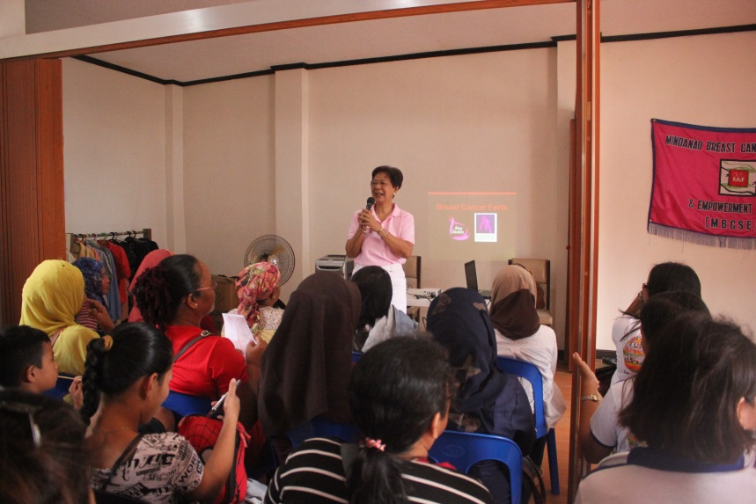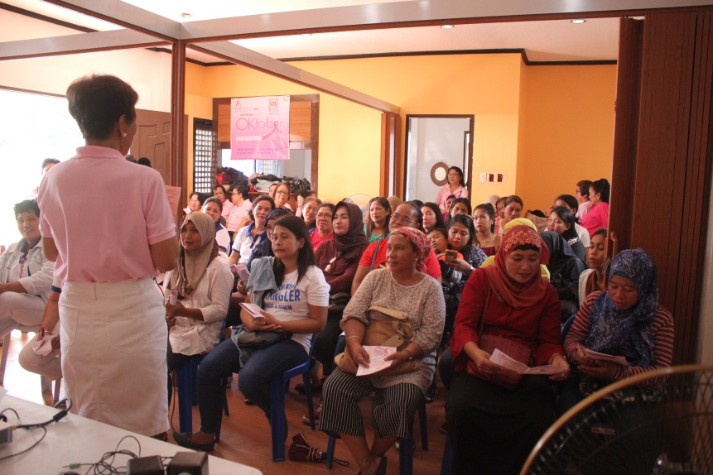

Ms. Florence Alcazar, the President of this Association welcome the participants on this special event. She introduced some of the members of the Association who are breast cancer survivors. She also discussed the objectives of this activity and why they were making this kind initiative. The association is also an active partner of Silsilah during the celebration of World Interfaith Harmony Week.

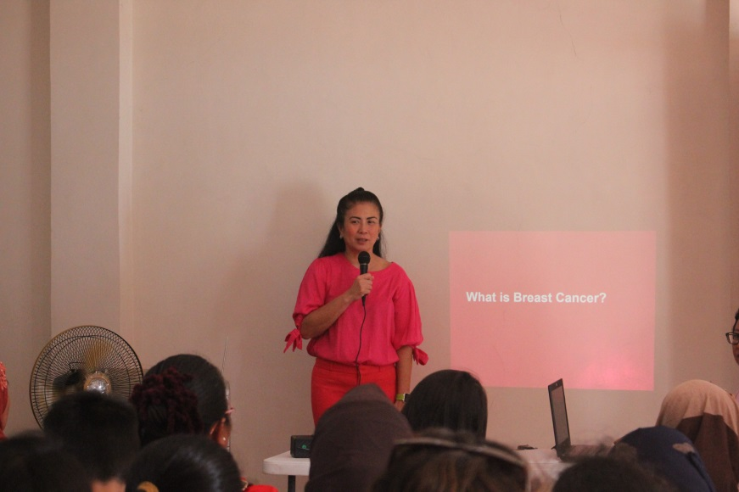

Dr. Marissa M. Lim, the adviser of the Association and the speaker for the activity started to share her experiences as a doctor of breast cancer patients.

The speaker begins with the questions, “what is breast cancer? How does it affect us?”

Awareness campaigns like the initiative of MBCSEA tells the women about breast cancer, the symptoms, the diagnosis and the signs which appear with the instructions especially for women to get checked once in a while. Although the disease is more common in women, men also fall target to breast cancer. Dr. Marissa shared that throughout the years of her service as a doctor, she had 3 men diagnosed with breast cancer.

With this initiative of awareness forums, women are more inclined to know about the disease and get them checked instead of ignoring this life taking disease.

The topic ended with the advised to know yourself and your body more for you to know what is wrong. She also advised to check oneself more often and get diagnosed if symptoms were found.

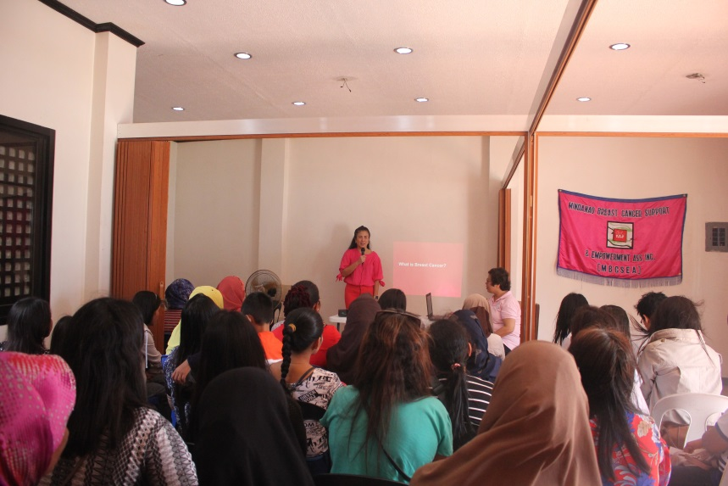

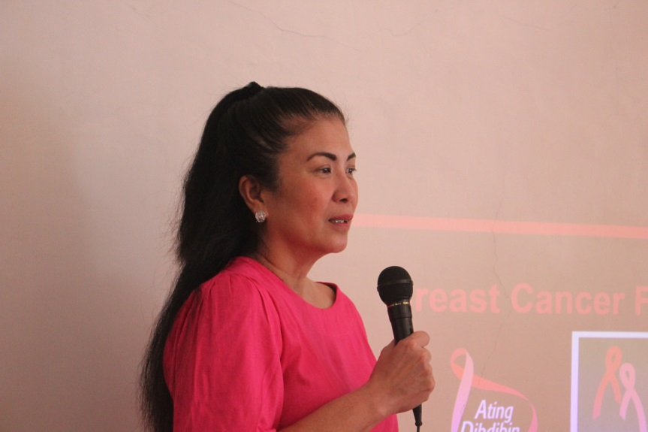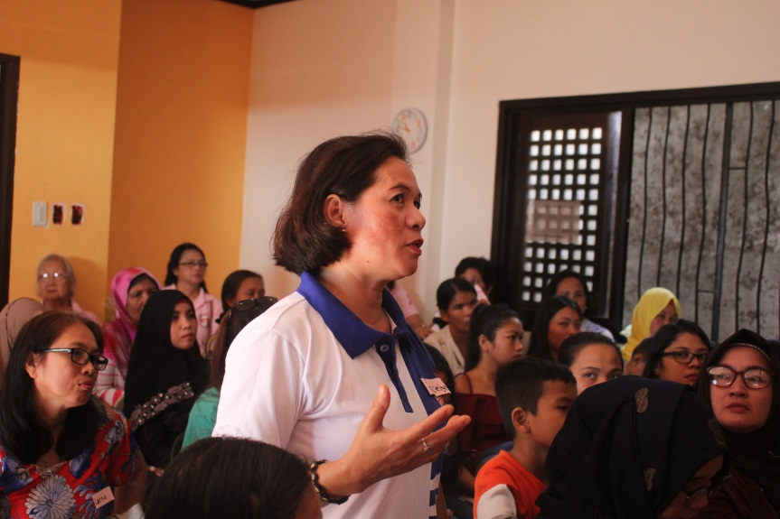

**OPEN FORUM**

The participants were encouraged to raise their questions to the speaker. The participants usually asked where to go once they see the symptoms of the disease and what are the preventions for those who are at high risk of this disease.

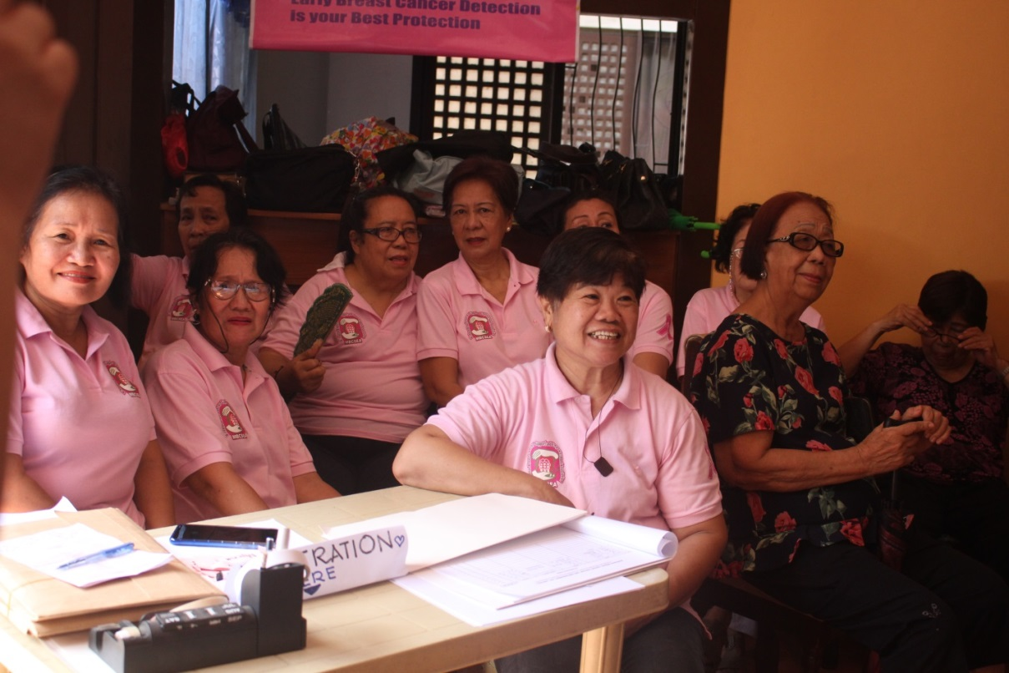

*This is the MBCSEA members who assisted this event and happily served the participants. Some of them are cancer survivors and are now giving people the sign of hope that quality life can still be achieved despite being diagnosed with breast cancer.*

World Interfaith Harmony Week is a great opportunity to gather people for this kind of initiative. Breast cancer is a term which has now become well-known in all societies around the world. It will be a great opportunity to spread awareness of this disease to women for them to be more conscious about their health and getting checked. In collaboration with Silsilah and with the spirit of the World Interfaith Harmony Week, the special activity was made possible. Hopefully, people will be aware that early detection of the disease saves lives which is better than cure.