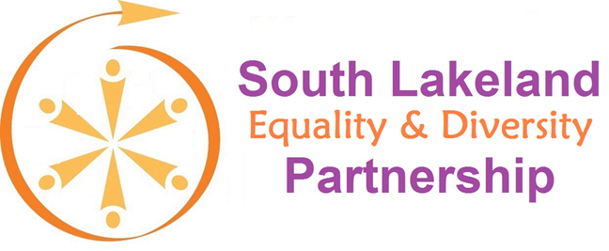
World Interfaith Harmony Week 1 – 7 February 2019
https://worldinterfaithharmonyweek.com/
South Lakeland Equality and Diversity Partnership (SLEDP) presents the Cumbrian launch of the third edition (2018) and first Cumbria supplement (2019) of Religion, Belief and Culture in our Community: Understanding, respecting and valuing the diverse cultures of the United Kingdom
Speakers include Councillor Guy Tirvengadum Mayor of Kendal & Chair of SLEDP, Joe Murray QPM – Chair Cumbria Neighbourhood Watch Association, Jacquetta Gomes – SLEDP Lead on Interfaith and Multifaith, Mark Clement – Cumbria Fire and Rescue Service, Mike Humphreys – Chair South Lakes Interfaith Forum, and Peter McCall – Cumbria Police & Crime Commissioner
Tuesday 5th February 10 am – 11 am
Kendal Town Hall, Highgate, Kendal, Cumbria LA9 4ED
Light refreshments available
You are all welcome to attend
The aims of the South Lakeland Equality and Diversity Partnership (SLEDP) are:
- seek to reduce inequality on the grounds of gender, race, disability, age, sexual orientation, rurality and religion/belief
- celebrate diversity and reduce discrimination
- improve the life chances and opportunities for people who live, work and visit South Lakeland
https://www.southlakeland.gov.uk/your-council/equality-and-diversity/south-lakeland-equality-and-diversity-partnership/
Further information from sledp2016@gmail.com

