WORLD INTERFAITH HARMONY WEEK EFFORT
INTERNATIONAL EFFORTS
Howard G Comen Ken McClenton John Bulinda
His Majesty King Abdullah II of Jordan
In reply to your e-mail of 3/4/2018 concerning our interfaith efforts I have prepared a brief summary of the efforts of myself, Ken McClenton, and Bishop John Bulinda. Mr. McClenton turned the tragedy of the murder of his 27 year old journalist daughter into an effort to bring racial and interfaith harmony worldwide. Bishop Bulinda and his Wife Mary as vwell as his family still in Kenya have labored at great hardship to bring interfaith, racial, ethic and tribal harmony to Kenya and Africa.
I have been fortunate to team up with these wonderful people dedicated to Interfaith, Racial, Ethnic, Tribal, and Gender harmony.
In our adventure to bring about cooperation between all segments of Humanity, inspired by the work of the WIHM we have developed a Weekly TV Show with Co Host Ken McClenton, the Exceptional Conservative TV/Radio Host SHADES OF HUMANITY:ONE RACE DIFFERENT SHADES. Ken is in DC, i am in Charleston, South Carolina. We have also developed an initiative to bring equal economic opportunity, equal education, and equal justice worldwide we call the Trinity of Equality. The show has plans to begin a Southeast and Northwest US show to compliment our international effort. Shades of Humanity, the Trinity of Equality, and other efforts can be viewed on my website comendetectives.com.
While speaking at a World Conference of Mayors meeting in Detroit in October on our Trinity of Equality alongside Kenyan Bishop John Bulinda we attracted the attention of the African Union Ambassador Afrikana Quao. She asked her to meet with her in November in her DC office. There we discussed our Trinity of Equality and our TV Show. She asked us to broadcast our program through the A.U Offices throughout Africa. We are working out the details. We are developing a second TV show “The African Diaspora”.
Bishop Bulinda and I have put teams on the ground in Kenya to try to move the Trinity of Equality to Kenya as an answer to political, terrorism, and economic turmoil there. We hope to expand efforts with Ken to the African Continent.
If take a personal interest in SHADES OF HUMANITY we would love to broadcast to Jordan and the rest of the Middle East. I can send you a link to one of the shows.
Ken McClenton and I developed the Open Heart Closed Case initiative ( I sit on the Board of Directors) to use my detective agency to solve unsolved murders, missing persons, and child endangerment cases.Ken attracted the attention of a Houston Texas transportation giant to find 300 underprivileged people in the Maryland/DC/Virginia area to be trained by the transportation industry for jobs paying $50,000 to $200,000 a year jobs in the transportation industry. Although a work in progress we have already been approached by ten or so other cities to institute our program.
At this point my 40 year adventure to bring about interfaith and racial harmony have been funded by income from my detective agency. Clergy, business leaders, government leaders all are paid to do the good works they do by companies, religions, taxpayers, our countries.
I have included photos:
1. Bishop Bulinda and I at the World Conference of Mayors Detroit Michigan; Bishop Bulinda blowing the Shofar ( Jewish Trumpet Joshua used in stead of swords at Jericho in ancient times) in Detroit as we were recognized for our interfaith and racial harmony work.
2. The World Conference of Mayors
3. Ken McClenton, Bishop Bulinda and wife Mary, African Union Ambassador Quao, and me.
4. Ken McClenton at the African Union Radio Station ready to broadcast.
5. Comen promo SHADES OF HUMANITY.
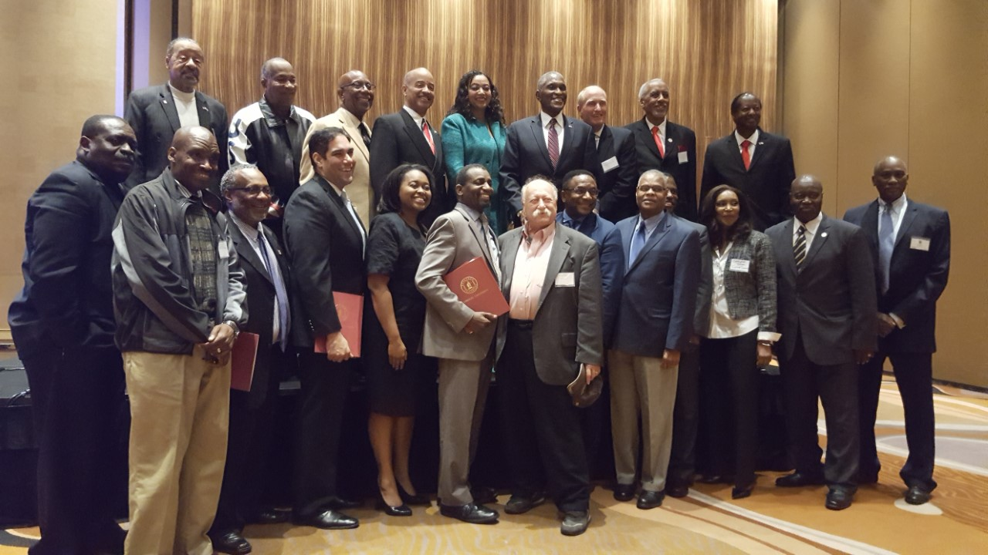

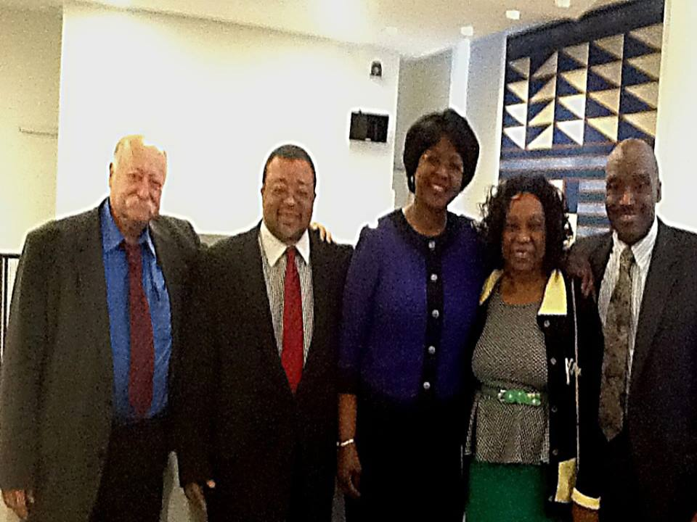

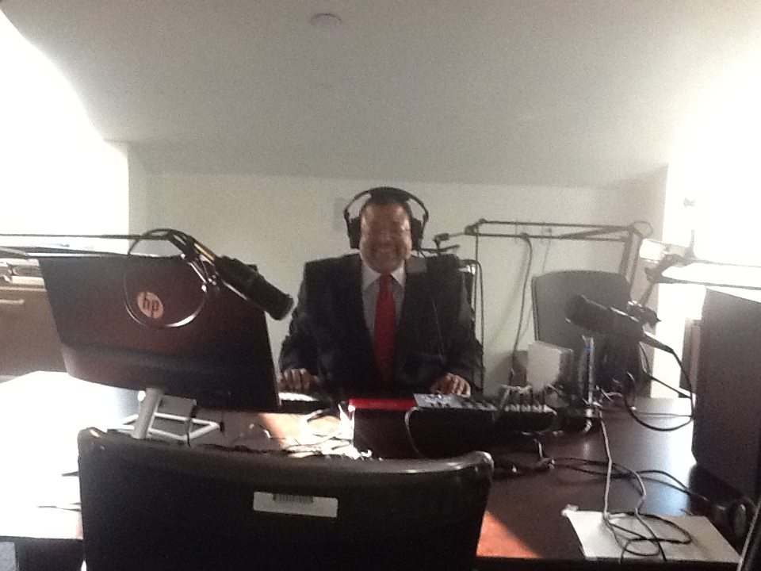

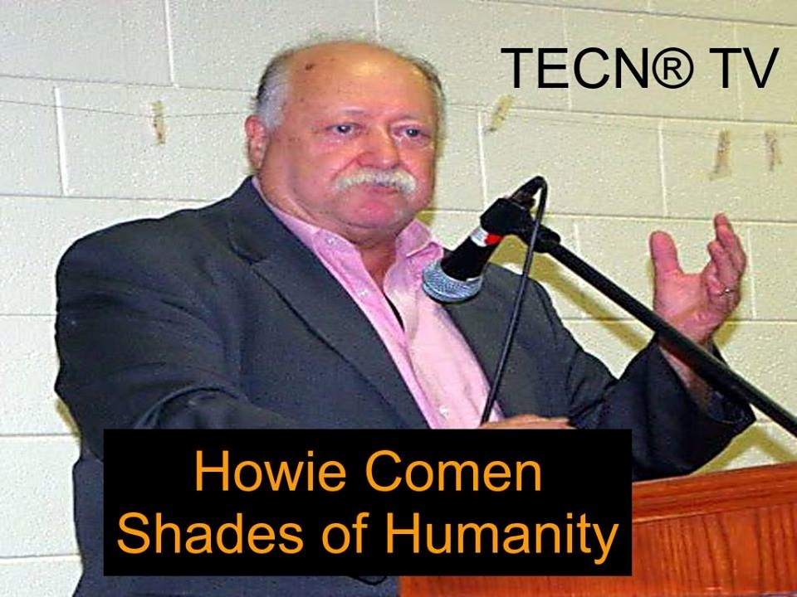
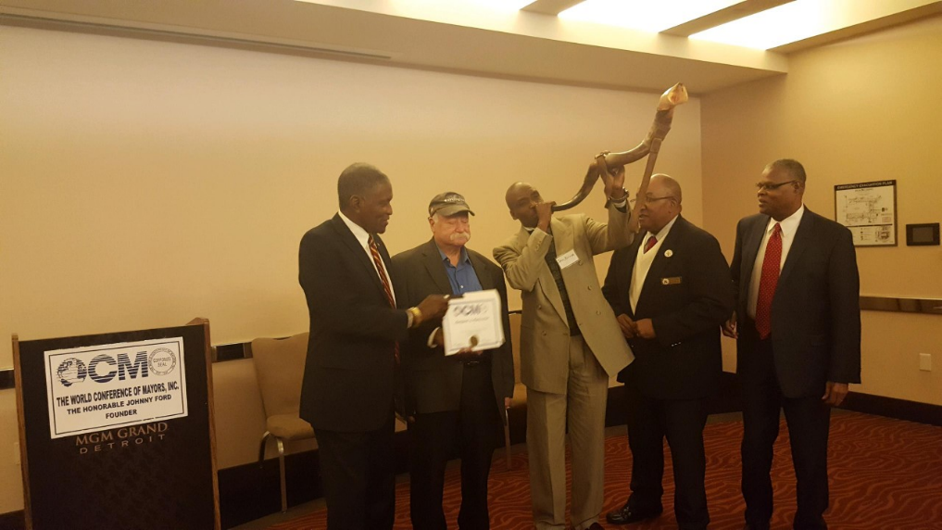

My best to your family,
Howie Comen
Charleston, South Carolina

