PRESS RELEASE
5 February 2018

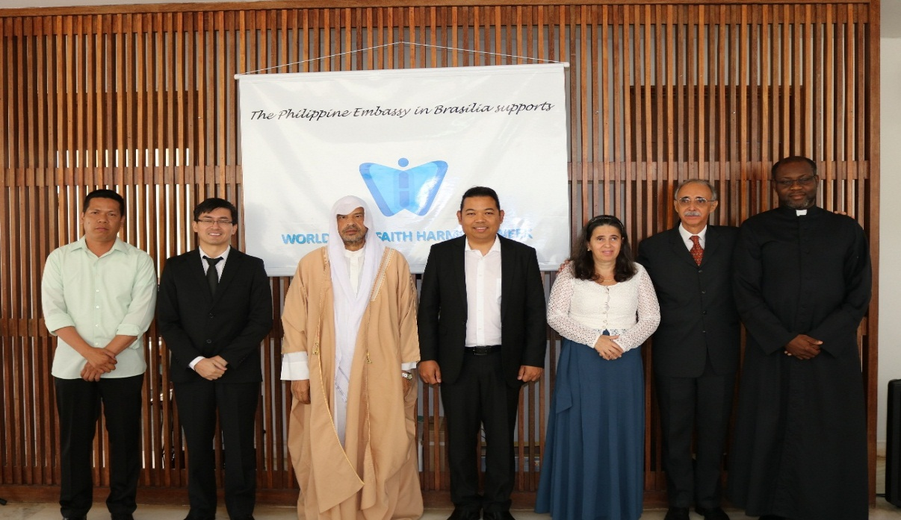
CDA Ariz Severino Convalecer poses with leaders of various religious groups to mark World Interfaith Harmony Week

Philippine Embassy in Brasília Celebrates World Interfaith Harmony Week

BRASÍLIA, BRAZIL – The Philippine Embassy in Brasilia celebrated the World Interfaith Harmony Week on 2 February 2018.

The solemn event consisted of a collective recitation of an interfaith prayer for peace by representatives from various religious organizations, namely:

- Reverend Fr. Godwin Nnaemeka Uchego, Parish Priest of St. Jude Parish and General Director of the Faculty of Theology of the Archdiocese of Brasilia;
- Sheikh Muhammad Zidan from the Muslim Community in Brasilia;
- Bro. Tony Santos from the Members Church of God (Ang Dating Daan);
- Bro. Giuseppe de Guzman, representing the Kingdom of Jesus Christ,
The Name Above Every Name, Inc.;
- Sra. Eli Soares Araujo from the Iglesia Crista Evangelica do Avivamento; and
- Mr. Hoeck Miranda from the Baha’i International.

After the ecumenical prayer, each religious leader offered a personal invocation for world peace and harmony. The “Kingdom Musicians”, a musical ensemble of the Kingdom of Jesus Christ, also rendered hymns on peace and other songs to the great enjoyment of the audience.

Around thirty (30) guests from the various religious groups and other friends of the Embassy attended the celebration.END

