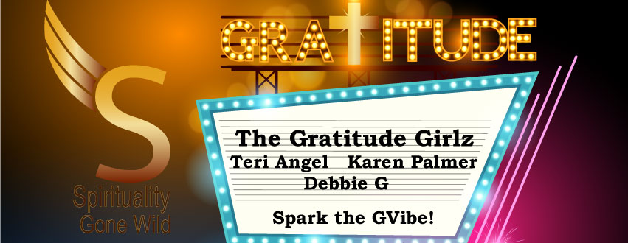

Report for Harmony Week
Happy #HarmonyWeek so grateful to volunteer with my dear friend and art teacher Cynthia Devine creating art and music with the seniors hands and hearts together. What a blessing #GratitudeMoment #GlobalKindness#OnlyLoveIsReal teaching songs about kindness and harmony. I also donated my coloring books and books of #Globalkindness Going Viral.
#HarmonyWeek begins with Path to Anandam Satya Kalra bliss and harmony for all check it out please share https://www.facebook.com/Spiritualitygonewild/videos/529505220769342/ How to be more happy and live a bliss-filled life. #HarmonyWeek Learn all the great ways people all over the world are raising the levels of love, harmony, and compassion. My guest is Satya Kalra
With World Kindness USA officially launching in April this is a timely article worth reading and I can not think of a better group to share with Karen Palmer is the Goodwill Ambassador of Kindness for her city of Solvang, California. https://indvstrvs.com/be-the-gift-that-keeps-on-giving-become-a-goodwill-ambassador/ and is a Founding Member of www.worldkindnessusa.org
Youth Empowered made 200 hand-made cards to give to less fortunate disabled adults for special occasions.Non-profit organization I work with to empower all ages through kindness and compassion.
#GlobalMeditation #HarmonyWeek Open To Receive Abundance, Love, and Joy. Simple ways to connect and Awaken to your #TrueSelf with help of #Abundance#Archangels #Daily#ChanneledMessages Clear all blocks. #Activations for #LightBody #ascension with David Nicol of Gaiafield Project. Global meditation with hundreds of thousands of people focused on harmony. The Gaiafield Project develops “subtle activism” practices, theories, and programs and works with like-minded groups to co-create local, national, and global networks of subtle activists to support a shift to a planetary culture of peace. Subtle activism involves harnessing the power of consciousness-based practices like meditation and prayer to support collective transformation, as in a globally synchronized meditation for peace. We believe that in our turbulent times there is a deep need for fostering greater coherence in the energetic fields that underlie communities at every scale.
Baltimore Maryland Speaker Series to end violence and add harmony to the neighborhood. Joyce Scott shared her wisdom and words of hope and harmony for all. Deneen Morgan-Burley shared inspiring and uplifting posts of hope and harmony from her town. Pictures are included in the report.
#PositivePostByDramMa: Here's to another Peaceful event. Everyone was hard at work on their Piece of #TheMonumentQuilt by FORCE.
(This Quilt will be displayed on the National Mall at a later date). Survivors from all over add their Square.
#HarmonyWeek I met a beautiful family visiting from India I will have them on my show when they return home I took pictures with them and showed them around our beautiful town #GratitudeMoment #GlobalFamily#GlobalKindness Going viral today spreading kindness touching hearts in every way!! Pictures in the report
#HarmonyWeek how to lead from our heart with Megan Gaiserwww.leadershipfordiversity.com please share and watch https://www.facebook.com/Spiritualitygonewild/videos/532168603836337/truly inspirational.

#HarmonyWeek 2nd Graders learn how their hands hearts and minds can help us experience peace on Earth #GratitudeMoment thank you Cynthia Devine beautiful art and music program centered around kindness, harmony, and gratitude. I am so grateful Sommer Joy Albertsen thank you for letting me know about pictures included. Students and teachers loved the classes.

I volunteered and donated coloring books with music and art programs to local schools in Solvang and Los Olivos, California and pictures are in the report.

Florida
Water Blessings of Harmony on Lake George, pictures in the report.

Harmony Healing Circles in Fort Lauderdale

Thank you for considering us in your contest we are a media channel dedicated to using all our social media platforms and technology to help raise the levels of gratitude, harmony, kindness, joy, love, and peace on Earth.

