World-Views in Dialogue
Widening and deepening the Interfaith Conversation
to include
secular humanism and search for renewal

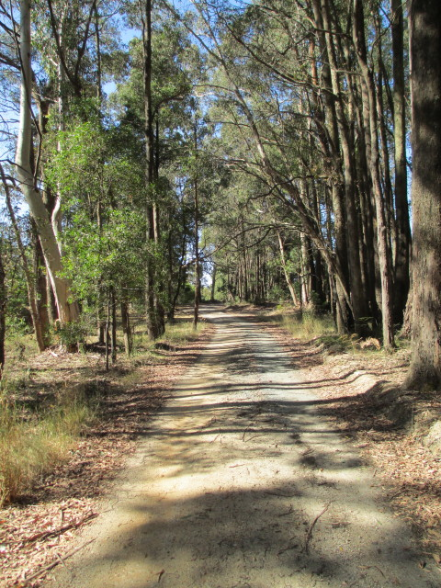

Meditative walk on parkland bordering on the
Wombat Forest, Trentham:
an imaginary journey between religious and secular sacred sites on the theme of the Golden Rule:
exploring
how humanist and religious world-views might empower their adherents – out of their original inspiration – to bring the recognition and practice of the Golden Rule back into the public domain.

“What we need today is an approach to ethics which makes no recourse to religion and can be equally acceptable to those with faith and those without: a secular ethics”
Dalai Lama. In: Beyond religion. Ethics for a Whole World. 2011

***
“…interreligious and intercultural dialogue can make an important contribution to attaining this lofty and urgent goal, so that there be an end to all forms of fundamentalism and terrorism which gravely demean the dignity of every man and woman and exploit religion.”
Pope Francis. Address to president and leaders, Turkey, November 2014

***
“We require effective centres for the restoration of our whole beings, new kinds of retreats devoted to educating, through an array of secularized spiritual exercises, our corporeal as well as psychological selves”.
Alan de Botton on a Buddhist Walking Meditation in: Religion for Atheists Hamish Hamilton. Penguin Books 2012 pages 156-157

***
“Know that violence is the root cause of all miseries in the world. …Therefore, neither does he (a sage) cause violence to others nor does he make others do so”.
Jainism (Acarangasutra 5. 101.2)

***
“The medium by which spirits understand each other is not the surrounding air, but the freedom which they possess in common.”
S.T. Coleridge. Biographia Literaria 1815

Meditative Walk:
(the sites have been kept open for variety of interpretation)
Each site an invitation to become attentive to what is most central and sacred in this particular worldview.
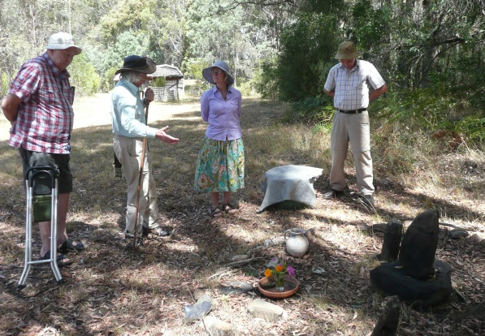
For those representing this worldview, an invitation to share something essential in symbol, object, word, song or ritual.

From site to site we may walk the earth, drink in the light, breathe the breath of nature and open ourselves to this thought:
“Just as distances are integral to landscape as a whole, differences between worldviews may be integral
to their unity in spirit”.

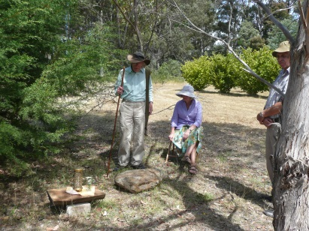

In alternating between still attention and attentive walk we might wake up to what might be the next step in each worldview’s development and in the evolution of the interaction between them.

The Evera Foundation Inc. has been incorporated in 2009 as a not-for-profit association. It is part of a Free and Worldwide Movement for Human Dignity, founded in Europe by Shin Gwydion Fontalba in 2009.
- The “Walking Meditation” project has been inspired by Shin Gwydion Fontalba’s Earth Celebrations (Switzerland, 1997-9; India, 2000) and Thich Nhat Han’s Walking Meditation (Plum Village, France; and worldwide).
- The project started in 2007, has been introduced to a wider community in 2012, with lectures and walks, and is since 2009 part of the work developed by the Evera Foundation Inc:.

From our constitution, statement of purpose: …to offer a context for listening conversation and shared meditation between the various religions and spiritual streams with a focus on how their differences are unique, integral and prerequisite to a new, shared, deeper understanding of the Godhead or highest Divine Being. In Shin Gwydion Fontalba's words: Many Rivers – One Ocean.

Henk Bak retired as Senior lecturer Art, Craft and Design History and Theory, Monash University and has been actively interested in the Ecumene of Cultures at least since 1964.

For individual or group participation and for enquiries phone 54241702 or email: hbak@westnet.com.au For further information consult www.evera-ecosophy.com.au under Articles and Activities. Postal Address: Evera Foundation Inc., 14 Forest Street, Trentham VIC 3458.

