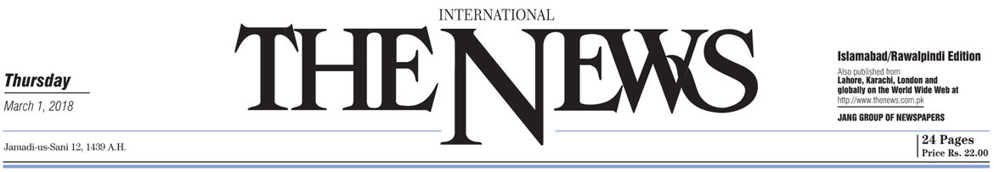
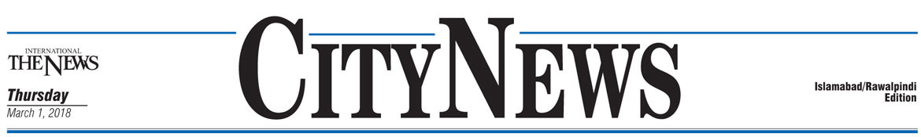
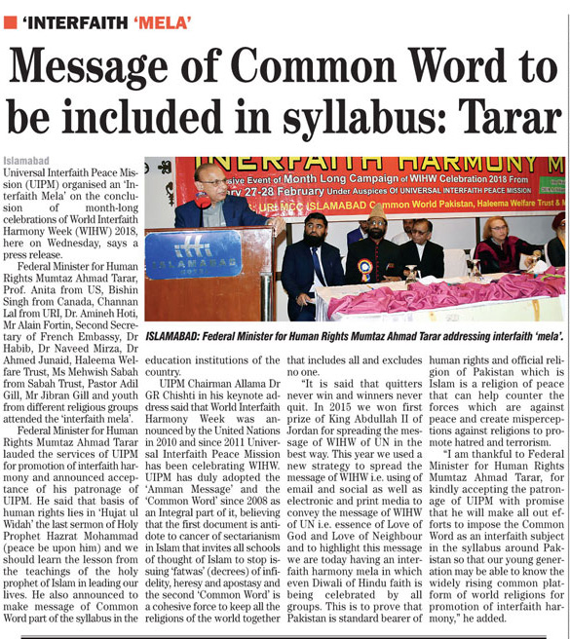

http://e.thenews.com.pk/pindi/3-1-2018/page14.asp
https://www.thenews.com.pk/print/286995-message-of-common-word-to-be-included-in-syllabus-tarar

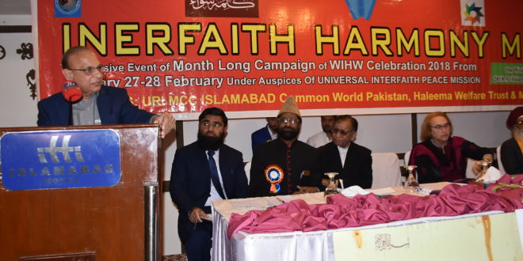

WIHW celebrations conclude with ‘interfaith ‘mela’
Arif Qureshi 9 hours ago National 10 Views
Islamabad : While celebrating the ‘World Interfaith Harmony Week’ (WIHW) 2018, Universal Interfaith Peace Mission (UIPM) on Wednesday celebrated a ‘Interfaith mela’ at the concluding week of the month long celebrations, says a press release.
Federal Minister for Human Rights Mumtaz Ahmad Tarar, Prof. Anita from US, Bishin Singh from Canada, Channan Lal from URI, Dr. Amineh Hoti, Mr Alain Fortin, Second Secretary of French Embassy, Dr Habib, Dr Naveed Mirza, Dr Ahmed Junaid, Haleema Welfare Trust, Ms Mehwish Sabah from Sabah Trust, Pastor Adil Gill, Mr Jibran Gill and youth from different religious groups attended the celebrations.
Federal Minister for Human Rights Mumtaz Ahmad Tarar lauded the services of UIPM for promotion of interfaith harmony and announced acceptance of his patronage of UIPM. He said that basis of human rights lies in ‘Hujat ul Widah’ the last sermon of Holy Prophet Hazrat Mohammad (peace be upon him) and we should learn the lesson from the teachings of the holy prophet of Islam in leading our lives. He also announced to make message of Common Word part of the syllabus in the education institutions of the country.
UIPM Chairman Allama Dr GR Chishti in his keynote address said that World Interfaith Harmony Week was announced by the United Nations in 2010 and since 2011 Universal Interfaith Peace Mission has been celebrating WIHW. UIPM has duly adopted the ‘Amman Message’ and the ‘Common Word’ since 2008 as an Integral part of it, believing that the first document is antidote to cancer of sectarianism in Islam that invites all schools of thought of Islam to stop issuing ‘fatwas’ (decrees) of infidelity, heresy and apostasy and the second ‘Common Word’ is a cohesive force to keep all the religions of the world together that includes all and excludes no one.
“It is said that quitters never win and winners never quit. In 2015 we won first prize of King Abdullah II of Jordan for spreading the message of WIHW of UN in the best way. This year we used a new strategy to spread the message of WIHW i.e. using of email and social as well as electronic and print media to convey the message of WIHW of UN i.e. essence of Love of God and Love of Neighbour and to highlight this message we are today having an interfaith harmony mela in which even Diwali of Hindu faith is being celebrated by all groups. This is to prove that Pakistan is standard bearer of human rights and official religion of Pakistan which is Islam is a religion of peace that can help counter the forces which are against peace and create misperceptions against religions to promote hatred and terrorism.
“I am thankful to Federal Minister for Human Rights Mumtaz Ahmad Tarar, for kindly accepting the patronage of UIPM with promise that he will make all out efforts to impose the Common Word as an interfaith subject in the syllabus around Pakistan so that our young generation may be able to know the widely rising common platform of world religions for promotion of interfaith harmony,” he added.
http://thefortress.com.pk/wihw-celebrations-conclude-with-interfaith-mela/

Message of Common Word to be included in syllabus: Tarar
TIMES OF NEWS
March 1, 2018
Islamabad: Universal Interfaith Peace Mission (UIPM) organised an ‘Interfaith Mela’ on the conclusion of month-long celebrations of World Interfaith Harmony Week (WIHW) 2018, here on Wednesday, says a press release.
Federal Minister for Human Rights Mumtaz Ahmad Tarar, Prof. Anita from US, Bishin Singh from Canada, Channan Lal from URI, Dr. Amineh Hoti, Mr Alain Fortin, Second Secretary of French Embassy, Dr Habib, Dr Naveed Mirza, Dr Ahmed Junaid, Haleema Welfare Trust, Ms Mehwish Sabah from Sabah Trust, Pastor Adil Gill, Mr Jibran Gill and youth from different religious groups attended the ‘interfaith mela’.
Federal Minister for Human Rights Mumtaz Ahmad Tarar lauded the services of UIPM for promotion of interfaith harmony and announced acceptance of his patronage of UIPM. He said that basis of human rights lies in ‘Hujat ul Widah’ the last sermon of Holy Prophet Hazrat Mohammad (peace be upon him) and we should learn the lesson from the teachings of the holy prophet of Islam in leading our lives. He also announced to make message of Common Word part of the syllabus in the education institutions of the country.
UIPM Chairman Allama Dr GR Chishti in his keynote address said that World Interfaith Harmony Week was announced by the United Nations in 2010 and since 2011 Universal Interfaith Peace Mission has been celebrating WIHW. UIPM has duly adopted the ‘Amman Message’ and the ‘Common Word’ since 2008 as an Integral part of it, believing that the first document is antidote to cancer of sectarianism in Islam that invites all schools of thought of Islam to stop issuing ‘fatwas’ (decrees) of infidelity, heresy and apostasy and the second ‘Common Word’ is a cohesive force to keep all the religions of the world together that includes all and excludes no one.
“It is said that quitters never win and winners never quit. In 2015 we won first prize of King Abdullah II of Jordan for spreading the message of WIHW of UN in the best way. This year we used a new strategy to spread the message of WIHW i.e. using of email and social as well as electronic and print media to convey the message of WIHW of UN i.e. essence of Love of God and Love of Neighbour and to highlight this message we are today having an interfaith harmony mela in which even Diwali of Hindu faith is being celebrated by all groups. This is to prove that Pakistan is standard bearer of human rights and official religion of Pakistan which is Islam is a religion of peace that can help counter the forces which are against peace and create misperceptions against religions to promote hatred and terrorism.
“I am thankful to Federal Minister for Human Rights Mumtaz Ahmad Tarar, for kindly accepting the patronage of UIPM with promise that he will make all out efforts to impose the Common Word as an interfaith subject in the syllabus around Pakistan so that our young generation may be able to know the widely rising common platform of world religions for promotion of interfaith harmony,” he added.
ttp://pakistan.timesofnews.com/message-of-common-word-to-be-included-in-syllabus-tarar.html

