Interactive on Better World organization activities of World Interfaith Harmony Week on social media
- The screen shot 1 shows a Kurdistan Parliament member attended the 4th day of the World Interfaith Harmony week activity by Better World Organization and sharing on her face book page writing as following in Kurdish language: (Participating in a seminar held by Better World Organization on Peace and Coexistence within three religions of Yazidi, Islam, and Christianity and fruitful discussion happened on how the harmony could be created. The activity was a part of World Interfaith Harmony Week UN declaration which starts in 1st to 7th February each year).
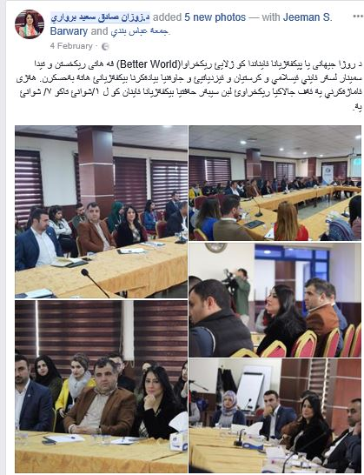

- The screen shot 2 shows the Yazidi scholar post on her personal face book page; the scholar is the one who presented Peace and Coexistence in Yazidi religion in Better World organization activity on 4th February:

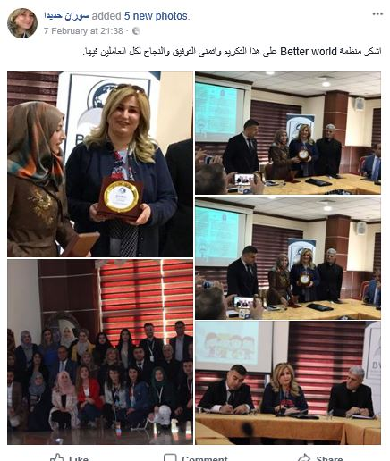

- The screen shot 3 shows a very famous public face book page in Duhok city which shared Al-jazeera report on Better World organization activity on planting trees on three religious places in Duhok. This post was very important as many people through this page shared the video and the idea of World Interfaith Harmony Week had more visibility in the community:
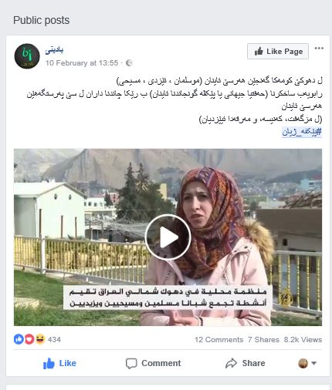

- The last screen shot shows Forqan Mousque face book page which shared Al-Jazeera repot:
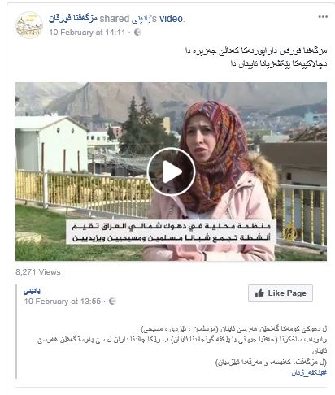
- In addition to the above screen shots there are many people shared Better World Organization activities on World Interfaith Harmony Week in which the community showed very positive feedbacks about the organization initiative and the important of such projects for our area.
- Moreover, many people personally have given wonderful feedback of the organization activities and encouraged by sharing more ideas for next years and how more governmental and religious institutions involve in celebrating World Interfaith Harmony Week.

