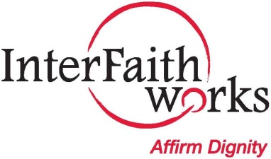InterFaith Rings - Adobe Illustrator

7th Annual World Interfaith Harmony Assembly

Monday, February 6, 2017

6:30 - 8:00 p.m.

University United Methodist Church

1085 E. Genesee Street

InterFaith Works, Women Transcending Boundaries,

and local faith communities collaborate

to help spread the message of harmony and

understanding by showcasing and celebrating

the many faith traditions in Central New York.

***“Love is the Answer”***

***7th Annual World Interfaith Harmony Assembly***

7th Annual World Interfaith Harmony Assembly

