InterFaith Words | Feb. 16, 2017

World Interfaith Harmony Assembly a joyous celebration
Hundreds of people joined representatives from InterFaith Works of CNY and Women Transcending Boundaries at the World Interfaith Harmony Assembly, held on Feb. 6 at University United Methodist Church, Syracuse.
Diverse faith traditions were celebrated through a candle-lighting ceremony, remarks, prayer and song.
"The room was filled with love and gratitude and peace," said Daryl Files, one of the organizers of the event. "Although many, we were ONE."
World Interfaith Harmony Week has been celebrated since 2010, when it was first proposed at the United Nations General Assembly by King Abdullah II of Jordan.The movement is strengthened by building ties among world religions, educating ourselves about each other, and helping our community appreciate the beauty and diversity of our faith traditions and our diverse cultures.

Members of nearly 20 faith traditions lit candles while standing in unity at the assembly. Elizabeth Lamb (center) is president of Women Transcending Boundaries, which helped organize the event.

World Interfaith Harmony Assembly was a attended by hundreds of people celebrating the diversity and commonalities of their faiths.
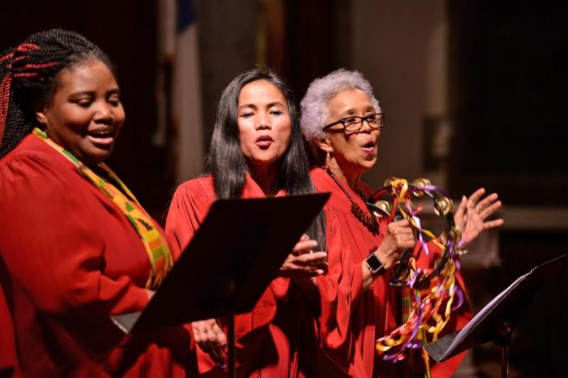
Members of the Syracuse Chapter of the Gospel Music Workshop of America, led by Dr. Joan Hillsman, led the assembly in singing "The Harmony Song."

