Magical Art of Silence: An Initiative from BRIDGE Foundation to create a space for the differently abled deaf and mute artists
Natasha Israt Kabir, Founder and President of BRIDGE Foundation
Background:
In 2015 December, we (BRIDGE Foundation) initiated the project “ARTPreneurfor Differently Able” where they do have opportunities to work under the experts through monthly basis workshop and selling their artwork through online as well. In this initiative, “Alliance Françoise” and CounterFoto being our strategic partners supported along with their venues.
Case studies:
I do believe that they are “Differently Abled” and this terminology brings the positive vibe and disability is at the end about our mindset and exclusion free society is important through more engagement and employment but still struggling for inclusion. We successfully ended our year along with participation in” Social Enterprise Day”,29 th December 2015 powered by British Council and facilitated by “ Better Stories” at their official venue. From that venture, we felt more motivated to engage them while creating a space for their income generation. After that, we initiated more activities towards arts and crafts, with a successful art exhibition at the residence of Netherlands Embassy, May 2016. We got more opportunity to interact with the creative people and one of our artists Muhammad Sohel Ahmed got the opportunity to start his career as graphics designer at “Red and Orange” communication ,before him it was another deaf and mute youth who bagged a job in a local advertising media, DOT3PRD, who is Shafayth Hossain Asif (23) working as a graphics designer in advertising media.

Jannatul Ferdous Srity (23) another deaf and mute female artist, who worked as an intern along with a national NGO, Democracywatch.
Our targeted stakeholders
We felt these spaces and inclusion for the differently abled would be the biggest challenge for our foundation and that is what has become a driven factor to start this new initiative to create a space for deaf and mute artists for their income generation along with the collaboration with the Embassies. As the head of Chancery Mr. Tanvir Kabir from Bangladesh High Commission in Mexico bought the deaf and mute artists paintings and an exhibition was held in Mexico City as well. The thing is still now the popularization of buying paintings and it’s customers are limited, so we are focusing on more innovative design according to the demand of the market and apart from paining, we are also selling wool made products, handmade potteries and miniature arts as well through the online page of “Magical Art of Silence”. That is the new initiative when we started our offline journey from January 13 th onwards at MIB ( Winter Meet Up Exhibit).

Conclusion :
We do hope that more national and international NGOs, embassies would come forward to collaborate with us to promote their artwork through diary, desk calendar as well as via web pages and social networking as well.
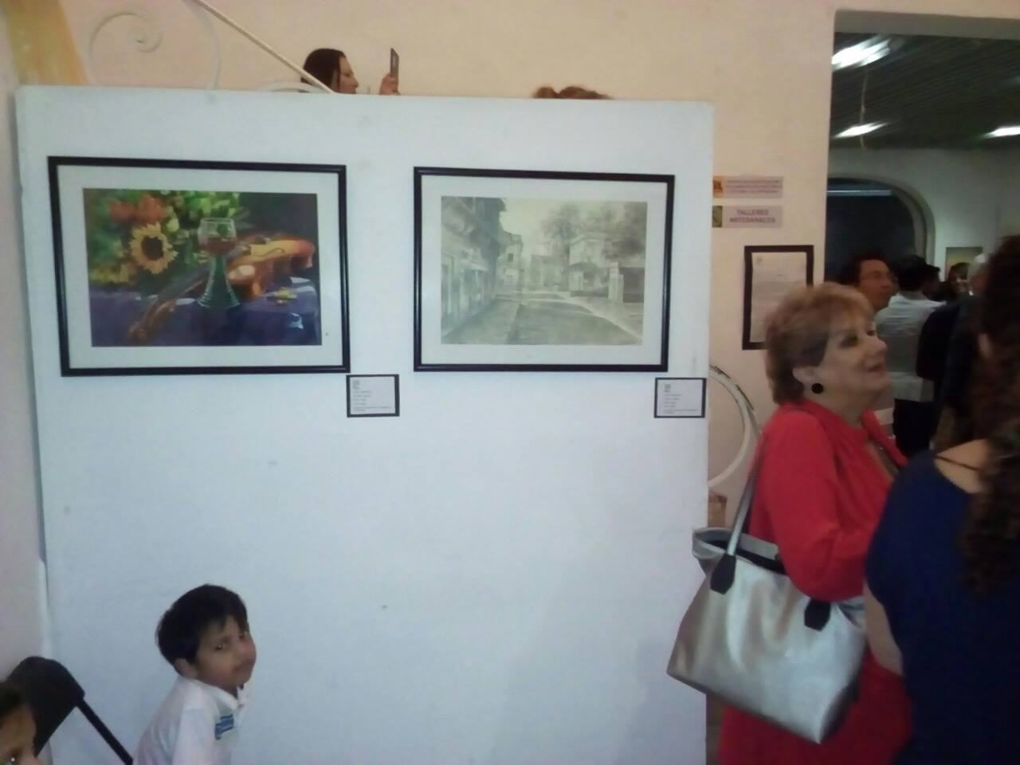
Art Exhibition along with the assistance from the Bangladesh High Commission and Head of chancery in Mexico

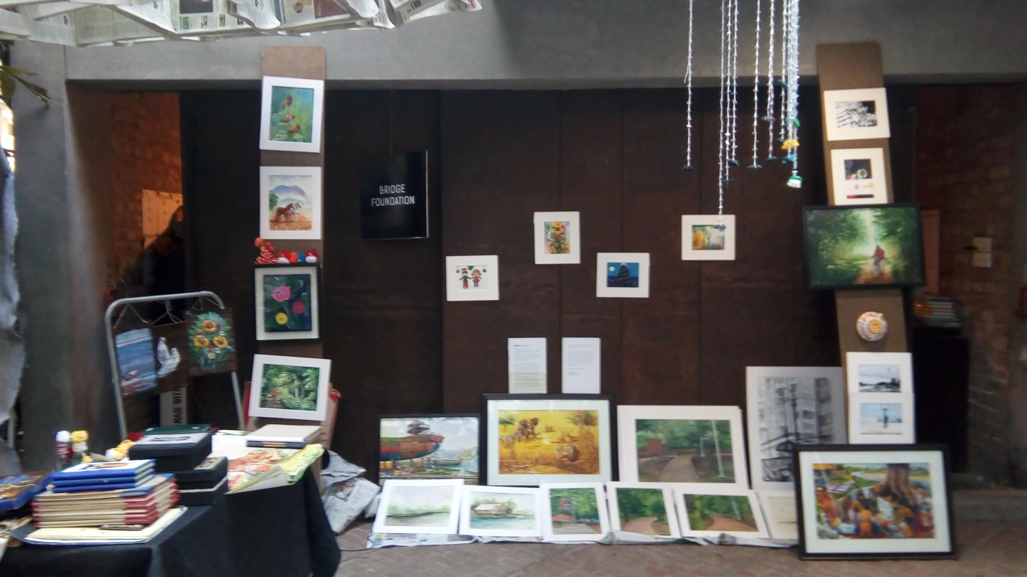
MIB Exhibition of Magical Art of Silence
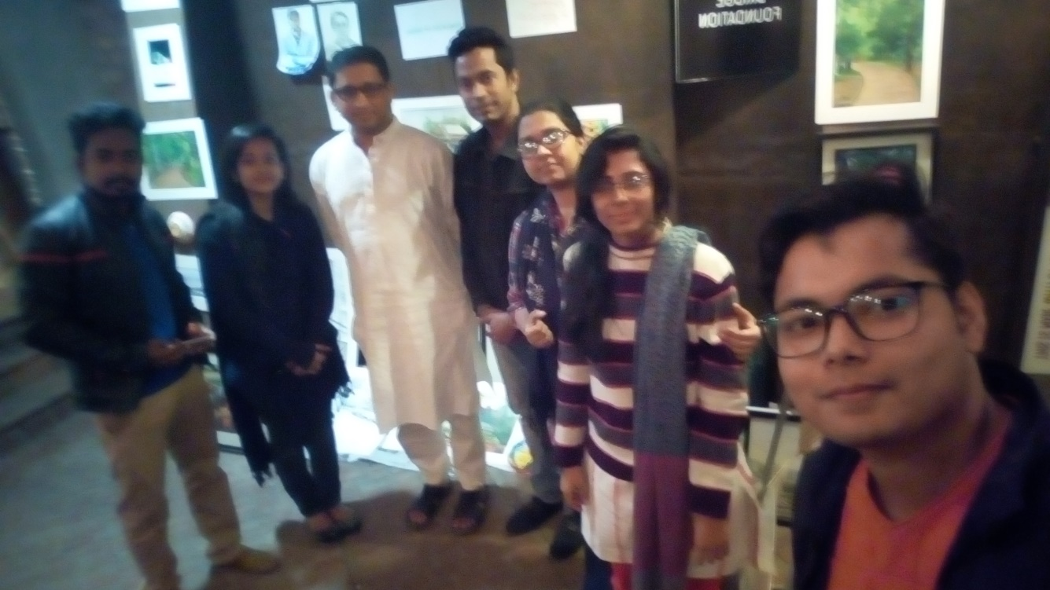

Our Artists along with the Bangladesh High Commissioner in Srilanka, who is our adviser as well, Ambassador Mr. Riaz Hamidullah

