UN-World Interfaith Harmony Week

Stuttgart, 05.02.2017

UPF Event in Cooperation with the House of Religion in Stuttgart

A significant event to mark World Interfaith Harmony Week was held in the hall of the Universal Peace Federation (UPF), which had been lovingly decorated for the occasion. Hubert Arnoldi, representative of the ‚House of Religion‘ in Stuttgart, greeted the audience and expressed that they should not hide their light under a bushel, but should bundle it together and radiate it with united strength. In this way darkness will illuminated with heartfelt prayers and the power of goodness will have more room to work actively together with the God of all religions. An intensive prayer can bring the ideal to flourish in various ways.

World Interfaith Harmony Week was proposed on 23. September 2010 to the UNO by King Abdullah II of Jordan on the following grounds.
It is also essential to resist forces of division that spread misunderstanding and mistrust especially among peoples of different religions. The fact is, humanity everywhere is bound together, not only by mutual interests, but by shared commandments to love God and one’s neighbour; to love the good and one’s neighbour.
We ask ourselves: why are the forces which divide us so strong? Why are there misunderstandings and mistrust? Why have there been so many terrible happenings in the last days, weeks and months? And is an interreligious week an answer to assassinations and wars, can it help? In all of the conflicts, is it not much more about the distribution of wealth and power, rather than religious questions?
I would event assert, that as long as people seek shelter in hate, we have all not loved enough. We only have one opportunity (see also 1 John). People from many nations and religious beliefs had gathered to take a stand for more peace and harmony together.

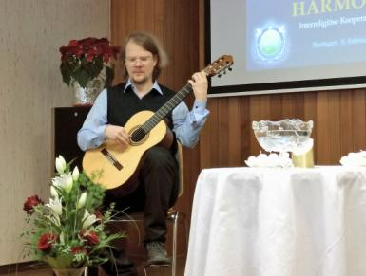
Daniel Henrich played some music on the guitar to set the atmosphere and so moved our hearts that we could prepare ourselves for the peace prayers and ceremonies.

UPF-representative Karl Christian Hausmann, gave an address in which he especially stressed the necessity of interreligious cooperation for mankind’s further development.

The next point on the programm was the light and water ceremony. Light, amongst other things, represents truth that is available to all equally; light and fire are transformative and have the highest vibration. Water represents the ocean of truth, into which all rivers empty. Water cleanses; is flowing love and represents growth and devotion.

In this spirit Hubert Arnoldi opened the ceremony in which the following representatives of different religions harmoniously, in unity, and complementary to each other, offered their heartfelt prayers: Mihr Foundation, Sufi Islam: Dr. Eda Yesil, Christianity: Margit Henrich, Scientology Church: Dieter Stukenbrock, Shinto and Buddhism: Yoshiko Arnoldi Ito, First Church of Christ, Scientist,: Volker Steinle, Christianity: Margarete Reinacher Belomo, Hinduism: Hubert Arnoldi, House of Religion in Stuttgart : Dr. Manfred Schick. After praying, each participant lit a swimming candle and set it in a basin of water. (A summary of all the prayer offerings will be made public later.)
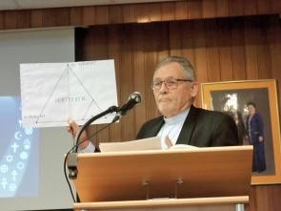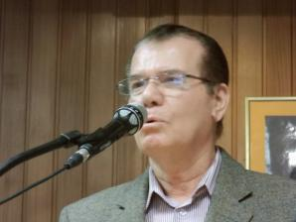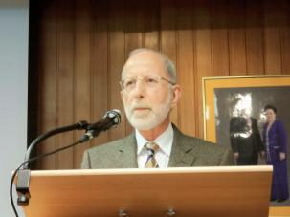

Mr. Arnoldi then thanked the audience for their wonderful support for this Interfaith Harmony Week event. „I was very inspired and moved by all the heartwarming contributions, which we could offer with a united power. I would like to take the opportunity to express my highest praise. Hereby the report for the honorable King Abdullah II of Jordan and the UN is on its way“.

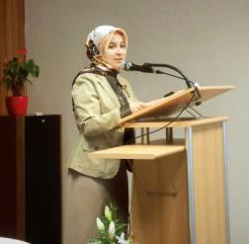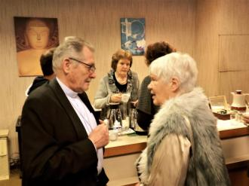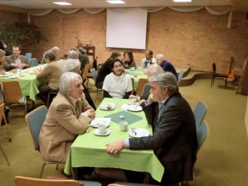

Further activities connected with the Interfaith Harmony Week: the Interreligious Round Table will evaluate a ‚learn by playing‘ game and will screen and evaluate it as a hopeful pilot project for religious education of the young and young in heart. (more about this later).
This special event was brought to a close by a guitar solo by Daniel Henrich and a ‚family photo‘, and we lingered over coffee and cake for a long time, sharing from heart to heart.

