‘Interfaith mela’ brings WIHW celebrations to an end

Islamabad

Universal Interfaith Peace Mission (UIPM) organised an ‘Interfaith Mela’ on the conclusion of World Interfaith Harmony Week (WIHW) 2017, says a press release.
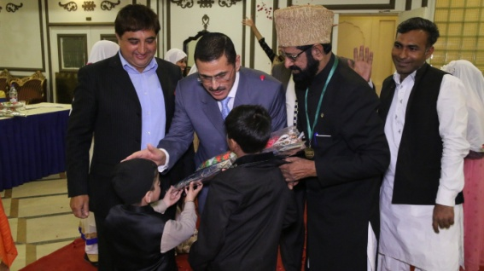
HE Mr Nawaf Saraireh the Chief Guest was received by Madressah Students with flowers
In the first session of Interfaith Mela at the arrival of Nawaf Khalifa Saraireh, Ambassador of Jordan, the chief guest, the proceedings of the 'Mela' commenced with recitation from the Holy Quran and following that the National anthems of the both brothely countries –Pakistan and Jordan were played.

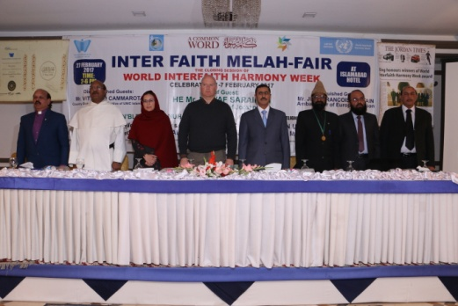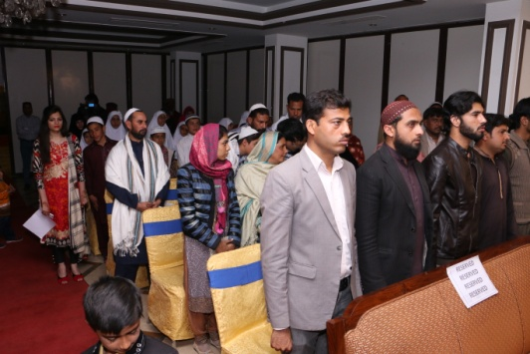
Guests respecting the Anthem of both countries
Jean Francois Cautain, Ambassador Delegation of European Union to Pakistan, United Nations Information Centre Country Director Vitirrio Cammarota were among the list of distinguished guests.
Speaking on the occasion, Jean Francois Cautain lauded the services of UIPM for promotion of interfaith harmony. “I earlier attended the function of UIPM and felt this organisation is truly working for promotion of interfaith harmony and it should be supported.
Vitirrio Cammarota was of the view that adoption of human rights declaration and respect of freedom of religion and freedom of speech so that peace should prevail in the world. He said that work on promotion of United Nations Strategic Development Goals 2030 is underway as it will get rid of all evils in the world
Father James Channan, OP Coordinator, United Religions Initiative Asia, Zubair Farooq, URI Global Trustee, representatives of URI from different circles from the across the country, Saeeda Yasmin, Ms Tasneem Youth Trainer URI, Saeed ur Rehman Siddiqui, Dr Altaf Hussain Langrial, and members of minorities in large numbers were also present on the occasion.
Divulging details of the celebration of World Interfaith Harmony Week celebrated by Universal Interfaith Peace Mission Chairman Allama Dr GR Chishti, who is now also the Coordinator of URI MCC Islamabad,
said that this year UIPM, Common Word Movement Pakistan, URICC Karachi which is constituent of URICC Islamabad decided to celebrate WIHW in a coherent manner.
He said that from January 15 till February 27, UIPM, delegation met different religious, political and diplomatic personalities all across the country to spread the message of WIHW. UIPM, he said
Dr Chishti said that in these programmes the true essence of WIHW which was drafted by Prince Dr Ghazi bin Mohammad of Jordan and presented at the UN by King Abdullah II of Hashemite Kingdom of Jordan were highlighted in true letter and spirit.
He said that UIPM has duly adopted the ‘Amman Message’ and the ‘Common Word’ as an Integral part of it, believing that the first document is antidote to cancer of sectarianism in Islam that invites all schools of thought of Islam to stop issuing ‘fatwas’ (decrees) of infidelity, heresy and apostasy and the second ‘Common Word’ that is a cohesive force to keep all the religions of the world together that includes all and excludes no one,” the newly appointed URI Islamabad coordinator said.
Dr Chishti said that UIPM has officially adopted the Common Word and Amman Message and had requested Ministry of Religious Affairs and Interfaith Harmony to make them part of the national educational curriculum so that culture of interfaith harmony may prevail.
