PL84U AL-SUFFA: World Interfaith Harmony Week Report
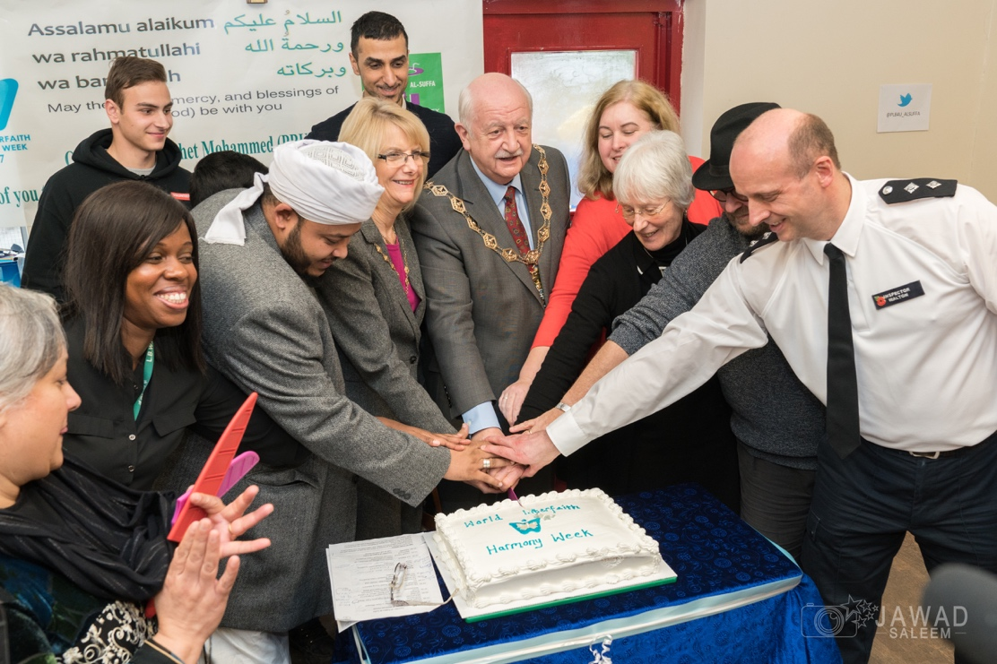

PL84U Al-SUFFA is run by Saira Mir and her family, is an East London based non-profit organisation that provides a hot lunch and company to the homeless, elderly and people in need on the first and third Sunday of each month. We welcome those of all faiths and none, and provide a welcoming environment for their guests to relax in.
Peace is the foundation upon which PL84U AL-SUFFA was built upon Supported by Muslim Aid and volunteers from our local community we exist to promote unity. Those of faith and no faith, the elderly and people in need, those we would possibly turn a blind eye to on the streets, and those who donate, those who serve, and play chess. Those who set aside time from their busy lives to volunteer on a Sunday. If you want an exceptional recipe for peace and harmony, these are the essential ingredients, and PL84U AL-SUFFA have them in spades.
The beloved Prophet Muhammad (Peace and blessings be upon him) said: ‘None of you truly believes until he loves for his brother what he loves for himself.’
And that’s why we feel blessed to live in a community where there are a lot of generous, kind hearted and diverse people. The need for genuine interactions and humanity is recognised, that human beings need more than a hot meal and clothes; that is what PL84U AL-SUFFA endeavour to provide. They host their guests with warmth in their hearts and welcome open and respectful discussions.
Where we can learn from each other about peace, empathy, and respect. When we open our hearts we discover that there is more that unites us than that what divides us. At pl84U AL SUFFA we welcome everyone and aim to see others as our fellow human being, first and foremost, and not see their gender, their faith, their race or any other labels we apply to ourselves.
Our guests are more than just ‘statistics.’ We empathise with the experiences of our guests and strive to provide a steady hand to hold over the stepping-stones. Something as simple as sharing a meal, a friendly chat or a game of chess in the hopes of making a small difference.
We all try to live in harmony in diverse communities on a daily basis. But the World Interfaith Harmony Week is an excellent initiative as it allows us to celebrate the efforts of our fellow human brothers and sisters. On Sunday 5th of February the fortnightly PL84U Al-SUFFA service held an event in order to celebrate World Interfaith Harmony Week. Assisted by volunteers and local businesses who give up their time, they offer a friendly chat, free haircuts (Haircuts 4 Homeless) and facilitate a food and clothes bank for our service users.
Speakers at the event represented a variety of faiths, backgrounds and ages, including Cllr Peter Herrington, Mayor of Waltham Forest, Cllr Paul Braham, Cllr Louise Mitchell, Cllr Ahsan Khan, Cabinet Member for Health and Wellbeing, Ivor Konstantinov a member of the Waltham Forest Youth Independent Advisory Group, Imam Shaykh Amin Mohammed, Leanna William, Wood Street Coordinator, Inspector Marcus Walton, Partnership of Waltham Forest, Sue Diplock, St Peter’s in the Forest Minister, Enaab Mohammed, Alumnae of the Patchwork Foundation, and Alia Nasim, Abdir Rahman Hanif and Ustadh Hamid Mahmood of the Fatimah Elizabeth Cates Academy.
The guests each delivered passionate and inspiring speeches about how their faiths and beliefs assist them in promoting peace and harmony in the local community. The audience was moved by their sincerity and the diversity of the speakers, united by one common theme.
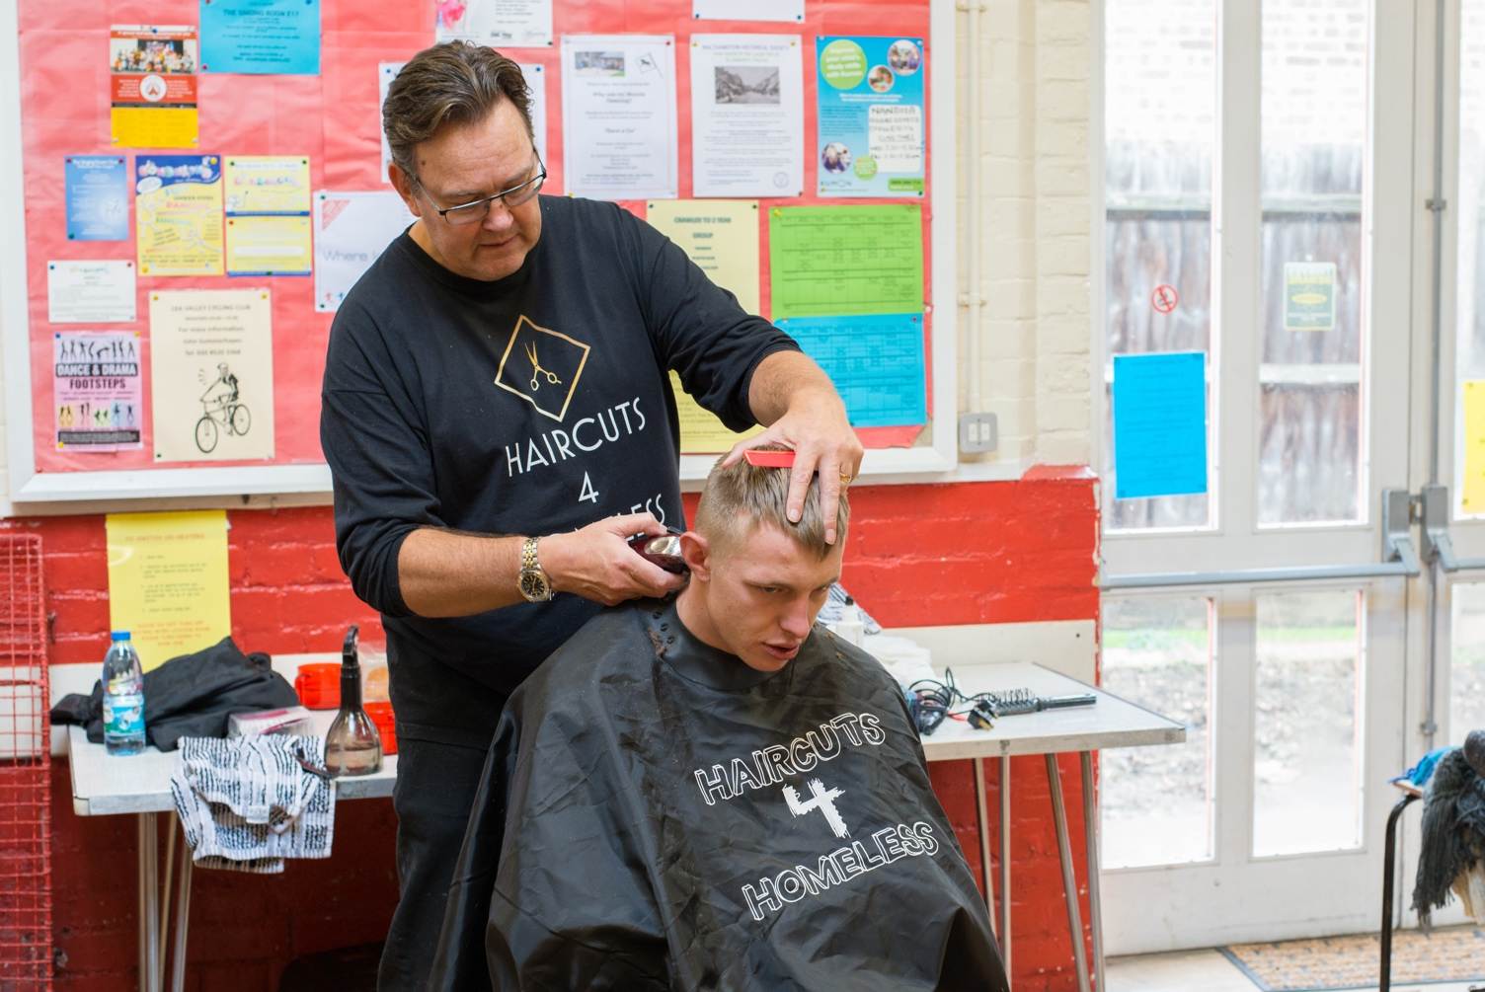
After the speeches, our esteemed guest speakers mingled with our volunteers and our regulars, sharing a meal together. The atmosphere was one of unity and harmony, a day to set aside all difference and embrace our common humanity. We will endeavour to capture the spirit of our World Interfaith Harmony Week celebrations and weave it into our everyday lives and interactions.
