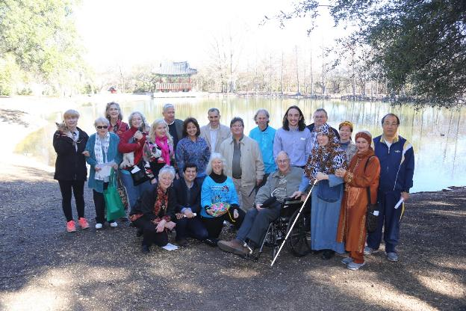

Some of the leaders and participants in the Blessing of the Interfaith Retreat and Conference Center (Photo curtesy of Chuck Gibbons)

Report on “TOGETHER Caring for Creation,” An Interfaith Week of Learning, Reflection, and Commitment to Action in San Antonio, Texas, USA, January 28 to February 8, 2016.

Part of the World Interfaith Harmony Week initiative: http://worldinterfaithharmonyweek.com/

Throughout the city of San Antonio a network of 14 religious and 4 environmental groups partnered in observing World Interfaith Harmony Week and benefited over 700 people who came to events and many others who read information on our ideas.

Before our week in San Antonio began, it was already a success because people of different faiths who had never met each other began coming together to plan through the invitations of Sister Martha Ann Kirk, Th.D., and Sister Alice Holden, D.Min. Catholic Sisters of Charity of the Incarnate Word. The people who gathered were united in the convictions that interfaith dialogue and care for creation are both essential in our world today. The University of the Incarnate Word has students from over sixty countries and promotes respect for diverse religions and cultures and was a main sponsor of the week. In late January we posted our common website TOGETHER caring for creation http://www.uiw.edu/ccl/together/

San Antonio Interfaith Power and Light under the leadership of Diane Duesterhoeft with the assistance of the Episcopal Church of Reconciliation led “San Antonio Interfaith Action on Climate Change: A Pre-World Interfaith Harmony Week Event,” January 28, 2016. Working groups united around action themes that emerged at the December 3 Interfaith Convergence for Climate Action. Contact:https://www.facebook.com/events/1054639157935228.

Diane Duesterhoeft and Imam Beytullah Colak met at the Interfaith Retreat Center Blessing (Photo curtesy of Chuck Gibbons)

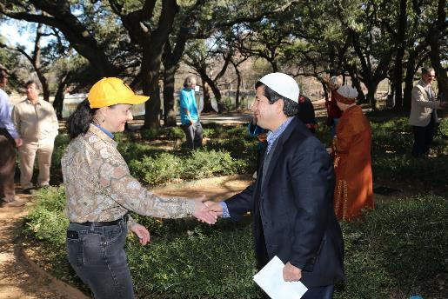

“Blessing of the Interfaith Retreat and Conference Center followed by a nature walk in Denman Estate Park,” was held on January 30, 2016. Sister Alice Holden, CCVI, the initiator of the center led the service with Native American, Muslim, Jewish, Christian participation, and the lovely Buddhist pagoda in the background.

Soft flute music, delightful drumming, singing, words of wisdom, reflections, and praying contributed. Jim Funk led the nature walk.

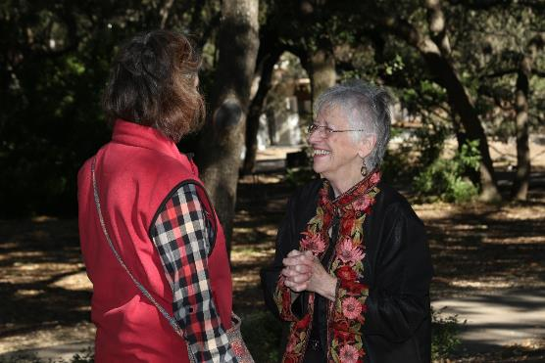

Sister Alice Holden welcomes a guest. (Photo curtesy of Chuck Gibbons)

The Islamic call to prayer was shared by Dr. Suleyman Tek. Within the gathering Sister Alice read the words of Rabbi Samuel Stahl for the Blessing of the Interfaith Retreat and Conference Center. Rabbi Stahl has led Temple Beth-El, the largest Jewish congregation in San Antonio and is now Rabbi Emeritus.
“MY COMMITMENT TO INTERFAITH RELATIONS”
Because of the Jewish Sabbath, Lynn and I regret that we can’t be with you today. However, we are grateful to Sister Alice Holden for her invitation to share some thoughts with you. I have been a rabbi for almost 50 years, and the chief emphasis in my rabbinate has been bettering interfaith relations. One of the main reasons is that I knew, first-hand, bigotry and prejudice. I grew up in an era of genteel anti-Semitism.
Many of my Eastern European forebears encountered the cruelty of pogroms and massacres, which the tyrannical Czarist regime often ordered. However, we Jews in the United States were spared those abuses. We also did not suffer the inhumane indignities of African-Americans during the disgraceful era of segregation.
The discrimination we Jews knew was more polite and subtle. We were clearly aware that in some places, we simply weren’t wanted or welcome. There was a Jewish quota of 6 to 10% at numerous universities and medical schools. We were barred from entering certain professions.
We couldn’t buy homes in many neighborhoods. We couldn’t book accommodations at numerous hotel and resorts. We got used to seeing large signs that read, “Christian Clientele Only!”
I learned as a child, growing up with this intolerance, that the best way to combat prejudice was to interact with people of other religious, racial, and ethnic backgrounds at deeper levels. One of the causes of prejudice is that we fear the outsider.
There is a story about a man who was lost in a forest at night. There was hardly any light. Suddenly, a creature looking like a bear was approaching him from a distance. He became frightened and feared a fierce attack. However, as that figure come much closer, he saw that it was not a bear. It was his next-door neighbor. Those whom we don’t know well can appear menacing to us.
In general, we tend to navigate toward those who are like us. However, we are afraid of those who differ from us in skin color, language, political views, country of origin or other factors that set us apart.
Yet God doesn’t really want us to be the same. God wants us to be different and to accept and embrace others who are different. That is God’s challenge to us. In the Five Books of Moses we are reminded 36 times that we must love the stranger, because we were once strangers in the land of Egypt.
Such is the rationale for my firm and ardent commitment to enhancing the dialogue among different peoples. There is one other reason. Working together across religious and racial boundaries can lead to a better world and bring us closer to the kingdom of heaven on earth.
We owe an enormous debt of gratitude to Catholic Archbishop Robert Lucey, Episcopal Bishop Everett Jones, and Rabbi David Jacobson. Through their close collaboration, they were largely responsible for desegregating San Antonio relatively peacefully in the 1960’s.
They also spoke out, as a tightly-knit team of clergy leaders, against other social ills of their day. They inspired us to fulfill the biblical mandate: “Justice, justice, shall you pursue.” (Deut. 16:18) They set the gold standard for the remarkable interfaith relations we enjoy in San Antonio today.
Rabbi Stahl’s words touched the participants.
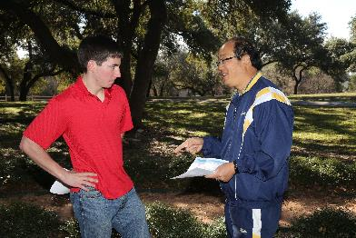
Corey Trevor Wilson, one of the UIW Cardinal Community Leaders, assists with programs at the Interfaith Retreat and Conference Center. (Photo curtesy of Chuck Gibbons)
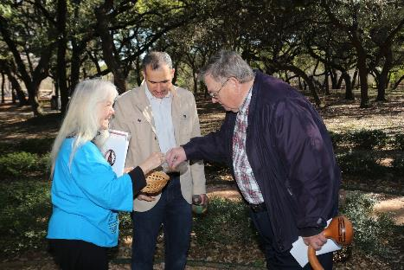
The words of Chief Seattle were shared: This we know: the earth does not belong to us, we belong to the earth. All things are connected like the blood that unites us all. We did not weave the web of life, we are merely a strand in it. Whatever we does to the web, we do to ourselves.

Sister Martha Ann Kirk shared Milkweed Seeds with Suleyman Tek and Joseph Cook. She led the following reflection and invited people to plant their seeds. (Photo curtesy of Chuck Gibbons)
Monarch butterfly migrations span four generations, traveling from Mexico to Canada and back. No single individual makes the entire trip. Along the way, monarchs lay eggs only on native Milkweeds. Larvae hatch in four days and feed only on Milkweed for about three weeks before continuing on the migration in search of mates and nectar.
In 2014 the number of Monarchs greatly dropped, probably because of logging and devastating climate events such as drought. Industrial agriculture in the corn belt is producing corn for biofuel and herbicides are being used on the genetically modified corn. All this is hurting the butterfly population. Be a partner to help the Monarchs by sowing Milkweed along their migration route. (Native American Seed, Helping people restore the earth http://www.seedsource.com/Default.asp)
(Then women and men alternated reading the following text.)
Let us remember that no one Monarch reaches the goal, but each contributes. ~None of us can do it all, but each of our parts are important.
The process involves the seeds and growth of Milkweed, the laying of eggs, larvae, ~the transformation into a butterfly, growing, flying, finding nectar, mating. . .
Are we willing to work and do our parts? ~At the same time are we open to processes and transformation beyond our control. . .
Let us learn from the Monarch. May their beauty transform us.
(Learn more http://monarchjointventure.org/get-involved/create-habitat-for-monarchs/ )

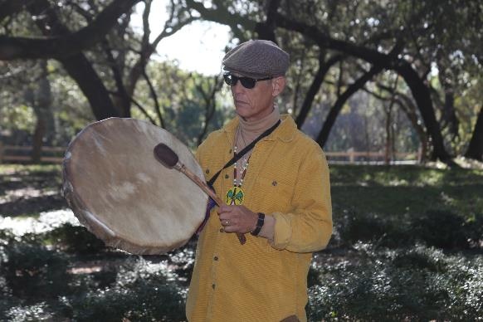

Rudy Harst leads the Native American song, “The earth is our Mother, we must take care of her.” (Photo curtesy of Chuck Gibbons)

“Caring for Creation: Celebrating our Connection to Mother Earth,” was held on Sunday January 31, 2016 from 11:00am-12:00pm. The founder of “Celebration Circle” Rudi Harst led an upbeat, interfaith worship service focused on celebrating our deep connections to Mother Earth through Creative Ritual, Music and Meditation.

“Deep in the Heart: A Passion For Peace,” was held on Sunday January 31, 2016 from 3:00-5:00pm at Oblate School of Theology. It was a celebration of the 10th Annual Blessing of San Antonio Peacemakers 9th Annual Declaration of the San Antonio Peace Laureate. People were invited to join the San Antonio peaceCENTER and the San Antonio Peace Laureates in their re-commitment for the long haul and in mutual blessing of holy legacy. The Blessing was filled with beautiful music, sacred images, human encounters, and words of wisdom. Fr. Ron Rolheiser, OMI, was appointed as the 9th San Antonio Peace Laureate.

The San Antonio Express-News, the largest newspaper in the city had a picture of the Blessing of the Peacemakers and mentioned “TOGETHER caring for creation, an interfaith week of Learning, Reflection, and Commitment to Action.”
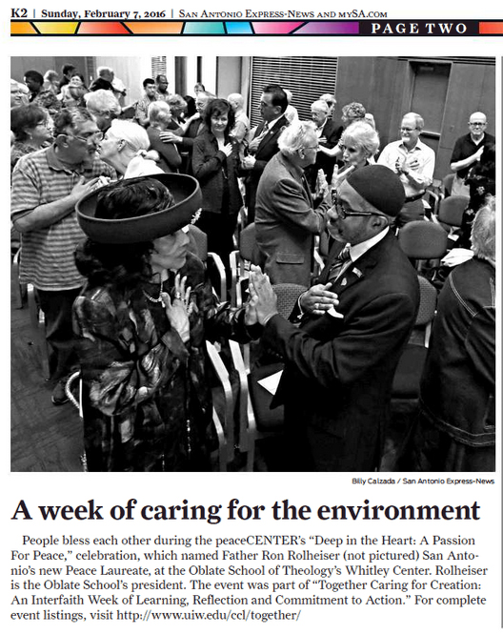

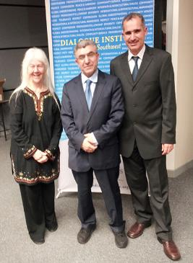
“Jesus in Islam,” was held on Monday February 1, 2016. It was a lecture and book signing by internationally respected scholar Dr. Zeki Saritoprak (http://sites.jcu.edu/nursichair/about/faculty/) who examined the place of Jesus in the Qur'an and Hadith and discussed the important role Jesus can play in interfaith dialogue. This was co-sponsored by the Dialogue Institute and UIW Religious Studies. About 160 university students and others from Saudi Arabia, Yemen, China, Turkey, Spain, Mexico, Switzerland, Argentina, Pakistan, and other places attended. The event created a respectful environment for dialogue between people from different faiths.

A local anti-Islamic group which is part of a national network planned a protest of the event and their followers showed up. Because news of this protest was discovered ahead of time, many persons who support interfaith respect and dialogue showed up in support of the speaker. Participants were invited to write questions on paper and give them to the moderator. The anti-Islamic group did not have an opportunity to disrupt the event.
A picture report in a local news blog http://walkerreport.blogspot.com/search?updated-max=2016-02-02T14:54:00-06:00&max-results=10&start=80&by-date=false
A photo of the speaker Dr. Zeki Saritoprak appeared in the University of the Incarnate Word weekly on-line news: Dr. Zeki Saritoprak, professor and the Bediüzzaman Nursi Chair in Islamic Studies at John Carroll University in Cleveland, presented “Jesus in Islam,” Monday, Feb. 1 at the ICC co-sponsored by UIW Religious Studies and the Dialogue Institute. http://www.uiw.edu/newsletter/archive/2016-02-05.html
(“Water Stewardship in the Face of Climate Change” which was advertised on the website had to be postponed.)

“RENEWAL,” a documentary film was shown on Tuesday February 2, 2016. The film was inspired by the many Americans who are answering a spiritual call to confront the enormous challenges of environmental degradation. These men, women, and children are finding ways to become caretakers of the Earth from within their Christian, Jewish, Buddhist and Muslim traditions. The religious-environmental movement grows as people from diverse traditions work to build a sustainable future. Sponsored by Headwaters at Incarnate Word, http://www.headwaters-IW.org. The Headwaters is a 53 acre nature sanctuary adjacent to the University of the Incarnate Word campus which seeks to promote reflection on God’s creation and encourage study of nature.

“Invasive Species,” was held in the nature sanctuary on Tuesday February 2, 2016 from 8:30-10:30am. The ten attendees were cutting down Chinaberry Trees which block out the natural plants. These gatherings to care for the nature sanctuary are held each week. Usually about 200 invasive trees are cut down every week. Sponsored by Headwaters at Incarnate Word, http://www.headwaters-IW.org.
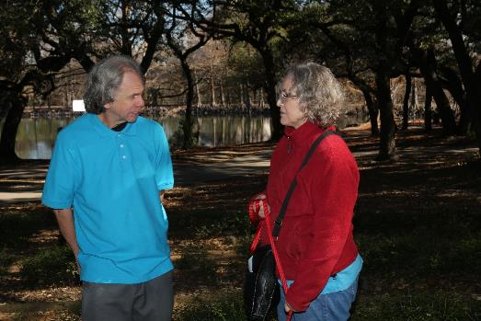
Jim Funk, Master Naturalist, who leads nature walks and frequently assists caring for the Headwaters Sanctuary (Photo curtesy of Chuck Gibbons)

“Solar House: Being Eco Conscious,” was held at the UIW Solar House on Tuesday February 2, 2016 from 4:30–5:45 pm, led by Daniel Potter, the director of the Solar House. Built by engineering students at the University of the Incarnate Word, the Solar House (http://www.uiw.edu/solarhouse/background.html) is a model for sustainable construction and an invitation to the community to learn more about sustainability. Read of university efforts http://www.uiw.edu/greenuiw/. Both people from the city and university class “Spirituality and Prayer” attended. The students were to take the Global Footprint quiz considering the resources they are using http://www.earthday.org/footprint-calculator . The discussion focused on what each of us might do to live more sustainably, and how we might unite across faith traditions. Finally, students wrote papers integrating this with spirituality.

“Weed Wednesday,” was held on Wednesday February 3, 2016 from 8:30-10:30am, with 20 attendees, at Phil Hardberger Park. Guests helped combat exotic invasive species, including Australian and Kleberg Bluestem, wild mustard, and malta star thistle by taking care of weeding the park plants.

“Evolution and Christogenesis,” was held on Wednesday February 3, 2016 from 6:30-8:00 pm. This was the first in a series of five weekly programs with films of noted theologian Ilia Delio, OSF, with discussion led by Alice Holden, CCVI. Dr. Delio specializes in science and religion, with interests in evolution, physics, and neuroscience, and their import for theology. Ilia is the author of fifteen books including Care for Creation (coauthored with Keith Warner and Pamela Woods) which won two Catholic Press Book Awards in 2009, first place for social concerns and second place in spirituality.

“Caring for Creation: An evening of guided and silent meditation, focused on our deep connections to Mother Earth,” was led by Rudi Harst at the San Antonio Quaker Meeting House, Wednesday February 3, 2016 from 7:30-8:30 pm with about 12 attendees who enjoyed the meditation.
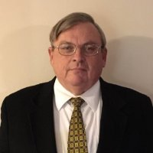
“Sustainable Systems: Environmental, Economic and Social--Looking Towards the Future,” was held on Thursday February 4, 2016 from 9:00-10:15 am at the University of the Incarnate Word. Joseph L. Cook, who holds a B.Sc in Natural Resources and the Environment (Univ. of MI), a M.Sc in Entomology with Minor in Soil Science (Univ. of MN), an MBA (UIW), a MTS (Oblate School of Theology, and a M.A. in Theology (St. Mary's University) presented from his breadth of knowledge and experience. He has worked worldwide in Natural Resources and the Environment with his last position being a Senior Environmental and Sustainability Scientist with the firm Consulting for Health, Air, Nature and a Greener Environment. The discussion was centered on the fact that there is environmental, social and economic aspects of creating a just and equitable world. Topics were covered using aspects of climate change, using renewable energy vs fissile fuels and the increasing velocity of job opportunities being created in the renewable energy sector vs for instance the large loss of jobs in coal industry- specific aspects of this were covered for San Antonio as to how a just and equitable social system and a viable renewable energy system would benefit the city.. Questions were raised on how we should create sustainable systems that meet these challenges so the people of the world can live fulfilling lives in harmony with one another and with nature. This program explored climate change as one environmental challenge among many, the future of energy as one of many economic challenges, and work as one of the social challenges facing the world.

“Caring for Creation, an Exploration of Climate Change and Faith from a Biblical Perspective,” was held on Thursday February 4, 2016 from 10:30 – 11:45 am at the University of the Incarnate Word. Using PowerPoint slides and films, the presentation covered climate change science and what is happening to creation and how we as people of faith are called on to be stewards of Creation.
“Healing the Earth, Saving Ourselves,” was presented by Betty Dabney, PhD. Thursday February 4, 2016 from 1:30 - 2:45 pm. Dr. Dabney shared how working together to solve climate change can unify Humankind. The presentation included descriptive scenarios of expected impacts of climate change, including loss of polar ice and glaciers, dry rivers, rising sea level, super-storms, drought and famine, loss of biodiversity, and mega-fires. Our attempts to mitigate them can be part of a spiritual practice that can bring people together in peace-building. There were many questions from the audience afterwards, creating a good discussion about ways to solve climate change.
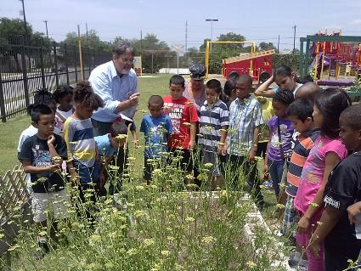
Dr. Jeff Crane leads university students in service learning to teach community gardening in disadvantaged neighborhoods and schools in San Antonio.

"Food Justice in the Era of Climate Change," was held on Thursday February 4, 2016 from 4:30 to 5:45 pm. Dr. Jeff Crane, author of The Environment in American History, Nature and the Formation of the United States (http://www.routledge.com/books/details/9780415808712) noted that approximately 50 million Americans, including about one-fourth of all children, suffer from food insecurity. The food that is available is often unhealthy and produced in an industrial-agricultural economy that is damaging to both farmworkers and ecosystems. Community and urban farming offer some solutions to those problems while also helping urban populations prepare for the unpredictable impacts of climate change.

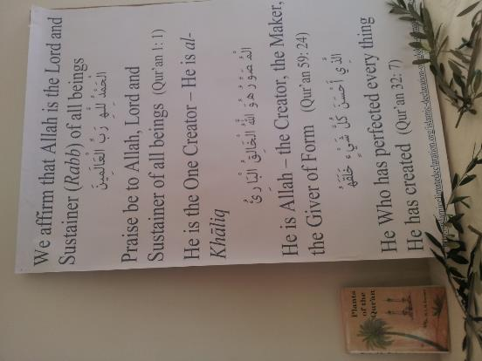
Words from the Islamic Declaration on Climate Change, a book on Plants of the Qur’an, and Olive branches decorated the room.

Foods from the Quran and the Bible,” was held on Thursday February 4, 2016 from 5:45 – 6:30 pm with about 40 attendees. Guests enjoyed a reception with foods mentioned in the Qur’an, Christian Scriptures, and Hebrew Scriptures. Food is a gift from God for all God’s people. There were also delicious Turkish dishes from the Rainbow Women’s Association of the San Antonio Dialogue Institute.

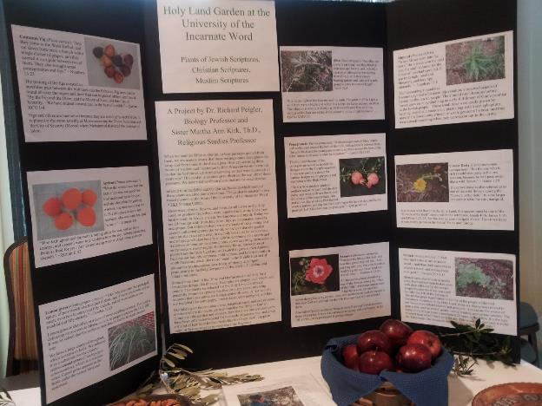

Plants from Hebrew scriptures, Christian scriptures, and Islamic scriptures have been grown at the University of the Incarnate Word as a project involving Biology, Religious Studies, and Arabic classes. This has helped to find “common ground” among us.

A presentation on “The Islamic Declaration on Climate Change,” was held on Thursday February 4, 2016 at 6:30 pm with about 40 attendees at the University of the Incarnate Word. Narjis Pierre, leader of the San Antonio Muslim Women’s Association, Sarwat Hussain, the leader of San Antonio CAIR (Council on American Islamic Relations), Suleyman and Sumayra Tek of the San Antonio Dialogue Institute showed slides and presented. The main ideas of the Islamic Document were shown
http://islamicclimatedeclaration.org/islamic-declaration-on-global-climate-change/
Everyone was invited to discuss little and big things individuals and groups can do about climate change. Sister Martha Ann Kirk, UIW Religious Studies professor, noted how both Islamic leaders and Catholic leaders are inviting united efforts for the common good.
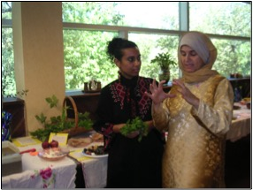
Dr. Rolla Alaydi and Narjis Pierre with Foods from the Quran and the Bible.

“Interfaith Meditation Centered on Caring for Creation,” was held on Friday February 5, 2016 from 7:15-8:00 am at the Denman Estate Library. There was discussion about caring for creation as well as a prayer with drums. One of the attendees, a professor from the University of Texas at San Antonio, said the meditation helped her relax after a busy week.

“Starting out Wild: Rockin’ and Rollin’,” was held on Friday February 5, 2016 from 10:00-11:00 am at Friedrich Wilderness Park. The event introduced 1-3 year-olds to nature and helped them learn all about rocks through stories, songs, and hands-on fun!

“You won’t save what you don’t love” People were invited to write on a piece of ribbon what they love of God’s creation as a way of making a commitment to take better care of creation. Strings of ribbons with English, Arabic, Spanish, Portuguese, and other languages have been growing as more events have been held.
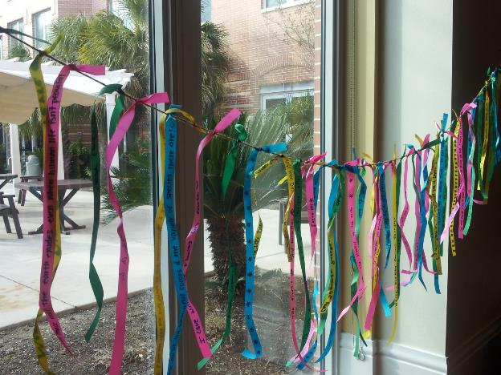

A workshop on “Laudato Si,” Pope Francis letter on climate change was held on Friday February 5, 2016 from 1:00-4:00 pm. The event was sponsored by the International Justice, Peace, and Integrity of Creation Office of the Catholic Sisters of Charity of the Incarnate Word.
About 60 Sisters and people who work with them in ministries of education, health care, and environmental care participated in the Community Conversation led by the Assistant Director of the JPIC office Jennifer Reyes Lay. They dialogued, reflected, and celebrated that together we have a responsibility to care for our common home wherever we are, in whatever we do. Dr. Jeff Crane, Associate Dean, spoke of sustainability efforts at the University of the Incarnate Word, Dr. Dennis P. Gonzales, Regional Vice President for Mission Integration in the CHRISTUS Santa Rosa Health System, and Howard Homan, a Trustee of the Board of the Headwaters Coalition spoke of their work. All were encouraged to promote “Laudato Si’.” http://w2.vatican.va/content/francesco/en/encyclicals/documents/papa-francesco_20150524_enciclica-laudato-si.html Similar workshops are being held in other places where the Sisters minister in Zambia, Peru, Mexico, and the US.
About three hundred people attended “Pursuit of Harmony,” at Temple Beth-El, the largest synagogue in San Antonio on February 5. The Shabbat Service included “A musical journey of friendship and peace” with Jewish singer and songwriter Michael Ochs and Palestinian songwriter and commentator Alaa Alshaham sharing music and their experiences building understanding. This opened a weekend of their sharing music, dialogue and friendship! https://www.beth-elsa.org/. Christian, Muslim, and other guests from around the city mingled with the Jewish congregation making new friends at the reception following the event. The two songwriters shared informal stories and autographed their works.

“First Friday Open House----Paris Climate Agreement and Climate Change,” was held on Friday February 5, 2016 from 6:30-8:00pm at the Mennonite Church. One hundred and ninety-five nations signed a climate agreement in Paris. The presentation examined the science of climate change and the Paris climate agreement and challenges to make the agreement work as planned to keep global temperatures within the agreements parameters. Scientific presentation on climate change, effects of climate change with PowerPoint slides and films were shared. Thoughtful discussion occurred during and after event.

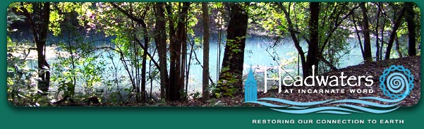

“Caring for the Headwaters Sanctuary,” was held on Saturday February 6, 2016 from 8:30-11:30 am. Guests assisted in the care of 53-acre nature sanctuary to preserve, protect, restore and celebrate the rich natural, cultural, historical, spiritual and educational values of the headwaters of the San Antonio River,(http://www.headwaters-IW.org.) The event consisted of getting rid of different types of vines that are blocking out sunlight from other plants. Youth and adults worked together both caring for creation and building friendships.

“Going Solar,” was held on Saturday February 6, 2016 at the First Unitarian Universalist Church. Dr. Roy Ellzey. led discussions of different types of photovoltaic solar panel installations. He considered how “Build San Antonio Green” helps customers decide the best solar path for them. They work with CPS Energy and Kate Rodriguez shared information. Dr. Roy Ellzey gave local options for families and businesses who are considering converting to all or partial solar energy.https://www.facebook.com/events/162111897491768/. The seventeen attendees were very interactive, asking questions.

“Mitchell Lake Bird Walk,” was held on Sunday February 7, 2016 from 8-:00-9:00am. About ten people attended this guided birding tour. They also planted Milkweed for a monarch butterfly garden. http://mitchelllake.audubon.org/birding-tours.

“Caring for Creation,” was held on Sunday February 7, 2016 from 9:30-10:30am. Joseph L. Cook led an adult Sunday school presentation at the Mennonite Church, which included an examination of creation care, scriptural aspects of creation care and aspects of challenges creation faces from environmental issues. Creation Care from a biblical perspective was presented using PowerPoint and films. Refreshments were provided - and discussion occurred throughout presentation and after. Comments from attendees indicated they were not aware of the scope of climate change challenges and they liked the aspect of linking how all creation is connected and our responsibilities as stewards of the environment. Fifteen people attended and there was much discussion and enjoyable questions.

“Kids Alive!” was held on Sunday February 7, 2016 from 11:00am-1:00pm. The event was a Wilderness Survival class for 6-14 year old children and their parents or guardians.

The San Antonio World Interfaith Harmony Week events ended with “Centering Prayer and a Discussion on Ecology,” on Monday February 8, 2016 from 6:00-7:00 pm at the Library of the Denman Estate.

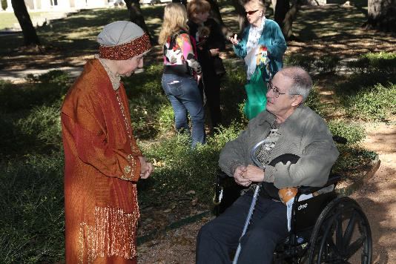
(Photo curtesy of Chuck Gibbons)

Those who had helped plan the events came together and discussed the various programs. They agreed that World Interfaith Harmony Week was beneficial for our city and that we personally had benefited. We wish to celebrate it again next year and hope to start planning in September.

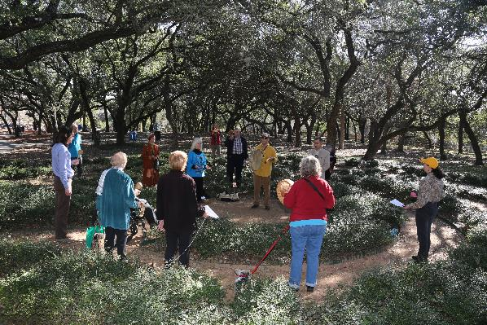
(Photo curtesy of Chuck Gibbons)
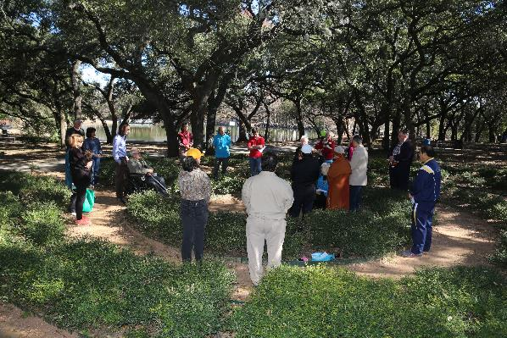
(Photo curtesy of Chuck Gibbons)

