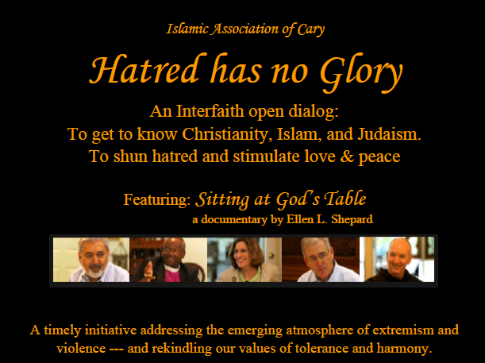

AN INNOVATIVE APPROACH FOR EFFECTIVE INTERFAITH DIALOG

_{SUBMITTED BY:}
_{SHAKIL AHMED}
_{ISLAMIC ASSOCIATION OF CARY}
_{ELLEN SHEPARD}
PRODUCER OF THE FILM – SITTING AT GOD’S TABLE
_{RABBI LUCY DINNER}
_{TEMPLE BETH OR}

_{MARCH 8, 2016}

Hatred Has No Glory
An Interfaith Dialog for Racial Harmony
An innovative approach promoting interfaith harmony by the faith leaders in Raleigh, North Carolina, USA
With the everlasting hostilities around the world – especially by the so called Muslim terrorists – there is growing tension among the people of different races and faiths. This is especially true in the West. We are not very familiar with the ground realities in Europe – but being residents of USA – we are very aware that this tension is growing since the incidence of 9/11. There exists a distrust among the citizens of USA and the foreign national origin people – whether they are residents or naturalized citizens. And more recently a discontent is developing against Muslims in the USA. Fortunately, a vast majority of U.S. citizens do not subscribe to this racial or faith divide and distrust – but even they are uncertain if the fear against Islam is baseless, and they too view Muslims in the West as a potential threat to peace. There are two main reasons for this fear: 1) Lack of knowledge of each other’s faith; and 2) Lack of interfaith outreach to get to know each other better. A New York Times survey (sometime in mid-1980’s) about general public’s trust in Muslims showed that a majority of people in the New York City metropolitan area distrusted Muslims and considered them a threat to the U.S. peaceful environment. In the same survey, those people who had exposure to Muslims, in social or work environment, had no concerns about Muslims as being hostile.
Given this backdrop, a group of interfaith leaders in the city of Raleigh, North Carolina, USA started an undertaking to address the interfaith and racial tension with the goals of promoting harmony among the various groups of people. This task addressed both dimensions, the lack of interfaith knowledge about each other’s faith, and then the outreach among various group.
Knowledge and Understanding of various Faiths
This activity was led by Ellen Shepard, an accomplished media expert, especially in motion pictures. She organized a group of interfaith leaders to come together and openly discuss some intricate issues that required shedding light from various faith viewpoints. To keep a fine focus, this activity was limited to the Abrahamic faith religions – Christianity (Baptist, Catholic, Episcopal), Islam, and Judaism. A full length feature film titled: “Sitting at God’s Table” was produced, Hollywood quality, to highlight that the three Abrahamic faiths have more in common than most people think. This movie has proven to be an excellent ‘ice breaker’ for effective interfaith dialog. Since the production – there have been several public showings in audiences of 200 – 300 plus with great reviews and response.
In the past the efforts for interfaith outreach have not been effective – since most people view them as a forum of criticizing other faiths. Most people who come to interfaith meetings come with an attitude - as Pastor David Hailey described: “I am right and you are wrong.” This does not lead to any harmony, at best it is a social gathering to express nice politically correct words about each other’s faith. In the movie the faith leaders discussed many controversial issues candidly and described the reason and logic behind it from the theological viewpoint. And suddenly the discussion turned from confrontational in nature to openness in sharing their viewpoints. Those who have seen the movie would attest to it. Almost always the discussion after watching the movie has been friendly and harmonious, and it brings interfaith people closer. Here are quotes from those who participated in interfaith discussion after watching the movie – and these are wonderful testimonies of the success of this approach:
Phyllis Zagortz Gordon: “I have so much admiration for Shakil (representing Islam in the movie), a lay person who has a mission to present his religion as a faith of peace in the face of media concentration on ISIS, Al Qaeda, the Taliban, etc. While his theology is far more conservative than my own beliefs, I appreciated that he LISTENED to everyone who participated, and they in turn LISTENED to him. He has a calling to outreach, to involve himself in the non-Muslim community. Many people of faith isolate and insulate themselves in their own congregations, seldom confronting, and being confronted by differing points of view. The message of your documentary was summed up by your Baptist preacher at the very beginning, when he talked of having world views that assume "I am right and you are wrong." I don't think that anyone's minds were changed 180 degrees by the discussion, but it was wonderful to see thoughtful, intelligent, deeply faithful people explain their own beliefs while listening respectfully to others.”
Heidi Schcognic, M.D. - "Not only did I enjoy it thoroughly; I really did learn a lot. I have been wanting to learn about different religions, especially the Muslim faith. Your passion for this material really shined through!!"
"Just when I thought I knew ‘enough’, I learned how beautiful it is to learn more."
"Kol HaKavod (all the honor to you) – “Amazing film, amazing heart behind it."
"It stimulated thoughts and discussion between my wife and myself about our own spiritual journey. Thank you."
"The rest of the world needs to see this!"
So, the first goal to spread the knowledge of each other’s faith was effectively accomplished with the movie as the main instrument.
Interfaith Community Outreach
We then used this movie as an instrument for community outreach. Many of the interfaith leaders used the movie to invite people for interfaith dialog in a non-threatening way. Temple Beth Or in Raleigh, St. Francis of Assisi in Raleigh, St. Paul’s Episcopal Church in Cary were the pioneers in implementing this approach. They hosted outreach meetings – bringing people of various faiths together. And the approach works!
The high watermark of community outreach for interfaith harmony was a meeting championed by the Islamic Association of Cary NC. This meeting took place on the Interfaith Day, February 7, 2016. The venue was the Town of Cary Arts Center – a key place for many social and learning conferences. The theme of this meeting was: “Hatred has no Glory”. All the churches, synagogues and Islamic mosques were invited to attend – and so were the people at large. Most religious leaders attended as well as many priests and Imams who addressed their views for promoting interfaith harmony. Response from the public at large was beyond expectations – the event was almost sold out – some 400 people attended the meeting. The audience represented various faiths, government officials, law enforcement agencies, academia, and racial diversity. The comments from the audience were overwhelmingly positive. Example:
Br. Shakil,
I would like to congratulate you on a very successful event last Sunday. The event was very well organized. We were all impressed by the number of attendees.
Thank you for your hard work for creating better understanding of Islam.
Khalid Nasim

The Promise of this Approach
As mentioned above, the simple approach of having interfaith meetings has been successful in socializing with likeminded people who already believe in racial and interfaith harmony – but for the larger population it has not been effective. Also, the efforts at the national level by large organizations has not been successful in reaching out to the grass root levels. The racial and interfaith divide continues to enlarge – the hatred and distrust is leading to increased fear in the community. Thus, a new approach that reaches the masses at grass root levels is paramount. Our approach thus far has been:
- Use an effective, non-threatening media to bring people together to learn more about each other’s faith. The movie “Sitting at God’s Table” was our instrument.
- To invite people from various faiths and races to watch the movie in different venues and follow up with open discussion promoting understanding and tolerance for each other’s faith and practices – and thus alleviate the fear of violence in the name of religion.
- Make it a local event – in small neighborhoods, towns and villages as a grass root effort.

We are very hopeful that our successful role-model process can be replicated across the USA – effectively. We intend to do that – but first we need to establish testimonials of success. Our accomplishments so far make us very optimistic that this approach will bring peace and harmony across the board beginning at the small community level.

And so it Continues …. We have been invited by the prestigious North Carolina Museum of History in Raleigh, N.C., USA to present our program in May, 2016.
Conclusion
We believe this is a very innovative approach for promoting interfaith, inter-race harmony as an organic process. So far many of our events presented by various churches, mosques, synagogues, and interfaith organizations have produced outstanding results, including educational workshops for their youth. People of different faiths who had reservations and even animosity have changed their views. An atheist who attended the “Hatred Has No Glory” event commented, “I came to this meeting with negative views – but after watching the movie and listening to the faith speakers – I have a different understanding of their faith – I don’t have to agree with their faith but I can live with it.”
A recognition from the Organization of the Interfaith Harmony Week – will provide us with the necessary testimonials to spread this approach across the USA. In our opinion, with the growing political rhetoric of “hatred”, especially against Muslims and Mexicans in USA presidential elections – the most productive and fruitful payoff for the intent of the United Nation sponsored Interfaith Week would be a recognition of a group in the USA – it would seed interfaith harmony in the USA and it spread worldwide. Our effort is pioneering work towards this cause – we believe that our work is unique deserving of an award – and we certainly hope that you agree!

