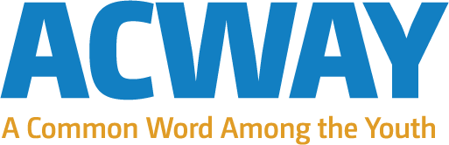

Clement Awanfe Ngueto’s references from Around the World :

Libby & Len Traubman (USA)
Contact infos: Email: ltraubman@igc.org Website: http://traubman.igc.org

H.E Ambassador Mussie Hailu (Ethiopia)
Contact Infos: Email: mussiepeace@yahoo.co.uk Website : www.uri.org Or www.kaiciid.org
Rawaad Mahyub (UK)
Contact Infos: Email: info@acway.org Website : www.acway.org Or www.rightstart.org.uk
Rev. Charles Gibbs (USA)
Contact Infos: Email: charles@catalystforpeace.org Website : www.catalystforpeace.org Or www.uri.org
Fred Arment (USA)
Contact Infos: Email: arment@fredarment.com Website : www.internationalcitiesofpeace.org

