Pakistani Youth Celebrates World Interfaith Harmony Week, 2016
On 4th February, 2016 URI Pakistan along with Peace Center organized a program for Youth to celebrate World Interfaith Harmony Week at Peace Center, Lahore. There were 16 Christian and Muslim young males and females present for this ceremony. The program started with introduction of each participant. Sr. Sabina Rifat, Coordinator URI Women Wing Pakistan was the main organizer.

Fr. James Channan OP, URI Regional Coordinator Pakistan welcomed all the participants. He said that World Interfaith Harmony Week is celebrated all over the World as announced by the United Nations. WIHW is celebrated 1-7 February every year. We always celebrated day with great spirit and enthusiasm to create interfaith harmony in our country and worldwide as there is great need of such activities. I urge the youth come forward for the celebration of WIHW in your own homes, cities, villages and continue to work for peace and harmony. Youth can play a vital role to spread this message of tolerance, respect and thus create a peaceful society.
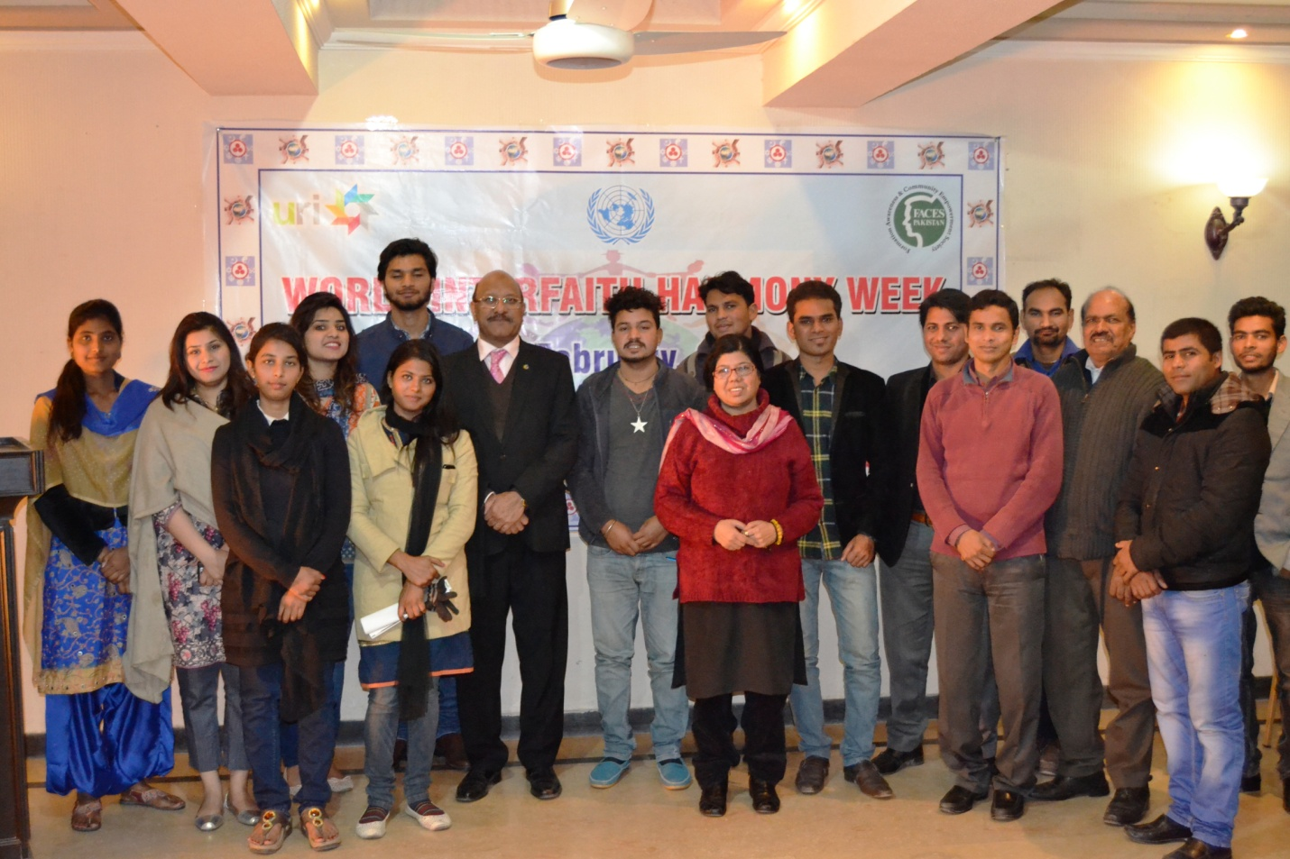

Different Youth leaders reflect their experiences that how we can promote the Interfaith Harmony on their work place in society.
Emmanuel Fazal, Zeeshan Asim, Miss Zara Pervaiz and Miss Saba expressed their thoughtful and experiences for creating love, peace and harmony. They also laid great emphasis on accepting of each other and work for the betterment of country. They also that let respect and love be the motto of our lives. This will further enhance the spirit of World Interfaith Harmony. In our daily life tolerance and acceptation is essential. The other guests Mr. Ashar Nazir, Mr. Yuel Bhatti also expressed that we have to respect each other and their religions to promote the Interfaith Harmony. Yuel Bhatti also said URI have Youth Department and also 45 Groups in Pakistan. Some groups are celebrating WIHW 2016 at their venue. On the whole the URI working as Bridge among the religions. Sr. Sabina Rifat, urged all young people to play their utmost best for the world peace and harmony among religions and cultures and put all their energies in a constructive ways. To bring a positive change in the world. The program was very successful
Young people also sung peace songs and recites poems. Towards the end of the program delicious supper to all.
Reported by:
Fr Dr. James Channan OP
Director, Peace Center, Lahore, Pakistan. www.peacecener.org.pk
Regional Coordinator, URI (United Religions Initiative) Asia Region, Pakistan
www.uripakistan.org
Cell> +92- 300 8730 669
Email: jchannan@gmail.com

