Youth in Iraq

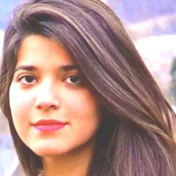

(by Fatimah Almukhtar - presented at Toward Peace and Reconciliation in Syria and the Middle East - The Role of Religions)

You’re on the beach, walking deeper into the sea. You can feel the water brush against you as you move further and further away from the shore. You STOP. The waves get stronger and stronger, with every tide you feel the force of the water get more convincing, trying to compel you to just let go of your grip and fall to your doom.

What do you do? Do you give up? Do you fall? Or do you stand resilient, strong and determined? Do you refuse to be pushed down? Do you refuse to allow yourself to be victimized by your circumstances?

I’ll tell you what the youth of Iraq decided to choose. We chose resilience; we chose to stand strong and refused to be victimized.

One of the worst waves hit my home, Baghdad, in 2003. This was one of the first instances where we vividly saw our youth decide to stand for their country and for their people. I remember the inspiring story of a young man I once knew. He was a graduate, fresh from medical school, on the eve of the war. He could’ve fled. He could’ve run. He could’ve taken refuge in Syria like so many others. But he didn’t. He refused to be a victim of the war. Instead, he and his colleagues, decided to stay. While their families all fled to safety in neighbouring countries, they lived at the hospital doing everything in their power to help the injured. They helped those who did not have the ability or the means to help themselves. They were put into the worst situations. Medical supplies were running low, they were untrained, they were not specialized, they were forced to perform procedures that some of the best doctors in Iraq had no experience performing. They learned to improvise; instead of traditionally relieving pressure from the chest cavity with medical supplies, they did it with pens. Every patient was a wave for them. With every injury they felt the pressure. With every tear they felt the waves get stronger. With every drop of blood spilt, thought of giving in. But they didn’t. They faced everything. They were resilient. They were strong. They did NOT give in.

The waves kept coming and with every tide, they got stronger and stronger. They seemed to never end. But neither did our determination. But neither did our willpower. But neither did our strength. This is Al-Mutanabi street. It is in the heart of Baghdad’s old district. It is named after a very famous Iraqi poet, Al-Mutanabi. It is a place where various intellectuals, poets, philosophers and artists meet to exchange knowledge, listen to lectures, have discussions, and educate the masses. The most well known of these cultural education sessions take place on Fridays. But it’s not just lectures and discussions. The street is drowned in books. A paradise beyond your wildest imagination if you’re a book-worm like myself. Knowledge on every subject you could ever dream of is laid onto the sidewalk waiting for you to engage with it. This is not just any open-book market. This is book-market where every store is owned by authors, poets and intellectuals who passionately tell stories about every book in their store and the whole subject’s history. It was weird for me to return there last year.
As a young girl I always remembered this street to be one of the most dangerous. The constant target of various terrorist groups and militias. However, when I was in Iraq last year for the first time since 2006, I was shocked. I skeptically visited Al-Mutanabi street on a Friday, expecting to see very few people, let alone any youth. I was very wrong. The street was overflowing with youngsters hungry for knowledge and education. Whether it was philosophy, art, politics or poetry; they just wanted to learn something knew. Al Mutanabi street is still not one of the safest places in Baghdad. However, that didn’t matter. These people were willing to risk their lives to fulfil their thirst for education, and hunger for knowledge. Target after target. Bomb after bomb. Shooting after shooting. That did not matter to the youth of Baghdad. For Friday’s meant education, and no wave, no matter how strong, was going to get in the way of that.

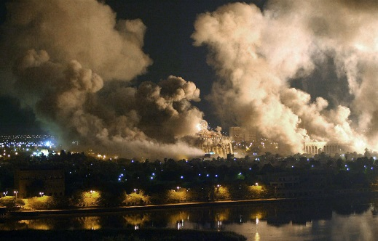 | 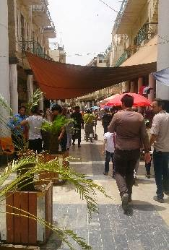 | 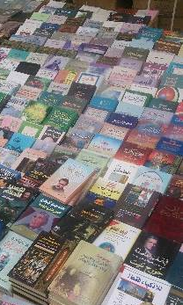 | 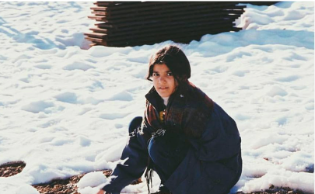

But it wasn’t just the Iraqi youth that decided to stay who showed this passion for resilience. Even those who eventually ended up leaving, radiated with determination, intent, and purpose. In the face of all those who saw us as victims, we stood tall. We proved that we were more than that.

I was 14 when I moved to Vienna with my brother. We were both minors leaving our family behind in Baghdad. We were lucky though. Our aunt offered us a home, warmth and a safe place to stay. However, a different type of wave hit me. I was in a new country. I was put in school without knowing the language or the culture. I had to learn everything by myself. I did not want people to see me as a victim of the war. As a poor Iraqi girl who survived the horrible circumstances. I wanted to be an equal. So I as well decided to stand resilient to these waves. I learned the language very fast. I finished school and entered university from which I graduated just last year. But my resilience did not stop there. This summer I decided to help with the current refugee crisis. I witnessed the fear of being seen as victims in their eyes. I witnessed the same willpower I had to start a new life. I decided to work with mainly youngsters. I wished to give them guidance and inspiration through their journey to overcome the waves. From teaching them German, to trying to integrate them through many activities such as sports to just sitting with them and telling them about life in Austria, I am doing everything in my power to give them strength and confidence. Just because they decided to leave, it does not make them weak. It does not make them victims. They can still show determination, they can still stand strong.

I will not stop being resilient. I will not stop holding their hands as they make their way through the waves. No matter what kind of waves we, youth of Iraq, face, we will still stand tall and determined. Our willpower and strength will not be taken away by terrorism or war. We are like everyone else. A 14 year old in Iraq is like any 14 year old in the world. They have the same dreams, the same ambitions and the same goals. They were just born in the wrong place at the wrong time.

