Vienna, February 5th 2016 - For the 4th successive year, the Universal Peace Federation (UPF) held a conference in the Vienna International Centre (United Nations) to mark the World Interfaith Harmony Week. This year’s conference, “Toward Peace and Reconciliation in Syria and the Middle East – The Role of Religions” was co-sponsored by the United Nations Correspondents Association in Vienna, the International Institute of Middle-East and Balkan Studies and the Women’s Federation for World Peace.

The two afternoon sessions, with an audience of 250 people, included Islamic, Jewish and Christian speakers from the Middle East as well as voices from the media, government and civil society, with speakers coming from Syria, Iraq, Turkey, Jordan, Lebanon, Israel, Serbia, Bosnia and Austria. The sessions included robust disagreement on the roles of nation states; warnings against the division of a nation or the region into sectarian mini-states; reminders that religion simply cannot be ignored and yet that its role must be to engage with society if it is to be an effective force for peace; and assessments and suggestions that were both realistic and forward-looking.
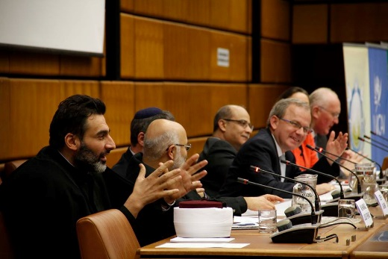 |  | 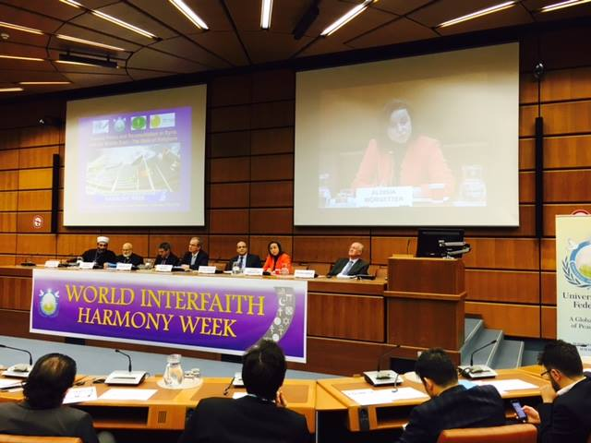

Peter Haider, president of UPF Austria, opened the proceedings with a reminder of UPF’s track record of Middle East Peace Initiative programs in Israel, Palestine and Jordan and the series of conferences addressing the Syrian conflict. We then viewed (and heard) the anthem of Interfaith Harmony Week „The Gift of Love“.
The first session was chaired by Jacques Marion, secretary general for UPF in Europe. After reminding us of the relevance to our discussion of UPF founder’s proposal for an interreligious council at the UN, Jacques introduced the first speaker, Mag. Aloisia Wörgetter, head of the Task Force on Dialogue of Cultures at the Austrian ministry of European, International and Foreign Affairs. Mag. Wörgetter told us of their three interfaith programs during this week: an open discussion on challenging issues (including recent events in Köln), a Peace Vesper at Austria’s Melk abbey, and the visit of Austria’s president to KAICIID dialogue centre, where he addressed the leaders of all the religious and confessional communities in Austria. Mag. Wörgetter finished with the president’s words, “A religion that teaches peace among people lives up to its calling.”
Jordan’s ambassador to Austria, HE Hussam Al Husseini, reminded us of his king’s constant emphasis on the importance of interfaith, including the Amman Message in 2004 and the Common World Initiative in 2007, both forerunners to Jordan’s proposal of World Interfaith Harmony Week, itself a week designed to allow “the world’s people to express the teachings of their own faiths on tolerance and peace”. It is our common values, he said, that should help us overcome our differences.
The following three speakers were Jewish, Christian and Muslim. Rabbi Yaakov Luft from Jerusalem read from an article that scathingly attacked the “pretty words” of religious leaders meeting at the site of a recent killing. Conceding the many failings of religions, he asked if there was really a better alternative, pointing to the millions killed by nationalism and communism in their various forms. Rather than condemning, he suggested, we should look to the best of religions and of nations and of universal values. It would certainly be disastrous to seek a solution to the Israel-Palestine conflict while ignoring nations and religions. Religious leaders have a responsibility to actually apply their noble values of the sake of real peace in the world. Father Joseph Saghbini of the Greek Melkite Catholic Church in Lebanon spoke strongly against division and passionately for Christian-Muslim cooperation. The role of the church in the Middle East is “to lay the foundation for peace, based on faith and shared living with Muslims.” Eastern Christians want to stay in the Middle East “with and for the sake of Muslims. We want to stay with you. After 13 centuries together we make up a common fabric. We (Christians) too are defenders of Islam and of Arab unity.” “I am certain that the Islamic mind is capable of adapting to the modern age. We Christians must contribute, working hard without fear so that the Arab world regains its strength.” Muhammad Jusufspahic, Mufti of Serbia, is a big man with a big heart. He helped us smile and look beyond our differences, reminding us that history is His Story, that all three Abrahamic faiths are waiting for the Messiah, and that Muslims expect Jesus to come back to Damascus. While some focus on Islam, they should be focusing on Salam – meaning that we should be looking to God, not focusing on our religion. Time permitted a series of substantial contributions from the audience before we took a short break.
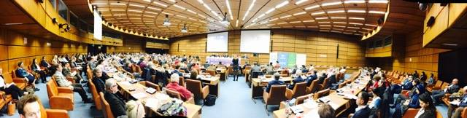

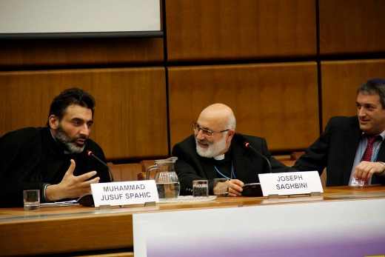 | 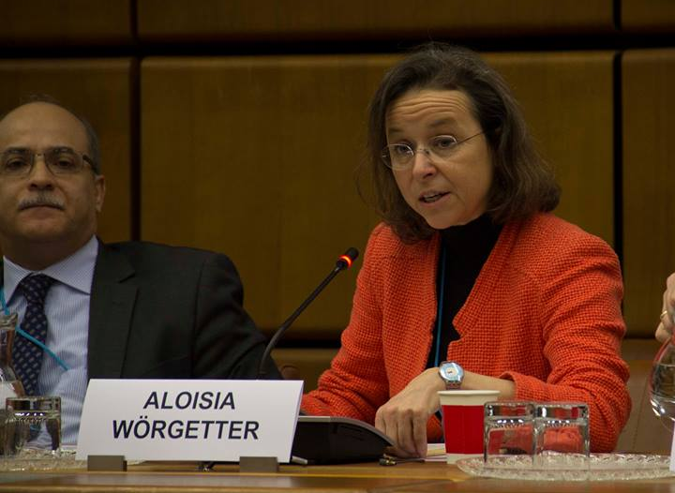 | 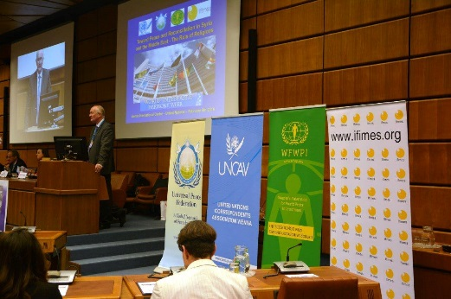

The second session was chaired by David Fraser Harris, secretary general for UPF in the Middle East. He drew attention to UPF’s regular emphasis on the interface between religion and society, expressed in joint efforts with civil society, governments and UN institutions, often focusing on education and building the kind of leadership that has the capacity to bring peace. He cited a recent joint effort with the UN information centre in Sri Lanka for leadership related to the achievement of the sustainable development goals; an example of cooperation made possible by more than a decade of effective interfaith youth programs. The first speaker of the session, Dr. Ismail Yasin, former professor of Damascus University, called for a moment’s silence for all those who have lost their lives in Syria. He spoke of Syria’s 9000 year history, its reputation as a trading people, its 17 ethnic groups and its former status as a model of coexistence. Speaking of those of his students he had seen demonstrating, he asked, “Is it a dream to feel you are free?” We have to stop the war and bring humanitarian aid to those who need it. As things are, we are all losers. The simplest way to end it is to stop arming both sides. Dr. Enes Bayrakli, professor at the Turkish-German University in Istanbul, referred to the many cultural similarities between Syria and Turkey. Syria is a microcosm of the Middle East, which means that any division of Syria will affect the wider region. For example, the war in Syria has already led to the collapse of the peace talks with the Kurds. He voiced alarm both at ISIS attacks and at Kurdish gains in Turkey, and at the 300,000 more refugees heading to Turkey as he spoke. He closed by reemphasizing the need to preserve the unity of Syria.
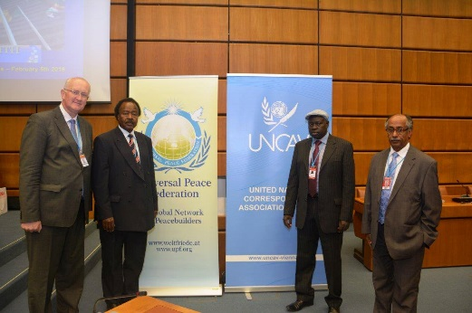 | 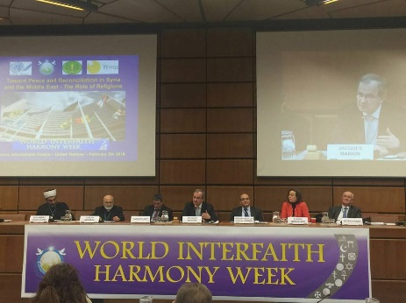 | 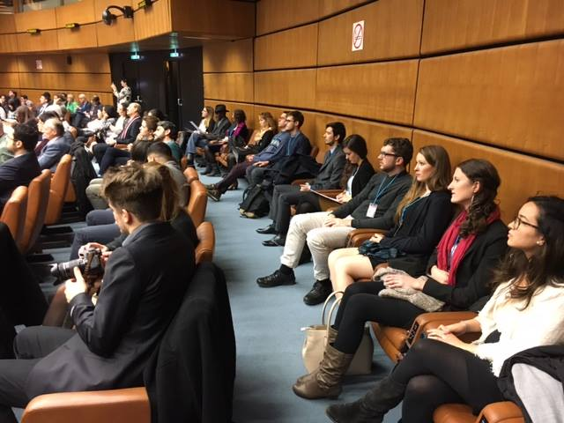

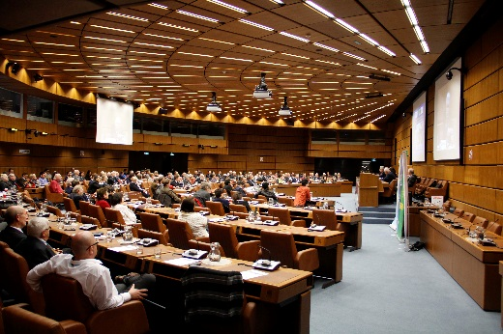 | 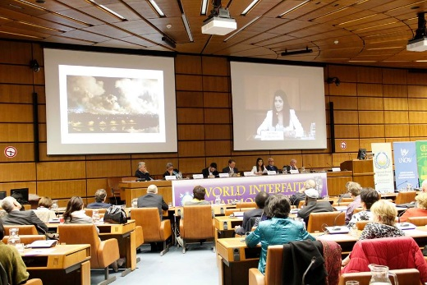 | 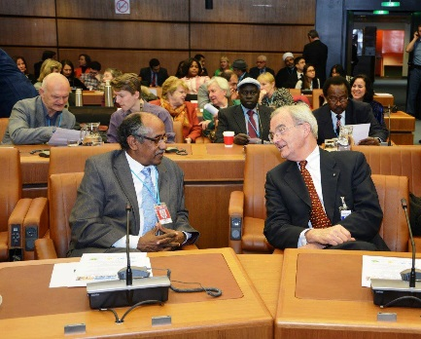

It was from our youngest speaker that we heard the voice of hope. Ms. Fatima Al Mukhtar left her native Iraq when she was 14 years old for Austria. When wave after wave of violence and destruction threatened to drown their hopes, “we, the youth of Iraq, chose to stand strong and not be victimized.” She told of untrained youth choosing to stay to help the injured in hospitals; of her own path, learning a new language and culture, completing school and university and deciding to help the new refugees; of last year’s visit – after 9 years away – to Al Mutanabbi Street’s Friday book market in Baghdad, amazingly overflowing as before with youngsters hungry for education and culture. “I will not stop being resilient.”
Dr. Anis Bajrektarevic of the International Institute for Middle-East and Balkan Studies challenged us to face some inconvenient truths: Saddam Hussein’s Iraq had been globally recognized for its eradication of illiteracy; the previous day’s London Syria conference had only one Syrian in the room; solving Syria’s problem requires more than intellectual acrobatics – it requires a physical presence, action (force) to stop any violation and a clear message that it must not be repeated. When a problem seems unsolvable, as Jean Monnet advised, “enlarge the context”. Europe is not a rich club anymore; it is time for Europe to be integrated. If you want to start programs with Muslims in Europe, start with Bosnians and Turks!
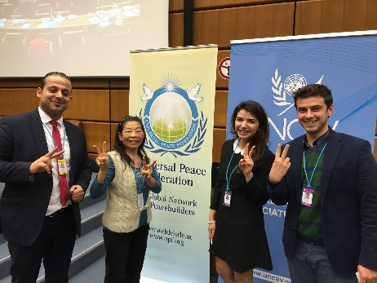 | 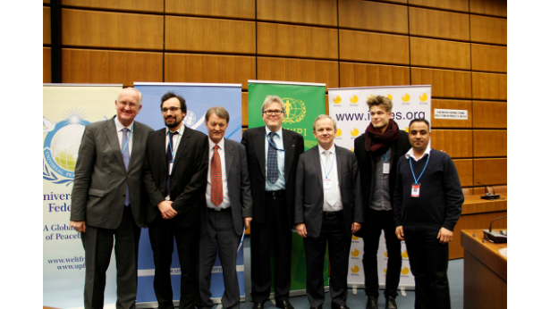 | 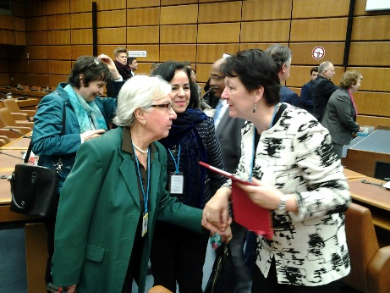

Dr. Leo Gabriel, one of the main organizers of the Peace in Syria initiative, spoke of the limitations of religion on its own, citing two Sunni leaders, one a propagandist for the Assad regime, the other very close to ISIS. “All these interfaith dialogues need to merge with social reality, to see whether they can actually bring people together or just preach.” Religious and political generalizations are inaccurate and unhelpful. Identifying a place with a religion is one of the problems: “we all share the earth.” As a journalist, he said he was a witness to a “filthy game” in which nations and groups pursue their own interests while the people of Syria starve to death. As a step in the right direction, he proposes looking toward the future – and launching a discussion on a new constitution for Syria. “What alternative structure can meet the needs of the different communities in all the regions? Let us give peace a chance.”
A lively discussion followed before Mr. Peter Haider came to offer some closing remarks. We should challenge ourselves, he said. “We need to hold a peace conference in Damascus.” Speakers and audience alike lingered. One thing was more than obvious: there was a lot to talk about.
World Interfaith Harmony Week
First proposed at the UN General Assembly on September 23, 2010 by H.M. King Abdullah II of Jordan. Just under a month later it was unanimously adopted by the UN and henceforth the first week of February will be observed as a World Interfaith Harmony Week.

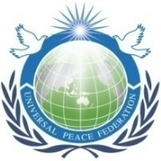 | 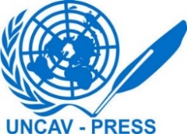 |  | 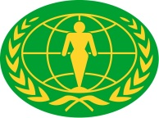
Universal Peace Federation - United Nations Correspondents Association Vienna - International Institute for Middle-East and Balkan studies - Women's Federation for World Peace

