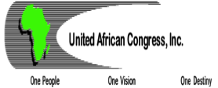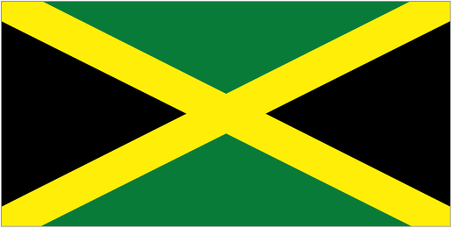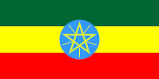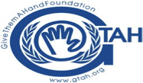

BUILDING BRIDGES ACROSS BOUNDARIES
In observance of World Interfaith Harmony Week
4 February 2016, 3PM-5.30 PM, United Nations ECOSOC Chamber

Sponsored by the United African Congress, Give Them a Hand Foundation, Nusantara Foundation, Buddha’s Light International Association and the
International Association of Applied Psychology
in partnership with the Permanent Mission of Ethiopia, the Permanent Mission of Jamaica, and the Permanent Mission of Indonesia to the United Nations

PROGRAMME
Welcome Dr. Mohammed Nurhussein, Chairman, United African Congress
MC Gordon Tapper, Give Them A Hand Foundation
Remarks H.E. Mr. Dawit Yirga Woldegerima, Charge d’affaires of Ethiopia to the UN
H.E. Courtenay Rattray, Permanent Representative of Jamaica to the UN
H.E. Mr. Muhammad Anshor, Charge d’affaires of Indonesia to the UN
Keynote H.E. Dr. Thomas Gass, UN Assistant Secretary-General Policy Coordination and Inter-
Agency Affairs, DESA
Statements Imam Shamsi Ali, Jamaica Muslim Center Masjid
Rabbi Dr. Alvin Kass, Chief Chaplain, New York Police Department
Reverend Dionne P. Boisierre, Chaplain, Church Center To the United Nations
Dr. Uma Mysorekar, Hindu Temple of New York
Abbess Venerable Yu Rang, Buddhist Light International Association. (BLIA)
Kevin Ka’nahsohon Deer, Spiritual/Cultural leader of the Longhouse People, Iroquois
Video Presentation Dr. Judy Kuriansky, International Association of Applied Psychology
Musical Interlude BLIA singers, followed by Jamaican Haitian Singer, Sheimyrah Mighty.
Panel Discussion and Q +A
Moderator Milton Alimadi, Publisher and Editor of the Black Star News
Panelists Rabbi Jill Hausman (The Actors’ Temple), Imam Shamsi Ali, Dr. Uma Mysorekar,
Reverend Dionne P. Boissiere, Venerable Ru Yang, Kevin Ka’nahsohon Deer
Closing Sidique Wai, President, United African Congress & Senior Advisor to the
Commissioner of Police (NYPD)

