**MAP OF WIHW 2016 CELEBRATIONS IN INDONESIA**

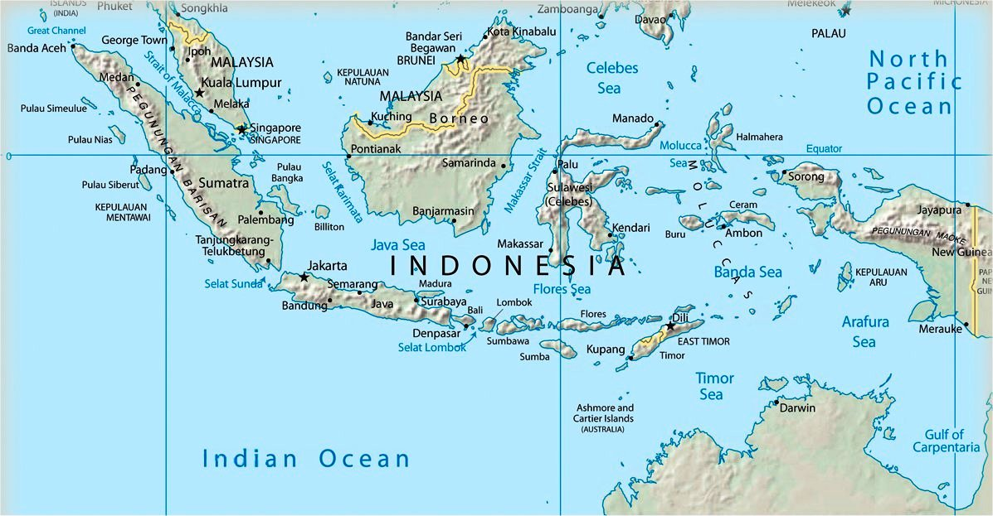

**Areas of World Interfaith Harmony Week** (WIHW) 2016 Celebrations: Banda Aceh, Medan, Karo, Jambi, Cimahi, Bandung Tasikmalaya, Kuningan, Indramayu, Tegal, Rembang, Jepara, Yogyakarta, Kulonprogo, Sampang, Malang, Mataram, Bima, Tambolaka, Waingapu, Kupang, Makassar, dan Bulukumba.

**Areas that photos were taken for a WIHW 2016 book, *The Culture of Interfaith Harmony in Indonesian Islam*** in Medan, Bukit Tinggi, Padang Panjang, Padang, Banten, Jakarta, Bogor, Sumedang, Indramayu, Cirebon, Kendal, Semarang, Magelang, Yogyakarta, Solo, Gresik, Surabaya, Sumenep, Jombang, Ponorogo, Pontianak, Banjarmasin, Martapura, Bontang Kuala, Makassar, Bali, Lombok, Flores.

**WORLD INTERFAITH HARMONY WEEK 2016 CELEBRATIONS IN INDONESIA**

**IN COLLABORATION WITH THE ASIA FOUNDATION AND ITS PARTNERS**

**24 January – 5 March 2016**

Indonesia consists of 17,000 islands, with 6,000 named islands inhabited by 1,128 ethnic groups which have hundreds of belief systems, local religions, customary practices and traditions derived from their beliefs. Apart from the six official religions recognized by the State (Islam, Christianity, Catholicism, Hinduism, Buddhism, and Confucianism), the archipelago has thousands of faith groups. The government has officially recorded 245 local religions, for example, in East Java there are 44 local religions recorded, in Central Java 55, in Yogyakarta 25, in West Java 26, and in Sulawesi 27. This diversity of ethnic and religious groups and their social, political and commercial relationships often results in social friction. Conflict has therefore been part of social life, long before Indonesia became a nation-state. In other words, conflict is “natural” in such a plural society. When managed properly, diversity can be an important balance among the various forces in society, and a tool to build cohesiveness amongst citizens.

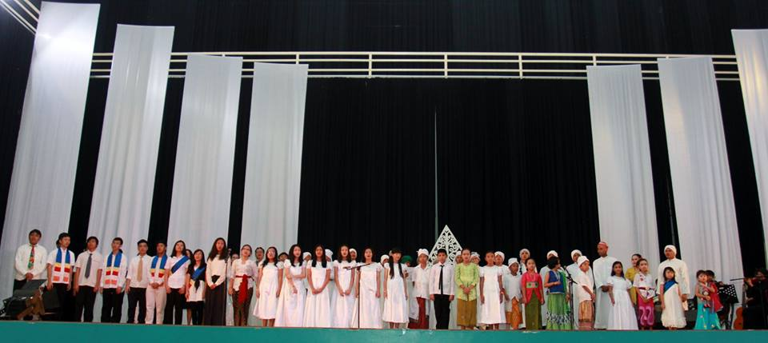

*Celebrate World Interfaith Harmony Week 2016 with Madania Students in Bogor.*

Evidence that conflict in Indonesia is “natural”, and existed long before the colonial period, when modern legal instruments for conflict management were introduced, can be seen from the existence of traditional mechanisms to prevent or resolve conflict. Conflict resolution is intertwined in many social traditions, customs and norms, both written and unwritten, and because conflict is the nature of diversity, it is not surprising that in many regions and ethnic groups we find mechanisms to “channel” conflict in traditional ways. The *Perang Topat* in Lombok is an example of traditional management of potential conflict between Hindus and Muslims. In Minang culture, the tradition of *musyawarah mufakat,* (meetings to achieve consensus in a forum where various community are present) acknowledges that conflict is unavoidable, and therefore a mechanism is needed to address it. In some regions, there are teachings about oaths to not attack one another and willingness to defend other groups that are considered to be “brothers,” such as the *Pela Gandong* tradition in Maluku and Ambon. In many traditional localities, agreements to avoid conflict are not simply values transmitted orally but also take the form of written regulations such as *awig-awig* in Bali or *Larwul Ngabal* in the Kei Islands.

It is easy to see that in pluralistic Indonesian society, people will naturally seek balances so that differences can be managed as strengths instead of giving rise to social friction. The question is: when and how does diversity create social tensions that give rise to open conflict and even violence in Indonesia?

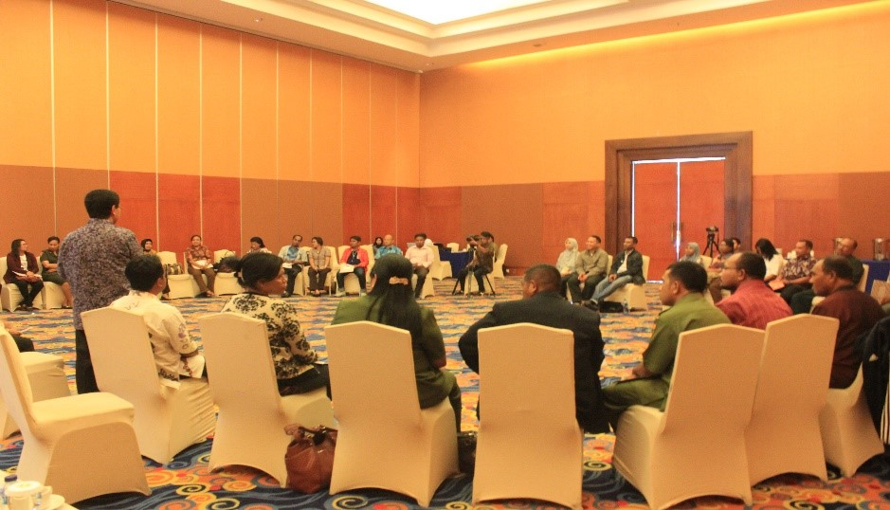

*The Asia Foundation Program Officer Budhy Munawar-Rachman facilitating an evaluation workshop with teachers in Ambon. The “peace makers” shared their stories of success and lessons learned in implementing 3 years Living Values Education program in Ambon. See WIHWprogram in Ambon. See WIHW 2016 video..*

Religious prejudice is not the only factor that leads to violent conflict, though it often seems to be a main factor. In reality, behind every conflict based on religious sentiment there is generally an underlying sense of injustice, whose roots can be traced to economic interests and sharing of resources. And while religious differences are not the only thing to spark conflict, they can become the basis for hatred that provides a “reason” for violence when conflict erupts, because each religion has a “truth claim” that it fights for. There are two situations that lead conflict to become unmanageable and end up in violence.

*First*, internally, within the community itself, frictions result from changes in the social and political situation and/or limitations or depletion of natural resources. In this situation, every element of difference that previously served as a unifier now becomes fuel for the fires of conflict. Traditional mechanisms that were previously relied on have not been renewed to face modern challenges, and, as a consequence, are no longer able to contain social frictions. Even worse, outdated traditional mechanisms, feudal elements, become instruments to maintain their power, because dissent is seen as opposition, and oppression emerges.

*Second*, externally, the legal instruments introduced through Western law and maintained by the Republic are not “impartial.” The legal instruments of the Dutch existed to defend their political interests and their control over natural resources. They were used to ensure that conflict did not occur, but with repression, there was no conflict management. As a result, the potential for conflict became like tinder wood that could ignite whenever the repressive force of the State weakened. Such situations have occurred repeatedly. This legacy, inherited from the colonial era, has used law, which should be neutral, to achieve particular political ends. Moreover, regulations are so general as to ignore the local experience of citizens in managing conflict, stifling the use of local wisdom to manage horizontal conflicts within a local context.

Based on the above situation (problem), in order to achieve an inclusive and non-discriminatory social condition, in the form of more optimal human rights, The Asia Foundation and its partners from 24 January until 5 March, have been participating in celebrating “World Faith harmony Week 2016”. This celebrations has been done through several activities, from very simple, such as meetings to build/create an inclusive society to big events like seminars or inter-religious festivals. The whole process used a way of thinking called “design for change” – for example – feel, imagine, do and share.

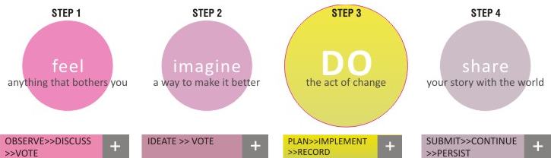

To celebrate WIHW 2016 this was done nationally in 23 cities, as shown on the above map - Banda Aceh, Medan, Karo, Jambi, Cimahi, Bandung Tasikmalaya, Kuningan, Indramayu, Tegal, Rembang, Jepara, Yogyakarta, Kulonprogo, Sampang, Malang, Mataram, Bima, Tambolaka, Waingapu, Kupang, Makassar, and Bulukumba.

At the same time, a photo-book, “The Culture of Interfaith Harmony in Indonesian Islam” was made, which explored the culture of inter-faith harmony already long-existing in Islamic Indonesia. This book, with its photos, tells of and describes the culture of peace and tolerance in Indonesia, a contribution of religions, especially Islam, as the religious majority, here. It also shows a special kind of Islam developed here - usually called “Indonesian Islam”. Photos have been taken in 28 cities in Indonesia - Medan, Bukit Tinggi, Padang Panjang, Padang, Banten, Jakarta, Bogor, Sumedang, Indramayu, Cirebon, Kendal, Semarang, Magelang, Yogyakarta, Solo, Gresik, Surabaya, Sumenep, Jombang, Ponorogo, Pontianak, Banjarmasin, Martapura, Bontang Kuala, Makassar, Bali, Lombok, Flores.

Following is a description of some of the activities:

**1. RELIGION EXPO AND YOUTH INTERFAITH DIALOGUE**

Banjarmasin, January 24 to 25, 2016

In celebrations of World Interfaith Harmony Week (WIHW) 2016, Asia Foundation and partners began in Banjarmasin, the capital city South Kalimantan. The celebrations was called “Religious Expo” – consisting of an Exhibition and a Religious Festival. 30 religious organizations took part each exhibiting symbols of their religions as well as religious books. This was held by the banks of the river Martapura in Banjarmasin. Around 5000 people came to watch many cultural and religious attractions - such as dancing, singing, dramas, etc.

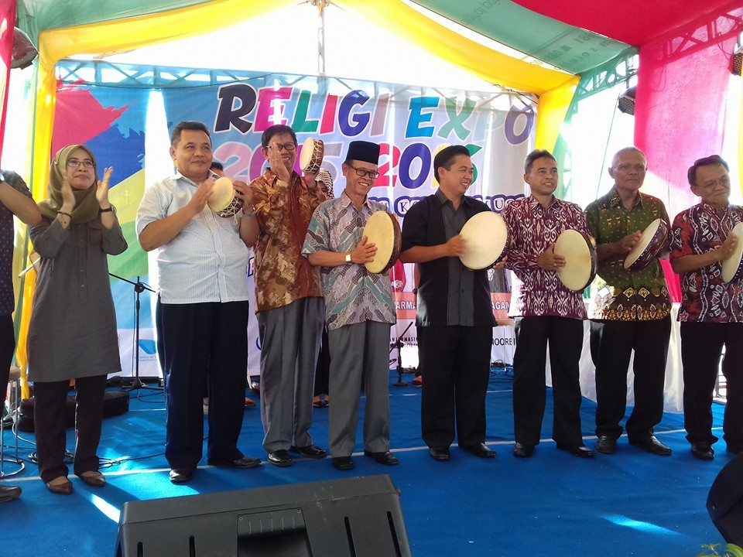

*Opening Religions Expo*

This “Religions Expo” was preceded and followed by activities such as discussions on religious pluralism, led by Dr Budhy Munawar-Rachman of The Asia Foundation, who emphasized the importance of continually developing religious pluralism in Indonesia. Rising intolerance and religious violations have resulted in a decline in democracy in Indonesia. As a result there is the increasing need to build a foundation of peace and tolerance in Indonesia, no matter what the challenges are.

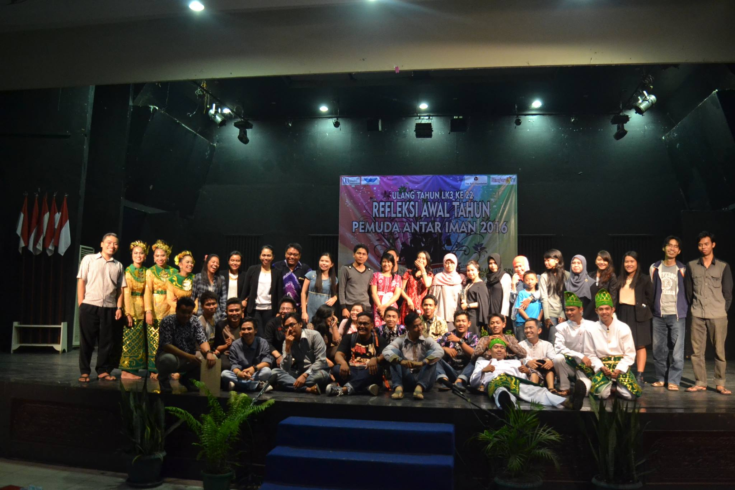

*Youth Interfaith Dialogue in committing to build a community of peace and tolerance.*

Another activity “story-telling”, where stories are told about living in religious harmony, is also important because they are told in the original language of the main ethnic group of South Kalimantan, Bahasa Banjar. This activity, in their own original language, shows caring, as many of the original local languages have now disappeared being replaced by the national language of Bahasa Indonesia.

The Banjar people have very strong tolerance, an example being the Dayak Meratus of South Kalimantan who have a different religion and culture, yet this doesn’t prevent them from tolerating others. Their art and culture is strengthened with traditions of story-telling, theater and literature.

A competition called “Bakisah” or story telling in Banjar language in South Kalimantan is open to all, so that 31 local people from all parts of South Kalimantan (from Tapin, Kandangan, Banjarbaru, Banjarmasin, Tanjung Tabalong and Palangkaraya) took part. In the program, “Religious Expo”, there was also a Youth Interfaith day. This forum involved the youth in committing to build a community of peace and tolerance.

**2. BOOK DISCUSSION ON MISBACH TAMRIN**Banjarmasin, January 30, 2016

Misbach Tamrin is an artist with leftist leanings (of the “left”) who became a victim in 1965, and was imprisoned without trial in the Soeharto government for 13 years. The Institute for Islamic Studies and Society (LK3) held the discussion on him, on the book “*Sailing in the Midst of a Storm – Misbach Tamrin in a turmoil of politics and art*” by *Hairus Salim HS and Hajrainsyah* which is a biography of Misbach Tamrin. The discussion, including also human rights, was very intense. This was also part of World Interfaith Harmony Week 2016.

After being given freedom in 1978, Misbach Tamrin continued his skills in painting and sculpture. Although he experienced a lot of discrimination and social exclusion (which was the case of all who had been branded communists in the Soeharto era), he continued his work, and now in his memory, statues and monuments stand tall as a landmark in the city of Banjarmasin as well as other cities in South Kalimantan.

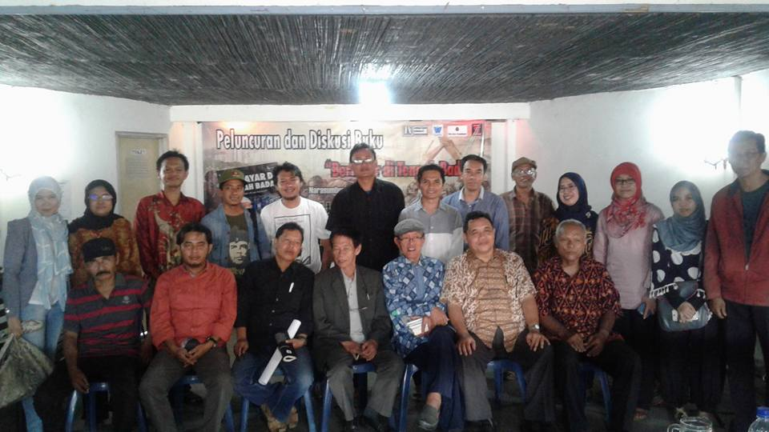

*Photo session after discussion with Misbach Tamrin*

*(with blue shirt, in the middle)*

**3. PSYCHO-DRAMA WORKSHOP**

Ubud, Bali, 29 to 30 January, 2016

The Asia Foundation collaborated with Campuhan College, Motivational Arts Unlimited (MAU), and Values Institute, to celebrate World Interfaith Harmony Week 2016 with psycho-drama workshop. The workshop trained the younger generation to inter-faith skills using drama. The training was led by Mario Cossadari from Motivational Arts Unlimited (MAU), Kuta, Bali, a psycho-drama therapist, and theater educator. Most participants were trainers ofLiving Values Education (LVE). They developed psycho-drama skills to use theater to revive the values of the young generation, and to use them for social therapy in a communities that have developed intolerance.

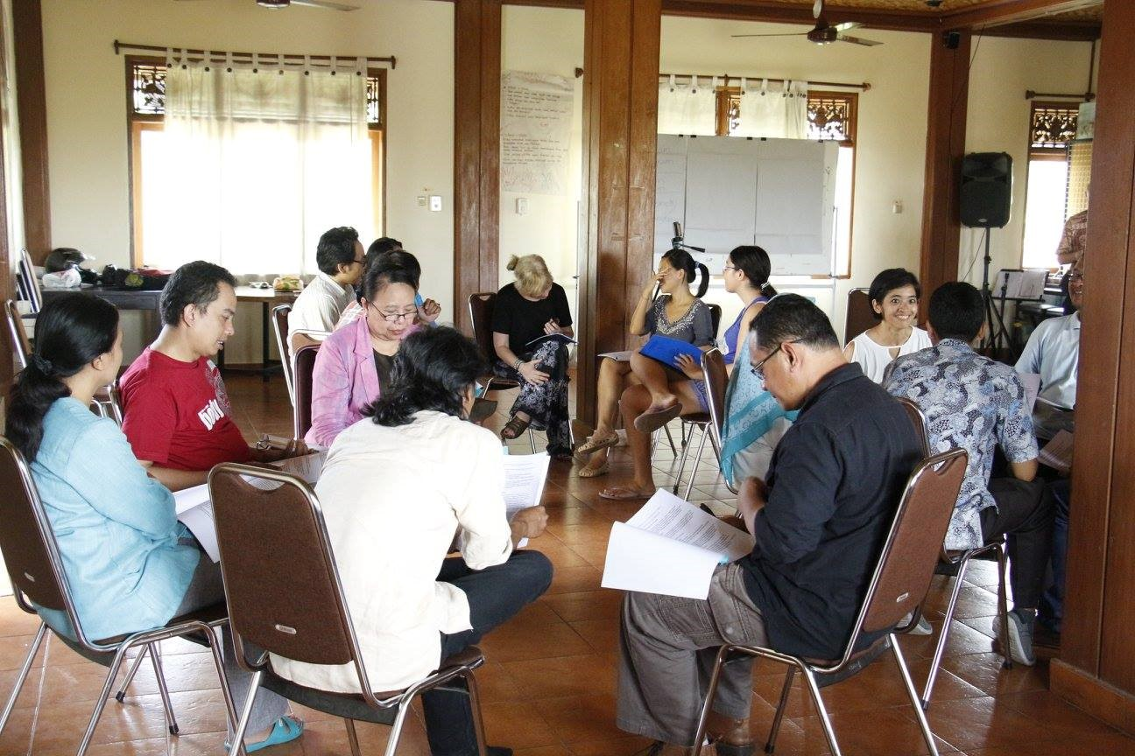

*Motivational Arts Unlimited (MAU) Workshop*

Motivational Arts Unlimited (MAU) is a movement for changing oneself through drama. MAU is the approach used to enhance expressive arts in education, self-development, healing, and more positive life changes. MAU uses creative methods to solve various problems teenagers face, such as narcotics, HIV/AIDS, domestic violence, sexual orientation (LGBT), the impact of social media, addiction to gadgets favoring violence, and the like. This training also develops in depth inter-faith tolerance among teens, by promoting inclusiveness

In celebrations of WIHW in Campuhan College, Ubud, Bali 15 participants from various regions in Indonesia agreed to contextualize MAU so that everyone could understand what happens to relationships whenanyone experiences intolerance, especially teenagers. The Psycho-drama workshops have coached 15 younger groups to anticipate the impact of intolerance in their lives.

**4. LIVING VALUES EDUCATION FOR ACHIEVING**

**SOCIAL INCLUSION AND EQUALITY.**

Bogor, February 1 to 5, 2016.

From the beginning of this year, The Asia Foundation has been developing an inclusive social Program for people who have experienced discrimination because of having a different religion or belief. This program is being carried out in the cities of Banda Aceh, Medan, Ciamis, Tasikmalaya, Kuningan, Indramayu, Tegal, Rembang, Jepara, Kulonprogo, Sampang, Jember, Mataram, Bima, Tambolaka, Waingapu and Bulukumba. In these cities, social inclusion is being developed. For this, 35 facilitators from these communities experiencing discrimination and social exclusion (from the above-mentioned cities) are coming to Bogor West Java, to celebrate World Interfaith Harmony Week 2016 for 5 days from February 1 to 5, 2016, in the form of a “retreat”- to reflect on values and basic human rights in the aim of achieving social inclusion and equality for their communities.

The program was opened with discussion and showing of a documentary film of World Interfaith Harmony Week on the islands of Ambon and Nusa Laut, East Indonesia. Budhy Munawar-Rahman and Renata Arianingtyas, two Program Officers of Asia Foundation, shared their experiences of developing a culture of peace in Ambon, a socially inclusive and equality developing program in an area of conflict- in the case of Ambon, which experienced religious conflict from 1999-2004, and which broke out again in 2011. The 35 participants from these various communities, experiencing social exclusion (above), also shared their experiences in building a culture of peace and tolerance in their areas.

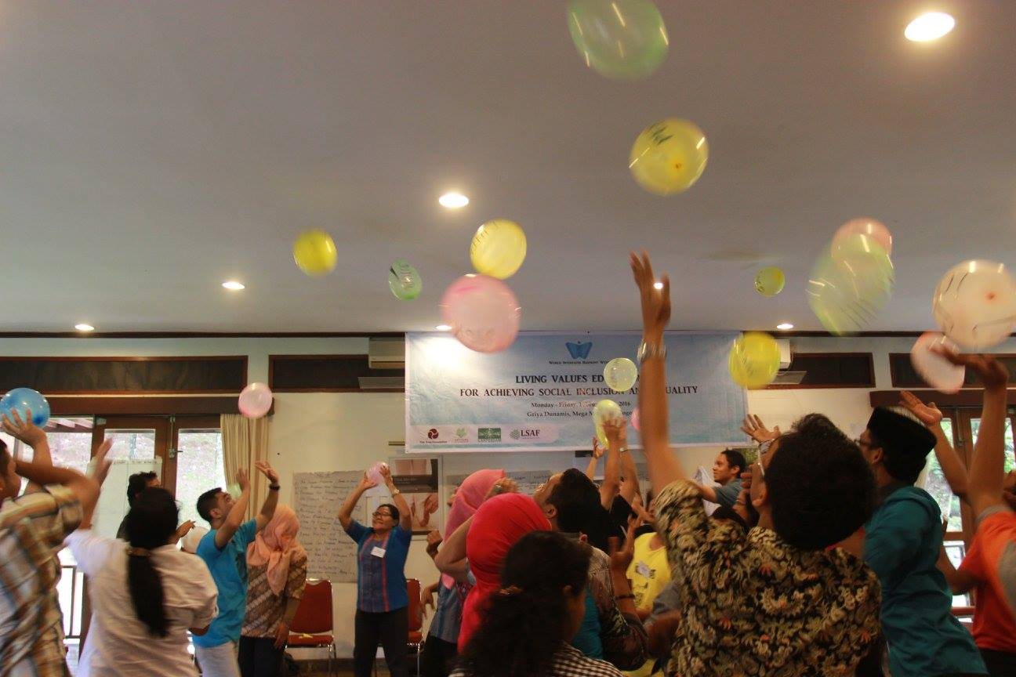

*Living Values Education for Achieving Social Inclusion and Equality (LVE for SIE) Workshop Activity*

**5. BOOK LAUNCHING**

**“THE CULTUR OF INTERFAITH HARMONY IN INDONESIAN ISLAM”**

Jakarta, February 2, 2016; Bandung, February 17, 2016; and Yogyakarta February 27, 2016.

To celebrate World Interfaith Harmony Week, The Asia Foundation has especially produced a book “The Culture of Interfaith Harmony Week in Indonesian Islam” (please attached). This book (presents the concept of) shows the contribution of Islam and other religions in Indonesia in building religious harmony together too illustrate the reality of this interfaith harmony in Indonesia, photos are added showing Muslims, being the majority religion, in activities with those of other religions in Indonesia. The result shown is a culture of tolerance and peace in this country. These photos were taken in 28 cities in Indonesia – in Medan, Bukit Tinggi, Padang Panjang, Padang,Banten, Jakarta, Bogor, Sumedang, Indramayu, Cirebon, Kendal, Semarang, Magelang, Yogyakarta, Solo, Gresik, Surabaya, Sumenep, Jombang, Ponorogo, Pontianak, Banjarmasin, Martapura, Bontang Kuala, Makassar, Bali, Lombok, Flores.

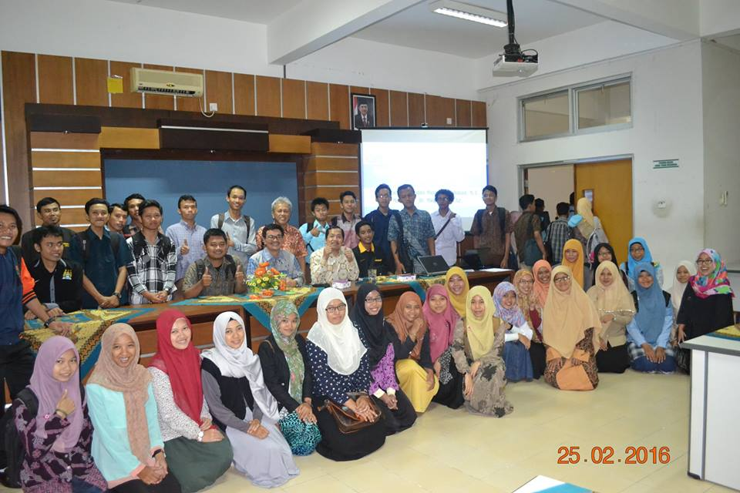

*Session after book discussion at State Islamic*

*University, Yogyakarta*

This book has been discussed recently in the following campuses – On February 2, 2016, at Driyarkara (Catholic) School of Philosophy, Jakarta, on February, 17, 2016, at the State Islamic University in Bandung, West Java, and on February 27, 2016, at the State Islamic University of Yogyakarta, Central Java. And it will continue to be presented and discussed at the vast network of 54 campuses of the State Islamic Universities, throughout Indonesia. About the book, please find attached: WIHW book – part 1 and part 2.

**6. YOGA FOR TOLERANCE**

Bogor, February 2 to 5, 2016; Jakarta, 6 and 21 February 2016

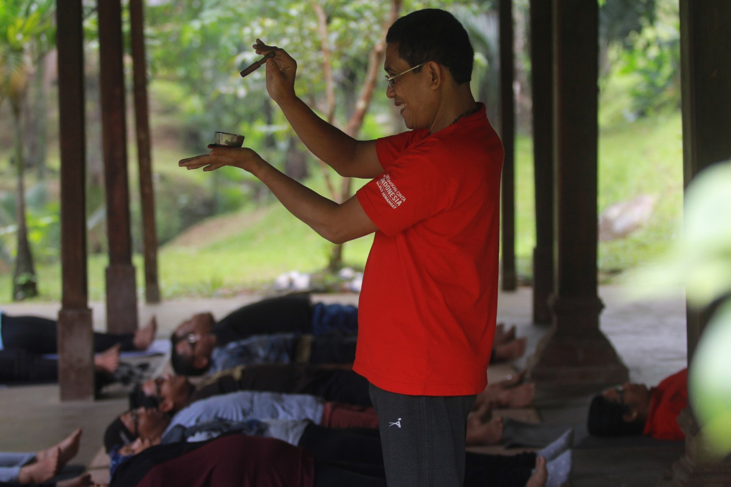

*Practicing mindfulness at Yoga activity for tolerance*

"Yoga is not just asanas". That's the motto Yudhi Widdyantoro, a leading yoga teacher in Jakarta, who 2-5 February 2016 lead a celebrations of World Interfaith Harmony Week in Bogor with the theme "Yoga for Tolerance". Human rights activists from 21 field social inclusion programsfollowed this yoga activity.The Asia Foundation in cooperation with NU LAKPESDAM and Satunama Foundation, Yogyakarta sponsored the program. The participants came from Banda Aceh, Medan, Jakarta, Cimahi, Semarang, Cilacap, Yogyakarta, Surabaya, Mataram, Tambolaka and Waingapu, Sampit and Makassar.

Yoga is derived from the word "yug" which means ‘oneness’. Yoga will develop integrated personalities that will produce a society of harmony. Yudhi, who founded theHappy Yoga Community, held "Happy Yoga" activities in Soerapatti Park, Menteng, Jakarta every Saturday morning, stressed that yoga is universal, not boxed into one way of thinking or acting or style.. Therefore, yoga is a means to develop an open and tolerant society, and is a good foundation to overcome fanaticaltendencies and closed interfaith relations.

As part of this WIHW activity, Yudi was interviewed on Bahana radio 101.8 FM, Sunday, February 7, 2016, 13:00. On Sunday, February 21, 2016, the Happy Yoga Community also will practice interfaith Yoga in Soerapatti Park, with the theme "interfaith harmony, " as part WIHW activity in 2016.

**7. CULTURAL FESTIVAL OF RELIGIONS**

Madania School, Bogor, February 4, 2016

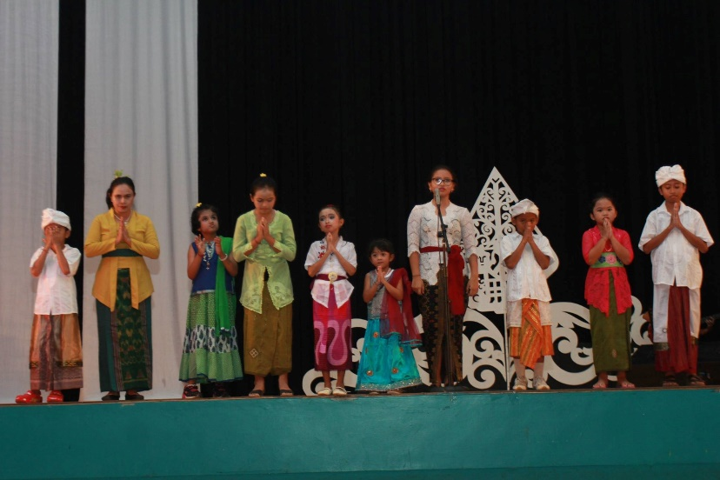

*Cultural Religious Festival at Madania School is expected to be a model of tolerant education for schools in Indonesia*

On February 4, 2016 The Asia Foundation in collaboration with the Madania School, held a Festival of Culture of Religions. The festival familiarized Madania students with interfaith relations. The students are 83% Muslim, and 17% Catholic, Protestant, Jehovah's Witnesses, Hindus, and Buddhists. This school successfully passed the critical controversial period, when it decided to develop a school with the spirit of Islam that is open and progressive. The fruit is a well-established inclusive school. One sign is its ability to hold this event in the cultural festival of religions, in which all 800 students deliberately get a chance to learn about other religions. With the cultural festival activity of these religions the students are expected to grow into tolerant religious students, full openness towards other faiths. Madania’s Festival is expected to be a model of tolerant education for schools in Indonesia which now seems increasingly intolerant and not open to other religions.

**8. MORNING EXERCISE FOR LIVING TOGETHER IN HARMONY**

Jakarta, February 7, 2016.

The Asia foundation collaborated with Aliansi Bhinneka Tunggal Ika celebrated World Interfaith Harmony Week on Car-Free Day (a Government weekly event in Jakarta). This celebrations was done in the form of morning exercises together with traditional well-known Indonesian dances like “Tor-Tor”, “Ja’I”, and “Gemu FaMiRe”. Besides these, the celebrations was also filled with photo booths on themes of Tolerance and Harmony between religious faiths - part also of a social media campaign.

The theme of this Program was to emphasize living together in harmony. It invited the people of Jakarta of all faiths to build a life of peace and tolerance, as well as increasing understanding and cooperation amongst them, remembering that Jakarta is a miniature form of the whole variety of Indonesia in its culture, ethnicity and religions. Through the unity of people having different social, ethnic and religious backgrounds, it is hoped to be able to create better relationships and more open attitudes and trust amongst all. This activity will be carried out once a month, as an effort to continue to build a Jakarta free from violence, discrimination and intolerance.

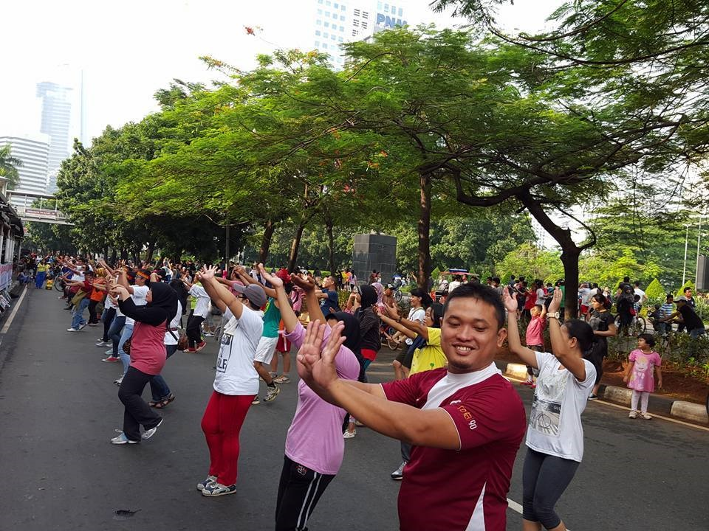

**9. DEBATE ON INTERFAITH TOLERANCE**

Bogor, February 2, 2016; Jakarta, February 9, 2016; Berastagi, Karo (North Sumatera), February 11, 2016; Also Medan, February 13, 2016; Mataram, February 13, 2016; and Bandung, February 25, 2016

In order to strengthen the perspectives of the younger generation on the aspect of interfaith, in 3 places – Jakarta, Berastagi, Medan, Mataram, and Bandung – a total of 150 youth delved into many aspects of Interfaith. This debate aimed at increasing religious understanding amongst the participants, to take them from “exclusive” to “inclusive”, so that tolerance could develop better amongst the younger generation. The debate was facilitated by Budhy Munawar-Rahman of The Asia Foundation, who then strengthened the debate with discussion on human rights, especially from the perspective of religious freedom and pluralism.

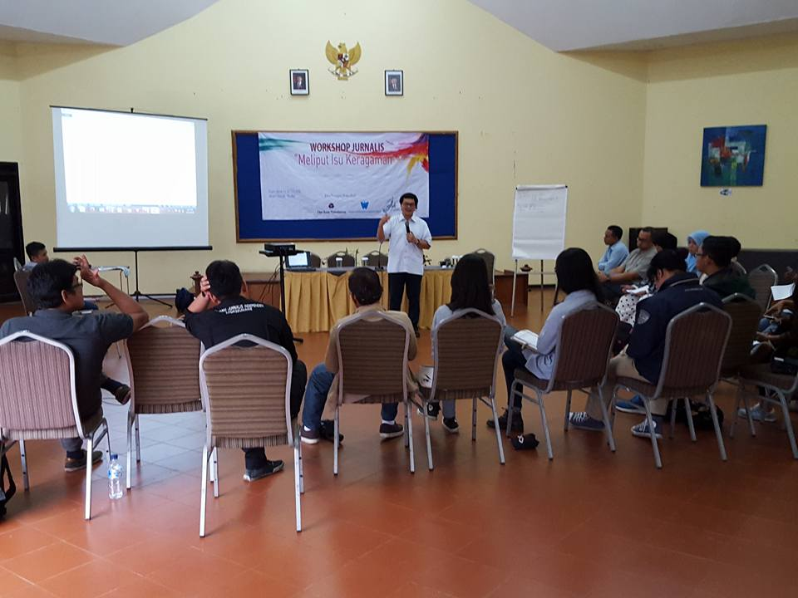

Material used to provoke understanding of inclusivism were questions from the documentary “Dear Believer”.

<https://www.youtube.com/watch?v=xl_TrvIIcBY>.

Below is the text used in the discussion from that documentary:

Dear Believer,

Have you ever stopped to consider why you believe what you believe?

Have you ever thought about why you chose the religion you chose?

Why do you believe in Jesus Christ as the only means to eternal salvation, and not in karma or reincarnation?

Why do you believe that Allah is the one true God and Mohammed is His prophet, and not in the four noble truths of the Buddha?

Why do you hold to the Torah as the only revealed word of God and not the Bhagavad Gita?

Dear Believer,

Do you ever wonder why your Heaven resembles a utopian Earth and is composed of the same base elements found right here on this planet?

Do you ever wonder why your deity governs within a power structure that resembles that of the specific time and place in which your holy text was written?

Do you ever wonder why your God looks just like you, or the animals with whom you share the planet?

Dear Believer,

Is the faith you practice the dominant one within your culture?

Do you not find it at least a little suspicious that the overwhelming majority of all religious believers adopt the religion of the society into which they were born, yet remain convinced they’ve lucked out (or been divinely admitted) into the one, true faith?

Does it not make you at least somewhat apprehensive that almost every person of faith chooses belief not because of its virtues, supporting evidence, moral codes or expression of worship, but rather because it was what they were born into?

Why, out of the abundance of faith choices available, does almost every believer on the planet choose the faith that’s within arm’s reach?

Are you a Christian because you were born in America or Europe, a Muslim because you were born in Saudi Arabia or Indonesia, a Buddhist because you were born in Japan or China, a Hindu because you were born in India?

Can it be that faith is, in almost every case, just an accident of geography?

Do you sincerely believe that had you been born in another country, you’d undoubtedly still be practicing the same faith you now embrace?

Dear Believer,

Is the faith you practice that of your parents and their parents before them?

Is it the first to which you were exposed?

Did you know that nearly all religious devotees end up believing what they were taught to believe by their parents?

Why is it that we scoff at the idea of labeling a young person a Republican Child or a Marxist Child or a Keynesian Child, understanding he or she lacks the intellectual discrimination, life experience and wisdom to make such a complicated and nuanced decision, but do not raise so much as an eyebrow when a youngster is referred to as a Christian Child, surely a choice no less complex?

Could it be that there’s no such thing as a Muslim Child, just a child of Muslim parents?

Dear Believer,

You are supremely confident in your faith.

You KNOW it is the right one and all others wrong.

You are literally willing to bet your eternal soul on that fact.

And yet, have you ever stopped to consider that there are two-dozen major religions and literally thousands of different faiths practiced on this planet?

Did you know that within Christianity alone, there are more than 45,000 different denominations, each claiming to understand ultimate truth better than the others?

Do you realize that each member of every faith practiced is just as devout, just as sincere, and their conviction every bit as sure as yours?

Did you know they too read infallible holy texts, have air-tight apologetics, have experienced miracles, feel God’s presence, sense His still small voice, obediently follow His perfect will for their lives, love Him indescribably, and can defend their belief with the same fervency as you do yours?

And yet, since every religion is mutually exclusive and contradicts the other in matters both large and small, they cannot all be right…right?

You know—you just KNOW—your faith is the exception—and yet, if every member of every faith feels as you do, what are the odds that you’re right?

Dear Believer,

I’ve often been told that my unbelief is a guarantee of missing out on heaven an ending up in hell.

But whose heaven?

Whose hell?

I’ve often been told that I should, just to be safe, accept God—after all, what have I to lose?

But whose God?

Given so many options, aren’t I more likely to chose incorrectly?

Might not I be better off wagering on no God rather than on the wrong God?

You put it to me, “What if you’re wrong?” But what if you’re wrong?

What if, rather than Jehovah, Allah is the one true God? Or Shiva? Or Wooten? Or some God you’ve never even heard of?

The truth is, you already know what it’s like to be an atheist in regard to every other faith but your own.

It’s clear to you that adherents to other faiths are mistaken, deluded or deceived.

But they think the same of you.

The way you view them is exactly the way they view you.

Every devout Hindu has embraced his faith for the exact same reasons you have embraced yours, yet you do not find his reasons compelling, nor do you lose sleep at night fearing that if you die you’ll wake up in his hell.

Given this, is it so hard to see why some of us just take our atheism one God further?

Dear Believer,

I wonder if religions just aren’t ancient constructs in which early humans attempted to both explain and control the chaotic world around them.

Though irrational in content, their emergence certainly isn’t.

We do not blame our ancestors for inventing religion.

There is no shame in stumbling when you are blind, or failing to properly construct a puzzle in the dark.

But we no longer live in the dark.

Science is ablaze in our world and illuminates our way, dissipating shadows and exposing even the deepest of crevices.

We no longer live in the cave.

We have crossed the valley, scaled the mountains and have begun to make out the magnificent vista on the other side.

We no longer require comforting stories to make us feel safe or valued.

Is it not time that our beliefs match our discoveries?

Is it not time that our ideas reflect our new perspective?

There is equal, if not greater, awe in reality than there is in fantasy.

Perhaps it is time to stop telling ourselves that we are the reason the universe was made; that our culture is somehow better than other cultures; that our tribe was chose over all other tribes.

It is time to learn how the universe really is, even if that deflates our conceits, wounds our pride, humbles our point of view, and forces us to admit that we do not have all the answers.

Believer, if you honestly value the truth above all things—as you claim—as I truly know you do—you must confront these fundamental questions.

Far better, Carl Sagan said, to embrace a hard truth, than a reassuring fable.

**10. MEDIA CAMPAIGN TO STIMULATE BALANCE REPORT**

**ON RELIGIOUS-BASED CONFLICT**

Medan, February 10, 2016

Journalists and media have a pivotal role to maintain harmony among societies. That is one of the commitments of SEJUK media visiting (in-house workshop) in the office of Tribun Medan (10/2/2016). This visiting was a part of a campaign on interfaith harmony week as a collaboration event between The Asia Foundation, the Alliance of Independent Journalists (AJI) and Journalists Association for Diversity (SEJUK).

Veryanto Sitohang, an activist of the Alliance of North Sumatra United (Aliansi Sumut Bersatu/ASB), said: ‘It is not enough for media to just reporting conflict among or intra-religious members, they also should move forward to promote and support harmony, particularly, in North Sumatra.’ Furthermore, based on their monitoring program on freedom of religion and belief in North Sumatra, Very added that his organization, ASB, found a lot of violation and conflict of religion and belief. However, media attention on those cases was in a minimal level. They hope that in the future, media can pay more concerns on it by bringing the peace journalism principle of their news products.

In line with that, Agoez Perdana, the chairman of AJI Medan, highlighted that the problem of journalism in North Sumatra is their lack capability to promote harmony due to their concern on reporting the event, instead of conflict. ‘We to build a common platform and cooperation between media and other civil society groups such as ASB who involve in grass root movement to support peace journalism practices,’ he said.

Meanwhile, Eti Wahyuni, an editor of Tribun Medan, analyzed the role of sensationalism in media stimulated unbalanced reports on social conflicts. Media, she added, have a chance to be a mediator for mitigating social tensions. “Controlling from all of the layers in media, from journalist to editor, should prioritize sensitive issues particularly related to diversity,’ she added. Moreover, she also suggested that AJI Medan takes a role as a learning center to rise their member’s capacity on diversity and peace journalism

A speaker from SEJUK, Andy Budiman, highlighted the key principle of journalism to be the main guide for journalists, especially when they work on diversity issues. Journalists, he said, should use the universal principles of Constitution or human rights, instead of religious belief. The co-founder of KBR 68-H and former journalist of Deutsche Welle also reminded about how resource person selection has an important role in shaping report whether to create harmony or tension. “Journalists have a main role as public enlighten actors to manage diversity. Therefore, do not ever give a chance for haters to broadcast their propaganda message,’ he said.

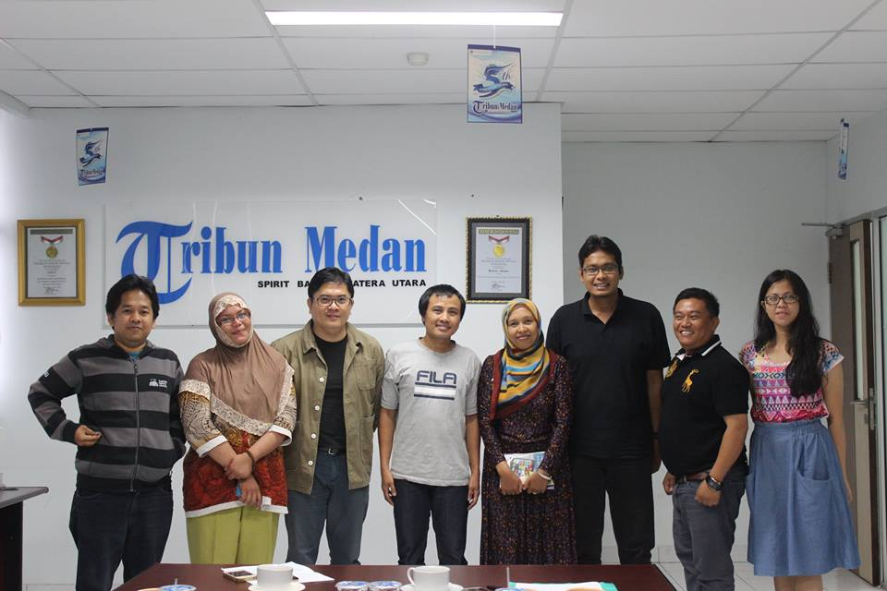

*SEJUK Visiting “Tribun Medan”*

**11. JOURNALISTS WORKSHOP FOR CREATING INTERFAITH HARMONY**

Brastagi, Karo, February 11 to 12, 2016

The Asia Foundation and The Journalists Association for Diversity (SEJUK) involves in a series of celebrationss and campaigns on the World Interfaith Harmony Week (WIHW) 2016. In the second week of February, SEJUK campaigned the interfaith harmony spirit among mass media and journalists by conducting journalist Workshop on “Reporting Diversity Issue was the second activity in the series of WIHW campaigns in various countries in the first week of February in an effort to create common ground pushing interfaith harmony and peaceful thoughts and actions.

The Asia Foundation and The Journalists Association for Diversity (SEJUK) involves in a series of celebrationss and campaigns on the World Interfaith Harmony Week (WIHW) 2016. In the second week of February, SEJUK campaigned the interfaith harmony spirit among mass media and journalists by conducting two workshops. The workshops, which cooperated with The Alliance of Independent Journalists (AJI) Medan chapter, targeted mass media and journalists in North Sumatra and Aceh. First activity was In-House Workshop held in Tribun Medan daily on Feb. 10. Tribun Medan is part of Kompas Gramedia national media group and the largest in term of circulation in the province. Besides publishing printed, the daily also issues online edition.

Through the in-house workshop, SEJUK supported Tribun Medan to develop news that respect differences and sensitive towards victims of religious based violence and discrimination and violence. Here is the information on the activity:

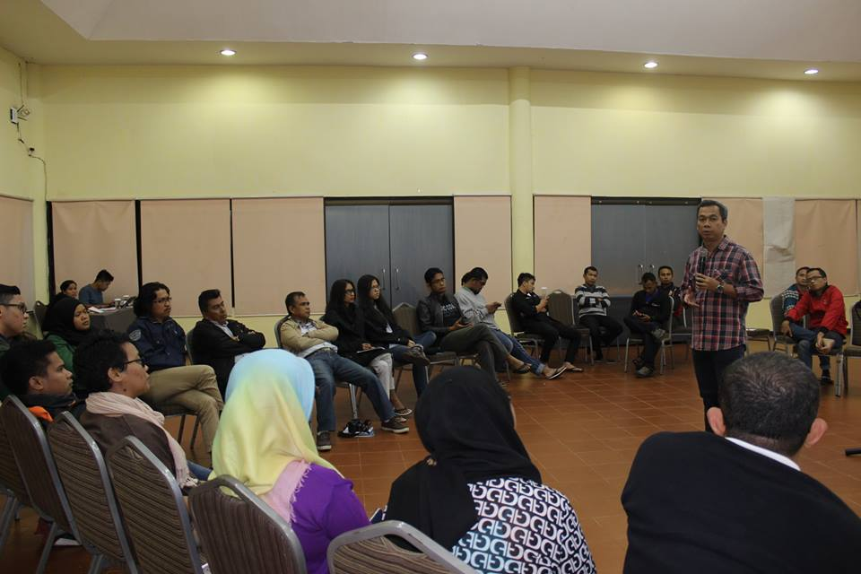

*Journalist workshop on reporting diversity issue*

Journalist Workshop on “Reporting Diversity Issue was the second activity in the series of WIHW campaigns in various countries in the first week of February in an effort to create common ground pushing interfaith harmony and peaceful thoughts and actions.

The workshop was conducted at Sibayak Hotel Berastagi, North Sumatra on Feb. 12 -13 and attended by journalists from the North Sumatera province (16 journalists) and Aceh (11 journalists) who working for printed, broadcast and online media. Resource person in the workshop Dr. Budy Munawar-Rachman called on Journalists to avoid exclusivity and develop inclusivity over differences on religions and beliefs. The journalists should determine that vulnerable groups, such as women, children and religious minorities could get protection from the state.

Relating to the first resource person, Daniel Awigra of the Human Rights Working Group (HRWG) discussed a topic on “Human Rights and Religious Freedom and Believe” and emphasized on the importance for journalists and media to uphold criticism. Awigra asked the participants to increase their role to watch and warn the government on its obligation to respect, protect and fulfill the rights and freedom of its citizens, including religious freedom.

Meanwhile, Yunianti Chuzaifah of the National Commission on Anti-Violence against Women, revealed facts on how conflicts and religious based violence have impacted mostly on women and children. The chairwoman of the commission for 2010-2014 term urged mass media and journalists to listen to the voices of the victims. “Media should use diction or language which do not stigmatize, harassing, as well as growing intolerance and discrimination,” she added.

Another resource person in the workshop which was supported by The Asia Foundation and the Tifa foundation, Usman Kansong, the news director of Media Indonesia daily, assured journalists of North Sumatra and Aceh to be able to uphold journalistic principles that respect diversity in the society, especially religions and beliefs. Meanwhile, Veryyanto Sitohang, pluralism activist, who advocate victims of prosecution of churches in Singkil, Aceh, revealed facts, chronology and update information on the case. Usman and Veriyanto similarly mapped and indentified diversity facts in North Sumatra and Aceh, hoping that journalists to take more concern to create interfaith harmony in their journalistic works.

In the last session, Ade Armando, communication expert from the University of Indonesia, explained the ethical and operational principles in reporting diversity issues. Ade viewed that conflicts and violations on religious freedom was a serious matter, instead of just usual news. “Reporting conflicts and human rights violations is not enough with only applying cover both sides principle, but journalists should select resource persons that do not justify the continuation of violence and should give more space to resource persons who support peace,” he said.

**12. CELEBRATE 3 YEARS PEACE EDUCATION PROGRAM IN AMBON/MALUKU**

Ambon and Kei Islands, February 13 to 14, 2016

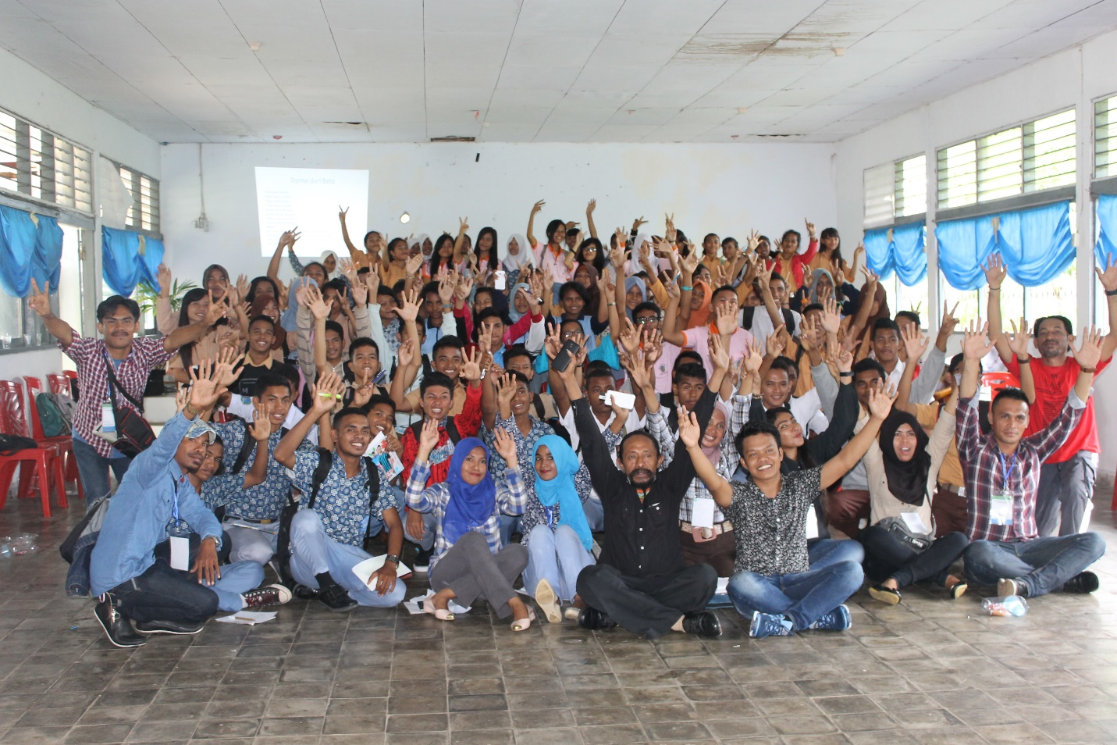

In the year 1999, conflict between the Islamic and Christian communities broke out in the Maluku Islands – a province in eastern Indonesia, consisting of 1,450 islands. One of the most tragic consequences of conflict experienced is the division between the Muslim and Christian communities. As a result, in Maluku, especially in Ambon and the surrounding islands, villages are divided into being Muslim and Christian villages. Unfortunately, even schools are separated in this way, despite the fact that they belong to the Government. Almost all State Schools as well as the teachers and students are labelled and divided as “Islam” and “Christian”. The outcome of this division is a strained or almost no relationship between the Muslim and Christian students and teachers for almost fifteen years. This is truly sad, especially because, since the colonial days of the Dutch, the people of the islands of Maluku were known to be multi-religious and multi-cultural where interfaith harmony between villages was part of daily life, and well-known to the whole world.

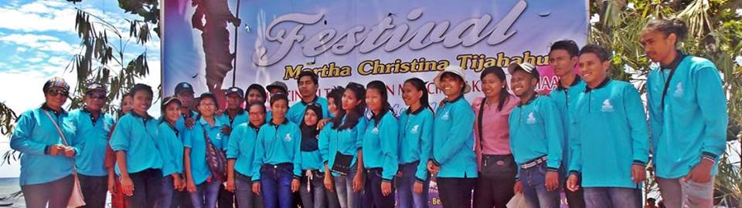

For the last three years, The Asia Foundation has been working for Peace building with the Ambon Reconciliation and Mediation Center of the State Institute of Islamic Studies (ARMC IAIN), and Parakletos Foundation, both in Ambon. The Programs have been focusing on creating teachers who can become agents of peace, religious tolerance, and harmony in schools. We call them “peace makers”. There are more than forty nine teachers from both religions from around thirty schools who have followed programs in peace education with all kinds of knowledge and skills needed – like multiculturalism, interfaith dialogue, values and peace education and “live in” (i.e. experiencing living in the homes and communities of people whose religions are other than their own). After three years of conducting these programs, The Asia Foundation has taken the initiative to work together with ARMC IAIN Ambon to gather again these forty nine “peace-maker” teachers to further ideas of interfaith, tolerance and harmony through a program for Tolerance and Peace Education conducted in World Interfaith Harmony Week with the theme “Love of God or the Good and Love of the Neighbor”. Using these two themes the document “A Common Word” is the focus of the festival and workshop of World Interfaith Harmony Week in the context of building peace on Ambon islands.

**13. DISCUSSION ON “A COMMON WORD” DOCUMENT**

**FOR MUSLIM – CHRISTIAN INTERFAITH DIALOGUE**

Jakarta, February 15 and 23, 2016.



Love of God or the Good and Love of the Neighbor as fundamental values for peace, is the common ground for interreligious harmony in Indonesia, especially in Ambon. These two important “A Common Word” values were clarified in the two discussion at Driyarkara School of Philosophy, Jakarta on February15 and 23, 2016 led by Dr. Budhy Munawar-Rachman; and at State Islamic Institute in Jambi on March 5, 2016 led by Dr. Muqowim. Discussion concretely by the fundamental human rights values and principle as participation, equality, transparency, rule of laws, preferential option for the poor and vulnerable group, and linkage to others human rights framework.

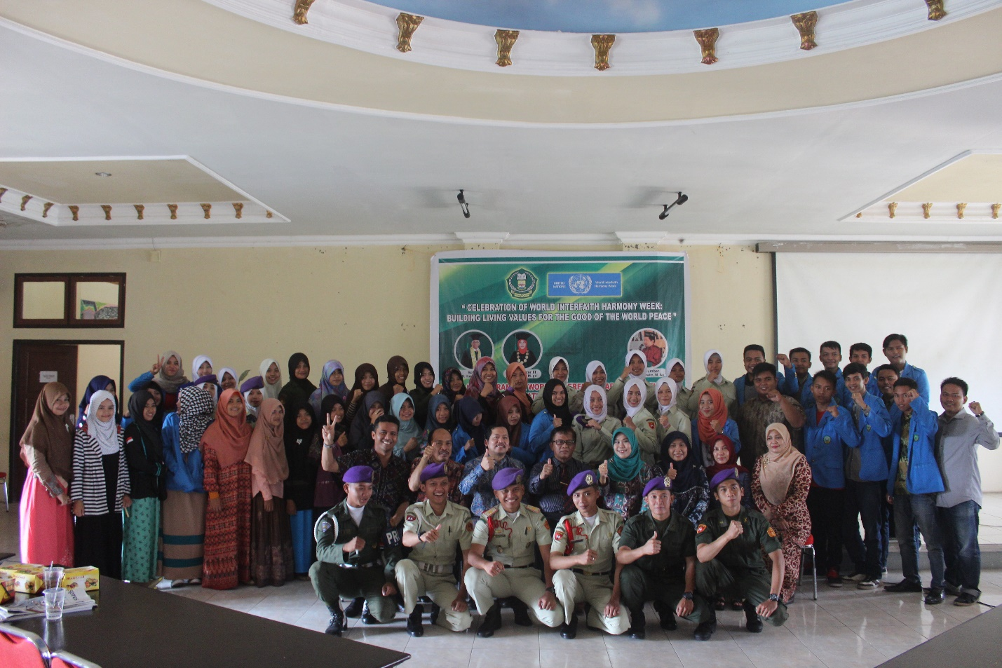

*Living Values Activities with Students from State Islamic Institute in Jambi*

**14. LAUNCHING OF THE RUMI INSTITUTE**

**Discussion on Rumi and His Ideas on Interfaith Dialogue**

Jakarta, February 21, 2016.

Launching of “the Rumi Institute” while celebrating World Interfaith Harmony Week 2016. Discussion was held on the meeting point between Rumi’s vision and that of different religions.

Rumi, whose full name was – Maulana Jalaluddin Rumi Muhammad bin Hasin al-Khattabi l-Bakhri, was born in Balkh (now Afganisthan) on September 30, 1207. Eastern (Oriental) philosophers from the West acknowledge Rumi as the greatest poet of all mystical poets who ever lived in Islamic civilization (times). And Sufis of the Middle East admit that his works are considered as a second Al-Qur’an because of their depth of meaning. Jalaluddin Rumi is the founder of “Mevlevi Order” in Turkey. Before the second World War, followers of Tarekat Mevlevi, spread the whole Balkan area, Africa and Asia, totaled 100,000 . There isn’t a poet in all history – not even Shakespeare or Dante – who literally had such an effect on civilization as did Rumi. And there is no poetry which is capable of rousing such mystical ecstasy and happiness in its readers as can the poetry written by Rumi.

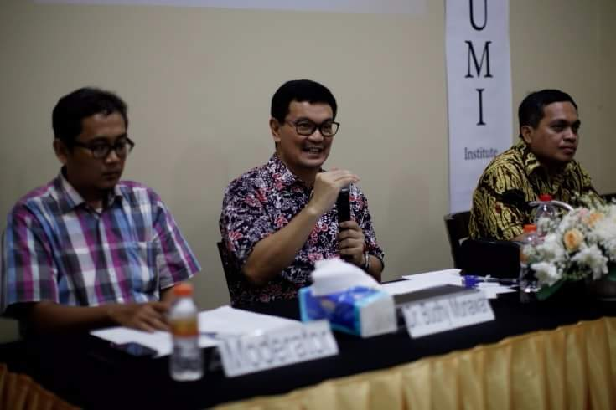

Rumi was a personality amongst very few personalities on earth who had such universal vision – except for Sri Ramakrishna, Sri Aurobindo, and Kabir – who came from religion and who colored life as well as human culture with the greatness of love. Then, at this time, when the world needs inspiration to love this world now quite threatened with destruction , when we have already forgotten our original divine selves (identity), our happiness and human responsibility, Rumi is present as a guide and a witness of the greatness of God as well as the greatness of the human soul. Rumi is present to carry or show the essence of religions, that is, of universal love. For Rumi, love rises above all religious dogma, love embraces the whole of creation. Love is the essence, truth or reality of all religions which unites human beings in the light of the Divine (or of God).

**15. LIVING VALUES EDUCATION FOR PARENTS**

Jakarta, February 23, March 1 to 2, 2016

In today' s world, we are constantly exposed to many  forms of violence even those which victimized the lives of our children. These various issues of violence are fast becoming headline news and has surfaced as a common problem in society. It seems  that the world of today is no longer a conducive place to raising  a child physically, mentally and emotionally. The world as we know, it has transformed into a perlious place for children. Parents who are at the  forefront and at the gateway to a child's education are often exhausted in search of effective method of parenting. Consequently, it is common that parents seek  the best education available and expect their children to be raised  and become characters with high morals and strong values.

And the foundation of any form of education can only start from homes and within families where parents are active participants. Ironically, most parents are neither prepared nor equipped to carry out the process of parenting. Meanwhile from the perspective of values education, “values are not taught but caught". In this case, children characters are direct by products of relationships carried between child and its parents and surrounding.

In the context of child rearing in Indonesia, religious studies are often used as a primary reference to an end by many parents. Somehow, since Indonesia is a pluralistic nation, the role of parents become extremely important in imposing universal values and inclusive  to diversity of culture in Indonesia. Religious differences have lately become the source of violence in the country. Religious studies should lead children to act by example and build  a sense of comradery based on three  key humanitarian values which are Respect, Love and Peace. Through these three values, The Asia Foundation, Yayasan Indonesia Bahagia in cooperation  with Association for Living Values Education (ALIVE) Indonesia participated in the commemoration of World Interfaith Harmony Week by organizing a series of workshop of Living Values Education for Parents. The workshop which took  on the theme of "Living Values Education For Developing Values to Make a Better World", conducted by Dr Budhy Munawar Rachman , Dra. Rani Anggraeni Dewi MA, Rifah Zainani and Mochammad Ziaulhaq, on February 23, March 1 to 2 2016 for 30 participants. The objective of the workshop is to provide a perspective of the importance of values awareness and equip participants skills for nurturing their children  with values-based parenting. The workshop is based on experiential learning and filled with dynamic  activities and  joyful.

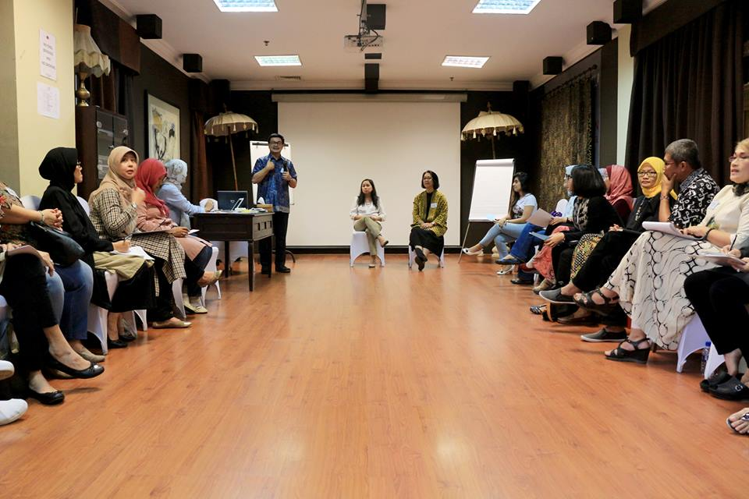

*Values-based workshop parenting*

**15. WORLD MEDITATION HOUR**

Jakarta, February 21, 2016

To complete celebrations of World Interfaith Harmony Week, the Brahma Kumaris World Spiritual University, Jakarta, held World Meditation Hour (WMH) on 21 February, 2016, using the method of Raja Yoga. Meditation is a journey inwards, one of self-discovery or, in fact, re-discovery. Meditation is time taken for quiet reflection and silence, away from the hustle and bustle of daily living. Taking time out enables us to come back to a centered place of being. In our modern world, where the pace of life is growing ever faster, we are losing touch with our original inner peace and power. Raja Yoga meditation is a meditation without rituals or mantras and can be practiced anywhere, at any time, with open eyes - as it is an awareness of who we truly are and an awareness of God. Meditation is a state of being, where spiritual empowerment begins. Spiritual awareness gives us the power to choose good and positive thoughts over those which are negative and wasteful. We start to respond to situations, rather than just reacting to them. We begin feel deep inner peace and harmony, creating better, happier and healthier relationships, changing our lives (and others) for the better.

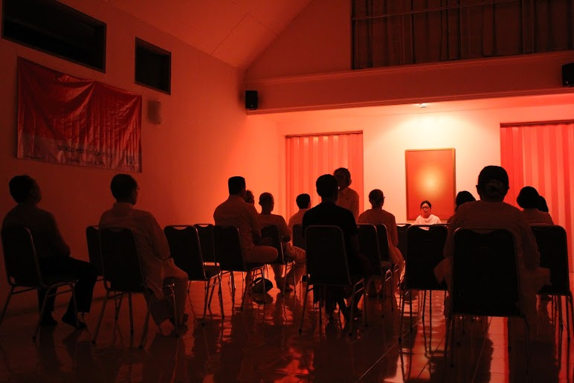

*World Meditation Hour*

**16. INTER-FAITH DIALOGUE MEETINGS**

South Tangerang, February 21; Bandung, February 25 and 29; Malang, March 2; dan Kupang, March 5, 2016

To celebrate World Interfaith Harmony Week 2016, The Asia Foundation (TAF) in collaboration with the International Conference on Islam and Peace (ICIP), on February 27, 2016 held a community interfaith dialogue on the Sikh religion in Ciputat, South Tangerang. On March 2, 2016 in collaboration with the Muhammadiyah University, Malang (UMM), TAF held a dialogue on Islam and Buddhism in the Buddhist community, Batu, Malang; and on February 25, 27, March 5, 2016, in collaboration with the Bandung State Islamic University and the Artha Wiyata Christian University (AKAW), in Kupang, TAF held an interfaith dialogue series on Islam and Christianity.

Inter-faith dialogue is a challenge for all religions, especially the monotheistic religions Judaism, Christianity and Islam, which have been "exclusive" for hundreds of years. Problems of interfaith dialogue have now become an integral part of reform movements of the world religions. The reality and complexity of today's world has led religious thinkers seriously to reassess their understanding of God's will and the teachings of Scripture regarding other religions. Many theologians today conclude that theology can not continue to be formulated separately from other religions. Today increasingly it is recognized that to be religious is to be intereligious, and that the real development of the theology of religions in the future will be a direct result of a serious dialogue with other religions.

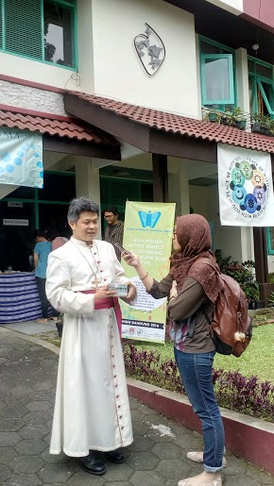

*Interview with Bandung Bishop at WIHW Celebration at RSCJ, Bandung*

In an effort to restore contacts broken off around world, religions have accepted dialogue with the community and other world religions as a basic. Most of this change of attitude is caused by the development of the pluralistic nature of the world, brought about by globalization, particularly by the development of information and communication technology. Earlier, religions wanted to share truth with others. This new situation forced religions to switch from an all-knowing attitude of "Let us teach you" to an approach of listening to the wisdom and the problems of other religions. The new dialogic attitude led to important changes in the doctrines of traditional religions tegarding other faiths, becoming more inclusive and plural and open to new perspectives. The understanding of pluralism, tolerance, and interfaith dialogue is only possible when the adherents of every religion are able to get rid of narrow exclusive views and tryto accept the assumptions of others and "see" the universe throughothers’ concepts. If this effort develops, a mutual recognition will arise where all world religions accept each other as fellow mountaineers, covered with clouds, seeking the peak which is covered in God’s invisible embrace.

To benefit from understanding the riches of other religious tradtions calls for inclusive and pluralistic attitudes. So interfaith dialogue requires two main things: first, an new awareness of the principal concerns of the faith of others; second, cooperation to solve humanitarian problems together. This type of dialogue leads to an authentic understanding of the faith of others, not underestimating, let alone distorting, their noble beliefs. An earnest dialogue is a step toward mutual enrichment and a deeper appreciation of others’ religion and one’s own.

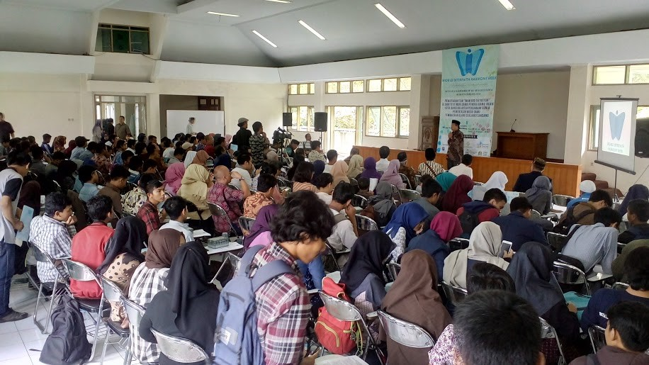

*Interfaith Dialogue Meeting at State Islamic University, Bandung*

**Here below is a summary of all activities of WIHW 2016:**

|  |  |  |  |  |
| --- | --- | --- | --- | --- |
| **No** | **WIHW Activity** | **Place (City)** | **Date** | **Amount of participants** |
|  |  |  |  |  |
| 1. | Religion Expo and Youth Interfaith Festival | Banjarmasin | January 24-25, 2016 | 2,000 |
| 2. | Book Discussion on Misbach Tamrin | Banjarmasin | January 30, 2016 | 100 |
| 3. | Psycho-Drama Workshop | Ubud, Bali | January 29 to 30 2016 | 15 |
| 4. | Living Values Education for Achieving Social Inclusion and Equality (LVE for SIE) Workshop and Retreat. | Bogor  Jambi | February 1 to 5, 2016  March 5, 2016 | 35  100 |
|  | Living Values Education for Achieving Social Inclusion and Equality (LVE for SIE) Activities in the field of religious minorities conflict. | Banda Aceh, Medan, Cimahi, Tasikmalaya, Kuningan, Indramayu,  Tegal, Rembang,  Semarang, Jepara, Yogyakarta, Kulonprogo, Sampang, Mataram, Bima, Tambolaka, Waingapu,  Makassar, Bulukumba. | February 6 to March 5, 2016 | 2.500 |
| 5. | Book Launch: “The Culture of Interfaith Harmony in Indonesian Islam | Jakarta, Bandung, Yogyakarta | February 2, 17, and 27, 2016 | 150 |
| 6. | Yoga for Tolerance | Bogor, Jakarta | February 1 to 6, and 21, 2016 | 100 |
| 7. | Cultural Festival of Religions | Bogor | February 4, 2016 | 800 |
| 8. | Morning Exercise for Living Together in Harmony | Jakarta | February 7, 2016 | 100 |
| 9. | Debate on Interfaith Tolerance | Jakarta, Karo, Medan, Mataram, Bandung | February 2, 9, 11, 13, 25, 2016 | 125 |
| 10. | Media Campaign to Stimulate Balance Report on Religious-Based Conflict | Medan | February 10, 2016 | 25 |
| 11. | Journalist Workshop for Creating Interfaith Harmony | Karo | February 11 to 12, 2016 | 24 |
| 12. | Celebrate 3 Years Living Values and Peace Education Program | Ambon, Kei Islands, and Jambi | February 13, 14, March 5, 2016 | 1,000 |
| 13. | Discussion on “A Common Word” Document for Muslim – Christian Interfaith Dialogue | Jakarta | February 15 and 23, 2016 | 40 |
| 14. | Inauguration of the Rumi Institute: Discussion on Rumi and His Ideas on Interfaith Dialogue | Jakarta | February 21, 2016 | 50 |
| 16. | World Meditation Hour | Jakarta | February 21, 2016 | 25 |
| 15. | Living Values Education for Parents | Jakarta | February 23, March 1 to 2, 2016 | 30 |
| 17. | Interfaith Dialogue for Religious Harmony in Indonesia | Bandung, South Tangerang, Malang, and Kupang. | February 25, 27, 29 March 2, and 5, 2016. | 1,000 |
| 16. | Making of WIHW Photos Book “The Culture of Interfaith Harmony in Indonesia Islam” | Photos were taken in 28 cities of Indonesia | February 24 to March 5, 2016. | - |

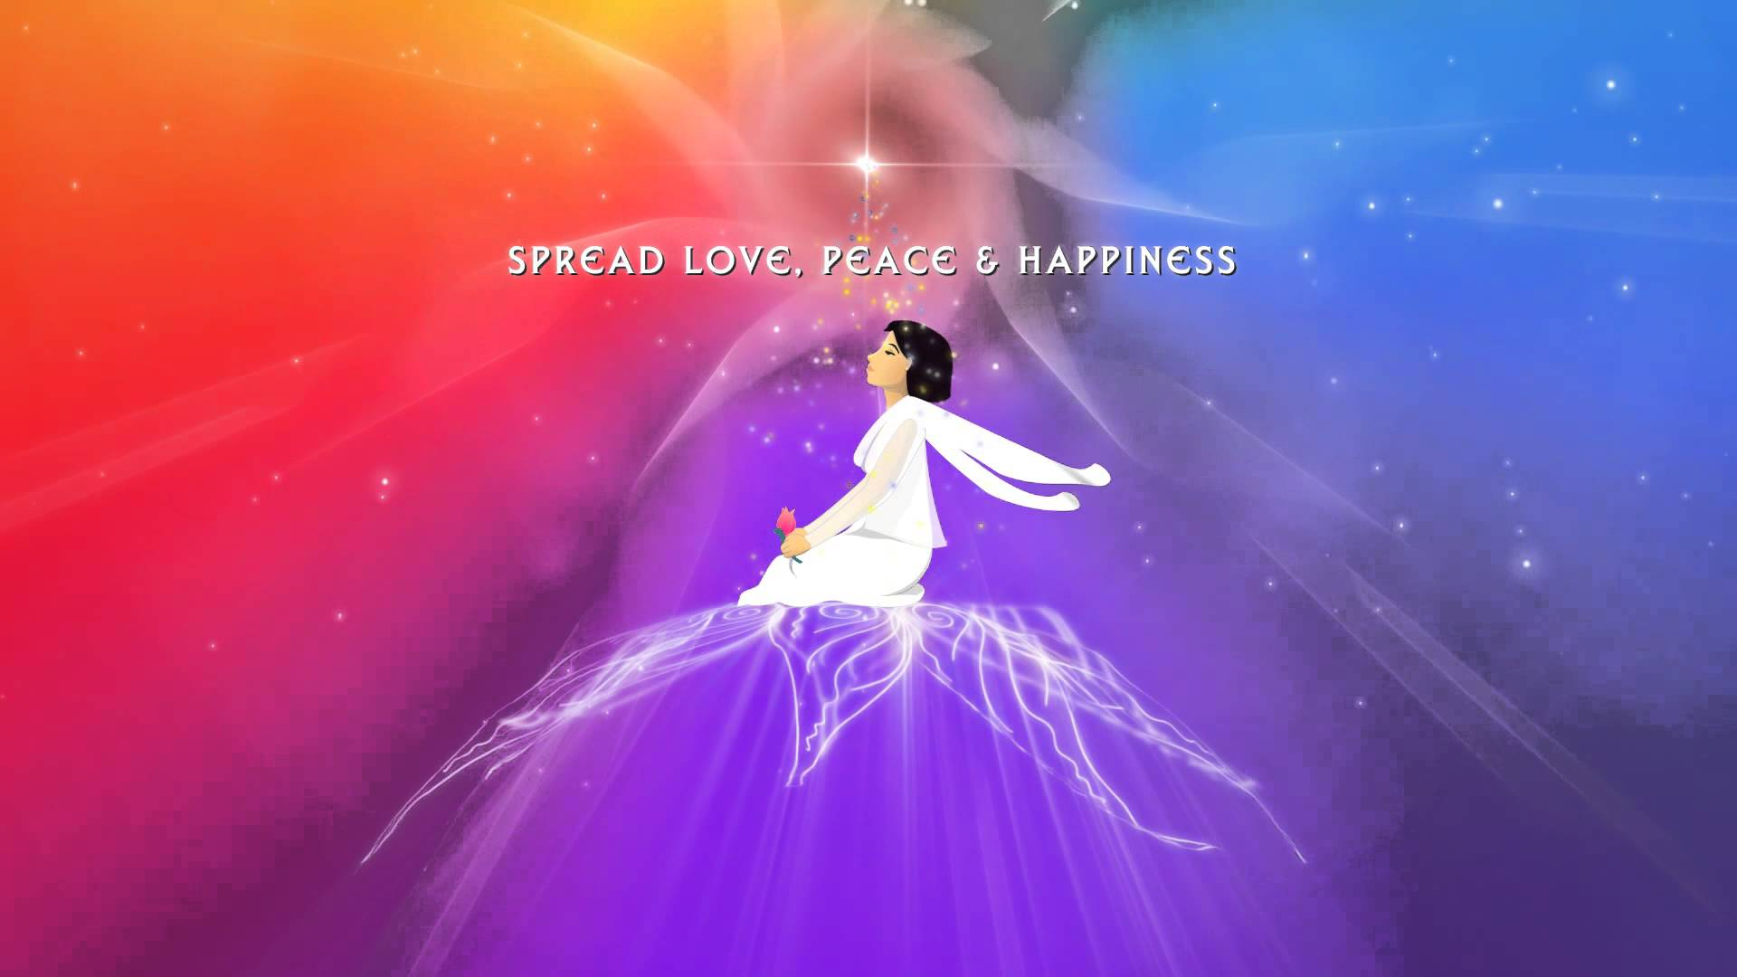



2016

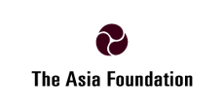

**SOME POSTERS OF THE EVENTS**

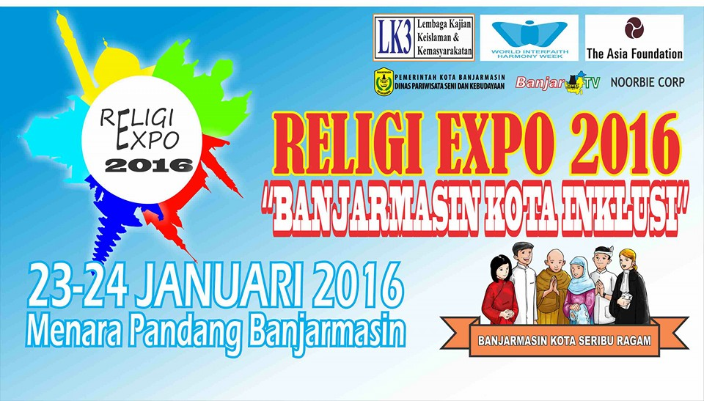

**Religion Expo**

Banjarmasin, January 24, 2016

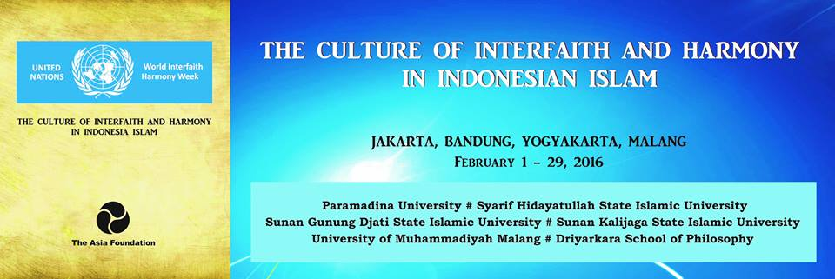

**Serial Discussion on**

**The Culture of Interfaith Harmony in Indonesian Islam**

Jakarta, Bandung, Yogyakarta, Malang

February 1 to 29, 2016

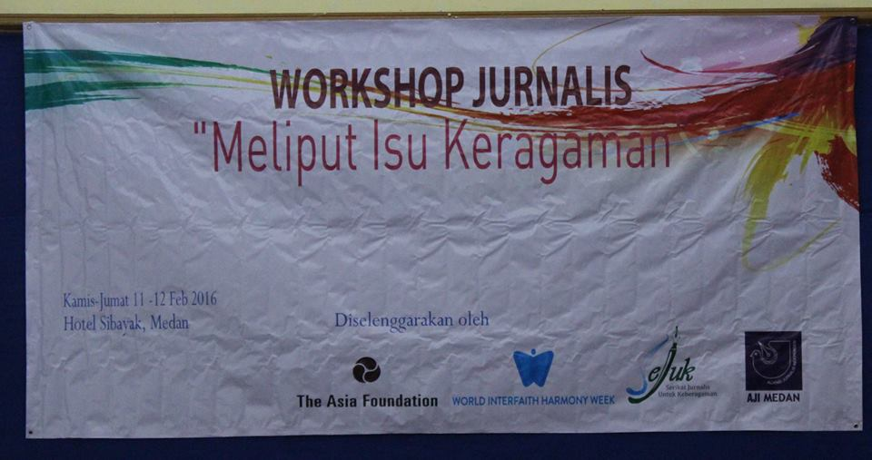

**Journalist Workshop for Religious Diversity Issues**

Berastagi, Medan, February 11 to 12, 2016

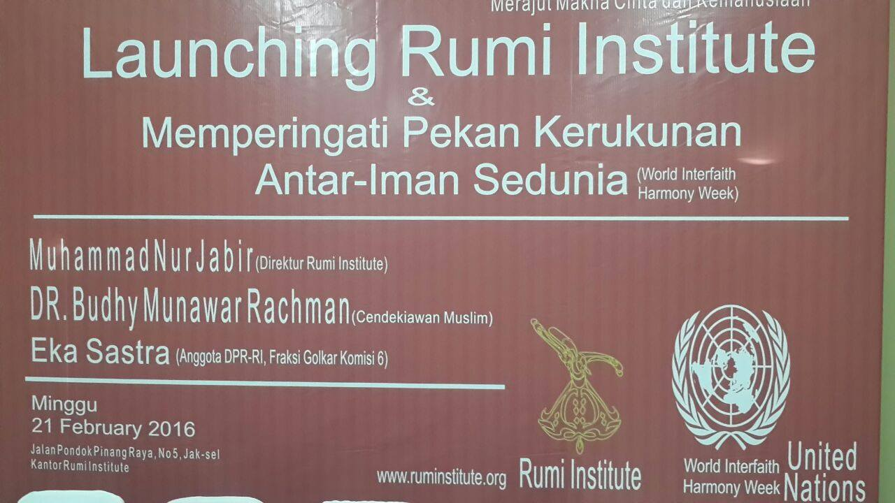

**Launching of Rumi Institute**

Jakarta, February 21, 2016

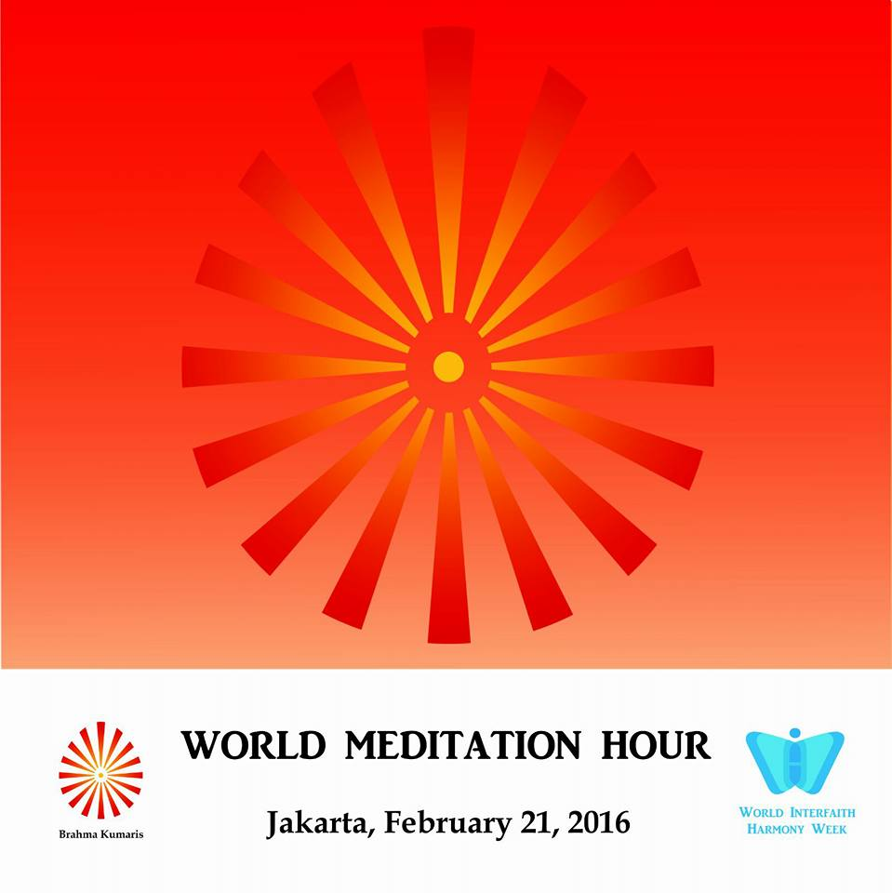

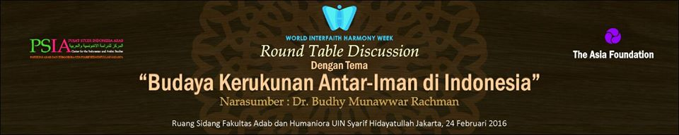

**Discussion on The Culture of Interfaith Harmony in Indonesian Islam**

**at Syarif Hidayatullah State Islamic University**

Jakarta, February 24, 2016

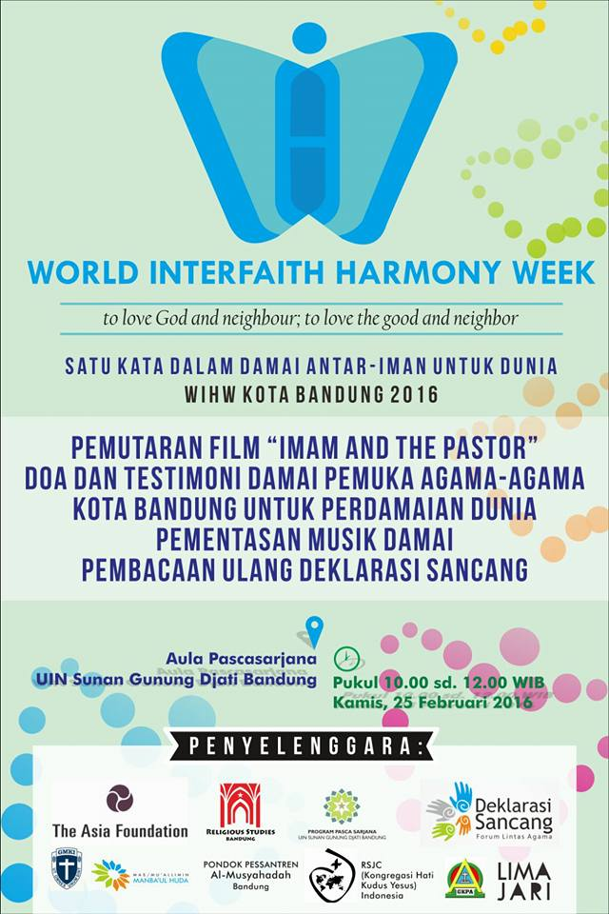

**Young Interfaith Dialogue**

at Sunan Gunung Djati State Islamic University

Bandung, West Java, February 25, 2016

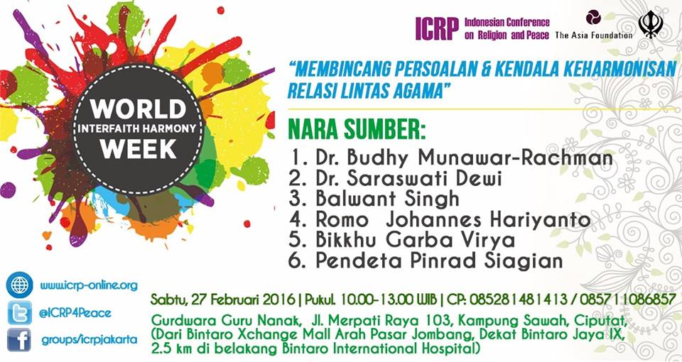

**Interfaith Dialogue on Interfaith Harmony**

**at Sikh Temple**

South Tangerang, Banten, February 27, 2016

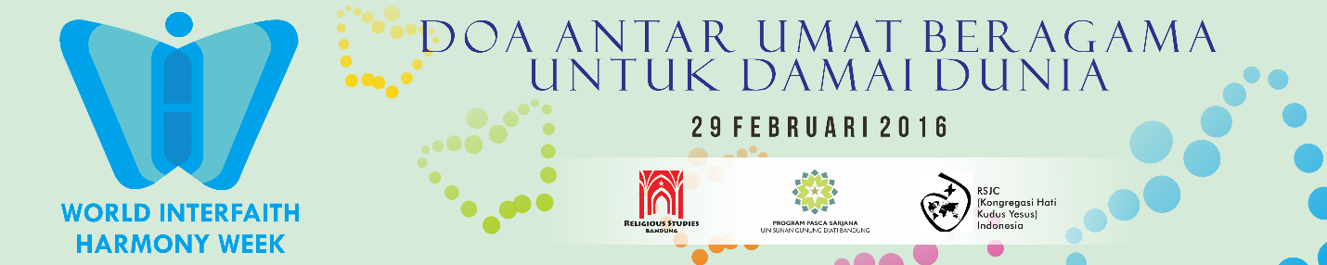

**Interfaith Prayer for World Peace**

Bandung, February 29, 2016

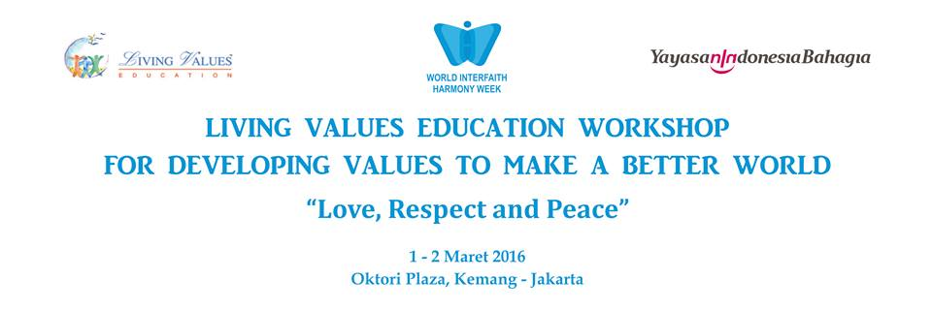

**Living Values Education Workshop for Parents**

Jakarta, March 1 – 2, 2016

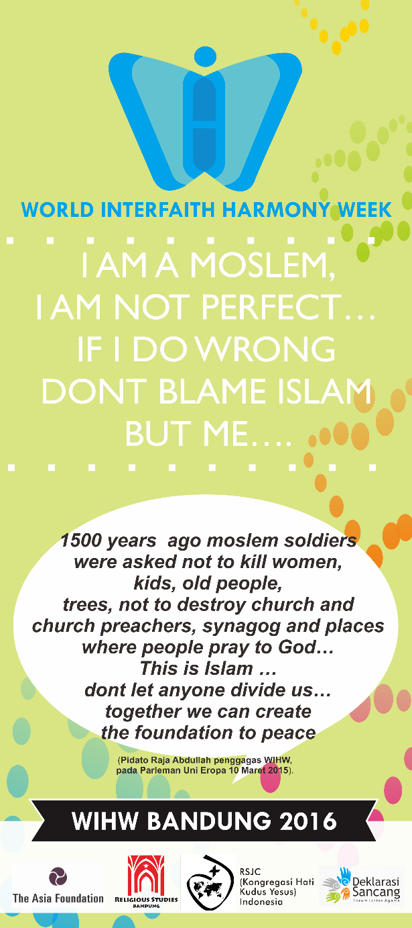

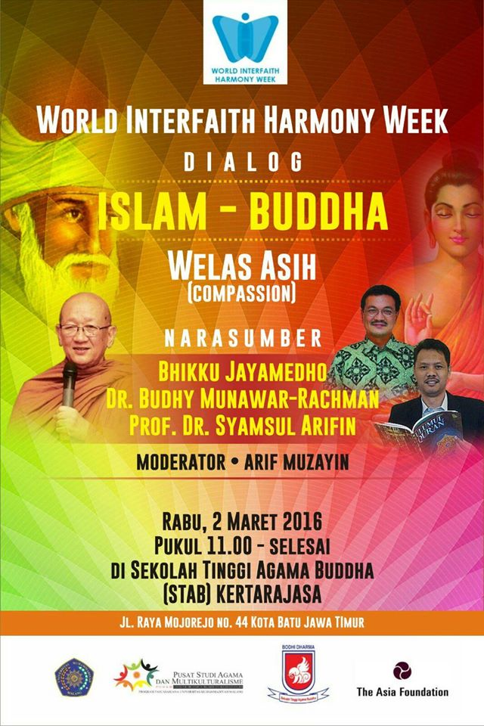

**Islam and Buddhism Dialogue on Compassion**

at Buddhist Temple, Batu, Malang, East Java, March 2, 2016

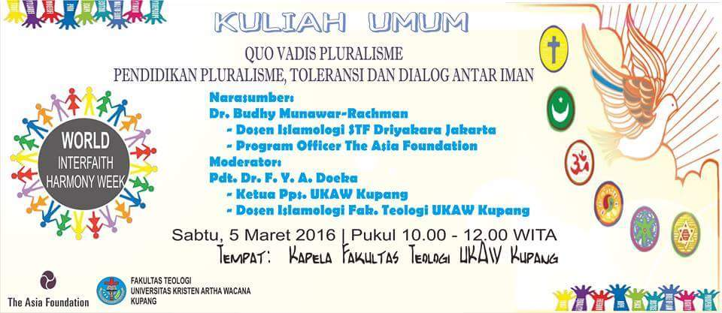

**Public Lecture on Interfaith, Tolerance and Pluralism Education**

For Lecturer and Students of Faculty of Theology,

Arta Wiyata Christian University (UKAW) Kupang, East Nusa Tenggara

Kupang, March 5, 2016

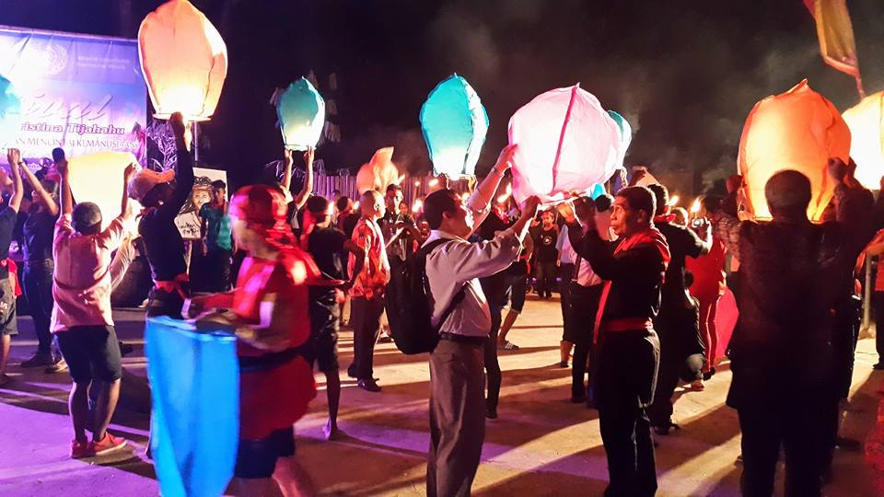

**TESTIMONIES**

**Celebrating WIHW 2016 in collaboration with**

**The Asia Foundation and Partners**

***Abdul Harris from Bima, West Nusa Tenggara.***

Everyone has positive qualities within him or herself, also the need to be loved, understood and values. This is the most important awareness that I got from celebrations of WIHW 2016, that values make us all connected to one another. Activities that I participated in, in the program for WIHW, helped me discover and reawaken these values through interacting with others – especially, when I was with victims of social discrimination.

***Afifuddin Toha from Yogyakarta, Central Java.***

The most profound effect that I experienced, from celebrating WIHW, was the way I understood myself. I saw myself more positive and I felt deep calmness, peace and happiness within. Problems will always be, but, the clear/obvious blessing I received from the WIHW program was that I saw myself in the long term as being much more positive. With peace beginning with me, I am optimistic that I can share this peace with others and the environment around me.

***Ajat Sudrajat from Tasikmalaya, West Java.***

Being optimistic and able to think more positively in facing problems was the direct effect I felt from following celebrations were of WIHW 2016. The atmosphere and natural environment of the place where the celebrations were held created a fresh new atmosphere within me, making my mind more relaxed. Several values activities we did there, made me aware of values within myself which will enable me to connect better with others and the world around me.

***Bambang Ertanto from Jakarta.***

During the celebrations, I churned again the meaning of my existence. It was as if I went deeply into myself and discovered values there which until then I hadn’t been aware of – Values like peace, love and simplicity. Then, I asked myself, if, in the activities of my daily life, I was reflecting these values? Celebrating WIHW 2016, helped me know the true self that I had forgotten.

***Deni Hartawan from Mataram, Lombok, West Nusa Tenggara.***

Celebrations of WIHW 2016 made me aware that, until now, the positive qualities in myself have been covered by negative feelings. During the celebrations, I practiced reawakening those positive values in my actions until people around me could feel the peace and happiness that I was experiencing. I hope celebrations of WIHW can be repeated amongst those of the community where I work.

***Desi Ratnasari from Jakarta.***

We became aware that values are within each and every one of us. This means that each human being has positive values which must be respected. Celebrations of WIHW 2016 wasn’t to teach us about values, but to share them, to reflect on them and to reawaken them. According to me, values education is important especially for minority communities discriminated against and their social workers , so that peace, love and happiness can be experienced by more people.

***Diana from Cimahi, West Java.***

I had a very positive experience from the WIHW 2016 celebrationss in that I was able to see the values within myself and understand myself better. I felt enlightened, more self-confident, more open to others and relaxed.

***Faisal Ramdhani from Sampang, Madura, East Java.***

Celebrations of WIHW 2016 had many positive effects on me. It was as if I just got to know myself. I felt so happy when I became aware that I was truly someone with values and I began to value/respect those around me whatever they were like. This will really help the process of social inclusion if practiced in the environment of minority communities discriminated against.

***Ferry Wira from Medan. North Sumatra.***

The effect of the celebrations WIHW 2016 was especially on me myself. Activities like self-reflection, visualizing values and and relaxing the self really helped me to discover myself again and to fill an empty space within the soul with peace and happiness. I experienced myself to be full of love and felt empathy with the others. I believe that events like WIHW can remove exclusivism/exclusion from society so that every member of society will be able to connect in harmony with the other.

***Hadi Utomo from Sampit, South Kalimantan***

One thing that left a deep impression on me during celebrations of WIHW 2016 was the atmosphere of togetherness amongst us all, the participants. Although we all came from different backgrounds geographically, culturally and from different religions and faiths, the whole process that we went through during the workshops helped us to feel connected to one another. We each learnt, shared experiences and values, so that our differences became woven into a beautiful tapestry.

***Hafizen from Yogyakarta, Central Java.***

Celebrations of WIHW 2016 reminded me of the importance of reawakening the values originally within myself. These values are many times forgotten so that there we are often not even aware of their presence. The processes of reflection, visualization and relaxation really helped me to awaken those values again. This WIHW event will be truly beneficial if it can be absorbed into the people of the local religion, where I work as a social worker, which is now experiencing trauma as a result of religious-political pressure in Indonesia.

***Hastin Trustisari from Jakarta.***

During the celebrationss of WIHW 2016, I tried to contemplate within myself, things which I have never before been aware of. The effect was simply wonderful! I became aware that I had positive values , that everyone has positive values. This consciousness helped me to respect everyone and that every individual in society is connected through human values. It is very important that Values workshops are held in the communities that we work with as social workers, so that each one within it can grow and develop as a positive human being.

***Imelda Sulis Setyawati from Tambolaka, East Nusa Tenggara***

I felt a very positive effect on myself after the process of celebrating WIHW 2016. I felt calmer, more patient, and I could think more positively about myself. All this influenced my way of looking at the world outside. I feel peace and happiness within now and I want to share this with those around me.

***Izzul Albab from Yogyakarta.***

As an activist and social worker who helps victims of discrimination, I received a lot of benefit from celebrating WIHW 2016. Activities we did, left a significant impression on me enabling me to understand myself better and to revitalize values within like peace, love and respect. The challenge for me now is how I can reawaken these positive values, in an inclusive effort, amongst those who are victims of social discrimination in society.

***Jayadi from Mataram, Lombok, East Indonesia.***

The more I participated in the peace activities of WIHW 2016, the more enthusiastic I became. Celebrations of WIHW 2016 made me more optimistic that every human being is connected to the other, although they have different religions and faiths. Within each person are the values of love, peace and respect, which, despite their other differences, enables each one to live together in harmony.

***Lukman Hakim from Jepara, Central Java.***

The personal effect that I felt, from celebrating WIHW 2016, was that I became truly aware of the truth and essence of values. Until then, I had felt that values were something implanted from outside, but in fact, values are intrinsically within ourselves. I must only rediscover and reawaken them. Happiness, peace and respect were the most powerful values that I experienced during these celebrationss.

***Marini from Banda Aceh, Nangro Aceh Darussalam (NAD).***

I felt positive, peaceful and happy. That was what I felt most celebrating WIHW 2016. From following this program, I felt I was better able to accept differences and respect people around me, because each person has positive values. It is very important that programs, like celebrating WIHW, could be reproduced in different varied communities so that this positive atmosphere and environment can be experienced by many more people.

***Muhammad Saleh from Bulukumba, South Sulawesi.***

Celebrating WIHW 2016 left a very big impression on me. I felt I more grateful for God’s gifts and for positive values within myself which enabled me to experience peace. This peace I will radiate in my attitude and my actions when I interact with others.

***Munif Ibnu from Semarang, Central Java***

During the whole time of our celebrating WIHW 2016, which I followed, I witnessed all the participants interacting full of love, respect, tolerance and other positive values. Celebrating WIHW succeeded in inviting participants to explore values within themselves, reawakening them when relating to others. From a program like WIHW, I now feel more optimistic that we can reawaken believing in and trusting one another from different communities to live together in peace.

***Ninu Rambu W. Lodang from Waingapu, Sumba. East Nusa Tenggara.***

During the celebrationss of WIHW 2016, I truly experienced an atmosphere of peace, tolerance, respect for one another, everyone full of love and happiness.

***Paulus Maramba from Waingapu, East Indonesia.***

Universal values truly exist. They don’t come from outside, but are hidden deeply within each one of us, so that we are often not even aware of them. Rediscovering these values makes me feel peaceful and happy, because I feel connected with others and with the world I live in. This celebrating WIHW is very relevant in that it can be used to re-connect segregated communities – because values function as a pillar in making the process of social inclusion more strong.

***Purwanto from Yogyakarta.***

I especially appreciated the facilitators who succeeded in creating a values-based awareness amongst the participants. Besides an atmosphere full of peace and love, a positive effect I immediately experienced, from these celebrationss of WIHW 2016, was an increase in my ability to interact with others, especially in communicating. I was better able to listen to others, feeling empathy, and could value the uniqueness of each and every person. All of these positive values are very important to share extensively in society.

***Ramonda from Jakarta.***

The celebrationss of WIHW 2016 had a very positive impact on my soul. During the celebrations, I practiced reflecting on myself. Deep within myself I discovered values which always will keep me peaceful and happy, values that I am going to keep alive in myself and in the community and society around me.

***Sudarto from Jakarta.***

These celebrationss of WIHW 2016 gave me training me in thinking positively. I was made aware that I, and everyone else, was truly a being full of values. Programs like WIHW 2016 will bring huge benefit if carried out amongst people who have little experience of interaction, who are segregated against, and amongst people who claim that their teachings and religious values are most right (better than others).

***Veryanto Sitohang from Sidikalang, North Sumatra.***

A process of healing took place within myself during the celebrationss of WIHW 2016. I discovered many positive values within me, which enabled me to relate easily with others and with the whole of life around me. The skills that I learned in the workshops also were of benefit as activities which can build peace that I will use amongst communities who are victims of conflict, helping them to heal trauma, to overcome hatred, fear, and other negative feelings as well.

***Zakiyal Fuad from Kuningan, West Java.***

Often, our focus on the world outside, makes us forget to look within ourselves. These programs for WIHW invited us to take ourselves within, to discover positive values that we have often forgotten. In awakening these internal values, we become instruments of God’s work bringing peace to the whole world.