UPF-Austria, Vienna - 200 people gathered on February 6, 2015 at the Vienna International Center (UN Headquarters in Vienna) to commemorate World Interfaith Harmony week. The half-day conference entitled “The Importance of Interfaith Cooperation for Securing Peace in the 21st Century” was organized by the Universal Peace Federation Austria (UPF) in cooperation with ACUNS Vienna, the Women’s Federation for World Peace and Media Partner The Best of the World Network. This age of globalization needs enlightened people in each faith who can examine their sacred writings and traditions and identify the aspects that can benefit all humanity as well as those that preserve each religion's identity. The UN designated the first week of February every year as World Interfaith Harmony Week. UPF and its network of Ambassadors for Peace celebrate this week each year, in a way that encourages understanding, respect, and cooperation among people of all faiths for the well-being of our communities and peace in the world.

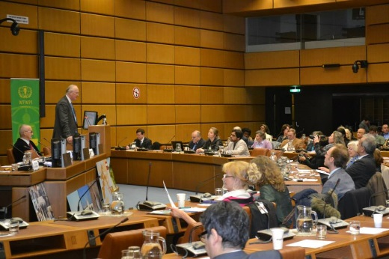 | 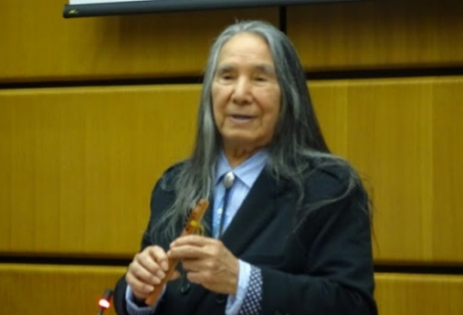 | 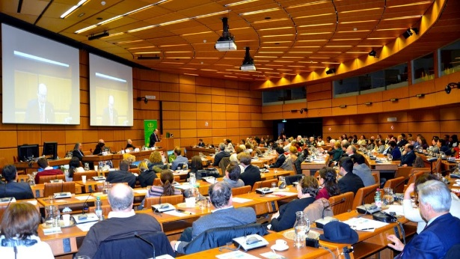

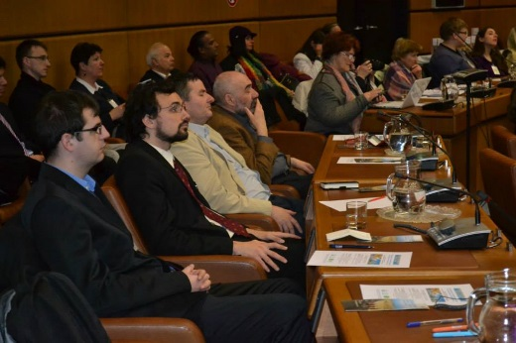 | 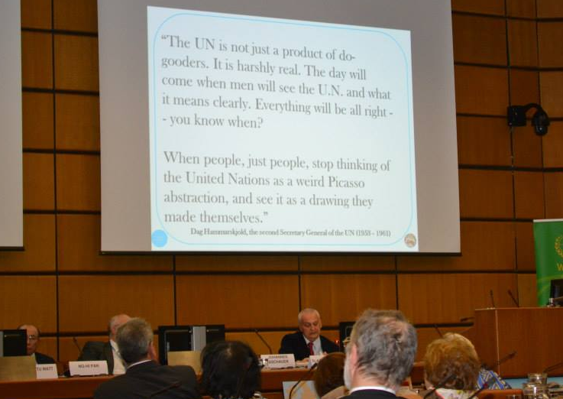 | 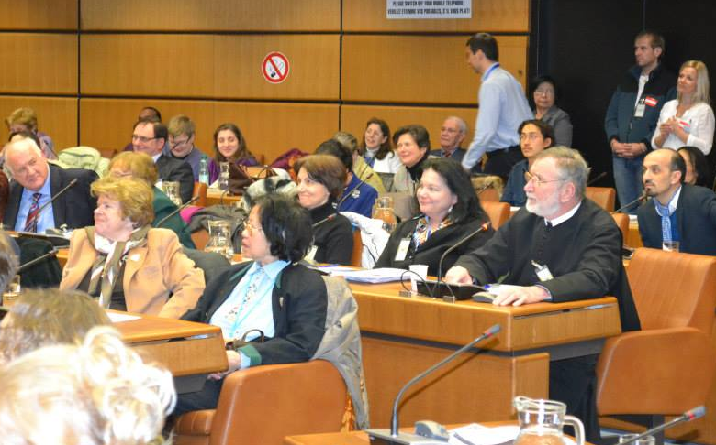

To set the tone for the conference a video of UPF promoting an Interreligious Council at the UN “Creating a Family of Faith” was shown. After words of welcome by Peter Haider, president of UPF in Austria, Elder Ruben Silverbird, a long-standing Ambassador for Peace, opened the conference with a Native American flute blessing, asking those present to close their eyes and say a prayer for peace in their heart.

As a first speaker Dr. Slawomir Redo, who has worked for many years as an UN Senior Crime Prevention and Justice expert, choose to speak on “An interreligious input for the United Nations 2016-2030 SDGs”. He explained that the Millennium Development Goals of the UN have been reviewed and will be developed as sustainable development goals for the next 15 years. He raised the question: How can religion be integrated into these goals? Of course the Golden Rule can be found in almost all religions: Love for God and love for your neighbor. This rule could already guide people to a more just distribution of wealth. In addition he highlighted two terms: dignity and justice. As an example he mentioned that Buddhism has contributed to respecting animals and nature in general, whereas justice could be strengthened by the idea of brotherhood of all men. Finally he told the story of the 6 blind men who tried to describe an elephant, with the moral of the story: we all have parts of the truth, and our fellow man can see another part of it!

Then Johannes Aschauer presented the project “Jerusalem way - a Pilgrimage to the Holy Land”. He and two fellow Austrians walked all the way to Jerusalem from the end of the Jacob’s pilgrimage way in Spain, Cape Finistere to Israel! The pilgrimage from Austria to the Holy Land – some 4500 km -took them 6 months, having a lot of time for thoughts, discussions and encounters. Later they marked the way and so developed a new pilgrimage path. They also turned it into an international peace project for Syria. “Walking this way you have to pass through many countries and meet people of many cultures. You can get rid of many prejudices. That’s why the Jerusalem Way stands for tolerance and understanding. There is only one religion, the religion of love!

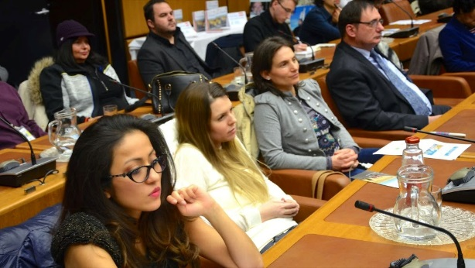 | 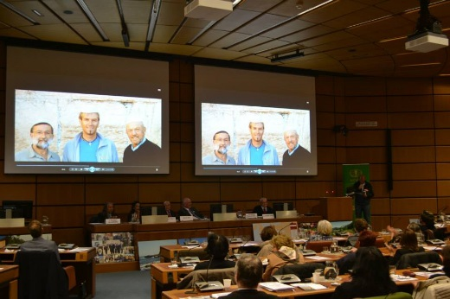 | 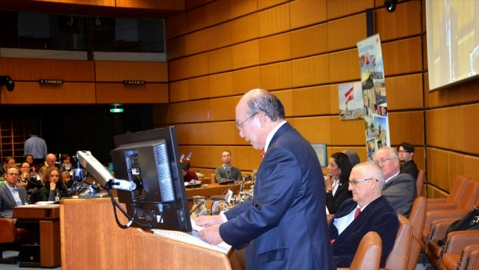

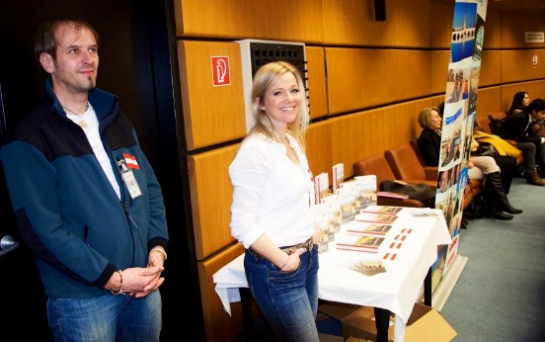 | 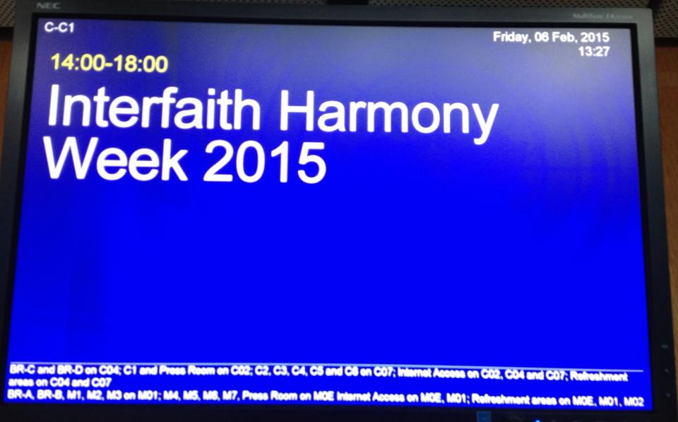 | 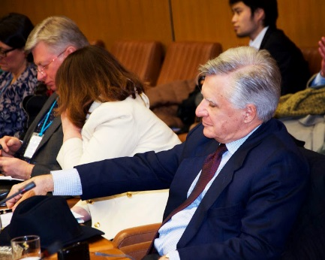

The next speaker was Dr. Shantu Watt, UN Women’s Guild and Women Federation for World Peace, addressing the topic ”The Role of Women in Interfaith Peace building”. Dr. Watt stated: “My goal is to bring forth every person to the forefront of visibility, also every woman!” She then spoke on the topic of Interreligious dialogue: There are 4200 religions in the world, and all of them claim to possess the truth. It needs a common ground in order to be able to have a dialogue. The common ground can be found by accepting the dignity and equality of the other religion.

Concerning the role of women: Most gods and most religious leaders are male, which entails the subordinate role of women. Almost never could they have leading roles in religions. Most interfaith dialogues don’t even address the discrimination of women in religions. In an ideal discussion there should be a harmonious number of men and women. Religious dialogues also have to address unacceptable religious practices, like female genital mutilation or abortion of female fetuses, if religions want to be bastions of morality and peace. A recent religious freedom report from America shows that in 2014 most people who have been displaced were so because of religious conflict: Christians, Muslims, Hindus and many others. The dark sides of religions also have to be addressed! Many people observe the ineffectiveness of interfaith dialogue. “My observation is that it is more effective to do things together than to organize meetings with leaders of religions! “
Her suggestions for interfaith dialogue were to look at cultural practices and look for their proof in sacred texts, to give women a larger role in religious institutions and that the media should show how many women are involved in peacebuilding and interfaith dialogue!
As the last speaker of the first session Dr. No-Hi Pak, UPF Korea was speaking on “Religious Peace Movements in multi-religious Korea”. Dr. Pak gave insight into the history of the multi-cultural Korean society. The percentage of officially registered religious believers in South Korea today is 52%. The main religions are Buddhism, Protestantism, Catholicism and Confucianism. Buddhism has been the main religion for more than 1000 years. It harmonized with Shamanism, the ancient religion of Korea. Then Confucianism was introduced by China. Buddhists were tolerant towards Confucianism, therefore a co-existence developed between the two sets of thought.
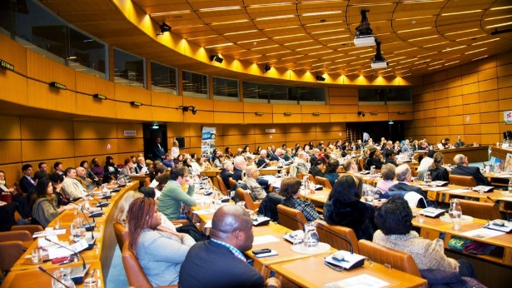 |  | 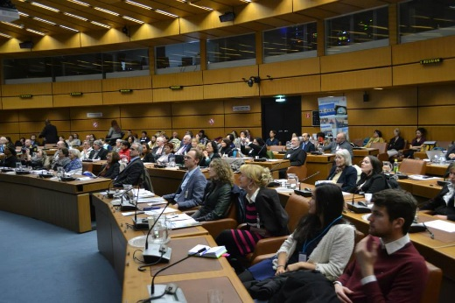

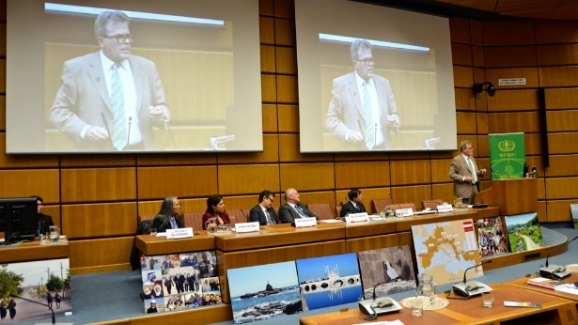 | 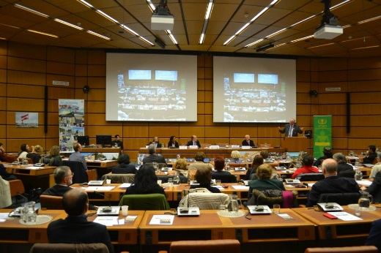 | 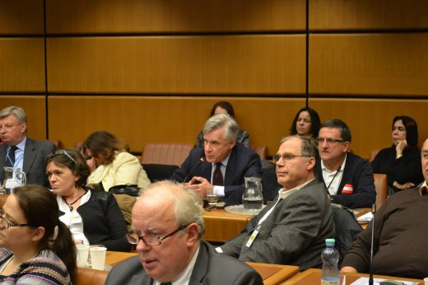
When in the 18th century Christianity was introduced, the intellectuals accepted it. Unfortunately Catholicism clashed with the Confucian tradition of worshipping the ancestors, and much blood was shed. When the Korean War broke out in 1950 and the Korean people were plunged into misery and anguish, the United States, representing Christian culture, extended a helping hand like a savior and offered assistance, which opened up the hearts of the Korean people. Moreover, the impassioned Holy Spirit movement, which swept across Korea when it was suffering in the wretched agony of war, served as the fertile soil whereon Protestantism was rapidly propagated.
While suffering amidst the agony of war and poverty, new autogenic denominations rooted in national spirit and traditions also came into active being within the Christian faith, sometimes even persecuted by mainstream Christianity. A principle example of this is the persecution against the Unification Church Movement centered on Rev. Sun Myung Moon, a religious leader who was more passionate than anyone else in carrying out an interdenominational and interreligious peace movement. The central ideology coherent in all his teachings is ‘One family under God’.

Rev. Moon thought that the fundamental reason lying behind religious conflicts was that believers were unable to overcome the differences between the doctrines of their different religions. And so he mobilized world-renowned theologians to come together and research the scriptures of the different religions collectively, and he ultimately had them publish an interreligious scripture under the name of “World Scripture”. The results of the research carried out by those renowned theologians revealed that 70 percent of the doctrines of the different religions were identical, and that the remaining 30 percent differed because they held different religious rituals and followed different religious procedures.

Korea is a multi-religious society, even though incidents giving rise to religious conflict have been committed now and then by a small number of extreme believers, for on the fundamental level, a spirit of tolerance in regard to religion is deeply enrooted in Korea.

As a start for the 2nd session the World's first Interfaith Anthem Sami Yusuf - The Gift of Love was shown.

Prof. Dr. Richard Trappl, director of the Confucius-Institute in Vienna, spoke on the topic “Religion in China in old and modern Times”. He had just returned from a trip to China where his flight started in the early morning, he passed through the world of Muslim culture during a stopover in Istanbul and spoke here the same day in a conference in the UN building in Vienna. For him dialogue is the center of our discussion today. It is important to know the other part, but it is also important to know yourself. In China which is still Communist today, there are the tombs of Matteo Ricci, the famous 16th century Jesuit missionary to China, in the center of the Communist party’s Academy building. There you can also find the place of the churchyard with 56 tombs of Jesuit priests who died in China.

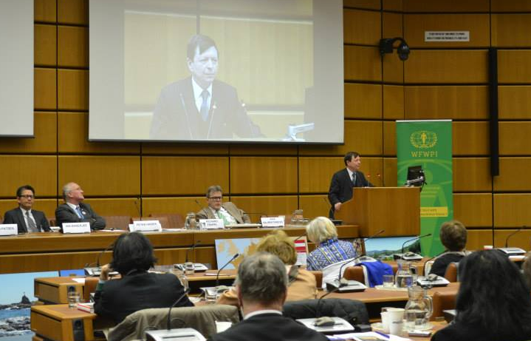 |  | 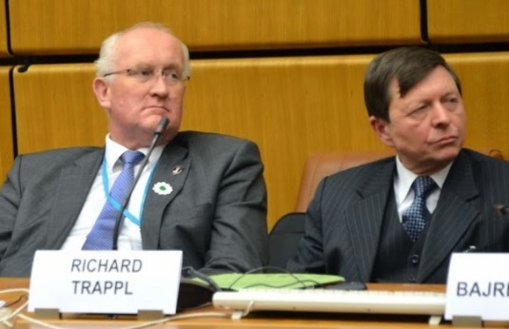 | 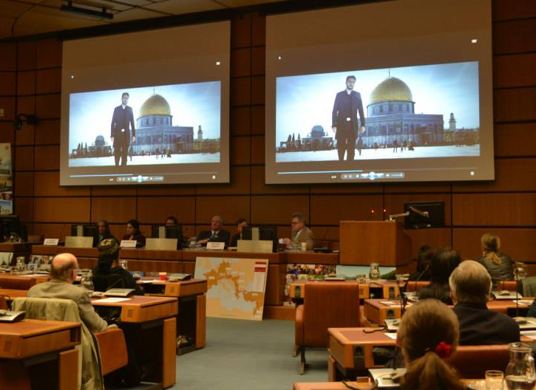
Dialogue with China and her 1.3 billion people is extremely important. China is not just an economic power but also its rich culture which should be studied seriously. Prof. Trappl raised the question whether Chinese religions like Confucianism and Daoism which complement each other in many ways are religions in the sense we have them in the West. The term religion zongjiao consists of zong “family” and jiao “teaching”. He argued the Confucianism is an ethical system, to create a human community that is defined by responsibility. Daoism on the other hand is an epistemology, to think in polarities between existence and non-existence. There is the rationality of Confucian thinking and the irrationality of the Daoist school of thought. For 2500 years these two schools of thought were complementing each other. In the 1st and 2nd century A.D. Buddhism entered China opening what we would describe from a Western perspective as a more religious dimension. That was a third pillar. When we look at the destruction of these heritages, highly respected for 2000 years, during the Cultural Revolution we have to ask why this could happen. During the time of colonization the Western powers taught the Chines that they were too weak with their ideals of harmony and peace derived from Confucianism, Daoism and Buddhism to match up with achievements of the Western world. It was the dialogue of aggression coming from the West.
Today the Chinese build churches for weddings to be held. Also Christmas is being celebrated in the whole country. This is a secularization of religion, but we can see a change in the atmosphere.
Prof. Anis H. Bajrektarevic, Professor for international law and international politics, reflected in his presentation “Multiculturalism, dead or dread in Europe?” upon Europe and its role in the world and he observed that all religions originate from Asia, whereas all political philosophies (later instrumentalized for ideological purpose) come from Europe. He also confirmed that the Asian religions (or as he calls them 'comprehensive philosophies of life') had the capacity to coexist, in contrary to the monotheistic believes of Judaism, Christianity and Islam, which very often were misused for ideological purpose, to purge the otherness in an alleged 'exclusive access to the truth'.

In the booming world of physics and metaphysics, Europe is lagging behind. Europe is rapidly losing its bio capital due to dismal demographic scores, as well as the migratory pressures (the best Europeans are leaving, while Europe mostly attracts the unskilled immigrants from the MENA and sub-Saharan Africa). The lasting Europe's crisis is not only economic, it is a recession of thought and ideas on how to move forward. Europe has to revisit its social but also cross-generational contract, before being able to conduct a sincere and comprehensive interfaith dialogue about multiculturalism and diversity. Prof. Bajrektarevic sees as one of the most urgent problems that European people have lost the ability to reproduce themselves – they lost the awareness of the preciousness of the family.

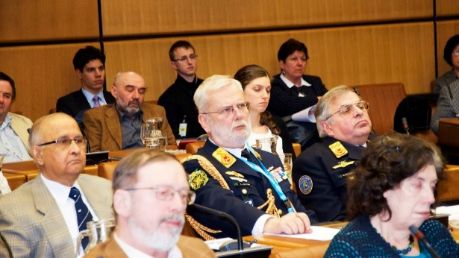 |  | 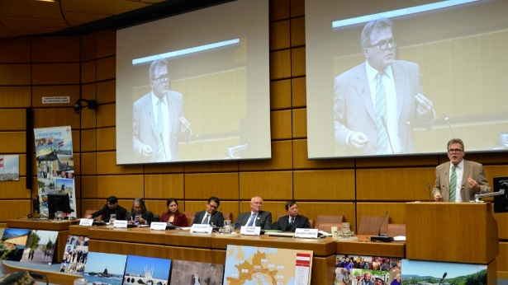

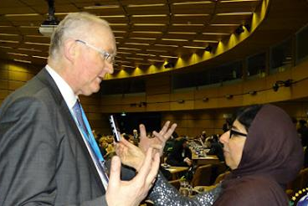 | 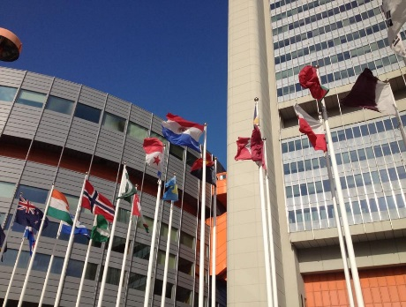 | 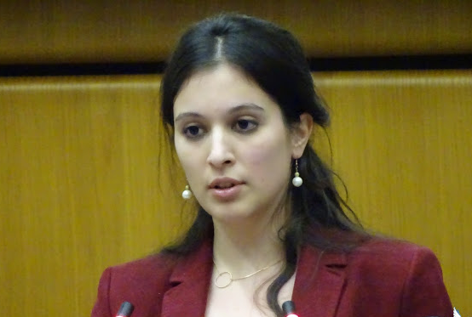

Talking about Austria, Prof. Bajrektarevic says that he can understand (although not accept as a fait accompli) the sensationalism of media coverage of so-called Austrians of Muslim origin or immigrants of the Arab or Muslims descent. He is very much against the nomadic way of dealing with this topic: nomadic meaning that, when the topic is trendy everybody is talking about it, not allowing space for the real experts, and then the topic is suddenly abandoned and interest moves to another trendy issue. Recent talks about Austrians returning from Syria, or about some Muslim centers and schools in Vienna are very dangerous and misleading 'nomadism'. While Turkish and Bosnian Muslims represent over 3/4 of overall Austrian Muslims they are excluded from debates. This seriously disfranchises people and plays a counterproductive card as regards an interfaith dialogue in Austria and the overall social consensus, security and safety of Austria.

Ms. Eirini Patsea, a young lawyer, specialized on “Cultural Diplomacy and Interfaith Mediation” (with her main focus on Greece), gave an account on the role of the Greek Orthodox Church in Europe and the Middle East, in respect to interfaith diplomacy. For instance, the case of Egypt and the interfaith diplomatic activities of the Greek Orthodox Church for the purpose of constructive conflict management of the tensions between the Muslim and the Coptic communities.

Another highlight, was the referenceto the mediating role of the Patriarchate of Jerusalem between the Israeli state and various Arab countries. There it was pointed out, among others, that the leverage of the Patriarchate largely depends on the fact that it is one of the biggest owners of land in Jerusalem; as well as on the deep rooted underlying relationship that Greek Orthodoxy has with both the Jewish and the Muslim cultures and traditions, allowing the Patriarchate to act as a credible, trusted mediator.

As illustrated through all the references, it was suggested that the Greek Orthodox Church has great potential in successfully engaging in interfaith diplomacy, even on a state level, acting as a stabilizing and equalizing power in the regions of Europe and the Middle East.

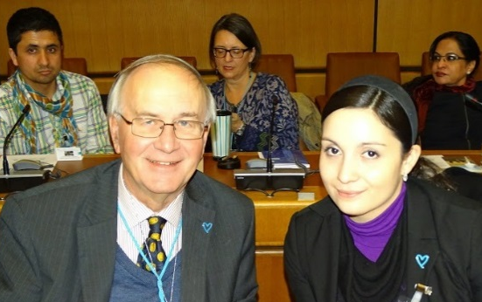 | 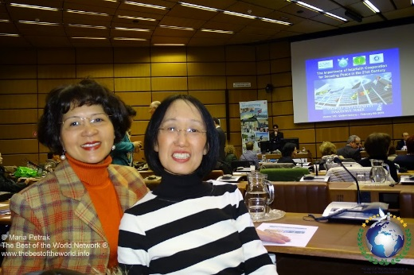 | 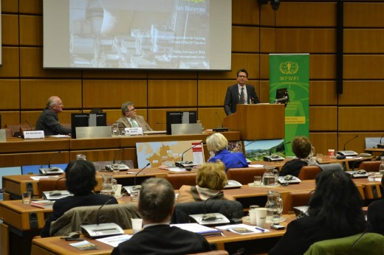

Dipl. Ing. Ian Banerjee, Ass. Professor for architecture at the Technical University of Vienna spoke on “An urbanist’s perspective on Education for Interreligious dialogue”. Mr. Banerjee was born in Calcutta and raised as a Hindu. As a practical example of interfaith harmony he started with two personal experiences: His best friend in school was a Muslim, although he himself didn’t have any idea about Islam. This year Mr. Banerjee visited India with Austrian students and their tour guide was a strong Muslim. This man knew nothing about Hinduism but his wife would cook vegetarian meals for his best friend, who was a Hindu. Friendship seems to be possible without knowing anything about each other’s religion.

As an urbanist he is researching the interaction between education and urban planning. First he spoke about “Deep Learning”. He took part in interreligious dialogue for many years as a student, but only after going to countries like Morocco, Jordan and Turkey, did he start to understand things better. In Oman, being involved for two years in a project and having friends there he really started to fall in love with the Islamic culture. This immersion is absolutely necessary: “It is not about talking but you have to get into it.” His second point was “Global Education”. UNESCO has done a great deal of work in this direction published in the UNESCO World Report on Cultural Diversity and their pedagogy is built on respect for cultural diversity. A second important document is the Maastricht Global Education Declaration, speaking about intercultural learning, citizenship learning and peace education, solidarity and inclusion and human rights education. We have to understand the complexities of the world, not just have a “be nice to each other” approach.

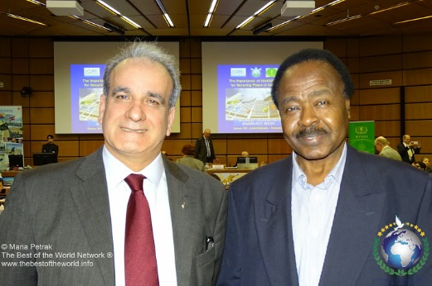 | 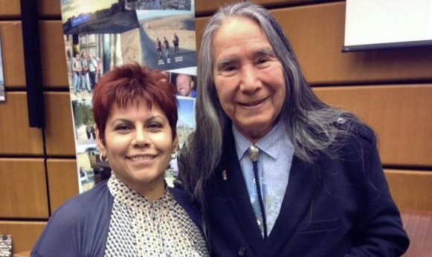 | 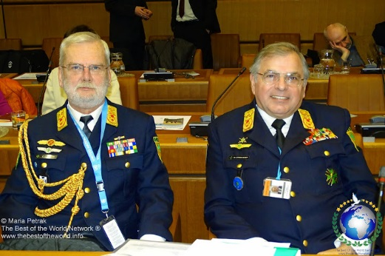

Then he spoke on the “Dilemma of Education”. Civil society and the state hammer out a consensus as regards what education is about. Educational institutions recreate and sustain society with all its norms but on the other side they also have to inspire for change. He mentioned the topic “Integration”, where there is no consensus as to what this really means. He continued to speak about the importance of narratives. He showed “Mapping Stereotypes -The Geography of Prejudices”. Incredible amounts of information is showered over us today by all kinds of media outlets, society is diversifying enormously and intensively. The challenge will be “convincing story telling” – to have the best stories and the best way to put them on the networks. He ended with speaking about a project by National Geographic. Seven-Year Walk Highlights Power of 'Slow Journalism' that Paul Salopek's "Out of Eden" walk may provide a new model for in-depth storytelling.

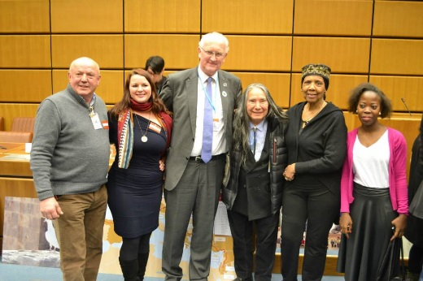 | 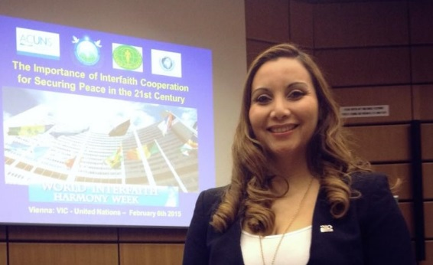

Further Information: Peter Haider, Tel.: 0650 2588846

