Dear InterFaith Friends

Please join us for

5 th Annual
World Interfaith Harmony Assembly: “Commonalities WithIn Our Diversity”
St. Paul’s Episcopal Cathedral
220 E. Fayette Street

Sunday, February 8, 2015
3:00 - 5:00 pm with Reception Following

InterFaith Works of CNY and Women Transcending Boundaries invite you to join us as we spread the message of harmony and tolerance, by showcasing and celebrating the many faith traditions in Central New York.

World Interfaith Harmony Week has been celebrated since 2010 when it was first proposed at the United Nations General Assembly by King Abdullah II of Jordan. It provides a platform for all interfaith and goodwill organizations to demonstrate their impact and necessity. The movement is strengthened by building ties among world religions, educating ourselves about each other, and helping our community appreciate the beauty and diversity of our faith traditions.

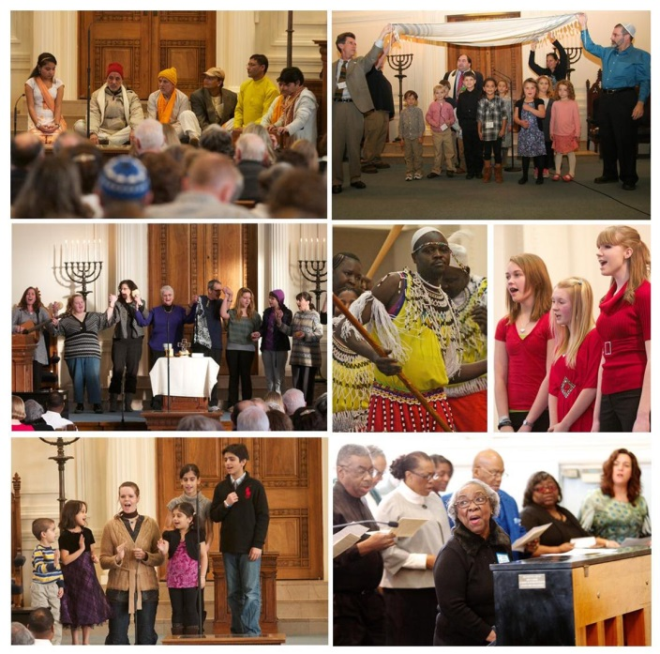

For more information contact Daryl Files at 315-449-3552, ext. 208, dfiles@interfaithworkscny.org

For more information about the global event, www.worldinterfaithharmonyweek.com

