“Commonalities WithIn our Diversity”
World Interfaith Harmony Assembly

InterFaith Works of CNY and Women Transcending Boundaries invite you to join us as we spread the message of harmony and tolerance, by showcasing and celebrating the many faith traditions in Central New York.

World Interfaith Harmony Week has been celebrated since 2010 when it was first proposed at the United Nations General Assembly by King Abdullah II of Jordan. It provides a platform for all interfaith and goodwill organizations to demonstrate their impact and necessity. The movement is strengthened by building ties among world religions, educating ourselves about each other, and helping our community appreciate the beauty and diversity of our faith traditions.

When IFW and WTB started planning the first World Interfaith Harmony Event, it seemed like the idea made perfect sense. We are an interfaith community and we value harmony and tolerance within all of our faith traditions.

Our first year we were guests at Bethany Baptist and Rev. Turner opened his faith home and community to 250 guests. 2nd year we passed the baton on to Temple Concord where Rabbi Fellman MC’d with Rev. Turner. 3rd year John the Baptist Catholic Church and a snow storm welcomed 300+. And the MC”s started the conversation with “did you hear the story about a Rabbi and a Priest.” 4th year Marc Clay, President of the Syracuse Stake Church of Jesus Christ Latter--day Saints hosted close to 500 guests. Snow storm and our created Hand Print banner was capped off with their young men and women cleaning off the cars for their guests to have a safe drive home.

We invite you to join us as we celebrate “Commonalities WithIn our Diversity” and our MC’s for 2015 Rev. Georgina Hegney and Marc Clay, President of the Syracuse Stake. Sunday February 8, 2015. 3-5 pm.

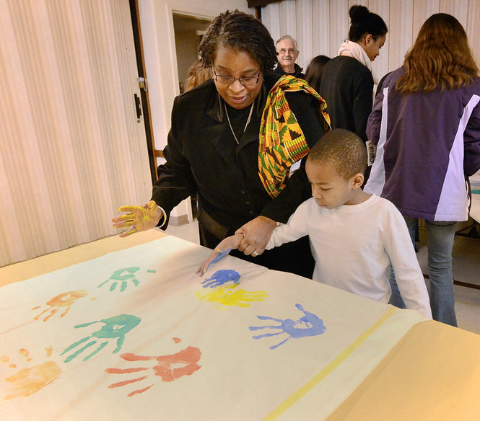

Sunday, February 09, 2014 9:25 PM
Taevion McMullin age 6 gets help from his grandmother Akosua Woods of Syracuse, getting a painted imprint of his hand on a banner to be sent to the United Nations as part of the World Interfaith Harmony Assembly held at The Church of Jesus Christ of Latter-day Saints on Bear Road in Liverpool. Mike Greenlar mgreenlar@syracuse.com

Please join us for our 5th Annual World Interfaith Harmony Assembly
Sunday February 8, 2015
St.Paul’s Episcopal Cathedral 220 E. Fayette Street
3-5 pm reception to follow

“Commonalities WithIn our Diversity” will be shared through the eyes and ears and words and hearts of ALL Faiths.

For more information contact Daryl Files at (315) 449-3552, ext. 208, dfiles@interfaithworkscny.org.

www.worldinterfaithharmonyweek.com

