THE ORGANIZERS

Youth Da’wah for Peace (YDP) is a community youth volunteer based organization aims to build bridges of understanding by promoting Da’wah initiative especially to non-Muslims through intercultural exchanges, providing various fora in the university/college and community, outreach programs, and the most recent project, Interfaith Dialogue.

United Religions Initiative (URI) is a global grassroots interfaith network that cultivates peace and justice by engaging people to bridge religious and cultural differences and work together for the good of their communities and the world. The Mindanao Peace Garden, its chapter in the Philippines, has been an active instrument in realizing its ideals. Hence, in full collaboration of the two organizations, Interfaith Dialogue with its dynamic modules was realized.

THE PARTNERS

The previous partners that contributed to the success of the initiative includes AFS Cagayan de Oro Chapter, AFS Xavier University, Liceo de Cagayan University – Muslim Students Association, Capitol University – Muslim Students Association, RisaleiNur Institute Philippines, The Church of Jesus Christ of Latter-Day Saints – Cagayan de Oro Stake, KL YES alumni - Cagayan de Oro, Baha’I Faith Community of CdO, Xavier University - United Religious Organizations, Kaliwat Kay Apo Agyo, Muslim Related Studies department of Xavier University, Mindanaw Tripartite Youth Core – Cagayan de Oro, Capitol University – Office of the Campus Ministry through Youth Representative.

This year, newly identified partners added to the group initiatives whereas other former partners are doing their interfaith dialogue on a separate schedule. These institutions includes Muslim Youth Council Cagayan de Oro, Institute for Peace and Development in Mindanao based in Mindanao State University – Iligan Institute of Technology, Mindanao University of Science and Technology, Cagayan de Oro College, Mindanao State University – Iligan Institute of Technology Muslim Students Association and MSU IIT Youth Chain of Peace.

THE PROGRAM

The third Sunday in January is annually celebrated as World Religion Day. A peace initiative was first created in 1950 and now on its 64th year, encapsulating all religions across the globe. The aim is to promote inter-faith understanding and harmony; unite everyone, whatever their faith, by showing us all that there are common foundations to all religions and that together we can help humanity and live in harmony. February 1 to 7, is the World Interfaith Harmony Week. It was first proposed at the United Nation General Assembly on September 23, 2010 and on October 20, same year, it was unanimously adopted by the United Nations. Henceforth, the first week of February is being observed as World Interfaith Harmony Week.

Both initiatives encourage followers of every religion around the world to acknowledge the similarities that different faiths have and engage in dialogue based on two common fundamental religious Commandments; Love of God, and Love of Neighbour, without nevertheless compromising any of their own religious tenets. In response to this call, a collective effort was founded in Cagayan de Oro City in order to help address the cause of the said initiative through Interfaith Dialogue. Now on its 3rd year, creating impact to the community at large, Interfaith Dialogue was initially organized on January 30, 2013 with the theme "Bridging the Gaps; Breaking the Barriers". In 2014, with greater participation of the community and various institutions, the 2nd Interfaith Dialogue was a success with its theme “In Search of Truth for Unity and Harmony in Service to God”. The activity aimed at promoting better understanding among various religions for a peaceful society especially in the City of Cagayan and in Mindanao.

The World Religion Day (WRD) observe the day by holding interfaith events such as interfaith dialogue where faith leaders get together to give talks and lectures on a common ground. People are encouraged to talk to and listen to people from faiths different than their own and to understand the basic tenets of other religions without compromising from one another. This year theme for WRD is “One Common Faith” and will be observe on January 18, 2015.

WRD was initiated by the National Spiritual Assembly of the Baha’is of the United States which institutionalized the World Religion Day in 1949. The first such day was observed in 1950. The day calls for members of all religions in the world to recognize that all religions have common spiritual goals.

The World Interfaith Harmony Week (WIHD) has this year theme “Say No to Violence in the name of Religion; spread harmony and peace among followers of all religions, faiths, and beliefs”. This was first proposed at the U.N General Assembly by H.M Abdullah II of Jordan. The WIHW is based on the pioneering work of The Common World Initiative. This initiative which started in 2007, called for Muslim and Christian leader to engage in dialogue based on two common fundamental religion commandments, Love of God and love of the Neighbor, without nevertheless compromising any of their own religious tenets. The two commandments are at the heart of the three monotheistic religions and therefore provide the most solid theological ground possible.

The WIHW extend the two commandments by adding love of the good and love of the neighbor. This formula includes all people of goodwill. It includes those with other faiths, and those of no faith. The WIHW provides a platform-one week in a year when other interfaith groups and other groups of goodwill can show the world what a peaceful movement they are.

YDP and URI continuously implementing Interfaith Dialogue since 2013 in order to reflect on interfaith values shared by others; celebrate our differences and embrace similarities between religions and belief systems. In order to listen to people from different faiths and encourage people to talk about their religion, religion which one different from their own. Thus, the objectives of this project revolve around this principle:

- To recognize that all religions have common spiritual goals or common foundation of their spiritual principles.
- To foster world peace, harmony, and understanding through education and dialogue.
- To discover and build upon the common threads of all religion and spiritual paths of the local community and the world.
- To call attention to the harmony and spiritual principle and the oneness of the world religion and to emphasize that religion is the motivating force for world unity.
- To encourage its partners to conduct the same module or at least come up with awareness campaign promoting the ideals of World Religion Day and World Interfaith Harmony Week and highlight the importance of Interfaith Dialogue.

This year, the team will conduct its 3rd Year of Interfaith Dialogue in Iligan City on February 02, 2015 with a theme “Understanding Oneness of God; a Dosage of Peace and Harmony”. It is hope that this initiative will provide a focal point from which all people of goodwill can recognize that the common values they hold for outweigh the differences they have, and thus provide a strong dosage of peace and harmony to their community.

For more inquiries, please do not hesitate to contact me (Adzhar J. Madjid) at 09051168071 or at adzharmadjid@yahoo.com.

Let this be our collective place for peace and solidarity for our community.

Respectfully yours,

MR. ADZHAR J. MADJID
LEAD CONVENER, INTERFAITH DIALOGUE
CHAIRMAN, YOUTH DA’WAH FOR PEACE
FOUNDING CHAIRMAN, MUSLIM YOUTH COUNCIL

DR. NOEMI A. MEDINA
CO-CONVENER, INTERFAITH DIALOGUE
DIRECTOR, UNITED RELIGIONS INITIATIVE – MINDANAW PEACE GARDEN
P R O G R A M M E

PART I
12:30-01:00PM
Arrival/Registration MIMSA/MYCoP
01:00-01:20PM
Interfaith Prayers
Reading of Qur’an Hafeedh Muhammad Ali Demirci
Christian
Baha’i LuaBurias
Lumad Arturo Conto
01:20-01:30PM
National Anthem LDP
WIHW Official Theme Song LDP sung by Sami Yusof
01:30-01:40PM
Welcome Address Mark Tristan Quimque, IPDM Peace Action Coordinator
01:40-01:50PM
Opening Remarks Dr. Noemi A. Medina, URI C.C. Leader
Project Convener
01:50-02:10PM
Overview/Video Presentation Adzhar J. Madjid, YDP Chair and MYC Chairman
Project Head Convener
World Religion Day
World Interfaith Harmony Week
Interfaith Dialogue

S N A C K S
(Intermission&World Interfaith Cafe)
PART II
Interfaith Lectures
02:30-02:55
Christian Iluminada Domingo, Director, GugmasaKabataan Center
02:55-03:20
Indigenous People’s Faith Rolando Soong, Datu - Higaonon Tribe

(Intermission&World Interfaith Cafe)
Interfaith Lectures
03:25-03:50
Baha’I Faith Alejandro M. Burias,Bahá’í Communities VisMin
03:50-04:15
Catholic Fr. Geovanni Quiblat, Redemptorist Church
04:15-04:40
Muslim Mehmet RizaDerindag, President, Risale-I Nur Institute Philippines

04:40-05:00
Open Forum/Panel Discussion Jamal Baulo, MIMSA President
Israela Luis, MYCO Rep.
05:00-05:15
Synthesis
Closing Remarks Adzhar J. Madjid, Project Head Convener

Masters of Ceremony:

THE HISTORY:
Commending the Success of 1st Interfaith Dialogue

Cagayan de Oro City – Youth Da’wah for Peace (YDP) in collaboration with United Religions Initiative (URI) – Mindanaw Peace Garden and SIRAJ Muslim Religious Organization Xavier University – Ateneo de Cagayan, successfully spearheaded an “Interfaith Dialogue” with a theme: "Bridging the Gap; Breaking the Barriers" held on January 30, 2013 at VIP Hotel Function Room, Cagayan de Oro City.

The project was to respond to the call of this year World Religion Day (WRD) and World Interfaith Harmony Week (WIHW). WRD was observed on 20th of January 2013 across the globe this year. It was first created in 1950 now on its 62nd year. The aim is to promote inter-faith understanding and harmony; unite everyone, whatever their faith, by showing us all that there are common foundations to all religions and that together we can help humanity and live in harmony. WIHW on the other hand was first proposed at the UN General Assembly on September 23, 2010. On October 20, 2010, it was unanimously adopted by the UN and henceforth the first week of February will be observed as a World Interfaith Harmony Week. This initiative, called for Muslim and Christian leaders to engage in a dialogue based on two common fundamental religious Commandments; Love of God, and Love of the Neighbour, without nevertheless compromising any of their own religious tenets.

The organizers of this interfaith dialogue aim to promote better understanding among various religions for a peaceful society especially in Mindanao. It convened youth leaders from various school and community based youth organizations and religious groups to come to realize the importance of interfaith dialogue. After the activity, it helped them better understand the different concepts of religion, initiated reforms on existing prejudices among different religion in Cagayan de Oro and made aware of World Religion Day and World Interfaith Harmony Week as annual event.

The three main groups of organizers come from various field of advocacies that shares a common goal in promoting peace.URI is a global grassroots interfaith network that cultivates peace and justice by engaging people to bridge religious and cultural differences and work together for the good of the communities and the world. In Mindanaw a group of dynamic and peace loving individual operate its circle called Mindanaw Peace Garden headed by Dr. Noemi Medina, project convener.YDPwas organized in 2012, a community youth based organization headed by AdzharJ. Madjid, project chair. “It aims to build bridges of understanding by promoting Da’wah initiative especially to non-Muslims through intercultural exchanges, providing various fora in the university/college and community, outreach programs, and the most recent project, Interfaith Dialogue”, Madjid explained. “SIRAJ is a Muslim organization that caters the needs of the Muslim students in Xavier University – Ateneo de Cagayan especially in protecting their Eiman (faith)” said Norhanie Lao Mama, convener and the representative of Siraj. Other participating organizations includes AFS Cagayan de Oro Chapter, Liceo de Cagayan University – Muslim Students Association, Capitol University – Muslim Students Association, The Church of Jesus Christ of Latter-Day Saints – Cagayan de Oro Stake, KL YES alumni Cagayan de Oro, Baha’I Faith Community of CdO, Xavier University United Religious Organizations, Kaliwat Kay Apo Agyo and the Muslim Related Studies department of Xavier University.

There are eighty five participants that represented various faiths, undergone through a series of talks on different perspectives of religion such as Islam, Christianity, Baha’i Faith and Lumads. A well-knowledgeable representative from the mentioned religion above was invited and gave their talk followed by open-forum after presentation. The second part of the activity is Interfaith Café. Five different stations are set where participants go around the corner and pass through each station to gain more wisdom on the above mentioned religions.

Photo Gallery on 1st Interfaith Dialogue; Bridging the Gaps, Breaking the Barriers"
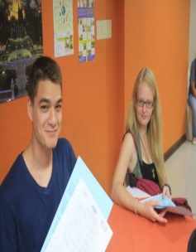
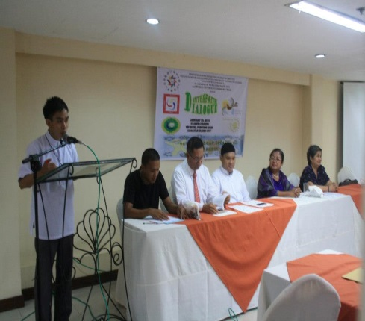
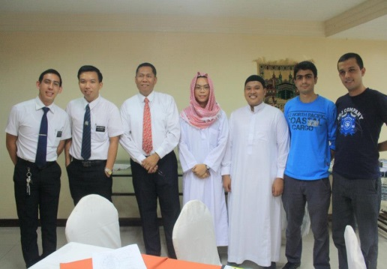
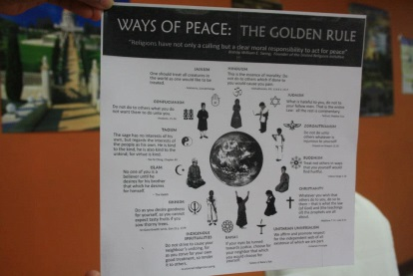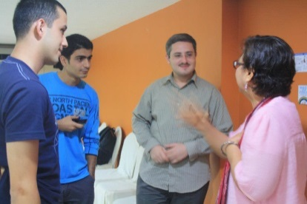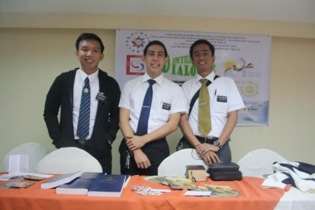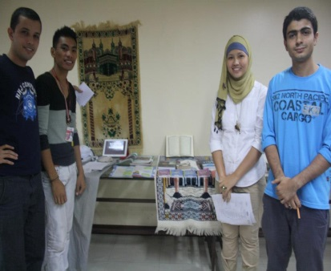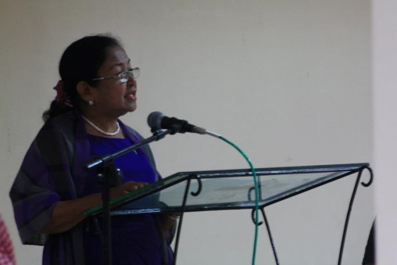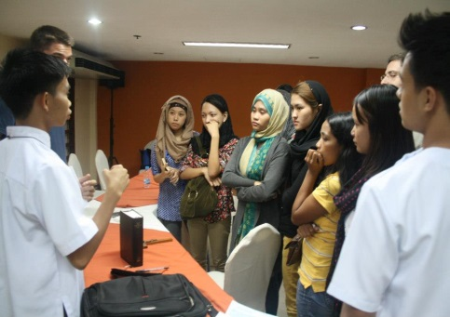
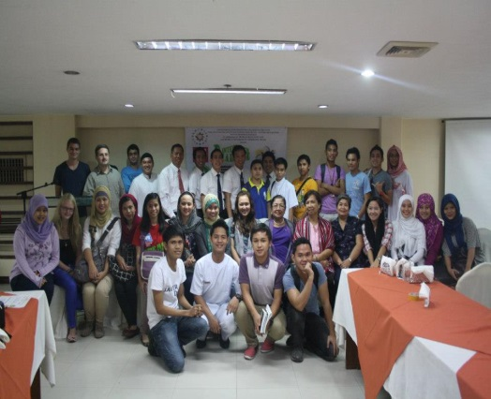
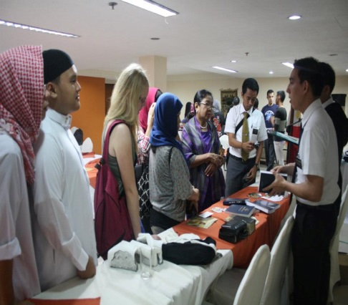

2nd Interfaith Dialogue

In promoting peace and development through mutual understanding of people from different faith in Cagayan de Oro City, an Interfaith Dialogue made realized amidst the issues of confrontation among some religious beliefs and practices. Firstly observed on January 30, 2013, this year, the 2nd Interfaith Dialogue once again made possible convening more or less 200 participants to the symposium and workshop guided with its theme “In search of Truth for Unity and Harmony in Service to God”. The event was held on Saturday, February 01, 2014 at the Church of Jesus Christ of the Latter-Day Saints in Cagayan de Oro City.

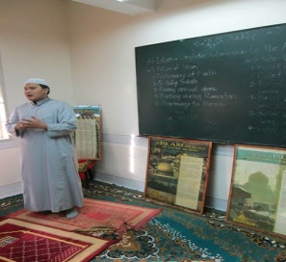
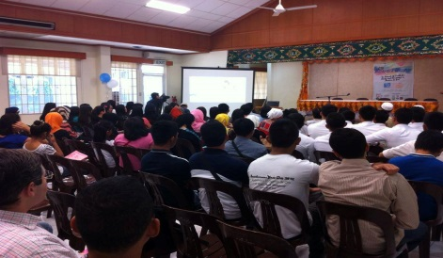
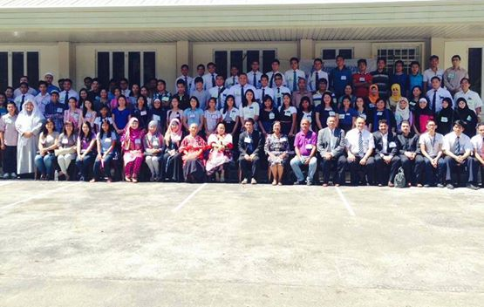
Photo Gallery on 2nd Interfaith Dialogue: “In Search of Truth for Unity and Harmony in Service to God”

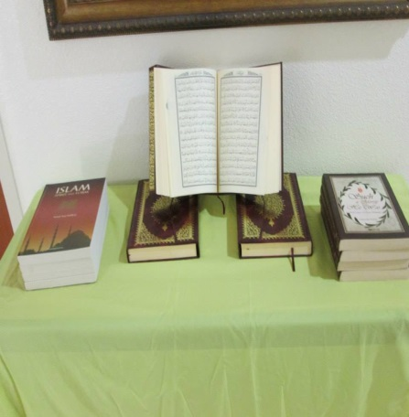
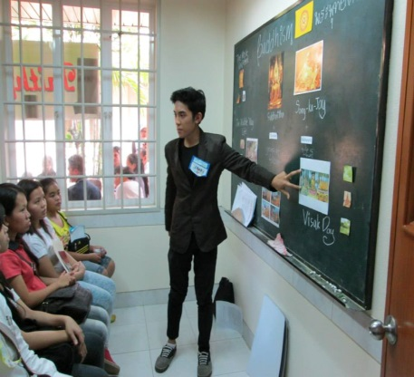
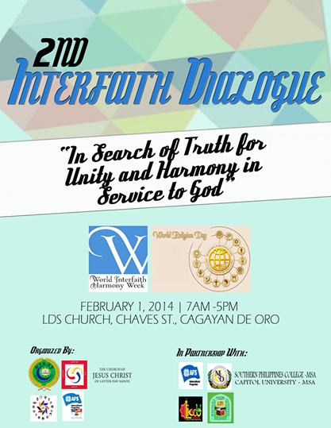

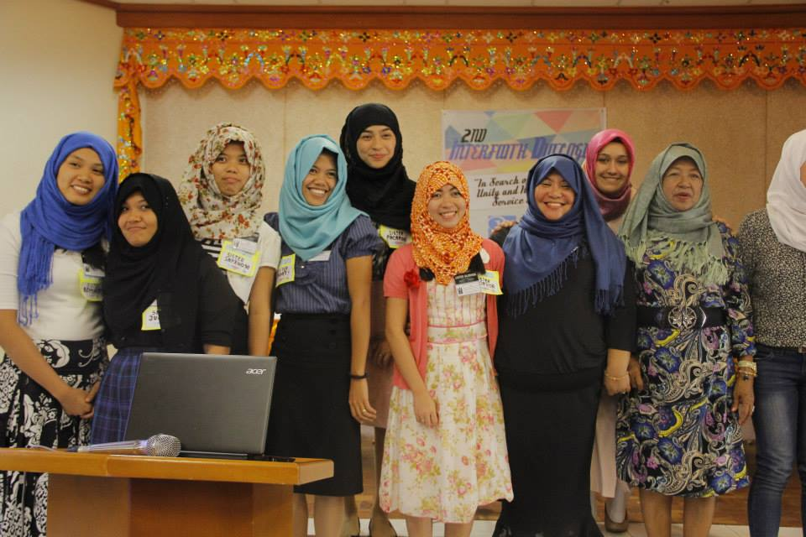
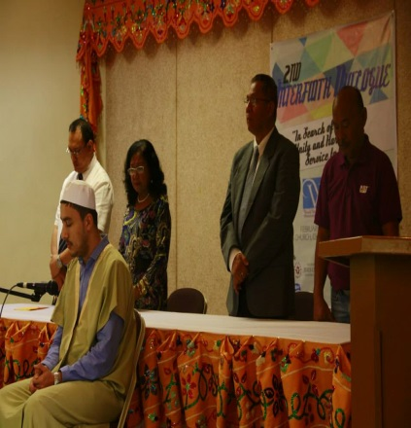
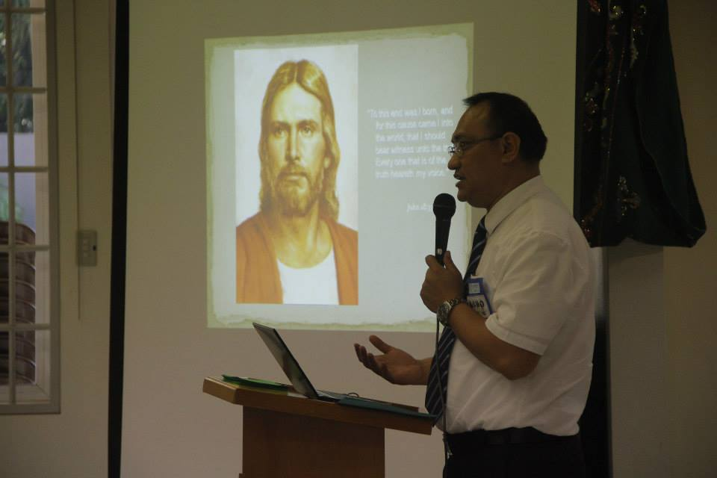

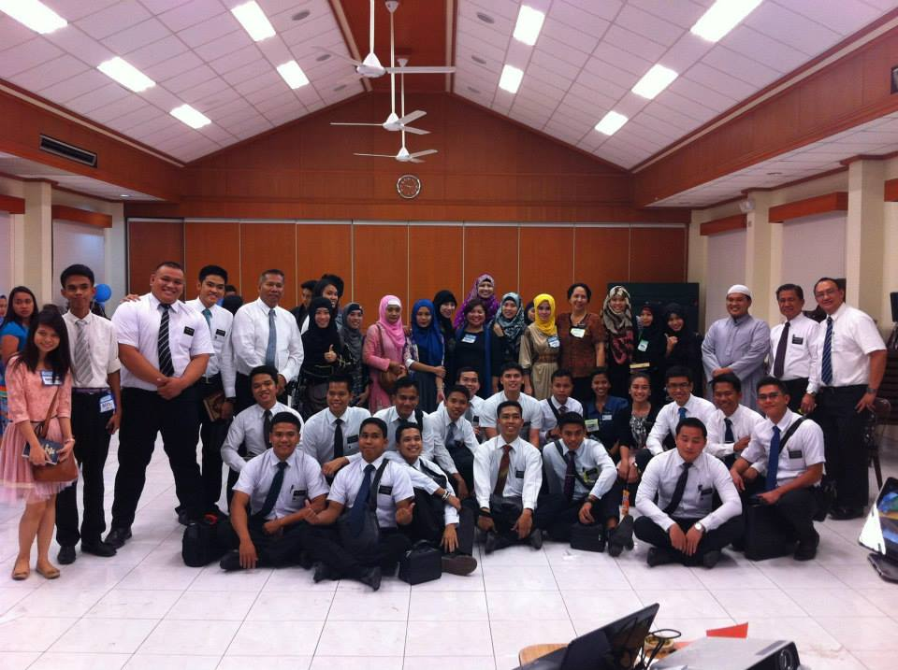
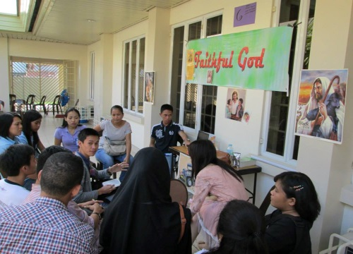
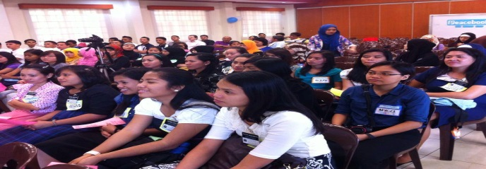
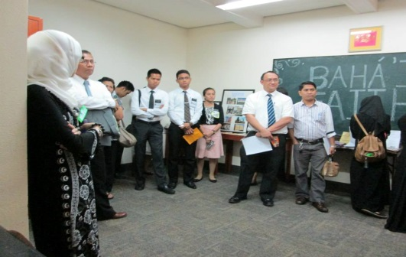
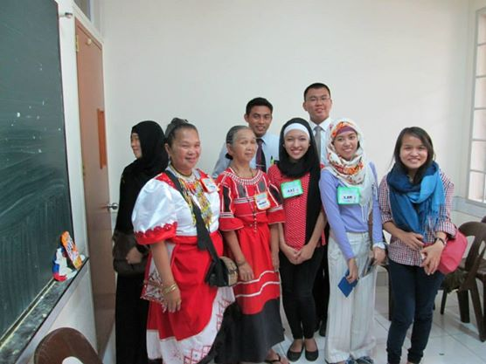
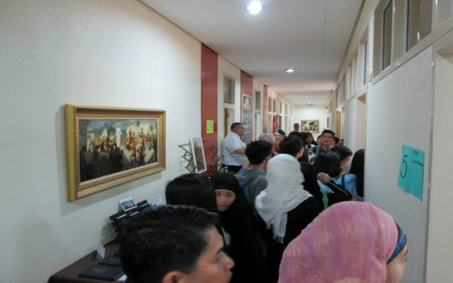
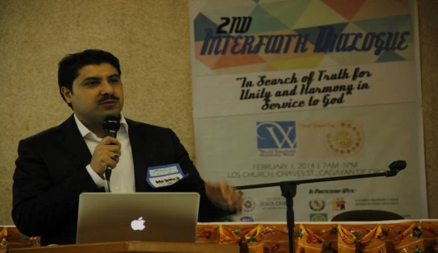
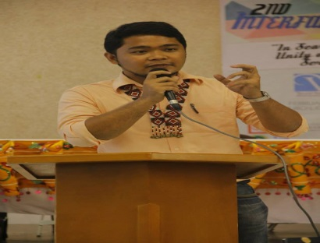
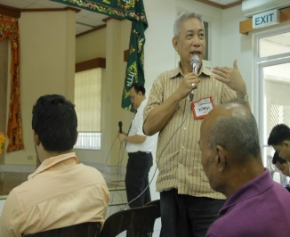
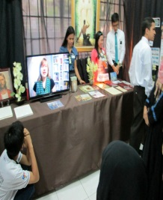
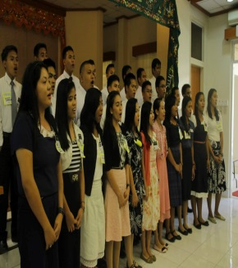
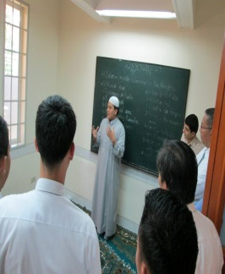
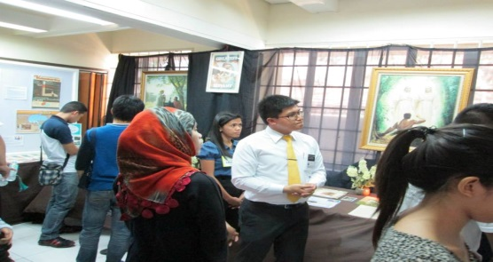
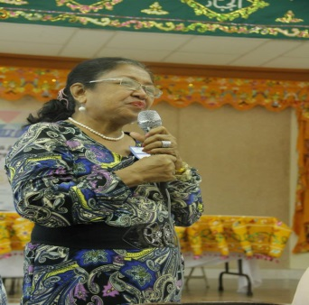
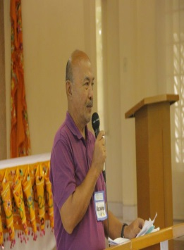
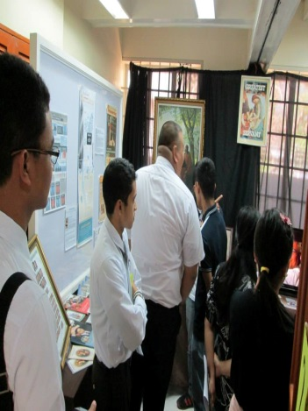
Photo Gallery on 2nd Interfaith Dialogue: “In Search of Truth for Unity and Harmony in Service to God

