U. N INTERFAITH HARMONY WEEK-2015:
6th International Interfaith Conference on Holy Books - Report

- Introduction:
The 6th International Interfaith Conference on Holy Books was held in the first week of February at the Sarvodaya Institute of Higher Learning, Sri Lanka. This was organized by the Cosmic Community Centre Karickam in collaboration with Dr.Alexander Marthoma Centre for Dialogue Kottarakara, Kerala and the Sarvodaya Santhisena, Sri Lanka.
It was held as part of UN Interfaith Harmony Week, 2015. About 125 delegates from different parts of the world attended the four days programs.
- Background:
The Intertextuality series of conferences was started in 2005 in Kerala India. Dr.Abraham Karickam, President of Cosmic Community Centre was invited by Melbourne University, Australia in 2004 for an Interfaith Conference, where he met a few eminent scholars from different parts of the world who were deeply interested in Holy Scriptures. He suggested the idea of a biennial Conference on Holy Books and they all welcomed it whole heartedly. The first Conference was held in 2005 which attracted a large number of scholars from academic and the theological circles.
- Themes:
The following were the themes discussed in the previous assemblies which were held in India.
2005 - Intertextuality of the Holy Books
2007 - One Word, Many Versions: a Re-reading of the Holy Books
2009 - Holy Books and Violence
2011 - Holy Books and People of Differing Faiths
2013 - Holy Books and Life after Life
2015 - Holy Books and Eco Spirituality
- Publications:
It is a custom to publish a book with all seminar papers during every conference. These books are widely circulated for discussion and study in academic circles.
- Inauguration:
The Colombo Conference was inaugurated by Magsaysay Award winner Dr. A. T Ariaratne popularly known as the Sri Lankan Gandhi, in the presence of a number of dignitaries from Sri Lanka. The meeting was presided over by Rev. Dr. Victor Kazanjian (International Executive Director of United Religions Initiative) . Dr Abraham Karickam (URI Asia Executive Director and Chief organizer) explained the dynamics of the conference. Dr. Vinay Ariaratne (General Secretary of Sri Lankan Sarvodaya Movement) , Dr. Ravi Kandage (Executive Vice President of Sarvodaya Movement), Dr. Jin Wol Lee (Prof. of Buddhism, Dongguk University, Korea), Prof. Kamal Waleboda (Colombo University), Ian Fry (Melbourne University, Australia, Dr. J. Prameeladevi (member, Kerala Women’s Commission) and others offered felicitation.
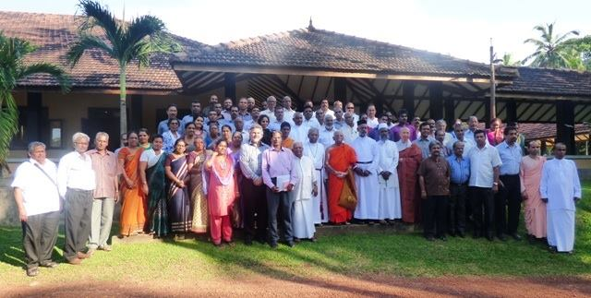
Delegates of the conference with chief guests and dignitaries

- Releasing of the Book:
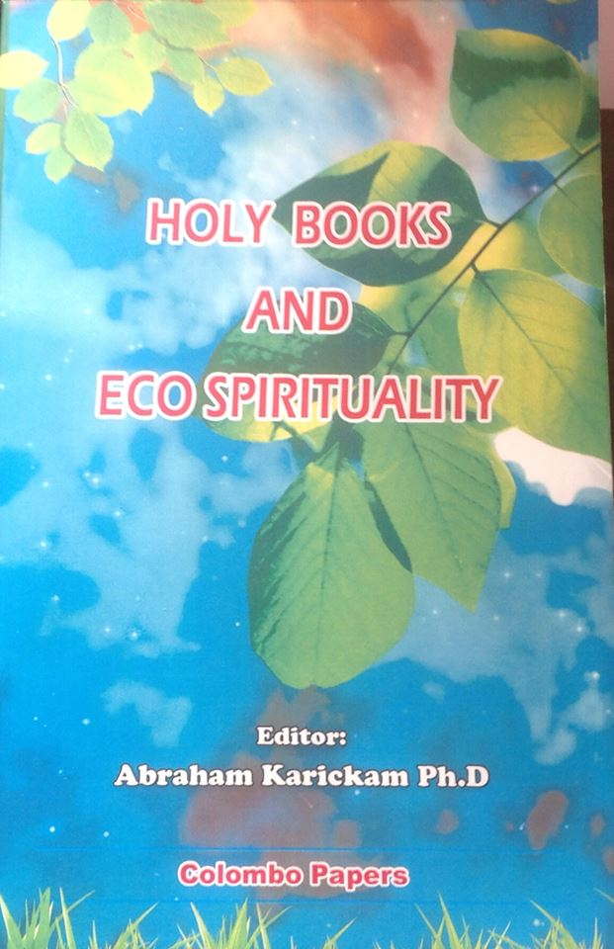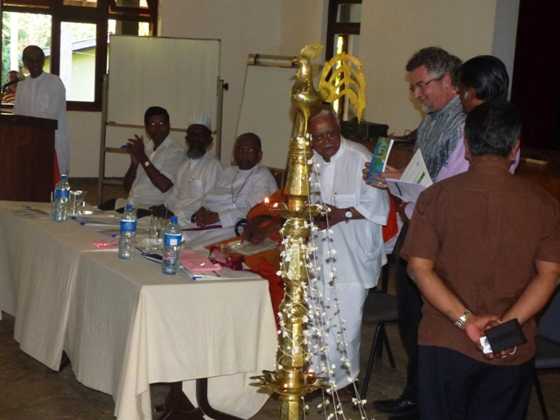

The book on ‘Holy Books and Eco Spirituality’ was released by Dr. Victor Kazanjian (USA) by presenting the first copy to Dr. Vinayaka Ariaratne (General Secretary of the Sarvodaya Movement in Sri Lanka)
- Presentations:
The following papers were presented during the conference
- Zoroastrian Perspective of Eco Spirituality - By Dame Dr. Prof. Meher Master-Moos, President Zoroastrian College
- Revisiting Green spirituality through the lens of Vedic scriptures – By Prof. Jayanti Ranganathan Chavan, Founder President, Dr. T.D. Singh's Institute of Science and Religion, Navi Mumbai.

&
Dr. Suhas. Chavan, Senior Professor, Sinhagad Institute of Business Management, Mumbai
- Spirituality for Transformation, Re-formation and Renewal - Bishop Kumara Illangasinghe, Principal, Theological College, Sri Lanka.
4. Eco-spirituality and the Hindu Perspective – Sivanandini Duraiswamy, President of Saiva Mangalyar Kalagam, Sri Lanka and Manager of Hindu Ladies’ College.
5. ÀDĀM VIS-À-VIS ’ADĀMĀH IN THE DIVINE PLAN, Theanthropocosmic Relationship in the Holy Bible – Jose Nandhikkara, Director of the Centre of Study of World Religions, Dharmaram Vidyashkethram, Bangalore and Chief Editor of the Journal of Dharma.
6. GLIMPHSES OF ECO-SPIRITUALITY IN HINDUISM - Dr. B. RAJARAM, President , URI Coimbatore Co operation Circle. &
B.R. NARAYANASWAMY, Secretary, URI Coimbatore Co operation Circle
7. One God One Creation - Rev.Dr.M.J. Joseph,Kottayam, He is the former Principal of
New Testament and Principal of Mar Thoma Theological Seminary, Kottayam. Former
Director of the Ecumenical Christian Centre, Bangalore and author of Several eco - books)

- Shades of ecospiriyuality - Radhamohon Das, President, Manipur URI CC

- Eco-Spirituality – a Christian Perspective - Ven. Dr. Rienzie Perera , archdeacon of Galle, and Committee Member of the World Council of Churches.

- ASPECTS OF ECO - SPIRITUALITY – Greshma P Raju, Graduate Student from All Saints College, Trivandrum.

- Responsibility Rejected. Our Obligation Now Is To Act On The Guidelines – Ian Rex Fry, University of Divinity, Melbourne, Australia.

- Jewish Faith Statements on Environment - Md. Abu Taher Assistant Professor, Dept. of World Religions and Culture, University of Dhaka, Bangladesh.

- The Way Back, The Path Forward – Charles Gibbs, Executive Director of United Religions Initiative.

- The Approach of the Tripitaka Towards the Relationship Between Man and Environment - Prof. Oliver Abeynayake, Former Director of Buddhist & Pali University, Sri Lanka.
15. Buddhist and Christian Reading of Eco-Spirituality as an Ethical Praxis – Santhikumar Hetrachchi, Visiting Lecturer of Colombo University.
16. Upanishads & Eco - spirituality – Dr. Abraham Karickam, Former Principal Mar Thoma College, Tiruvalla and Chairman English Board of Studies MG University.
17 . Water: The Great Divide Between the Earthly and the Ethereal - Prof. Dr. Jacob George, Former Head of the Dept. of Chemistry, CMS College, Kottayam.

18. A Zeon – Buddhist Response to the Ecological Situation – Jin Wol Lee – Prof. of Dongguk University, Korea

19. Towards an Islamic Environmental ethics – Mohamad Ashrof, A renowned scholar of Islamic studies and professional columnist.

8. Program Managers:

Prof. Dr. Santhi Kumar Hetearachchi of the Colombo University and Jiji.P.Mathew( Principal, Karickam International Public School) served as the program managers.

9. Valedictory:
The valedictory function was chaired by Swami Vasudev Rao (President, Vedanta Institute, Calcutta) and Dr.A. T Ariaratne gave away awards and certificates for all the delegates. Office bearers of the conference were also given prizes.

10. Yoga:
Mr. Yogi Devaraj, an International Yoga practitioner from Bangalore led morning sessions of yoga, during the conference.

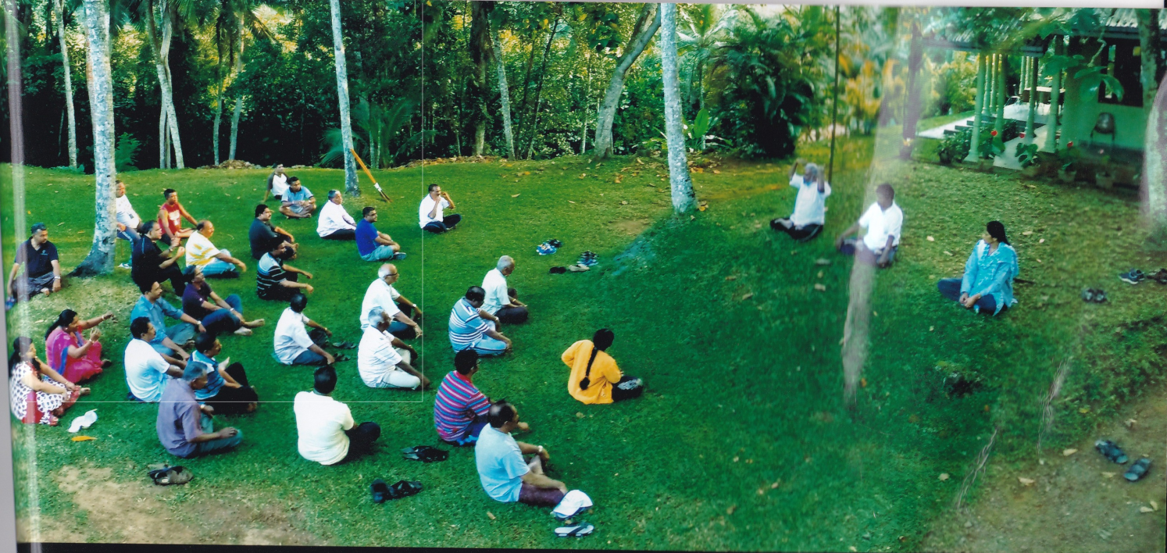

10. Visit to Kandy and Galle:

The delegates also visited the famous Buddhist ’Temple of Tooth’ in Kandy and the Hanuman Mountain and Peace Pagoda of Galle District.

Sd/-
Dr. Abraham Karickam
02/03/2015

