

**LOVE OF GOD AND LOVE OF THE NEIGHBOUR  
(Door to door meet the diversity, Heart to heart we greet the Unity)**

**Tolerance and Rainbow..**

Tolerance and rainbow has different meaning by word and definition. But they has same meaning in beauty. Tolerance is when we appreciate other people’s decissions, path, faith, and much more. Tolerance is understanding other, that is really such a blessed feeling. And rainbow, it has much colors in one view. And the colors are different in one another. Red, orange, yellow, green, blue, pink, and purple. But their looks beautiful in the color of harmony. Tolerance and rainbow they are beautiful in their difference. Because they can appreciate one another, together, the colors of rainbow makes such a beautiful view from God. How it could be a harmony, when all colors just combined in one color? It can be a harmony because it has much colors and different. The colors may different one another. But, it combined perfectly. Perfectly. Just like the tolerance, when it apply in our way, all the difference will never looks like a difference, it just like a harmony. There is a beauty in a diversity. Because everyone is perfect in their ussual way. Just appreciate, and cares another, and all difference will looks like the rainbow, colorful. The colors of differences, it becomes a perfect harmony in our life.



Quote : “Peace is more than the absence of war. Peace is accord. Harmony.” –Laini Taylor

**Unity in Diversity**

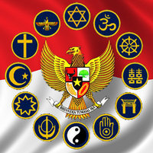 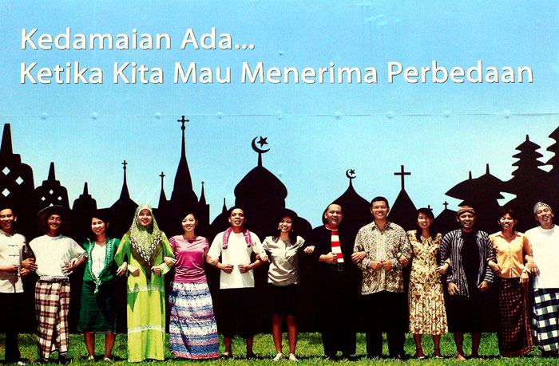 “Bhineka Tunggal Ika” (Sanskrit) or “Unity in Diversity” is an Indonesia’s national motto. It articulates the diversity that shapes the country. Indonesia is a sovereign state in Southeast Asia and Oceania. Indonesia is an archipelago comprising thousands of island with an estimated population of over 252 million people, making it the world's fourth most populous country. There is so much differences here. In culture, language, religion, and other. We appreciate one another. It becomes a habit in our life to make a tolerance with another. And we learned about the tolerance since we’re in kindergarten or when we’re younger. When we are in formally school we always get the lesson about the tolerance minimum once a week. And in our life, we make much interaction with interfaith peoples.While religious freedom is stipulated in the Indonesian constitution. The government officially recognizes only six religions : Islam, Protestantism, Roman Catholisism,Hinduism, Buddhism, and Confucianism. Indonesia is the world's most populous Muslim-majority nation, at 87.2% in 2010, with the majority being sunni(99%). The shias and Ahmadis rescpectively constitute 0.5% and 0.2% of the Muslim population. On 21 May 2011 the Indonesian Sunni-Shia Council (MUHSIN) was established. The council aims to hold gatherings, dialogues and social activities. It was an answer to violence committed in the name of religion. Seven percent of the population was Christian, 1.7% Hindu, and 0.9% Buddhist or other. Most Indonesian Hindus are Balinese and most Buddhists in modern-day Indonesia are ethnic Chinese. Though now minority religions, Hinduism and Buddhism remain defining influences in Indonesian culture. Islam was first adopted by Indonesians in northern Sumatra in the 13th century, through the influence of traders, and became the country's dominant religion by the 16th century. Roman Catholicism was brought to Indonesia by early Portuguese colonialists and missionaries, and the Protestant denominations are largely a result of Dutch Calvinist and Lutheran missionary efforts during the country's colonial period. A large proportion of Indonesians—such as the Javanese abangan, BalineseHindus, and Dayak Christians-practice a less othodox, syncretic form of their religion, which draws on local customs and beliefs.

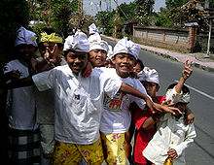 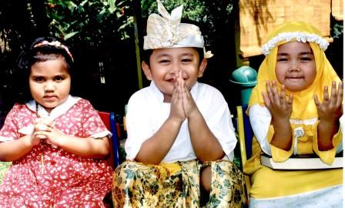

And give the warm greet to the Interfaith Tolerance. Set the cultural carnival or other events as the fun way to learn more about the diversity, especially for the Interfairth diversity. That may everyone can interest and join with the event. And for the children they can learn more about the tolerance, and may they will see the diversity as the beauty and harmony, not a different. And hope that they will grow as the peoples who appreciate the tolerance, and save the diversity. I hope so..

#Quotes : “If we cannot end now our differences, at least we can help make the world safe for diversity.” -John F. Kennedy

**Interfaith Tolerance in Islam..**

Islam, like Judaism and Christianity, believes in prophets and messengers of God. That is one interesting way of understanding the Islamic view on freedom of religion is to look at the role of the prophets and messengers. And the messengers, had they been sent to forcefully bring the people into their teachings? Were the messengers ordered by Almighty to impose their teaching upon the people by sword? Abolutely not! The messengers, they are a teacher, a leader, an intercessor. On their mission, the prophets teached with patience and gentle. Without violence and obligation. Look at the Noble Qur’an :

“(And as for My messenger,) there is no (obligation) on him except to deliver (the message). God knows what you expose and what you conceal”. (Qur’an 5:99)

In Islam, tolerance is not only an instruction or suggestion, it is become a must and obligatory to all muslim to respect, appreciate and tolerant to other, especially for Interfaith tolerance. It is according by the Noble Qur’an :

Say, “O disbelievers, I do not worship what you worship. Nor are you worshipper of what I worship. Nor you will be worshipper of what I worship. For you is your religion, and for me is my religion.” (Qur’an 109:1-6)

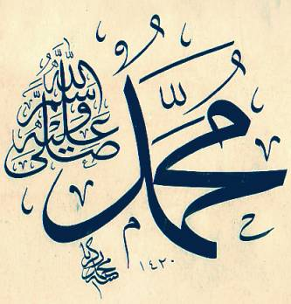 As a Muslim, Prophet Muhammad (PBUH) is the most perfect role model for me. I got learn a lot from him. Like when Prophet Muhammad migrated to Medina, he found that besides those who hid accepted Islam, there was a large Jewish community in that city but this did not bother him. He did not contemplate on forcing them into the Fold of Islam, nor making a violence in the name of religion. Instead, he made a peace agreement with them and called them ***ahlul kitab*** - the people of the Scripture. This was indeed the supreme example of tolerance shown towards the followers of other religions. And the peace agreement between the Prophet (PBUH) and the Jews of Medina dearly guaranteed the physical safety and security of the Jewish community and also the freedom to practice their religion freely. So we can see that even it is historically, the Prophet was prepared and ready to live in peace with other monotheistic followers, especially Judaism and Christianity. And the Prophet said, “Whoever does injustice to a protected non-Muslim, then I will be his enemy (on the Day of Judgement).

Quote: “Christian, Jew, Muslim, Shaman, Zoroastrian, stone, ground, mountain, river, each has a secret way of beingwith the mistery, unique and not to be judged.” –Rumi

**Let’s share the Love..**(Door to door greet the unity)

Can you find the unity without the differences? No, you can not. Because the differences arise when we expect for unity. The difference will be beauty with the tolerance. So lets share the love from the nearest you. Careful with our ego, and give the warm greet to the tolerance. And how to take children and young adult to take part on this event? Just try to let them know about what is the World Interfaith Harmony Week, make a promotion and give them explain about the event they can make by personally or with their group or their own organization. Spread to them about the mission and what they can change with their effort. They can be the Peace Maker in this world, with their tolerance, with their love to their neighbour..

# Love of God and Love of the Neighbour..

1 . Meet with Permata Ibu Hospital’s employees

* Shared about the World Interfaith Harmony Week
* Heart to heart discussion about Interfaith Tolerance
* Seek support for the event
* Spread the event

2 . Meet with AIUEO Learning Center

* Meet the teacher and promote the World Interfaith Harmony Week
* Help the children to be more tolerance with their interfaith friends
* Seek support for the event

3 . Meet with students of Letris Indonesia Vocational High School

* Meet the teacher and promote the World Interfaith Harmony Week
* Meet the students and promote the World Interfaith Harmony Week
* Explained to the students about Interfaith Tolerance and about the importance of tolerance
* Make an Interfaith discussion
* Invite them to join with the event or create their own event
* Explained the steps to create an event
* Gave them support that their effort can change the world to be better place to life
* Seek support for the event

## Finally..

Im so grateful knowing that still there is so much people who really hoping peace and respect other even with all the difference. Thank you for United Nations and especially for World Interfaith Harmony Week program and all peoples who take efforts. That may we still can remember that God sent us as His servant, and He love to them who makes peace, and He dislike to them who makes disunity and corruption.

**# LOVE OF GOD AND LOVE OF THE NEIGHBOUR**