Aware Center Report for Interfaith World Harmony Week Activities
Febrauary 1-4, 2015
This Report is aimed to give a brief summary of AWARE Center mission and main events and activities conducted by AWARE staff in an effort to support the Center’s mission. This Report covers activities occurring between autumn 2008 to autumn 2009. The Report also highlights extraordinary events hosted by AWARE Center to promote the inter-cultural dialogue.

Report Date: February 8, 2015
INTRODUCTION
The Advocate for Westerners-Arab Relations center is a non-profit organization working for promoting positive, constructive relations between Westerners and Arabs by organizing social activities and information services related to Arab and Islamic culture. The AWARE Center was established in 2003 by a group of Arabs and Westerners whose aim was to foster better understanding between the West and the Arabs through dialogue and friendship. It is through culture that we preserve our heritage, that we express our creativity and that we share our individuality with the world. Over the years, AWARE has built a reputation as a consistent, trusted, and reliable resource for westerners in Kuwait.

Our Core Values

AWARE is guided by Arab and Islamic humanitarian values which advocate peaceful co-existence between cultures and civilizations. Among key values aware promotes are tolerance, better understanding and mutual respect between the westerners and Arab/Islamic world.

Executive summary of the event

In order to commemorate and celebrate the Interfaith World Harmony Week, the AWARE Center invited Reverend Deborah Lindsay form First Community Church in Columbus Ohio to Kuwait for the purpose of promoting interfaith dialogue and better understanding between different faiths. Reverend Lindsay is famous for her efforts in building bridges between Christians and Muslims across the United States. Reverend Lindsay conducted several lectures and television interviews as well as successful meetings with officials and religious leaders in Kuwait.

Desired outcomes
- Identify and suggest methods to achieve the goal of bridging the gap and formulating a better understanding from both sides; Muslims and Westerners.

- Identify and establish a course of action which can be taken by all concerned individuals allowing the public to move forward and increase awareness and better understanding between Muslims and Westerners.

- Promote the importance of interfaith dialogue and activities in order to achieve the desired harmony.

The program

Day one
On Sunday, February 1, Reverend Lindsay met with Dr. AbdulMohsin AlKhurafi, the Secretary General of Ammana Foundation to be introduced to the mission of Kuwait Public Awqaf Foundation (KAPF) – which is “Developing the society and satisfying its various needs through the call for Al-Waqf and the performance of all that is related to its affairs including its fund management and investment and the disbursement of its income according to the conditions set by the endower and to the Waqf legitimate purposes.” The KAPF is similar in its workings to a Trust in the Western World. Dr. AlKhurafi explained the manner in which the money is utilized and invested in such a manner that it is available for future generations. Later that day, she met with a group of women activists to discuss with them the importance of interfaith dialogue and ways of corporations.
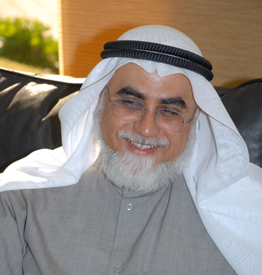
Dr. AbdulMohsin AlKhurafi

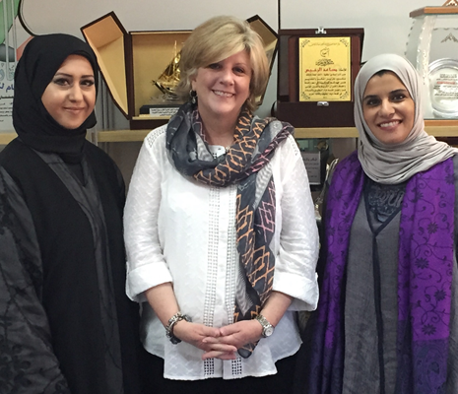
Rev. Dr. Deborah with the Islamic Women Leaders

In the evening, Reverend Lindsay visited the Historic Americani Hospital, now known as the Americani Cultural Center, which was established in the early 1900s by the Missionaries built friendships, shared their skills, and worked together with the Kuwaitis for a common cause.

Day Two
On the 2nd of February, Reverend Lindsay visited the Supreme Consultative Committee which is in charge for the implementation of the processions of Muslim sharia law. Reverend Lindsay met with Dr. Essam AlFulaij, the Deputy Director of the committee. Dr. Alfulaij discussed with Rev. Dr. Deborah the true meaning of Shariah. He explained that the Shariah does not focus only on punishment; rather it encourages development of communication, economy, education and values.
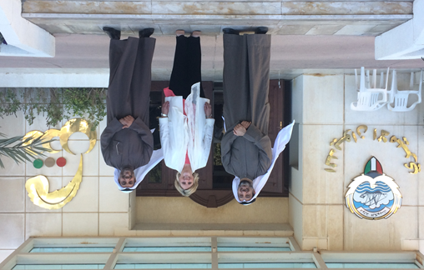
Rev. Dr. Deborah with the Deputy General Secretary of
Shariaa Council & AWARE Center General Manager
Dr. Ebrahim Adsani
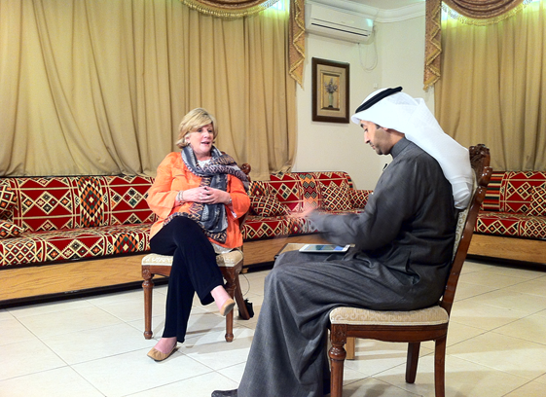
Rev. Dr. Deborah’s interview with AlRai TV

In the evening Reverend Lindsay was interviewed by AlRai, a local TV channel & by a reporter from KUNA (Kuwait News Agency) to discuss the purpose of her visit to Kuwait and to share her experience in Kuwait.
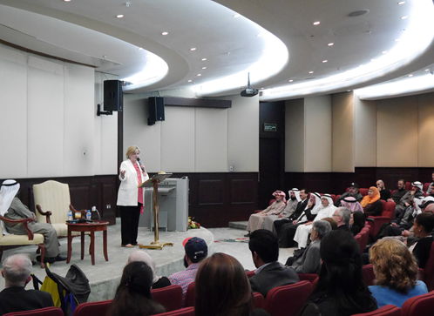
Rev. Dr. Deborah at the
Public Authority of Industry
In the evening, Reverend Lindsay gave a lecture at the Public Authority of Industry on the topic “Finding Common Grounds: Overcoming Negative Images” which was well-attended. She started her lecture by stating that the UN Interfaith Harmony Week is an outcome of Common Word Initiative which began with an exchange of open letters between the Muslim leaders from around the world to the Christian community. During the lecture, she emphasized the importance of dialogue & highlighted shared values between Islam & Christianity such as compassion, honesty & peace. She also praised the AWARE Center saying that it is a significant & important center for interfaith & intercultural activities.
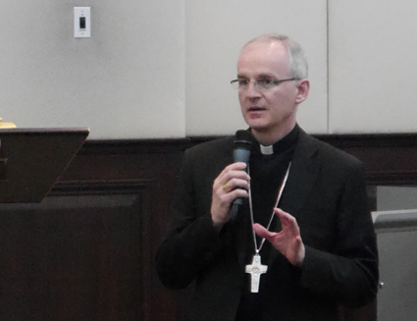
Archbishop Petar Rajic addresses the audience
Also attending the lecture was head of the Vatican mission to Kuwait, the Apostolic Nuncio to Kuwait, Yemen, Bahrain, Qatar & UAE and Apostolic Delegate to the Arabian, Archbishop Petar Rajic. He was quoted as saying “Kuwait has had diplomatic relations with the Holy See for almost 48 years now, but even before that there were Catholic communities here in the country that were small initially but grew over time.”
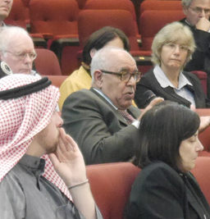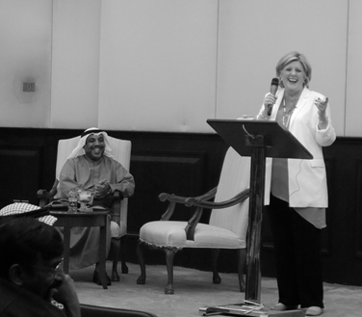
Guest Participation in the Question & Answer Session

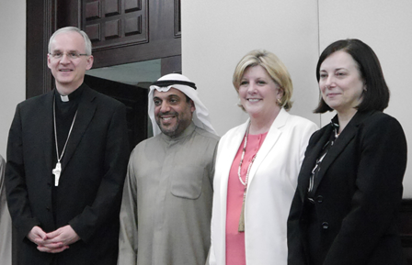
From the left: Archbishop Petar Rajic, AWARE General Manager Dr. Ebrahim Adsani, Rev. Dr. Deborah & Canadian Ambassador to Kuwait H.E. Martine Moreau
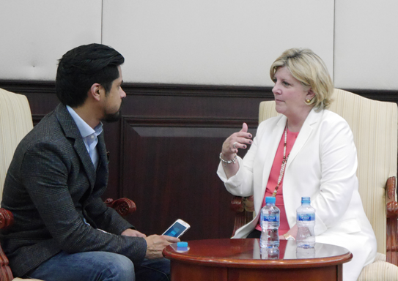
KUNA Reporter Samie Al-Dulaimi interviews
Rev. Dr. Deborah

Day Three
On Tuesday, February 3, Rev. Dr. Deborah visited the Arab Organization Headquarters. The Arab Organizations Headquarters Building is home to four major Arab organizations: the Arab Fund for Social and Economic Development, OAPEC (Organization of Arab Petroleum Exporting Countries), the Inter-Arab Investment Guarantee Corporation and the Arab Maritime Petroleum Transport Company.
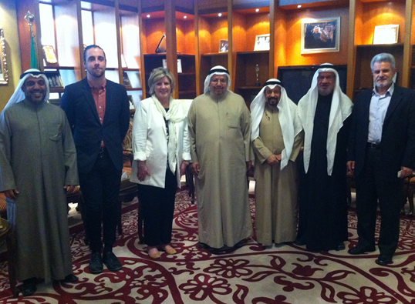
Rev. Dr. Deborah with the Deputy Minister of Islamic Affairs Dr. Adel AlFalah
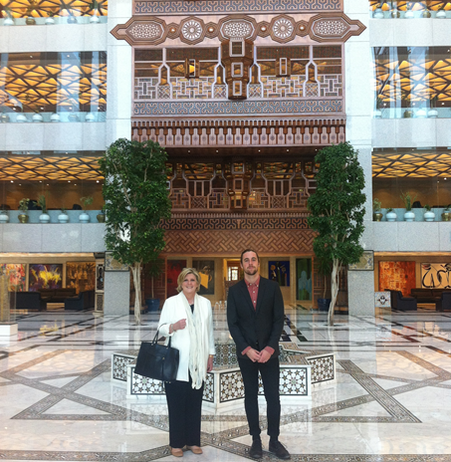
Rev. Dr. Deborah with her son at the Arab Organization Headquarters

The tour was followed by a meeting with Dr. Adel AlFalah, the Deputy Minister of Ministry of Islamic Affairs, who emphasized moderation in Islam and detailed the activities of the Ministry in spreading peace and promoting the importance of dialogue.
In the evening, Rev. Dr. Deborah went on a tour of the Grand Mosque, which is the largest and the official mosque in the country of Kuwait. After the tour, she gave her second lecture entitled “The View of Religious & Tolerant Co-existence”.
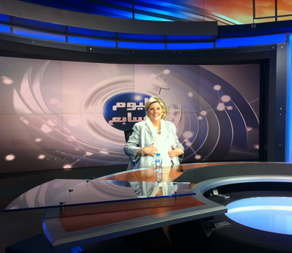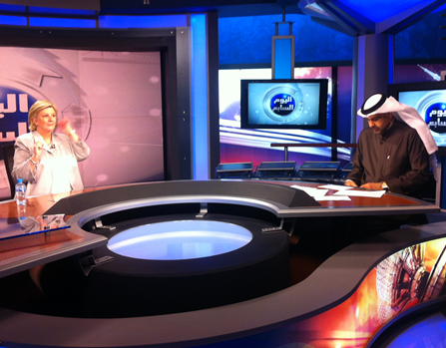
Rev. Dr. Deborah at set of The Seventh Day (AlWatan TV)
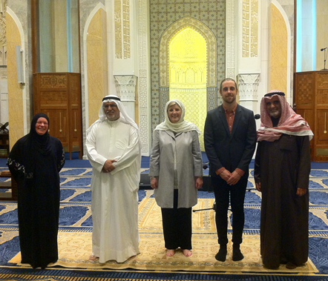
Rev. Dr. Deborah at the Grand Mosque

In the evening Reverend Lindsay was interviewed by a famous anchor Mr. Ahmad Al-Fahad on his famous show “The Seventh Day” by AlWatan TV were they discussed the importance of interfaith dialogue. The show has lots of viewers both in Kuwait and outside Kuwait.

links to rev. deborah activities in kuwait

Alwatan TV interview with Rev. Deborah on “The Seventh Day” show.
https://www.youtube.com/watch?v=piFnPbbFzNQ

An article on Rev. Deborah visit to Kuwait by Alkuwaitiya Newspaper
http://alkuwaityah.com/Article.aspx?id=184411

An article on Rev. Deborah visit to Kuwait by KUNA
http://www.kuna.net.kw/ArticleDetails.aspx?id=2422605&language=en

An article on Rev. Deborah visit to Kuwait by Alwatan Newspaper
http://alwatan.kuwait.tt/articledetails.aspx?Id=416198

An article on Rev. Deborah visit to Kuwait by Kuwait TV
http://www.media.gov.kw/News/show_news_details.aspx?id=22347&cid=6

STUDENT RESPONSES TO THE KUWAIT DIALOGUES

“Media inaccurately portrays stereotypes about Arab Muslim living based on what they want you to believe. This is clear from the discussion with fellow Arabs and Muslims.”
Anita Tracy – Pennsylvania

“Talking directly to someone is much more effective and reliable than a Google search. Personal exchange is most important.”
Ahmad Kandar – Egypt

“It is important that we remember to look through several points of view before making any conclusions. We should assume that most of our assumptions about others are wrong and interfaith dialogue proved that”
Mafaz Suwaidan –Kuwait

“For me the most important thing that came up in the interfaith dialouge was how much we could actually connect and deepen our understanding not only of one another, but of how our cultures as a whole perceive one another. Once we moved past the normal barrier of Americans asking questions and Muslims answering, we were able to get to more
‘neutral’ ground that everyone could play an equal part of. ”
Beatrice Hunt – Florida

CHANGING ATTITUDES

During the interfaith dialogue we asked the attendees a series of pre and post dialogue questions designed to measure the degree to which their attitudes shifted as a result of the conversations with counterpart attendees. The results are encouraging. For example:

Changing Attitudes about the Middle East
“It is safe for Westerners to visit and live in Arab‐Muslim Middle Eastern countries.”
Pre dialogue response: 34 percent “strongly agree” or “agree”
Post dialogue response: 75 percent “strongly agree” or “agree”

Changing Attitudes about the West
“When I think about the west, I immediately think about a nations that’s is arrogant and wants to dominate the world and change our way of life”
Pre dialogue response: 61 percent “strongly agree” or “agree”
Post dialogue response: 15 percent “strongly agree” or “agree”

CONCLUSION
Interfaith dialogue is extremely important, specially now a days. World Interfaith Harmony Week is a way to promote harmony between all people regardless of their faith. Recognizing the imperative need for dialogue among different faiths and religions to enhance mutual understanding, harmony and cooperation among people, the AWARE Center conducted very successful events during that week to the spread the message of interfaith harmony and goodwill. In conclusion, interfaith dialogue proved to be an important way to promote peace and change attitudes and as we move forward and get better at interfaith dialogue and discussing the common issues that we all share, we are certain that attitude change will be even more striking and pronounced.

