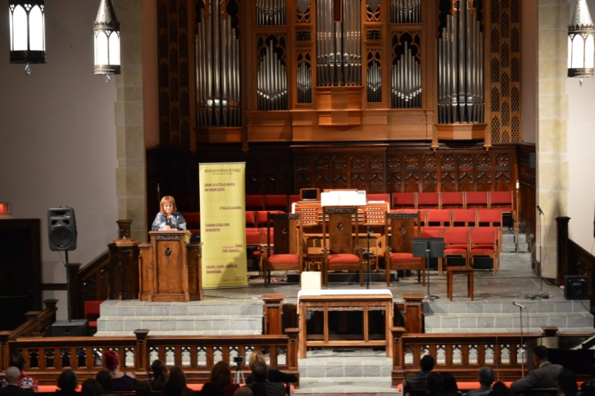
Interfaith Paths to Peace (IPP) third annual Community Peace Concert took place with the theme of “Call to Harmony” on Saturday, February 3rd, 2018 at St. Paul United Methodist Church in Louisville, KY with 300 guests in attendance. The concert was led by the renowned jazz pianist Harry Pickens, who opened the concert with a piano solo piece that he composed for His Holiness the Dalai Lama. IPP director Haleh Karimi welcomed guests, she spoke about the purpose of the community peace concert, which is held each year as part of the United Nation’s World Interfaith Harmony Week to celebrate the commonality of one human race. She said that the Community Peace Concert was conceived in order to promote inter-religious and inter-cultural dialogue for global unity and peace through music, and emphasized that while there are many who seek to divide us, this concert brings us all together as one – regardless of our faiths, traditions, or backgrounds.

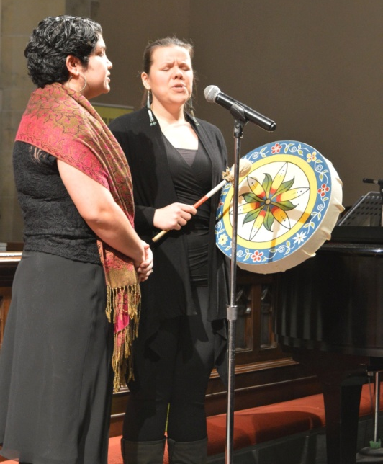
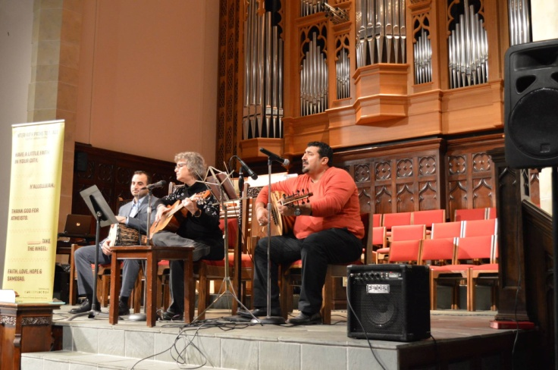
The first musicians were Rabbi Gaylia R. Rooks of Congregation Adath Israel Brith Sholom, who performed with Dr. Louie Bailey from The Louisville Presbyterian Theological Seminary. The duo performed a rendition of Ave Maria. The rendition was first performed by Noa, an Israeli singer who performed the piece during a 1994 performance in front of Pope John Paul II in Vatican City. Rabbi Rooks also performed a Jewish-Islamic piece drawn from the Book of Psalms with Muhammad Alani and Khaldoun Almousily, who accompanied her on oud and drums.

Next, Shabnam Mockon, Jessica Gaines, and Penelope Quesada from the Louisville Baha’i Community performed “Listen” by Red Grammer, a Baha’i children’s singer. Jessica’s voice carried the message of the song while Shabnam performed on piano and Penelope performed on flute. Shabnam and Jessica performed a second song that was derived of the words of Baha’u’llah. Jessica spoke about the Baha’i faith, stating that Baha’i sees all religions as flowers from the same garden, and that Baha’u’llah was The Return, but that there were many others before him and that there would be many after him. She said that the Baha’i faith was but a stepping stone in the line of religions of the world.

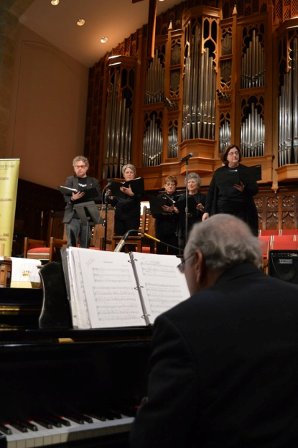
The next group to perform was the Shir Chadash Choir from The Temple - Congregation Adath Israel Brith Sholom, accompanied by Dr. Louie Bailey of The Louisville Presbyterian Theological Seminary. The group performed a selection of Jewish works that emphasized creating peace within all countries and nations through the passionate belief of G-d. Their choir’s name, Shir Chadash, derives from the Jewish phrase meaning “A New Song”. Their choir is composed of singers of many faiths and invites anyone who has a song in their heart to join them.

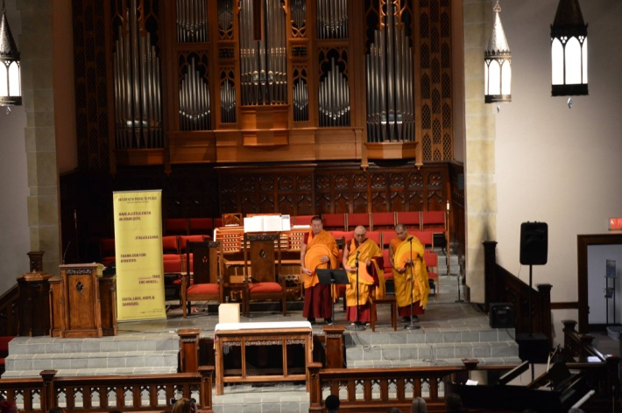
The last group to perform in the first act were Geshe Rapgyal, Geshe Sonam, and Geshe Gedun, three Tibetan Monks from the Drepung Gomang Center for Engaging Compassion. The Monks shared a prayer from His Holiness the Dalai Lama. Geshe Rapgyal, Geshe Sonam, and Geshe Gedun are all resident Monks of the Drepung Gomang Center for Engaging Compassion, located in Louisville, Kentucky. The center strives to implement the vision of Buddha within and beyond Louisville, as well as practice an interfaith vision with other faith leaders that truly engages compassion with all people.

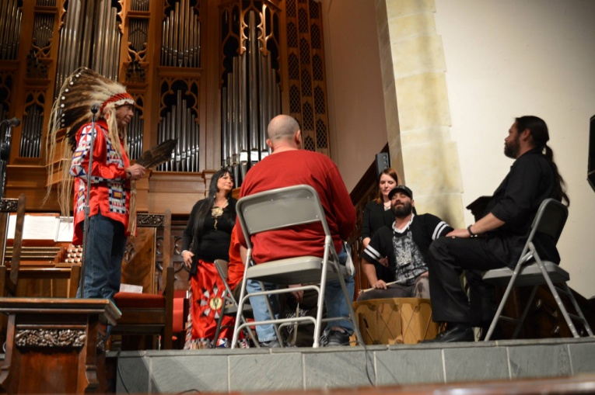
After a brief intermission, the Native American Chief Steve McCullough-Iktomi Sha and Mary EagleHorse presented Donovan White and the Salt Creek Unity Drummers, a group representing the Lakota people. Chief McCullough blessed the singers, drummers, and drum itself with tobacco and recited a prayer before the performance. In his prayer, Chief McCullough spoke about feeling the presence of Grandfather Spirit in the space, and how everyone has a guiding spirit that protects them.

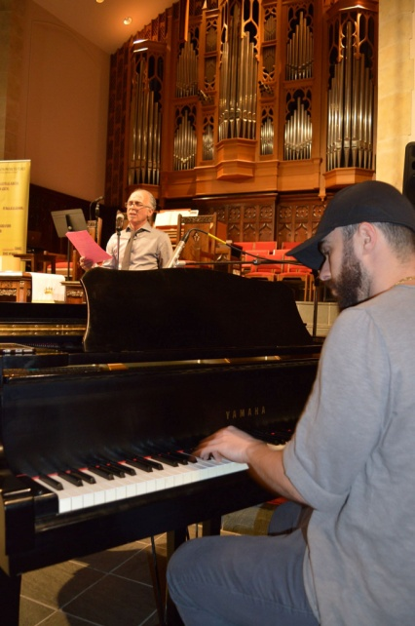
Next, our Muslim Rumi soloist Masoud Farokhi Louie recited selected works from poet Rumi, while his son Dustin Que performed on the piano. Dustin talked about Rumi, who was an Islamic scholar and Sufi writer from Persia, whose works influence literature throughout most of the Arab and Mediterranean world. Rumi’s work, which is revered as the most popular in America, often spoke of love, which was the focus of this duo’s performance.

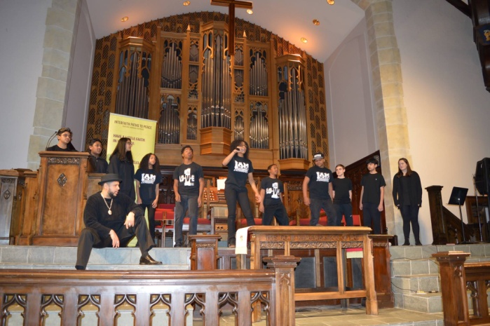
Then, we had the youth (13-19 years old) perform their “Call to Harmony” through rap music. The Mighty Shades of Ebony from Meyzeek Middle School and the Global Alliance from duPont Manual High School, two multi-ethnic and multi-faith groups who combine education with hip-hop. Their songs were a passionate combination of justice for the environment, justice for education, and racial justice through interfaith and interethnic collaboration.

Our last participants were the choir composed of combined members from all Louisville churches of the Church of Jesus Christ of Latter-Day Saints. The combined choir, composed of a large group of men, women, and children performed three selected works. The three songs that they sang were chosen with the purpose that they were beautifully written and highlighted that, as the Church believed, we were all God’s children. This was the first time their congregations participated in an interfaith event.

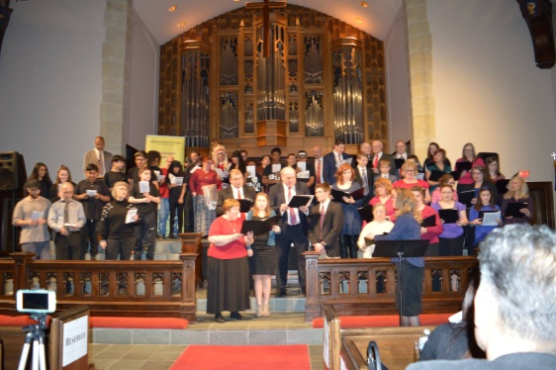
As a grand finale of our call to action, all performers, a total of over 60 peacemakers, gathered on the stage and with Harry Pickens on the piano, led an ensemble with all guests singing the song “Get Together” by The Youngbloods. This united participation of everyone present at the Peace Concert, singing this song, reminded everyone that peace through interfaith dialogue is possible and that each one of us is an agent for peace in our community.

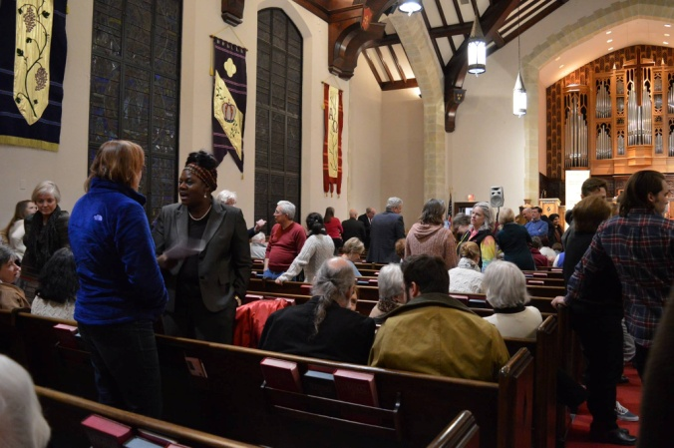
Haleh Karimi closed out the evening by thanking the diverse group of musicians and performers who participated in the event, as well as the guests who attended the concert, and invited everyone back for the fourth annual community peace concert in 2019. She once again spoke to us collectively about the significance of being part of one race – the human race – and that tonight’s events was an inspiration for them to work on creating a world that is filled with love, peace, and harmony, starting with Inner Peace.

IPP received many testimonials in regards to the community peace concert. One guest remarked, “Thanks for all you have done and are doing to promote unity and harmony in our community!!” Another attendee commented, “The concert was simply harmonious and most effective to bring us together as one. Thank you for your work for peace!” And yet another guest stated, “We loved the concert, the diverse group of faiths, nationalities, and ages were just beautiful to watch and hear their sound for the call to harmony.” Their affirmations were a testament to the community’s active work in inclusiveness and peace.

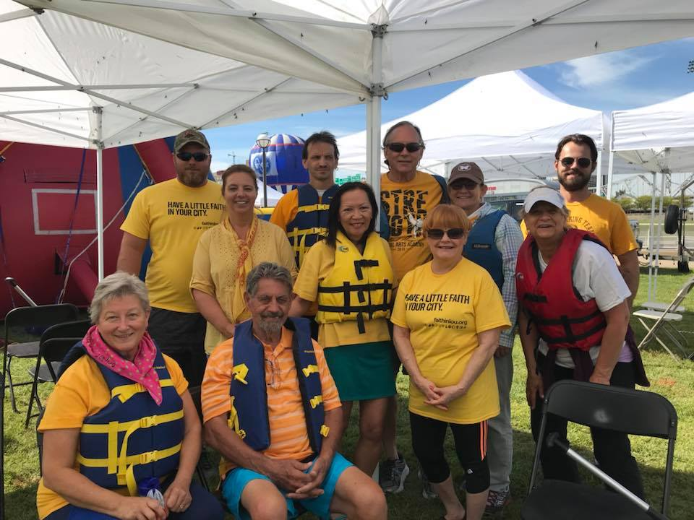
IPP Board Members Al Klein, Alice Wright Belknap, Allan Weiss, Andy Bronger, Angela Yeasayer, Anne Walter, Bryan Warren, Chris Wooton, Elwood Sturtevant, Fred Gross, Fred Whittaker, Geshe Rapgyal, Helen Starr Jones, Jahangir Cyrus, Johnny Alse, Nancy Lacer, Natalie Pope, Rashaad Abdur-Rahman, Rhody Streeter, Rita Butler, Jeannie Samdani, Susan EngPoole, and Tarik Nally, in conjunction with IPP Partners St. Paul United Methodist Church, Rabbi Gaylia R. Rooks, and Harry Pickens are able to testify to the qualifications of Interfaith Paths to Peace and the work they do for the Louisville interfaith community.

