INTERFAITH REFUGEE DAY
In conjunction with the World Interfaith Harmony Week (WIHM)
Date: 3rd March 2018 (Saturday)
Venue: International Institute of Advanced Islamic Studies (IAIS) Malaysia

The humanity crisis is deteriorating over the last few decades. The world has been witnessing the escalating acts of violence, terror, oppression, and persecution leading to bloodshed, massacre, destruction of resources and economic retardation. These man-made disasters have forced people to leave their countries to escape the terrible situations. According to the United Nation, we are approaching the highest level of displacement in history. Around 65.6 million people across the globe are forcibly displaced due to war, persecution and other issues. In every single minute, 20 people are forced to leave their home. This figure includes 22.5 million refugees and 10 million stateless people who are denied the basic human rights such as education, healthcare, employment and freedom of movement. Sadly, 51 per cent from the total number of the world’s refugees are the innocent children.

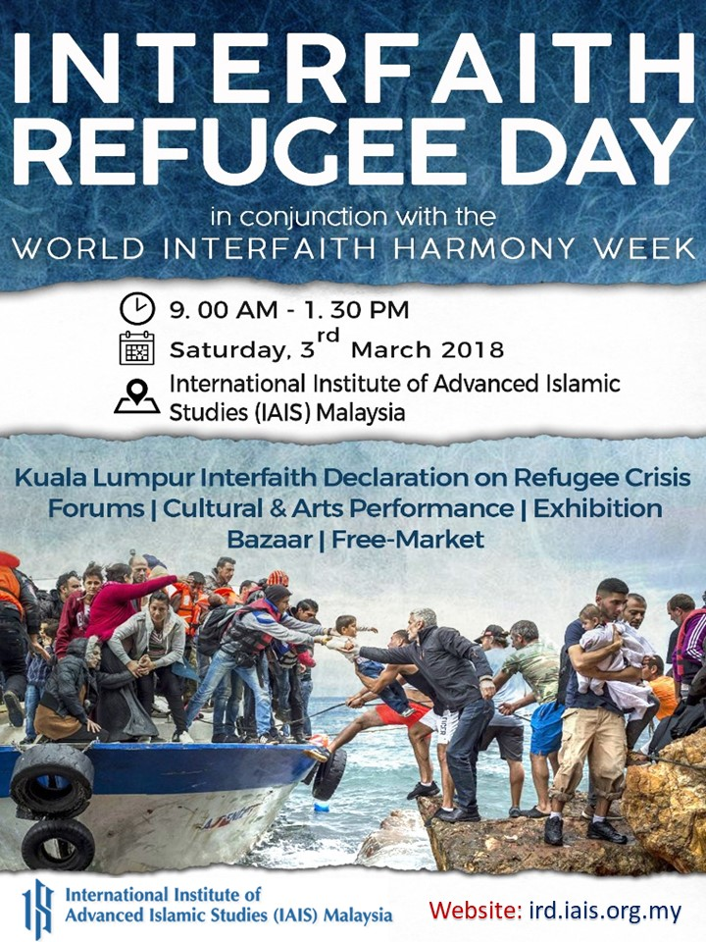
Despite the civilisational development, economic progress and sophistication of modern technologies, the humankind struggles to reclaim its basic sense of humanity – the natural interest towards the well-being of others. We have long lost our spiritual good of compassion, love and kindness. The corruption of minds and souls result in greed, selfishness, covetousness, arrogance and wrath. The passions for respect, values and altruistic behaviours for the welfare of people have been taken for granted.

There is an urgency to call for peace at the conflicting zones of the world and to protect the innocents and minority group from injustice and persecution. The message of love, peace, justice and sustainability are commonly shared by all religions of the world. It is against this backdrop that the International Institute of Advanced Islamic Studies (IAIS) Malaysia felt the needs to explore the roles of religions to combat injustice, genocide, oppression and extremism. Religious institutions indeed should be the main platforms to spread the message of interfaith harmony and goodness across the globe.

In conjunction with the World Interfaith Harmony Week’s under the auspices of the United Nations, the Interfaith Refugee Day was organised by IAIS Malaysia on 3rd March 2018 under the banner of ‘Love of God & Love of the Neighbour, Love of the Good and Love of the Neighbour’. This event was meant to empower religious institutions to be the main platforms in spreading the message of interfaith harmony and goodness across the globe.
Message from the Founding CEO of IAIS Malaysia
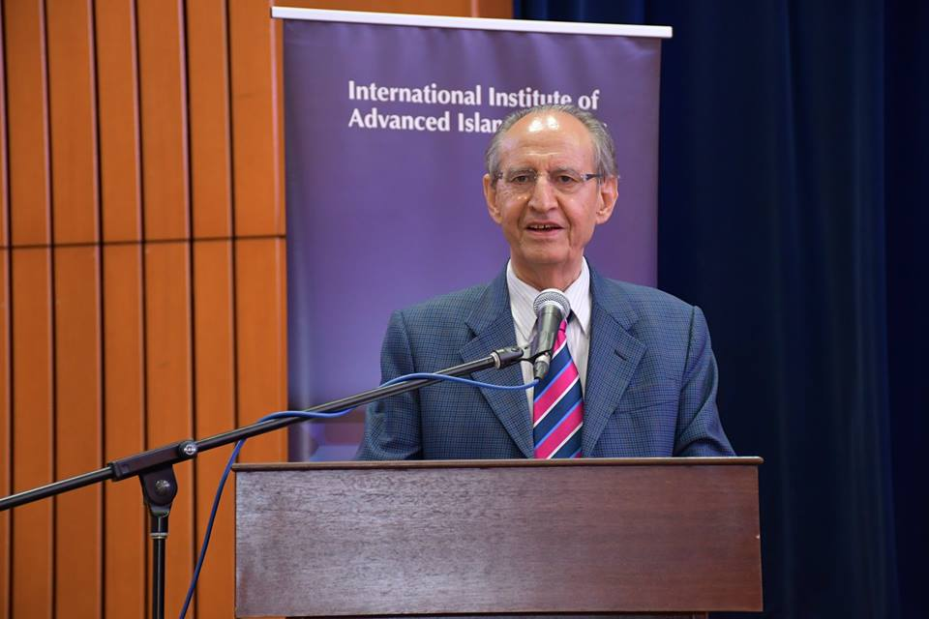

Prof. Dr Mohammad Hashim Kamali in his welcoming remarks stated that the Interfaith Refugee Day combined both happiness and sorrow; happiness because we were together for a noble cause to commemorate the World Interfaith Harmony Week. But it was also a moment of sorrow, as we mourned the devastating global refugee crisis.

In understanding the issue of refugees in Muslim historical context, we should take a lesson from the establishment of brotherhood between migrant (Muhajirun) and helper (Ansar) during Hijrah event, a journey of the Islamic prophet Muhammad and his followers from Mecca to Yathrib, later renamed as Medina. The Ansar is very generous to provide accommodation and share their belongings with Muhajirun, and they worked together to address economic problem.

To create a harmonious atmosphere between the hosts and refugees, we should always try to inculcate the sense of love, compassion, and benevolence so that we would willingly help and share what is ours to the needy. Islam encourages Muslim to love each other, to both their fellow Muslim and non-Muslim for the sake of protecting societal wellbeing. This effort will eventually provide psychological support to the refugees. "None of you truly believes until he loves for his brother what he loves for himself". (Bukhari) & "Righteousness is not that you turn your faces toward the east or the west, but [true] righteousness is [in] one who believes in Allah, the Last Day, the angels, the Book, and the prophets and gives wealth, in spite of love for it, to relatives, orphans, the needy, the traveler, those who ask [for help], and for freeing slaves..." (Al-Baqarah, 2:177)

To develop good unity between the host and refugee, we should get to know each other better, so that we will be more understanding, tolerate and pay respect to each other culture, custom, sensitivity etc. "O mankind, indeed We have created you from male and female and made you peoples and tribes that you may know one another. Indeed, the most noble of you in the sight of Allah is the most righteous of you. Indeed, Allah is Knowing and Acquainted" (Al-Hujurat, 49:13). Besides, it is also important to let each other practice different faith, because "There shall be no compulsion in [acceptance of] the religion". (Al-Baqarah, 2:256) & "... To you be your religion and to me my religion". (Al-Kafirun, 104:2-4), because the world is made for all "And We have not sent you, [O Muhammad], except as a mercy to the alameen / worlds (mankind, jinns and all that exists)" (Al-Anbiya, 21:107)

To further promote the effort to help refugee, we should take this as an "opportunity" to do good deeds and to be an example for the righteous. "Worship Allah and associate nothing with Him, and to parents do good, and to relatives, orphans, the needy, the near neighbour, the neighbour farther away, the companion at your side, the traveller, and those whom your right hands possess. Indeed, Allah does not like those who are self-deluding and boastful" (An-Nisa, 4:36) & "And Allah increases those who were guided, in guidance, and the enduring good deeds are better to your Lord for reward and better for recourse" (Maryam, 19:76) "... And whatever good you do - Allah knows it ..." (Al-Baqarah, 2:197)

Peace-making process can be actualised by bringing in a significant importance of the religious values and spiritual dimension as it contains and highlights a soft aspect of peacebuilding. "...And do not transgress. Indeed, Allah does not like transgressor’s. (Al-A'raf, 5:87), & "We have appointed a law and a practice for every one of you. Had God willed, He would have made you a single community, but He wanted to test you regarding what has come to you. So compete with each other in doing good. Every one of you will return to God and He will inform you regarding the things about which you differed.” (Al-Ma'ida, 5:48).

Apart from the World Interfaith Harmony Week Initiative, there were three important episodes that occurred in the United Nations pertaining to interfaith development, and all of them were initiated by Muslim leaders. One of them was in 1997, when talk of clash of civilisation was gaining traction at that time, President Khatami introduced the idea of dialogue of civilisations in the United Nations General Assembly. And then, in 2004, the idea of the alliance of civilisations was mooted at the initiative of Turkey and Spain. And in September 2010, Prime Minister of Malaysia, Najib Tun Abdul Razak, introduced the Global Movement of Moderates. The principle of moderation, wasatiyyah, has been celebrated and internalised as an underlying guiding philosophy of all government programmes in Malaysia.

Understanding the Global Refugee Crisis

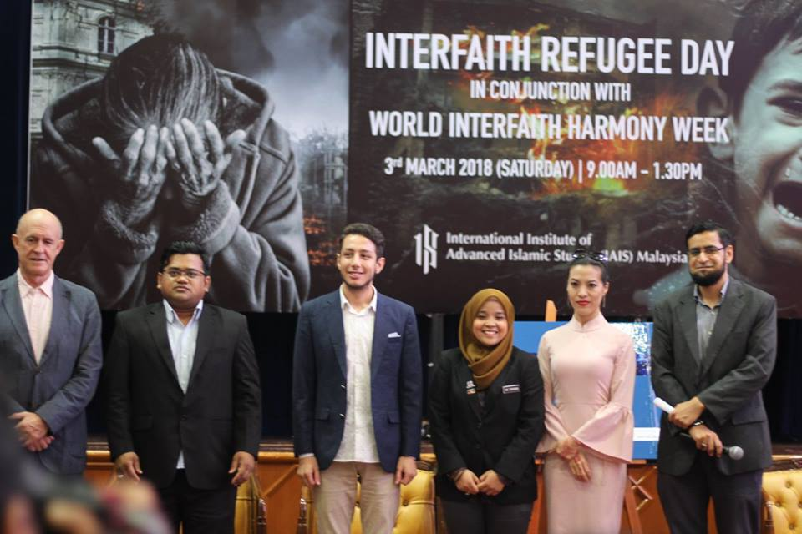
Two forums were held during the Interfaith refugee Day. The first one entitled ‘Understanding the Global Refugee Crisis - The Need for Effective Solution & Strategy for World Harmony, Protecting the Stateless and Promoting Financial Inclusion’. This forum featured activists and experts of the global refugee issues, namely: Richard Towle, Head of UNHCR Malaysia; Muhammad Noor, Co-Founder of Rohingya Project; Hasan Al-Akraa, Founder of Al-Hasan Volunteer Network; Lilianne Fan, International Director of Geutanyoe Malaysia; and Siti Zurianah Ismail of Yayasan Sukarelawan Siswa.

From Left to Right: Richard Towel, Muhammad Noor, Hasan Al-Akraa, Siti Zurianah, Lilianne Fan and Saqib Sheikh

Richard began his presentation by emphasising that the trauma of displacement has always been enormous to refugees. While acknowledging that national security is a legitimate concern of States, we cannot assure national security unless and until we start taking care of human security. Therefore, effective strategies are required to help the aggrieved people. He pointed out that the long term solution to the crisis has to be holistic by addressing the root cause of the problem in the war-torn conflict zone, while continuing giving humanitarian aid to the refugees.

Muhammad Noor drew a demarcation line between refugees and the stateless persons. Speaking on his NGO, Rohingya Project highlights grave issues faced by the refugees in terms of identity crisis, education, health care and financial sources. He suggested for a decentralized technology with digital access to empower the people. To top the plan, social entrepreneurship should be enhanced, backed by digital monetisation system, such as the blockchain technology.

Hassan Al-Akraa reminisced about his journey into refugeehood and the difficulty of resettlement process faced by thousands of refugees. Unemployment is rampant. There are many qualified engineers and doctors among the refugees, but they end up washing dishes to make ends meet. Hasan also had to wash dishes at 12 years old to support his family, and he was detained when he was 14 years old. In the spirit of “Leave a humanitarian mark behind you”, Hasan decided to volunteer to help others. He realised many refugees in Malaysia needed assistance, so he started volunteering locally and helped the needy refugees in Malaysia. Small businesses from home could be key to aid peoples’ economy besides cultural integration activities to integrate people into local culture.

The International Director of Geutanyoe Malaysia, Lilianne Fan elucidated that Geutanyoe is a humanitarian and community empowerment organisation based in Aceh, Indonesia. “Geutanyoe” is an Acehnese word means “We”. When the stranded Rohingya refugees were neglected by the global community, Acehnese villagers invoked religious and traditional adat (custom) to help them. According to her, refugees should be seen as development actors and assets who can develop vibrant private sector in Malaysia, and not as economic burden. Moving forward, adopting Global Compact for Refugees (GCR) can be seen as a renewed commitment to the international standards on refugee protection. Though there is no agreement within ASEAN currently, Bali Process is a step ahead to establishing cooperation on refugee protection and management of international migration in the region of Southeast Asia.

Volunteerism outreach at the refugee camps may induce paradigm shift of mind and soul, said Siti Zurianah. She shared her challenges in volunteering abroad in three places; Calais, Rohingya and Gaza. Challenges include facing the extreme weather (-10 degrees); bombings every night; signing death certificate in advancing agreeing to have one’s body repatriated in the event one dies in the camp and sanitary problems. Even with scarce halal foods, she had to prioritise the refugees over her own interest.

Interfaith Forum: Religious Contributions in Peace-Making Process

The second forum on ‘Religious Contributions in Peace-Making Process: Calling for Justice, Love, Compassion and Mercy’ featured speakers from multi-faith backgrounds; S. S. Datuk Abdul Halim Tawil, the Mufti of Malacca; Most Ven. Datuk K. Sri Dhammaratana Nayake Maha Tera, the Buddhist High Chief Priest of Malaysia; Jason Leong, Founder & Advisor of Association of NextGen Christians of Malaysia (ANCOM); Dr. Jasbir Singh, President of Sikh Naujawan Sabha Malaysia; and N.J. Singam, Vice-Chairman of National Religious Bureau of Malaysia Hindu Sangam. The Archbishop of Kuala Lumpur, Most Reverend Julian Leow Beng Kim also attended the programme.

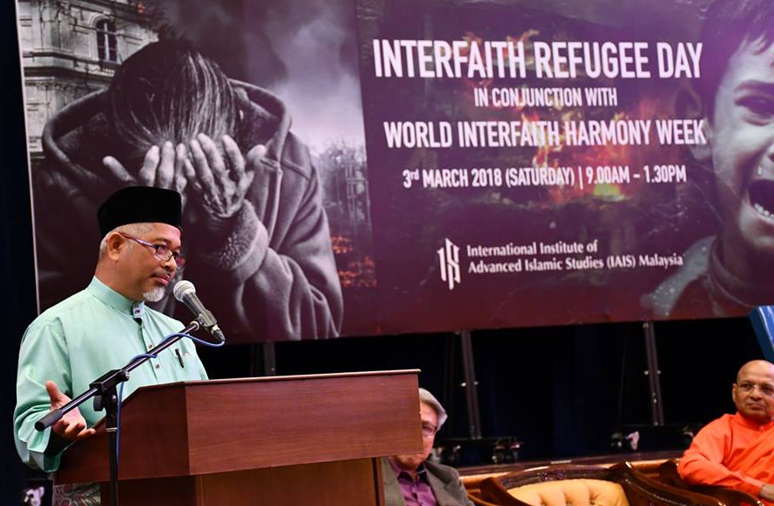
The Mufti of Malacca explained the roles of religion in peace-making process. According to him, the prophet was sent as “mercy to the worlds” and Islam encourages Muslims to promote harmony. The prayer of the oppressed will be accepted, even if they were non-Muslims, so we should “help” an oppressor by preventing him from committing oppression. In understanding “refugee” vs. “migrant”; refugees are those who want to return to homeland but migrants leave legally and want to stay abroad. Reflecting upon verse 32 of Surah Al-Maidah, Islam enunciates that whoever kills a soul - it is as if he had slain mankind entirely; and whoever saves one - it is as if he had saved mankind entirely.

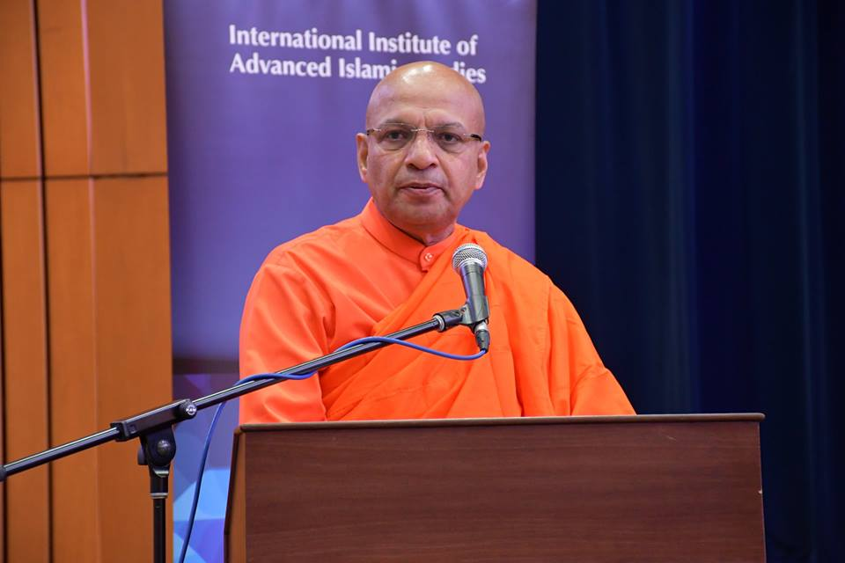
Datuk K. Sri Dhammaratana Nayake Maha Tera, focused on common values of respect, love, and kindness in reclaiming peace and justice in the conflicting areas.

The Buddhist Chief Priest of Malaysia later said that Buddhist notion of suffering (dukkha) and the five principles of Buddhism (pancha-sila) promote good conduct and prohibit any form of misconduct and misbehaviour that could harm the society.

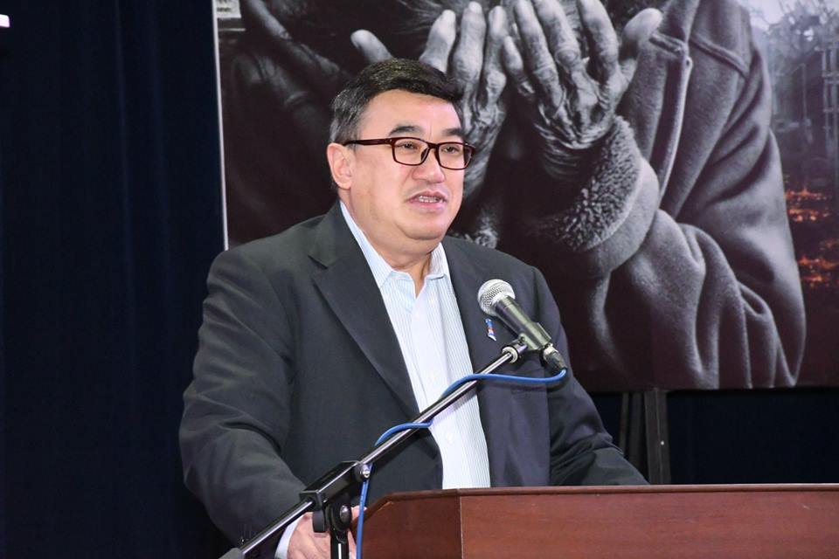
Mr. Jason Leong shared Jesus Christ's message from the Bible: “If you’ve shown kindness to human beings, you’ve shown kindness to me”. He proposed five steps on how religion can contribute to equanimity against the difficult situation: (1) respect a set of values; (2) ability to rehumanise the “dehumanised” situations; (3) ability to mobilise community; (4) have a sense of calling that gives spirit of perseverance; (5) spiritual dimension to peace-making process.

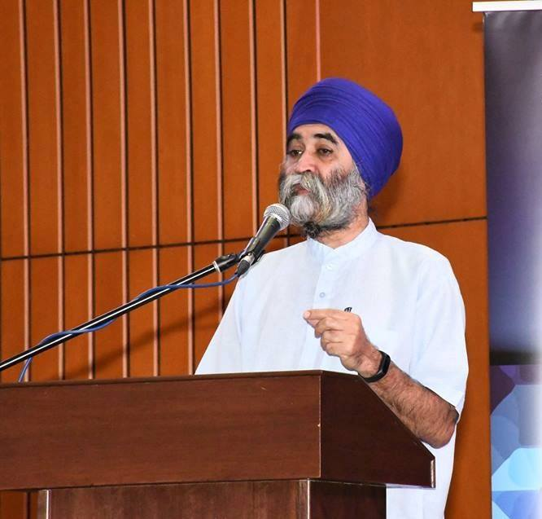
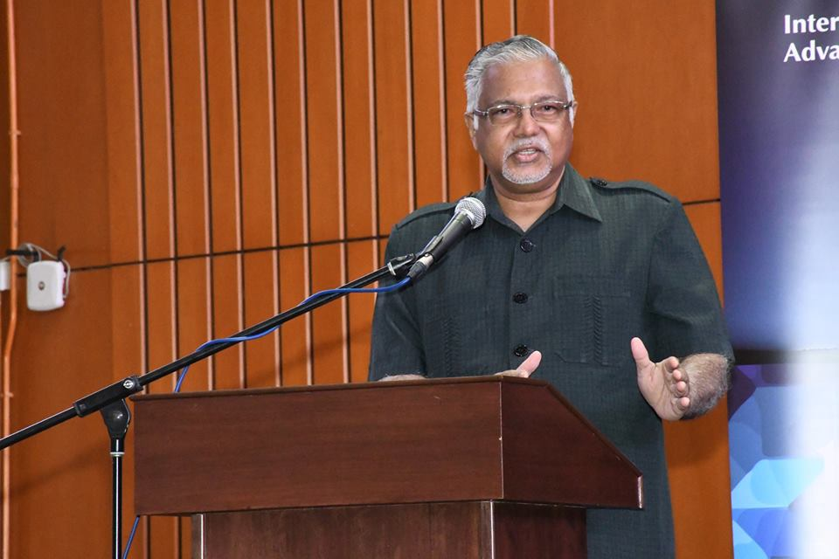

Dr. Jasbir Singh offered a remedy to the current existential crisis of having no sense of direction and purpose that we are facing- the illusory war that blocks one’s path to God- by quoting Guru Nanak’s teaching to value three important things in life: honesty, do good and share earnings with all.

Mr. N. J. Singham promoted the concepts of love, tolerance, understanding and acceptance by stating that only the ignorant and unenlightened believe that love and divinity are separate. And there is no problem without solution. Certain rules of war mentioned in Mahabharata should be implemented: (1) Peace must be observed, even in war, (2) Stop fighting by sunset, (3) If enemy surrenders, must give protection as asylum, (4) To practice dharma (righteousness) by doing right things in the right way.

Kuala Lumpur Interfaith Declaration on the Global Refugee Crisis
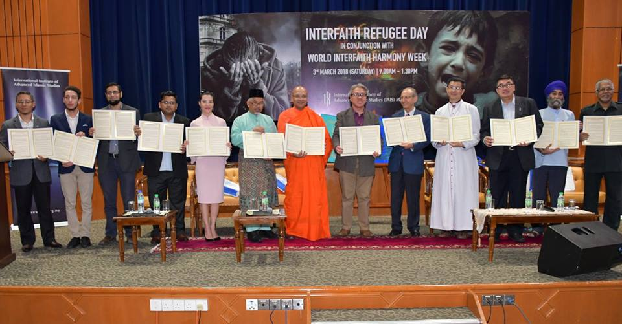

The highlight of the event was the launch of Kuala Lumpur Interfaith Declaration on Global Refugee Crisis, officiated by Prof. Dr Mohammad Hashim Kamali, the Founding CEO of IAIS Malaysia. It was a joint declaration by the participants of the programme comprising of religious leaders from Muslim, Christian, Hindu and Buddhist communities, refugee activists, humanity champions and academics. The declaration signifies a solemn commitment towards overcoming the global refugee crisis, unbound by faith and cultural differences in the name of humanity and harmony.

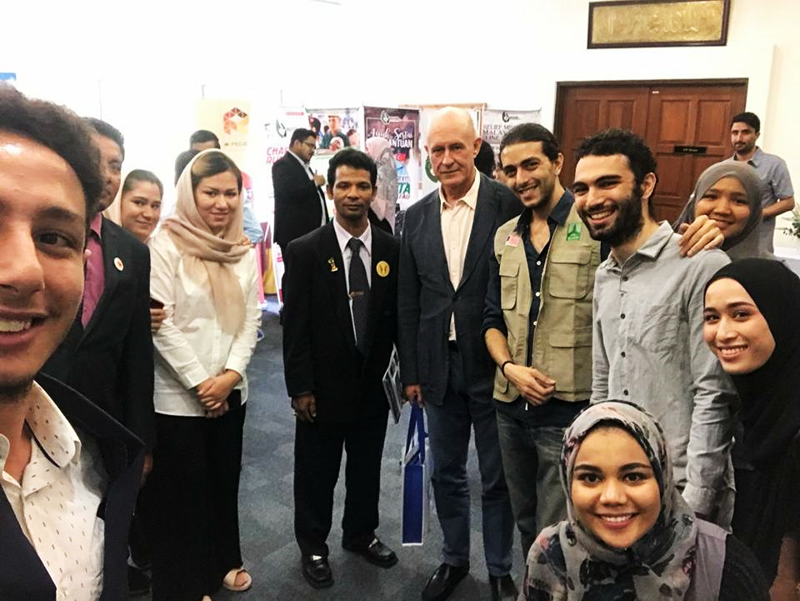

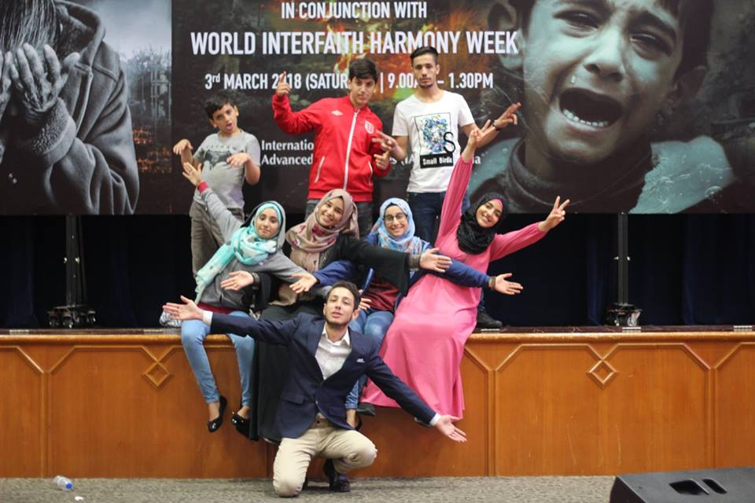

Wonderful performances were presented by the refugees. Majd Hassan and Omar Al-Khammash performed a duet of Arabic oud and flamenco guitar, displaying the layered influences and confluences of Oriental and Occidental music and culture. A theatre performance “Refugeehood” by refugee children from Iraq, Syria and Palestine directed by Hasan Al Akraa narrates the life of children refugees, facing massacre, persecution, hostility and their struggle to overcome the trauma of war. And Geeti Ara from Pakistan presented a spoken word poetry. The participants were served with foods from refugee community kitchen.
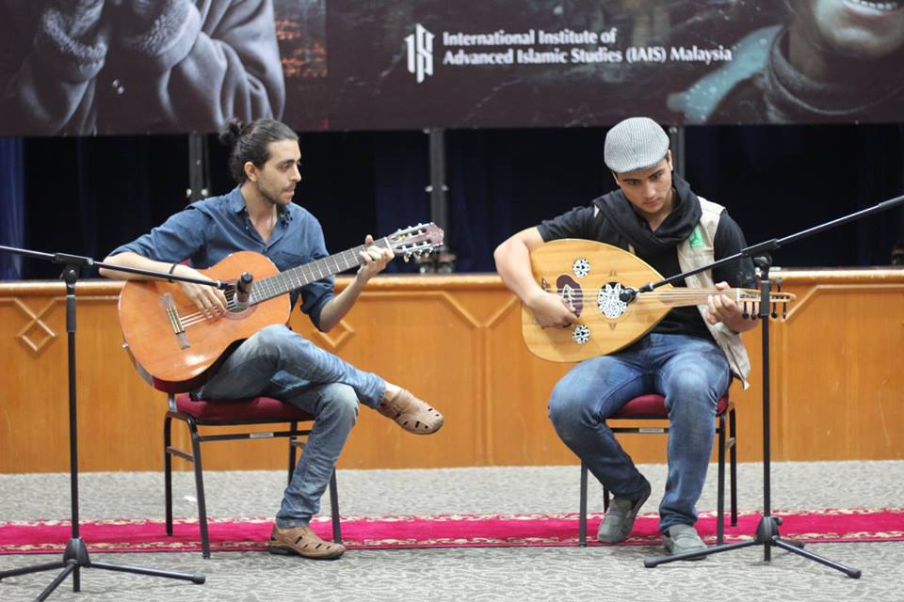
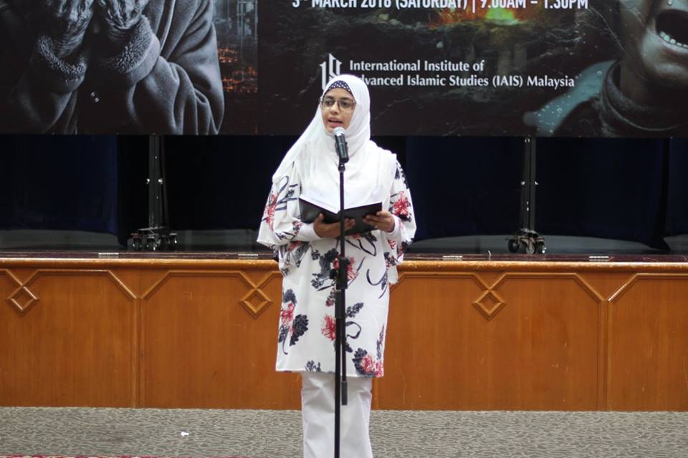

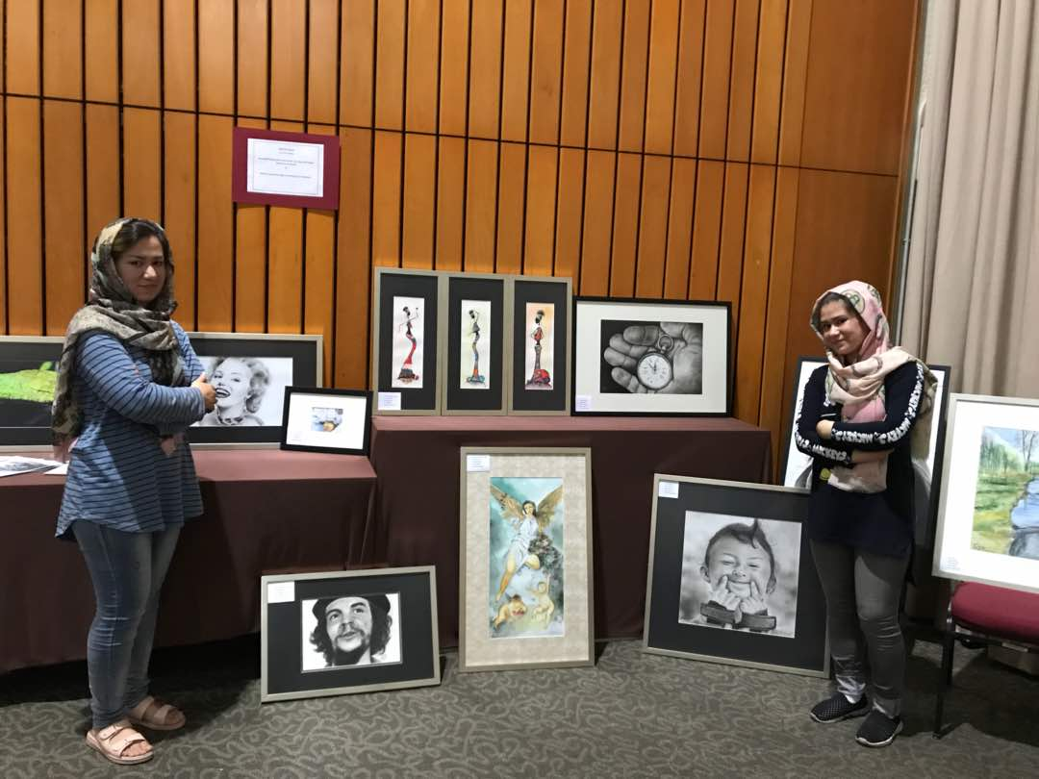
During the event, refugees from Syria, Palestine and Iraq set up exhibition booths selling confectionaries and handicraft products to the guests. Some of them displayed their artworks, like Geeti Ara and Parisha sisters from Afghanistan who opened mini art galleries featuring their fabulous masterpieces. Other organisations that joined the exhibition were Rohingya Project, Guetanyoe Foundation and Global Peace Mission. IAIS Malaysia was honoured to play a part in the noble cause of restoring humanity and spreading the message of interfaith harmony through this programme.
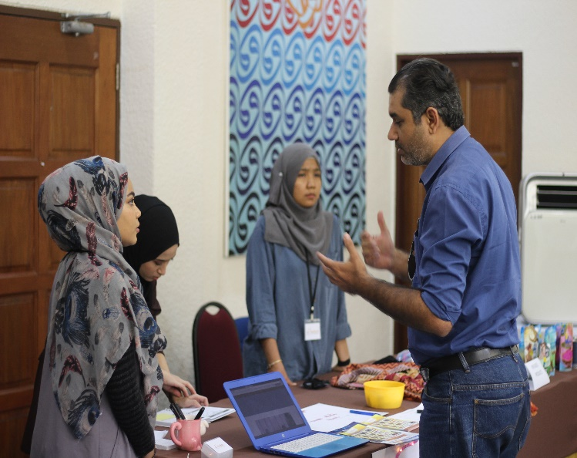
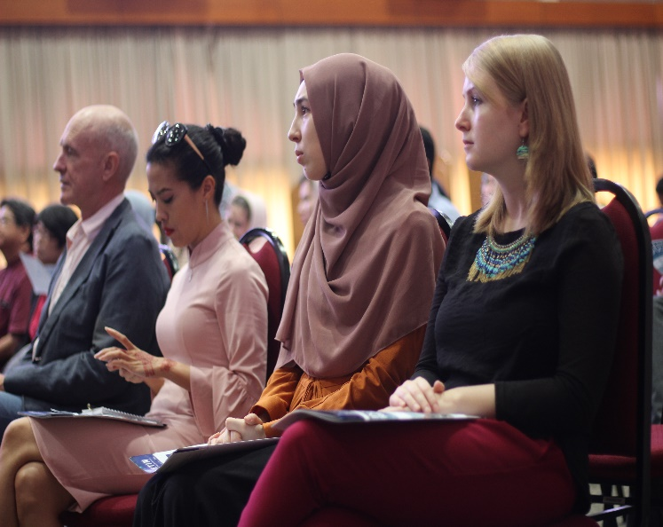
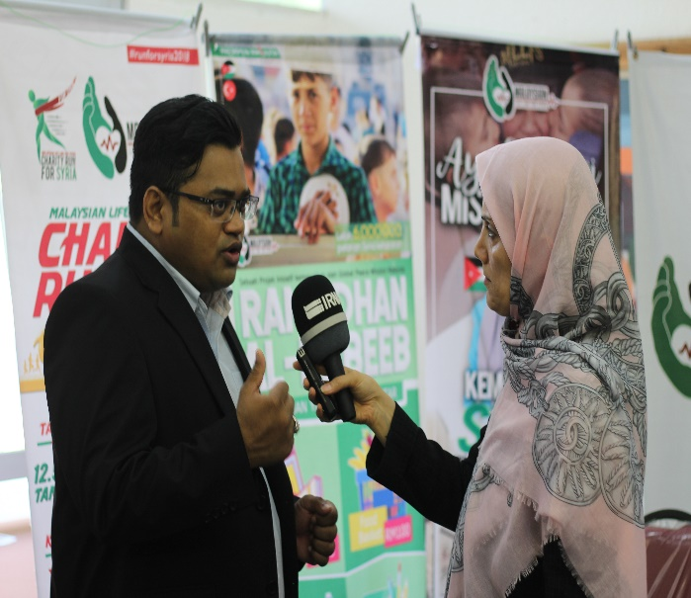
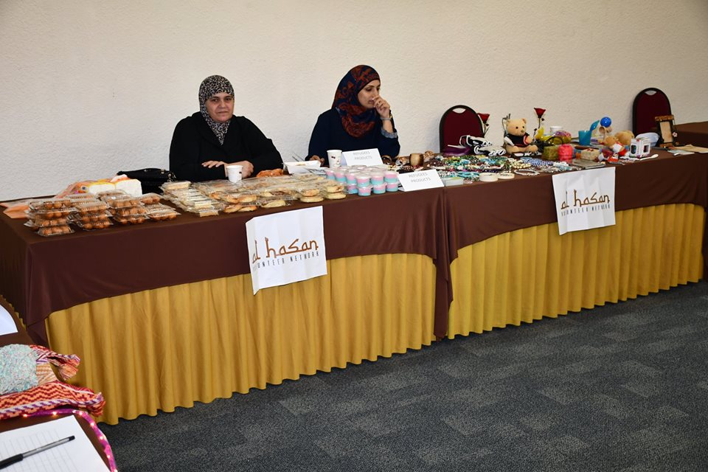
Prepared by:
Dr. Razi Ahmad
IAIS Malaysia
8 March 2018

