REPORT ON THE 2018 WORLD INTERFAITH HARMONY WEEK IN HAWAII

This year Interfaith Open Table of The Interfaith Alliance of Hawaii, hosted Hawaii’s second World Interfaith Harmony Week event. A breakfast was held on Thursday February 1st, 2018 to bring people of different faiths (or no faith) together for conversation and food and to reaffirm their commitment to interfaith peace and harmony in Hawaii. We expanded our horizons this year with representatives from Baha’i and the Ahmadiyya Muslin Community joining our planning team. This year’s breakfast theme was “Service Together”. Thirty-seven people, from ten faith traditions, nine denominations, three interfaith organizations and four Chaplaincies gathered to honor and celebrate each other. We were particular pleased to have representatives from two denominations of Islam. Each attendee was asked to contribute a prayer, chant, or benediction in advance and a commemorative booklet with those contributions was presented to each person at the breakfast. The gathering was opened and closed with a moving traditional Oli (chants and blessings) from Kahu Pohāleo Quintero and Ihilani Chu of the Hawaiian Church of Hawaii Nei. Please notice the attached photos.

Our event is registered on the official web site. Please see http://worldinterfaithharmonyweek.com/ for more detail on this event, and others worldwide. Plans for next year’s event are already under way. We are expanding our planning team again with an open invitation to all faith traditions to join us. If you are interested in becoming involved, please contact Rev. Dr. Thomas D. Lynch at tlynch@interfaithacademy.org or by phone at (808) 799-4866.

Aloha e
I ho`okahi kahi ke aloha
~Be ONE in Love.

Faith Traditions Attending the 2018 World Interfaith Harmony Week Honolulu Breakfast

Jewish Community Services
Oahu Jewish Ohana
Muslin Association
Ahmadidyya Muslin Community
Honpa Hongwanji Betsuin
United Methodist Church
Roman Catholic
United Church of Christ
Unity
Unitarian Universalists
Quaker
Unification Church
Hawaiian Church
The Church of Jesus Christ of Latter-day Saints
National Spiritual Assembly of the Baha’i Honolulu
Chaplaincy - U.S. Marines
U.S. Navy
HIS
Pacific Health Ministry
The Interfaith Alliance – Hawaii/ Interfaith Open Table
Hawaii Interfaith Power and Light
International Academy for Interfaith Studies

THREE PHOTOS

- Representatives of the Hawaiian Church who opened and closed our event with the traditional Oli Hawaiian chant and blessing.

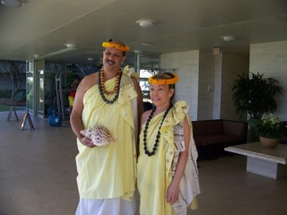

- In the back and on the left is Rev. Thomas Lynch (Interfaith Minister), in the center is Ihilani Chu giving the Oil chant, and behind her is Rev. Piaula E. Ala’alma (Methodist Minister).

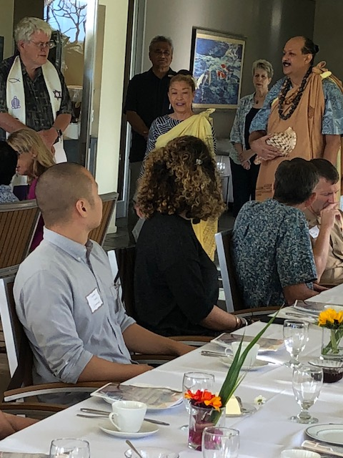

- Standing in the back from left to right are Bishop Matsumoto (Honpa Hongwanji), Rev.Darian Galindo (United Church of Christ), and Iman Matiulla Joyia (Ahmadidyya Muslin Community).
