Ms. Robyn Bernstein Donati
454 Loring Road
Barre, MA 01005
March 5, 2018
Dear Interfaith Harmony Week Judges,
I am writing to you to recommend Shaheen Akhtar, an interfaith educator at the Islamic Cultural Center of Boston in Wayland for the World Harmony Week Interfaith Award. First, I would like to introduce myself. My name is Robyn L. Bernstein Donati. I lost my mother at the World Trade Center on September 11, 2001. A couple of years after that, I became a member of September Eleventh Families For Peaceful Tomorrows. Following the tenth anniversary of 9-11-01, with the encouragement of my rabbi, Katy Allen, I walked into a mosque, the Islamic Cultural Center of Boston in Wayland for the first time. This was a big deal for me as for the first time in my life as a Jewish woman, I walked into a mosque. Everyone was so warm and welcoming. When I met some of the members there, they immediately introduced me to Shaheen, and we have been close friends ever since. When she invited me to join the Interfaith Book Club there, I quickly said yes. Even though I have moved over 50 miles away, I attend whenever I can, either in person or virtually.
But enough about me; Shaheen is one of the pioneers of interfaith work, building bridges among all people of all faith traditions since 1995. Her passion is the promotion of interreligious and intercultural dialogue, understanding and peace. Some of the groups that she is involved with are the Wayland Interfaith Leaders, the Framingham Interfaith Leaders, the Open Spirit Center Advisory Committee and Multi-faith Council in Framingham, and leading two interfaith book clubs (one in Wayland and one in Framingham). Shaheen and I have collaborated on a few interfaith projects together.
In November of 2012, “September Eleventh Families for Peaceful Tomorrows” was one of two organization honored at a dinner sponsored by the Islamic Cultural Center of Boston in Wayland. This event brought together many from the local interfaith community, as well as members of September Eleventh Families for Peaceful Tomorrows. Our organization was acknowledged because of all the work that it did and does to combat Islamophobia that has grown since 9-11-2001. One of the things that touched me most at the event was the number of Muslims that thanked our members over and over for not blaming them for the events of September 11 and for standing up for them.
Shaheen continued to assist ‘Peaceful Tomorrows’ to promote interreligious dialogue in our Anti-Islamophobia bus shelter ad campaign in Boston which launched in July of 2014? Working in collaboration with Gloria Williams (co-chair for our Anti-Islamophobia Committee) Shaheen assisted us tremendously. She reached out to all of her interfaith contacts in the area, and shared her contacts with us so that when a press conference was scheduled to announce the ad campaign, local clergy leaders and members of almost all religions were present.

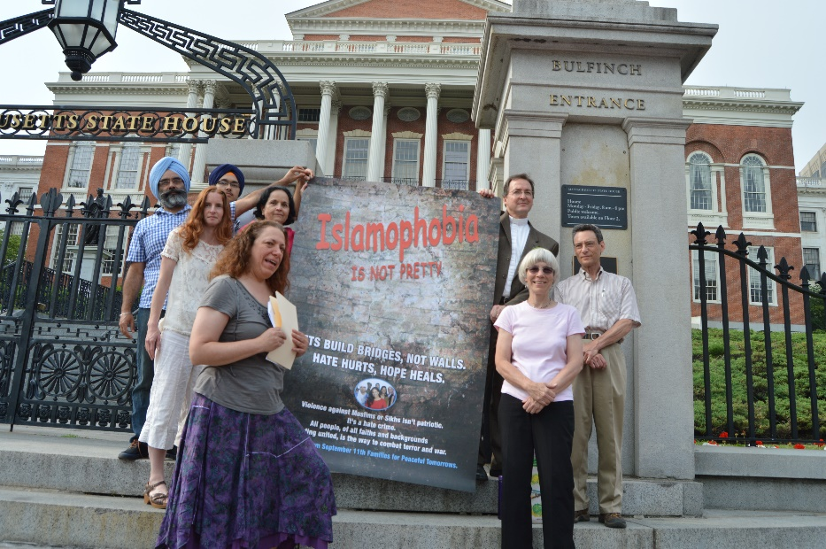
Shaheen has worked tirelessly to create forums for inter-religious and intercultural dialogue through the two interfaith book groups she leads. One of the ideas that we talk about in the group regularly is that only through reaching out to individuals in our communities who are different than us, to learn about their cultures, beliefs and values, will mutual understanding grow and prejudice decrease. Out of these book groups Shaheen developed the first community read a year and a half ago at the ICCB in Wayland. It was so well received that they have been able to continue, being held every six months. With support from members of the interfaith book group in Wayland to help plan, and lead discussion groups at the community reads, more than a hundred people come together to talk about books based on interfaith understanding. At the end of each community read, Shaheen leads the group to identify ways that individuals can act now in their communities.
Shaheen truly embodies Hamurabi’s Code to love thy neighbor as thyself. Each year since we have met, no matter where I am, she calls me on September 11th to see how I am doing. She has invited me to events at the ICCB, or to spend some time together. It truly touches me that she does this; I know that as a Muslim woman it has impacted her life almost as much as mine. She has shown me that interfaith dialogue and cooperation is possible. Now that I live farther away from my treasured book group, I am working on starting some local interfaith actions in the area where I now live. Shaheen has given me her support and guidance about how to grow this in my new part of the world. Shaheen is not just an interfaith colleague but a dear, dear friend. I am so very pleased to recommend Shaheen Akhtar to be recognized for her work as part of Interfaith Harmony Week.
In Friendship and Peace,
Robyn L. Bernstein Donati

