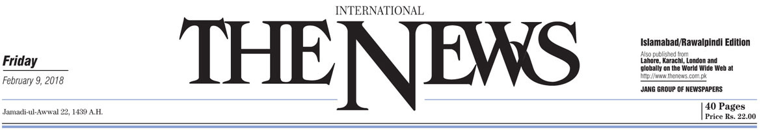

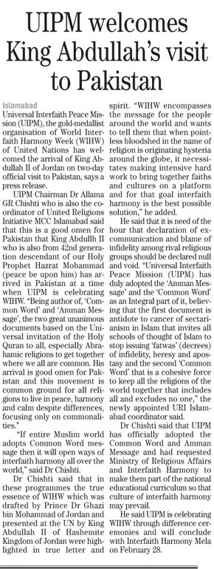
http://e.thenews.com.pk/pindi/2-9-2018/page19.asp

UIPM welcomes King Abdullah’s visit to Pakistan
Listen
Islamabad: Universal Interfaith Peace Mission (UIPM), the gold-medallist organisation of World Interfaith Harmony Week (WIHW) of United Nations has welcomed the arrival of King Abdullah II of Jordan on two-day official visit to Pakistan, says a press release.
UIPM Chairman Dr Allama GR Chishti who is also the coordinator of United Religions Initiative MCC Islamabad said that this is a good omen for Pakistan that King Abdullh II who is also from 42nd generation descendant of our Holy Prophet Hazrat Mohammad (peace be upon him) has arrived in Pakistan at a time when UIPM is celebrating WIHW. “Being author of, ‘Common Word’ and ‘Amman Message’, the two great unanimous documents based on the Universal invitation of the Holy Quran to all, especially Abrahamic religions to get together where we all are common. His arrival is good omen for Pakistan and this movement is common ground for all religions to live in peace, harmony and calm despite differences, focusing only on commonalities.”
“If entire Muslim world adopts Common Word message then it will open ways of interfaith harmony all over the world,” said Dr Chishti. Dr Chishti said that in these programmes the true essence of WIHW which was drafted by Prince Dr Ghazi bin Mohammad of Jordan and presented at the UN by King Abdullah II of Hashemite Kingdom of Jordan were highlighted in true letter and spirit. “WIHW encompasses the message for the people around the world and wants to tell them that when pointless bloodshed in the name of religion is originating hysteria around the globe, it necessitates making intensive hard work to bring together faiths and cultures on a platform and for that goal interfaith harmony is the best possible solution,” he added.
He said that it is need of the hour that declaration of excommunication and blame of infidelity among rival religious groups should be declared null and void. “Universal Interfaith Peace Mission (UIPM) has duly adopted the ‘Amman Message’ and the ‘Common Word’ as an Integral part of it, believing that the first document is antidote to cancer of sectarianism in Islam that invites all schools of thought of Islam to stop issuing ‘fatwas’ (decrees) of infidelity, heresy and apostasy and the second ‘Common Word’ that is a cohesive force to keep all the religions of the world together that includes all and excludes no one,” the newly appointed URI Islamabad coordinator said.
Dr Chishti said that UIPM has officially adopted the Common Word and Amman Message and had requested Ministry of Religious Affairs and Interfaith Harmony to make them part of the national educational curriculum so that culture of interfaith harmony may prevail. He said UIPM is celebrating WIHW through difference ceremonies and will conclude with Interfaith Harmony Mela on February 28.

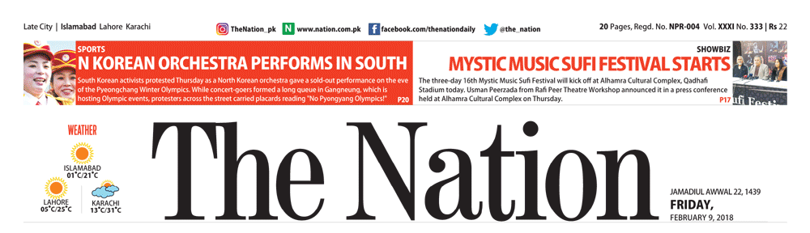
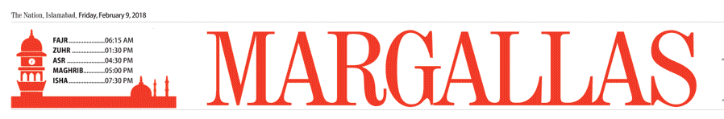

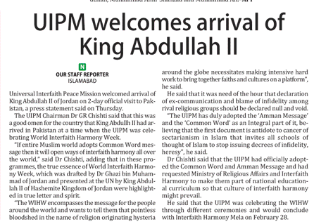
https://nation.com.pk/E-Paper/islamabad/2018-02-09/page-14

UIPM welcomes arrival of King Abdullah II
Our Staff Reporter February 09, 2018
SHARE :

Our Staff Reporter
islamabad - Universal Interfaith Peace Mission welcomed arrival of King Abdullah II of Jordan on 2-day official visit to Pakistan, a press statement said on Thursday.
The UIPM Chairman Dr GR Chishti said that this was a good omen for the country that King Abdullh II had arrived in Pakistan at a time when the UIPM was celebrating World Interfaith Harmony Week.
“If entire Muslim world adopts Common Word message then it will open ways of interfaith harmony all over the world,” said Dr Chishti, adding that in these programmes, the true essence of World Interfaith Harmony Week, which was drafted by Dr Ghazi bin Muhammad of Jordan and presented at the UN by King Abdullah II of Hashemite Kingdom of Jordan were highlighted in true letter and spirit.
“The WIHW encompasses the message for the people around the world and wants to tell them that pointless bloodshed in the name of religion originating hysteria around the globe necessitates making intensive hard work to bring together faiths and cultures on a platform”, he said.
He said that it was need of the hour that declaration of ex-communication and blame of infidelity among rival religious groups should be declared null and void.
“The UIPM has duly adopted the ‘Amman Message’ and the ‘Common Word’ as an Integral part of it, believing that the first document is antidote to cancer of sectarianism in Islam that invites all schools of thought of Islam to stop issuing decrees of infidelity, heresy”, he said.
Dr Chishti said that the UIPM had officially adopted the Common Word and Amman Message and had requested Ministry of Religious Affairs and Interfaith Harmony to make them part of national educational curriculum so that culture of interfaith harmony might prevail.
He said that the UIPM was celebrating the WIHW through different ceremonies and would conclude with Interfaith Harmony Mela on February 28.

