WORLD INTERFAITH HARMONY WEEK 2017 PRIZE SUBMISSION

Inaugural Peace Forum on Forgiveness and Reconciliation

‘The Power of Forgiveness and Reconciliation in our Contemporary World’
Co-organised by the Charter for Forgiveness and Reconciliation:
4th Feb 2017, at the Nishkam Centre of Nishkam Civic Association

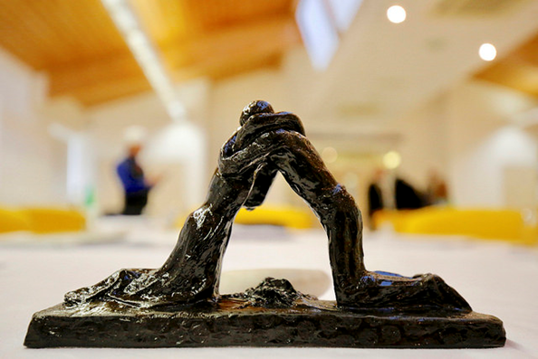

We are grateful to His Majesty King Abdullah II bin Al-Hussein of Jordan for sponsoring the annual WIHW prize and humbly make our submission in consideration of the award process.
Event Summary
The Nishkam Civic Association (NCA) and parent organisation Guru Nanak Nishkam Sewak Jatha (GNNSJ) have hosted seven key interfaith harmony events, every year since the inception of World Interfaith Harmony Week in 2010.
The NCA is a faith inspired organisation and GNNSJ a Sikh faith based organisation. We passionately believe, exercise and commit to the World Interfaith Harmony Week initiative designed to allow us to recognise that our common values outweigh our differences, in order to provide peace and harmony in communities”.

“The UN resolution for a world interfaith harmony week is a very welcome, historical and unprecedented event, capable of promoting healing of interfaith tensions in the world”
“Celebration of Interfaith weeks should include sharing wisdom, respecting each other, loving each other and sacrificing for each other” “All the religions of the world need to be tuned together with the respect, love and sacrifice so that there is resonance, and ultimately harmony and peace” (Bhai Sahib, Bhai (Dr) Mohinder Singh Co-Convener of Charter for Forgiveness and Reconciliation)
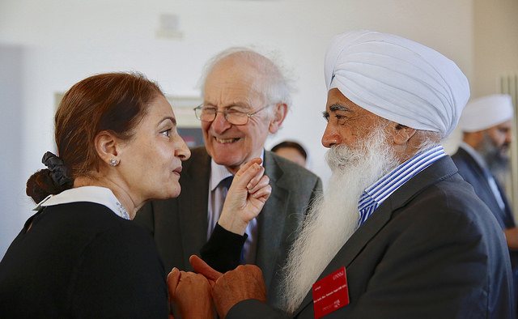

This year NCA, GNNSJ and the Charter for Forgiveness and Reconciliation under the guidance of Bhai Sahib, Bhai Mohinder Singh KSG OBE, Co-convener of the Charter for Forgiveness and Reconciliation, and Dr Josef Boehle, its Director, spearheaded the inaugural Peace Forum on Forgiveness and Reconciliation. It contributed to the ongoing development of the Charter’s vision, activities and envisaged road map. The Peace Forum aims to provide an annual opportunity to link and apply the values of forgiveness and reconciliation, to peacebuilding, harmony and understanding.
Harmony and interfaith understanding are crucial for peaceful societies. The Charter for Forgiveness and Reconciliation is envisioned to make a contribution to processes of forgiveness and reconciliation not only between individuals, communities and states, but also between faith traditions, leading to sustainable peace.
“Fostering and practicing forgiveness has the power to transform deep-seated responses to memories and legacies of injustice, conflict and war. It can liberate people from being imprisoned in their pasts and long ingrained mental and emotional conditions created by such legacies. Faith and spiritual traditions have long guided us and inspired us to awaken the best of our human potential, to practice love, mercy, forgiveness and reconciliation, and to reshape our destinies.” (Paragraph from Statement of Vision and Purpose, Charter for Forgiveness and Reconciliation)

The Charter for Forgiveness and Reconciliation proposes, as one of its activities, the establishment of a World Day of Forgiveness and Reconciliation, to be held annually during World Interfaith Harmony Week.
The Nishkam Media Centre Press Release ‘World Interfaith Harmony Week 2017 Event on Forgiving and Reconciling in a Contemporary World: A call to action’ provides a concise summary of the event and the presentations made:
“The event opened with a prayer invoking God’s mercy and blessings. ‘The Power of Forgiveness and Reconciliation in our Contemporary World’ was the title of the forum on peace held on 4th February 2017 by the Charter for Forgiveness and Reconciliation. The event was attended by a diverse audience with people from many different faith groups and parts of the world.”
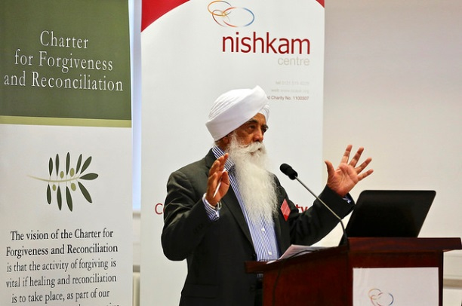
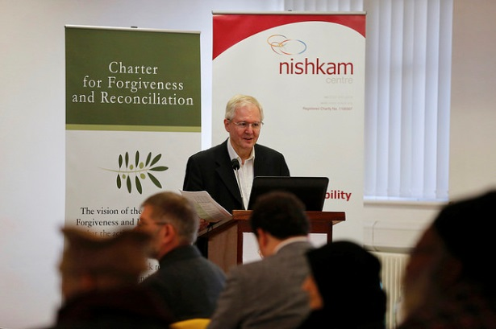
“Speaking about the forum, Dr Josef Boehle stated “The Peace Forum on Forgiveness and Reconciliation takes place today as part of World Interfaith Harmony week in Birmingham. The vision of the Charter is to make a contribution to processes of forgiveness and reconciliation not only between individuals, communities and states, but also between faith traditions.”

Dr Josef Boehle Bhai Sahib, Bhai Mohinder Singh KSG OBE.
Bhai Sahib, also speaking on the forum and the nature of forgiveness, stated that “the highest and the best form of human generosity and benevolence is forgiveness”. He then summarised and closed the event a prayer of thanks.
The event was clearly a landmark development in the journey towards sharing, inviting input and inspiring collaboration from like-minded people in support of the Charter for Forgiveness and Reconciliation. The participants left the event full of praise having been part of World Interfaith Harmony Week 2017 event at the Nishkam Centre.”
https://nishkammediacentre.com/2017/02/04/world-interfaith-harmony-week-2017-event-on-forgiving-and-reconciling-in-a-contemporary-world-a-call-to-action/

The one day event was selflessly supported through 100 hours of volunteering, attended by over 50 guests & presenters from 7 faith communities, the event included inspiring exhibition, videos & presentations on forgiveness, followed by facilitated dialogue & feedback.
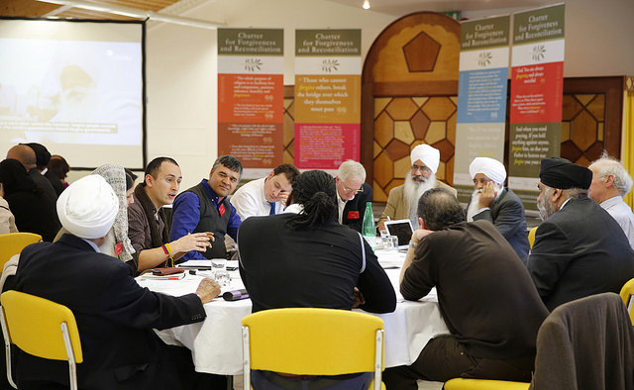
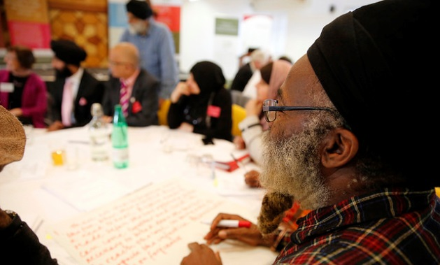
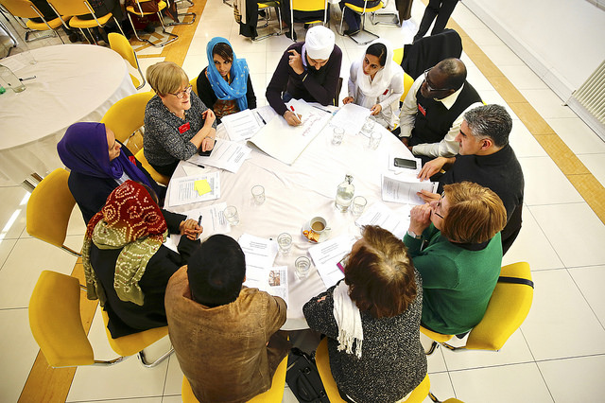
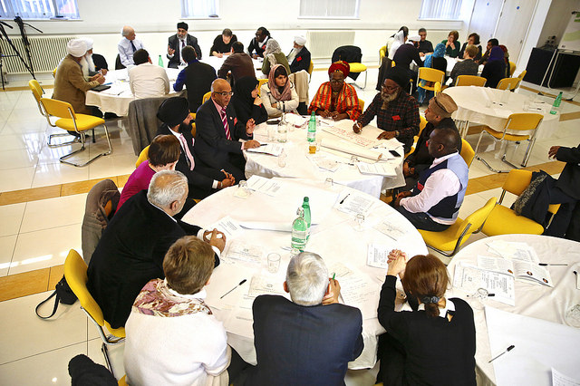
Delegates engaging in dialogue
The inaugural Peace Forum achieved the following outcomes:
- Greater engagement with the Charter for Forgiveness and Reconciliation, including local communities
- Growth and a gain of momentum of the Charter’s forgiveness movement
- Action to involve more youth
- Production of media resources to spread the message about forgiveness and reconciliation, reaching an international audience
- A replicable format for forgiveness dialogue

A- In support of our submission kindly review the following:
- Event Programme
- Event Video - recorded and edited by in house volunteers
- Event Press Release
- Testimonials from Event Attendees
- Charter for Forgiveness & Reconciliation Brochure
- Photographic Gallery https://www.flickr.com/gp/121938483@N04/hs07nS

B- Resources sourced, adopted and shared at the event on the subject of forgiveness:

His Holiness Pope Francis speech
- https://youtu.be/gULPKyxrQac

Archbishop of Canterbury, President Santos & Valerie Kaur
- https://youtu.be/49quFHamsQs

His Holiness the Dalai Lama & Archbishop Desmond Tutu, H.M The Queen,
Fetzer Institute
- https://youtu.be/tmQz2o45paQ

- (6) Verses from Guru Granth Sahib Ji & Bhai Gurdass Ji’s Vaar

C- Social media
Facebook links to 2 selected speeches made by Forum Speakers:

- Bhai Sahib Bhai Mohinder Singh KSG OBE speaking at the event, reaching 15,852 viewed by 4000 people, and shared 60 times.
https://www.facebook.com/ncauk/videos/1570214399670502/

2- Tariq Jahan speaking about his very personal journey about forgiveness, reaching
2354 people and viewed by 653 times.
https://www.facebook.com/ncauk/videos/1570058539686088/

