A BRIEF REPORT OF` WIHW WELCOME CONFERENCE 31/01/`-17
On Tuesday 31 January 2017, a momentous `WIHW Welcome Conference` was held under auspices of Universal Interfaith Peace Mission(UIPM)- Gold Medalist and awarded the First Prize of HM King Abdullah II of Jordan for the best performance in spreading the message of the World Interfaith Harmony Week of UN in 2015. At Islamabad Hotel Melody Market Islamabad from 2-6 pm, Excellency Mr Jean Francois Cautain Ambassador of European Union Delegation to Pakistan Islamabad was the Chief Guest, while the Conference was presided over by the most respected Mr Sardar Khan Niazi Sahib, Chief Editor Pakistan Group of News Paper and Chairman Roze TV Pakistan. The most respected Mr Tikka Khan Abbasi Sahib Life time Secretary General All Pakistan Hawkers Association, the most respected Mr Ijazul- Haq MNA President Pakistan Muslim League (Z),Mr Zubair Ahmed Farooq Global Trusty United Religions Initiative ( URI, Ms Tasneem URI Youth Trainer, Mutram Mr Waheed Alam Khan MNA Muslim League(N) Ms Mussarat Zaib MNA Pakistan Insaf Party (PTI) were Distinguished Guests at the event.
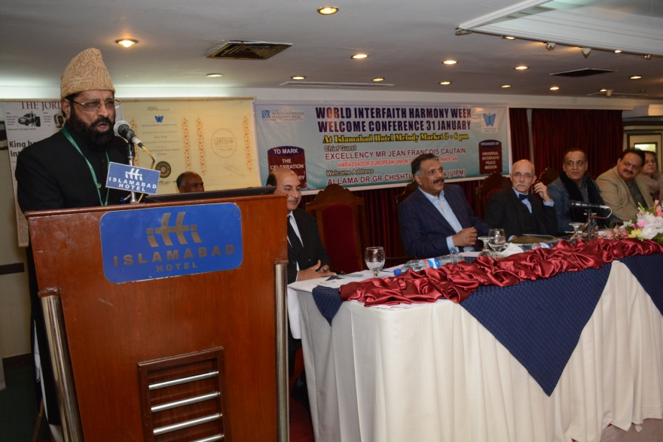
Allama Dr G R Chishti Founder/Chairman UIPM delivering welcome Address at WIHW Welcome Conference on the stage HE Mr Jean F Cautain Ambassador European Union in Pakistan, Mr Sardar Khan Niazi, Mr Ijazul Haq MNA , Mr Zubair Farooq ,Mr Waheed Alam MNA, Mrs Musarrat Zaib MNA are seen.
The function was attended by all the religious groups living in Pakistan especially Muslim, Christian Hindu ,Siekhs, Budhists Baha`Is and Messianic Congregation while a group`s representatives requested that there name may not be declared for security reason even if the Chief Guest mentioned their name once in his speach.
The Proceedings of the Conference were commenced by the recitation from the Holy Quran and following to that passages from Holy Torah, Psalm, and Evagles and Kitab e Aqdas were read with equal reverence as well as Baha`Is recited Traditional Prayer and Messainic s Souded the Jewish trumpet and `Shima` was sung from Holy Jewish Scriptures in Hebrew in its original Hebrew Language. 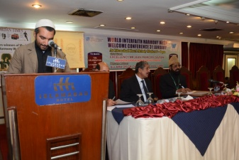 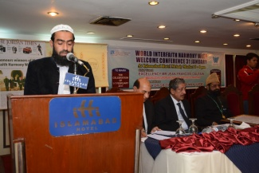 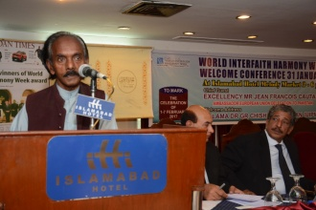 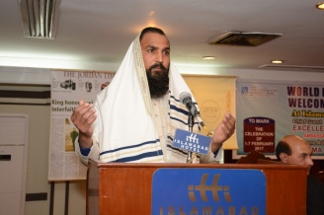
Qari Jameel and Qari Bdiu Zaman reciting from the Holy Quran,Oam Perkash from Gita, Mr Asher reciting Shima in Hebrew,
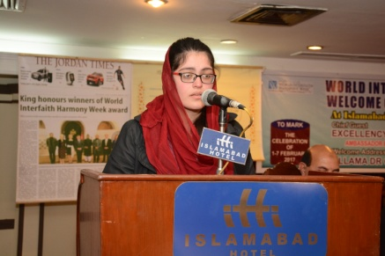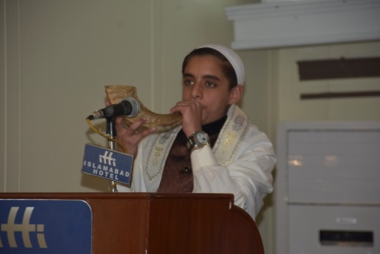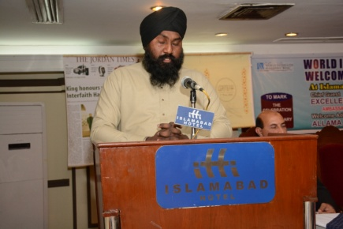
A Baha`I Young Lady Saba reading from Kitab e Aqdas, A Messainic boy is sounding Tumpet while Sardar Ranjeet Singh reading from Garanth Sahib Jee
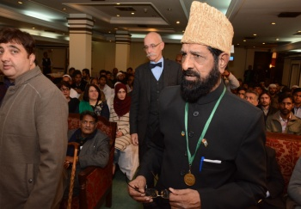
After the recitation from nearly all religious groups` respective holy Scriptures in the first session it was now 4 pm when our His Excellency Mr Jean Francois Cautain European Ambassador to Pakistan the Chief Guest arrived even a few 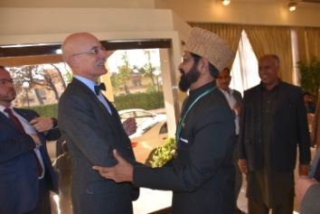 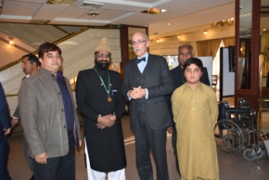
1)Allama Dr G R Chishti Receiving The Chief Guest at Hotel`s Reception 2)posing for a group photo 3)coming to the stage
minutes before time so audience and organizer raised their voices with joy `O you are a real man of word and promise. At HE Ambassador of European Union` s arrival the
second session was commenced, Stage secretary Mr Zubair Farooq Advocate Supreme Court Pakistan and Global Leader of URI called the Chief Guest and Guests of honour to the stage and the series of religious Leadrs` speeches began,

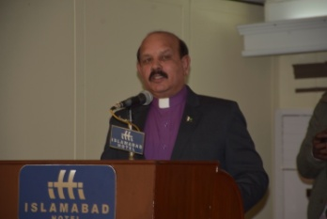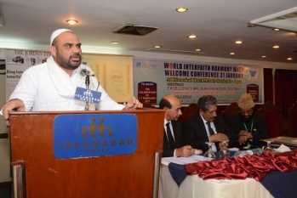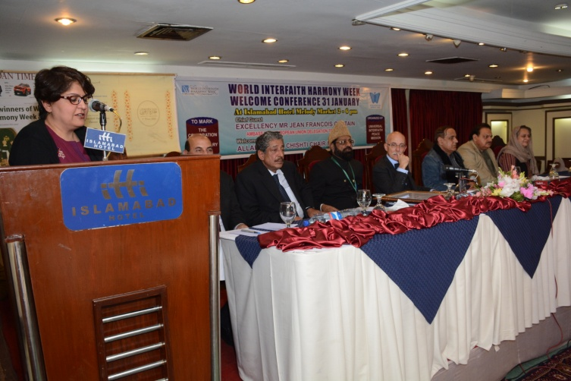
Rev.Pastor Pervez Suhail head of Pur Fazal Church Pakistan presented the love of God and Love of the neighboure from the Holy Gospels, on the same subject spoken Rt. Rev. Bishop of Messianic Congregation Pakistan with reference from Hol Torah, While Dr Sema presented the Love of God and Love of neighbor from the teachings of Hazrat Bahaullah, Similarly other religious leaders supported the principles of WIHW ie the Love of God and Love of the neighbor.

Now there were Young students{Children)girls and boys from Muslim, Christians and Baha`I faiths who had come to show religious harmony by singing Na`t e Rasool and poems on ones of Humanity at first Muslim Student from Modern Islamic Studies Centre Sohan Islamabad a Masjid Madresah run under UIPM in the Masjid Mai Saleem Akhtar Sohan Islamabad were called to recite Na`at Shareef
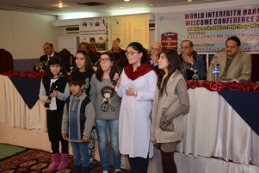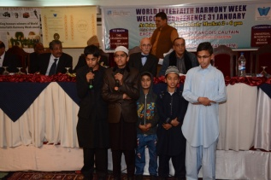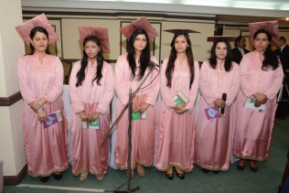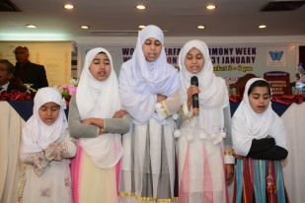

Baha`I Muslim Christian Muslim
Then Muslim girls sung Hand Khuda following that Baha`I young students sung a poem on ones of humanity lastly Christian students sung hyms and poem of Love of God and Neighbor,

After these activities the stage secretary called Allama Dr G R Chishti to deliver his speech on the subject of `hurdles and hindrences in the way of Interfaith Harmony the rest of the speakers spoke on the topic after listening Dr GR Chishti`s guiding speech of URI, Mr Tikka Khan Abbasi Mr Zubair Ahmed Farooq Advocate Ms Tasneem Mr Waheed Alam Khan MNA (MLN) Ms Mussrat Zaib MNA (PTI) afterwards Sardar Khan Niazi Sahib delivered his Presiding Address and
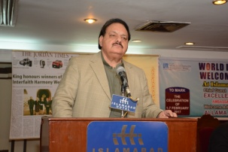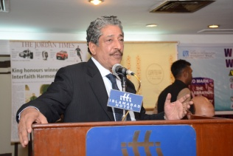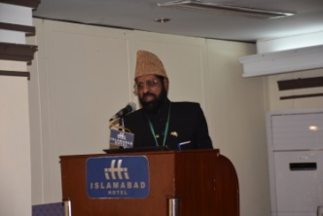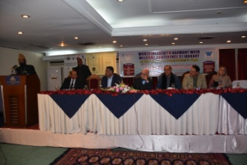
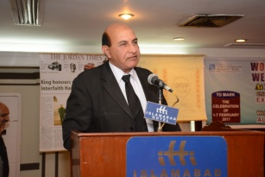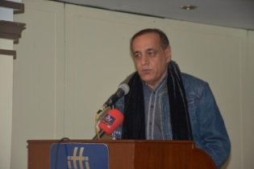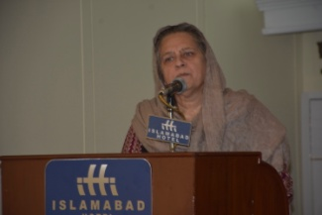
finally His Excellency Ambassador of European Union Delegatio to Pakistan Mr Jean Francois Cautain the Chief Guest was requested to come to the mice give benefit of his erudition on the subject of WIHW Celebration and its importance as soon HE got up the whole audiences stood clapping to sho their respect to the Chief Guest.
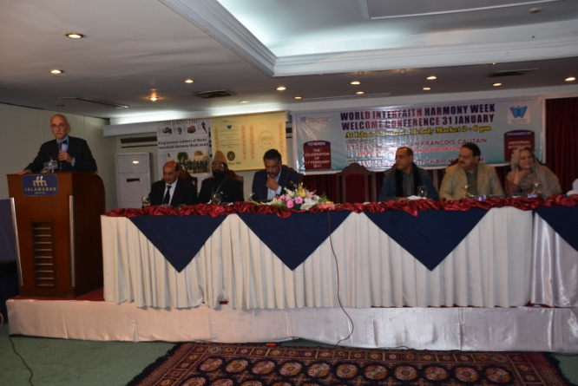
Now after the Chief Guest`s speech the stage secretary announced that now there will be an award presenting session Firstly Allama Dr Chishti the host of the 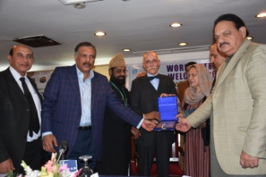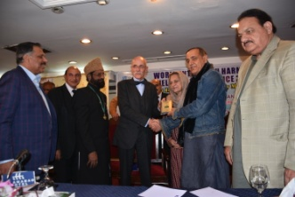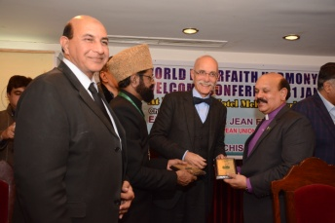
Conference will present a shield as Award of Appreciation of Cooperation to HE Ambassador and H E will bestow the award to Sardar Khan Niazi afterward Sardar Khan Niazi will give award to RT Rev Bishop Aftab Anwar and Rev Pastor Pervaiz Suhai These all awards were provided and giving away from Universal Interfaith Peace Mission to mark the celebration of WIHW 2017

Yhe Chie Guest speech has ben reported by Newspapers. The extract of which is pasted blew now time was running short and the Guest has other commitment and we have to make arrangements to make him leave on time so it was requested that only our last activity is to make a group photo for memory so it was done
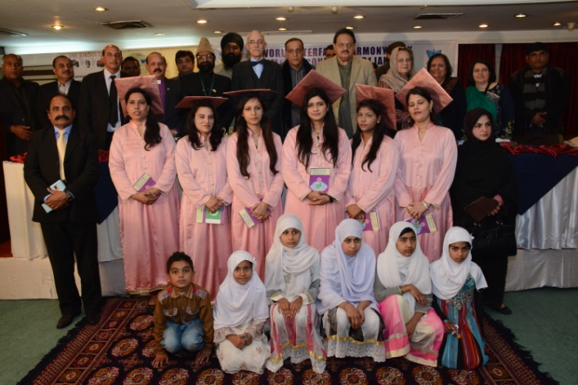
As soon the group photo was taken the journalists moved forwards to ask

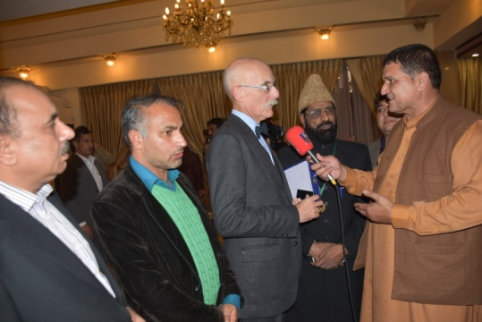
questions and Roze Tv Chief Reporter Mr Raza Abid Mustafa came to make a report for tv so H E Ambassador stopped for a while to say some words for tv.
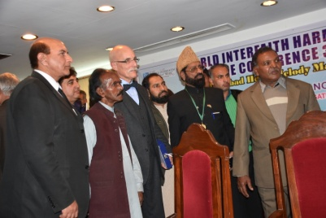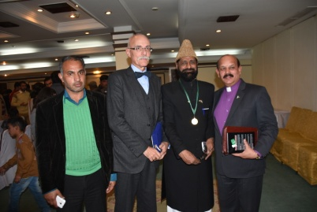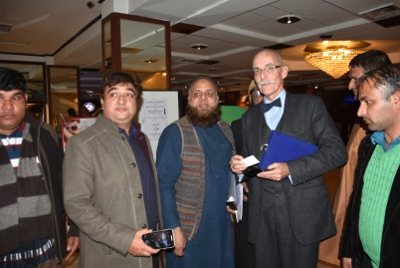
After the tv interview now all people came forward and surrounded the Excellency each one wanted to make photo with him well he being kind enough made all the people happy by fulfilling their requests.
Few images of the audiences
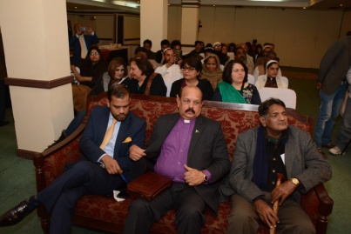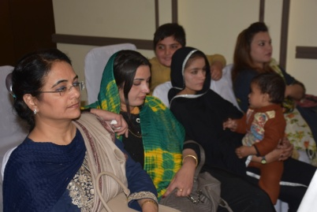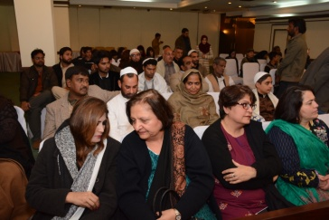
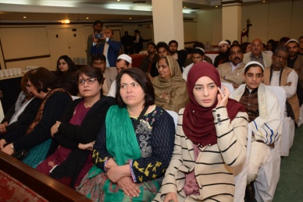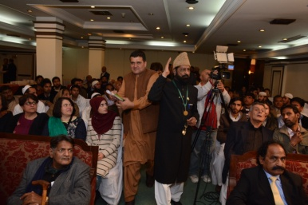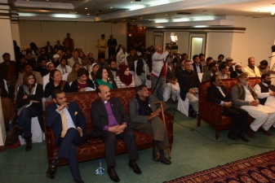

NEWS Papers report pf the Event
