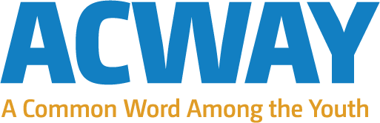
Global Collaboration for Local Action
For the UN World Interfaith Harmony Week 2016

A Common Word Among the Youth’ (ACWAY) is an innovative global youth movement launched in December 2015. It brought together 100 young people from over 75 countries and at least 7 different major religions and cultures with a common goal; to promote harmony and understanding locally so as to foster coexistence between different cultural and religious communities around the world. The project is lead, driven and managed by young people and is open to all ages and all backgrounds and faiths and no faith who want to deliver action.
To commemorate the UN World Interfaith Harmony Week 2016, the ACWAY project through its fellow ambassadors did not delivered just one activity but a series of projects and activities to promote peace and harmony. Below is a selection of those activities.
- Peace Education and Mentorship for Students (PEMS) in Nigeria.
On Saturday, the 5th March, 2016, Muhammad Salisu Abdullahi did his peace project for the united Nations World Interfaith Harmony Week with the name ‘Peace Education and Mentorship for Students’ (PEMS) program. It was carried out successfully at Federal Government College, Kiyawa, Jigawa State of Nigeria. The target group are the Safe School Initiative students (73 in number), who were traumatized by the Boko Haram terrorism in Nigeria and are coming from Maiduguri, Yobe and Adamawa States. The objectives were to teach them the basic concepts of peace and conflict, their relevance to everyday living and how to engage in conflict resolution. And to mentor them on how to better cope with emotional trauma, which many of them suffer, from previous experience to violence.

- ProjectHumanism.com – Based in Bangladesh but a global website
Celebrating the United Nations World Interfaith Harmony Week 2016, Mr Shariful initiated ProjectHumanism.com. ProjectHumanism.com is a platform to promote the initiatives and life stories of religious harmony and multi-faith collaborations from all over the world. By presenting the incidents, initiatives and ideas on the topic it hopes to inspire others to also come forward with the message of tolerance and initiate change in their respective communities. It also works as a source of secondary data for all researchers, journalists and activists working on the topic.

- Bridging the Divide (Bangladesh)
This project started in association of Gen Lab; a pool of young & energetic youth from Bangladesh, we have started to work on World Interfaith issues on recent times. One of the core work area of the organization is Peace. Interfaith is a very important issue that triggers peace & its development. With inspiration & guidance from Ms. Anupoma Niloya Troyee, ambassador of ACWAY forum; Gen Lab decided to go live on this area and to:
- Promote interfaith week
- Make people familiar with the term Peace & its inner meaning
- Inspire & build up a network of young people who work towards peace
- Build up the primary platform towards larger events

- ACWAY Nusantara Project (Indonesia & Singapore)
ACWAY Nusantara project is an innovative project done by Azizah Syiami Mutik (ACWAY Indonesia) and Lina Sakina Salim (ACWAY Singapore) to bring a new perspective to high school students in Indonesia and encourage dialogue for peace and harmony, also to open their eyes that differences exist out of their current world. This activity was done in three different schools.
The objectives of this project were to:
Increase the critical thinking of students;
Promote open mindedness and culture of “ask and listen” instead of assuming;
Promote tolerance and acceptance of differences among students;
Promote the interreligious and intercultural friendship.

- Unity in Diversity (Tajikstan)
Unity in Diversity initiated by Firuza Abdullaevna from Tajikistan in which participants can bring their own contribution to the program, including through the organization of the past projects, and also distribution of the received knowledge among young and adult people in the local communities and organizations. Intercultural Exhibition – as one of the forms of interethnic and intercultural dialogue. Within the framework of an intercultural exhibition participants can present culture of the community in different intercultural exhibition is considered as a basis for application of values of cultural variety in daily life, as means for development of environmental communities by means of those opportunities which are caused by presence of a wide variety of cultures.

- ACWAY-Ghana Interfaith Dialogue (Ghana)
During the prestigious World Interfaith Harmony week, Inusah facilitated discussion between Muslim & Christian students at Business College International, Tamale-Ghana (a high school in his local Kanvilli community). As part of this discussion session, he formed an interfaith team which will be responsible for executing constructive projects in several communities within Tamale. Watch out soon for projects by the ACWAY-Ghana Interfaith Team in collaboration with YES Alumni Ghana

- AGAPeace: Love and Peace Feast (Philippines)
Bobby Ray Atmosfera initiates the AGAPeace: Love and Peace in Philippines. The idea of his project is for each student to approach someone they have never met before and ask if they can take their picture, and talk to them a bit to get some kind of background or story on but not limited to religion, peace, harmony and love. They can also take creative shots that promote religious tolerance, respect, and understanding. Printed copies of the photographs shall be exhibited at the Philippine Science High School- CAR Campus from February 22-29, 2016. Thirty photos will be selected and to be printed on a larger size by the Baguio-Mountain Provinces Museum and will be exhibited in the said museum for the whole month of March 2016.

- Co-Exist documentary (Pakistan)
This project is planned by ACWAY Pakistan, Hassan Saeed with series of activity below:
- reach out to faculty and students located at various universities in Peshawar where they will be inquired about their opinion of the focused topics. The team will have pre-arranged questionnaires and interview questions which will be shared with the audience.
- the team plan to create a conversation on social media such as Facebook, twitter and youth voices international to engage team and general public from all over the country where they will have the chance to share their sentiments, views, personal experiences and opinions regarding the topic. Innovative ideas generated as a result of these conversations will be made part of the final documentary.
- the team will compile the final documentary comprising of the short video feedback. This documentary will be shared on social media.

- Zambia Youth Interfaith Network (Zambia)
Jethro from Zambia started his project for ACWAY which is called ‘Zambia Youth Interfaith Network’ with the aim to promote knowledge, understanding, and mutual respect between various faith communities and bring them all together into a dialogue. This project is done in the beginning of February as the World Interfaith Harmony Week 2016 was held. This activity has a key message “Humanity is our race. Love is our religion”. This message is designed to give young people motive to aspire more harmony in life and raise the spirit of coexistance to have a sense to respect and promote peace among different tribes and religions.

- Breaking Barriers – Eliminating stereotyping through dialogue (USA)
Lina Zdruli from Washington DC presented a workshop to fellow students about the negative consequences of stereotyping and the need for understanding the other.

- Interreligious/intercultural community outreach mission (Kenya)
As part of ACWAY #Do Good Campaign, Zachariya Munayi called upon different religious leaders and community members to come together to reach out to street children to support them by providing food and essential items. All it took is a simple call to reach to and make a difference despite our cultural and religious differences. These young people gave us more than just beautiful memories. In them we saw young people living and sharing life experiences despite their ethical/cultural/religious backgrounds. On the streets they are one family with one purpose-survival. The spirit of brotherhood is embedded in them and I believe we could all borrow a leaf from this and strive to live as one despite our differences.

Contact details:
Rawaad Mahyub
Project Manager for ACWAY
rmahyub@rightstart.org.uk
www.forum.acway.org
info@acway.org
+44 121 448 550
Facebook.com/ACWAYProject

References for support of ACWAY and its projects
The Rev. Canon Charles P. Gibbs (USA)
"Of the many possible futures facing the Earth community in this time of enormous challenge, I embrace the inclusive, open, resilient, responsible future this new generation of leaders, who are ACWAY fellows, are creating through their inspiring visions and consequential actions."
Charles@catalystforpeace.org

Dr Brian J. Adams (Australia)
Director
Centre for Interfaith & Cultural Dialogue, Griffith University
“ACWAY has struck the right chord with youth from around the world. Historically, efforts have focused on incorporating youth into ongoing or traditional interfaith structures and processes. This has proven to be like dragging the proverbial horse to water.

ACWAY has turned the traditional approach on its head. Instead of trying to fit youth into traditional interfaith work, ACWAY has found a way to fit interfaith work into the pursuits and passions of the youth, unleashing impressive energy, innovation and potential”.
b.adams@griffith.edu.au

Dr Abbas Pannakal (India)
Director, International Interfaith Initiative
“I am so happy to say that ACWAY is the best Youth Project, introduced in the year 2015, to promote Interfaith Harmony.
It has delivered sessions at the Parliament of World Religions in Salt Lake City, at G20 Interfaith Summit in Turkey, at Interfaith Harmony Day in Dubai and International Interfaith Harmony Seminar in Malaysia. Here in Malaysia, in my introductory speech I mentioned the importance of ACWAY and scope for developing a better world of coexistence, bridging various gaps”.
apanakkal@gmail.com

Hany Abdulwahab Abdulmonem (Worldwide)
Director, Youth Programme at the World Scout Bureau
hany@scout.org

Dr Teh Su-Thye (Malaysia)
CEO Global Peace Foundation
tehst@globalpeace.org.my

Selection of pictures to add in addition to those uploaded separately.

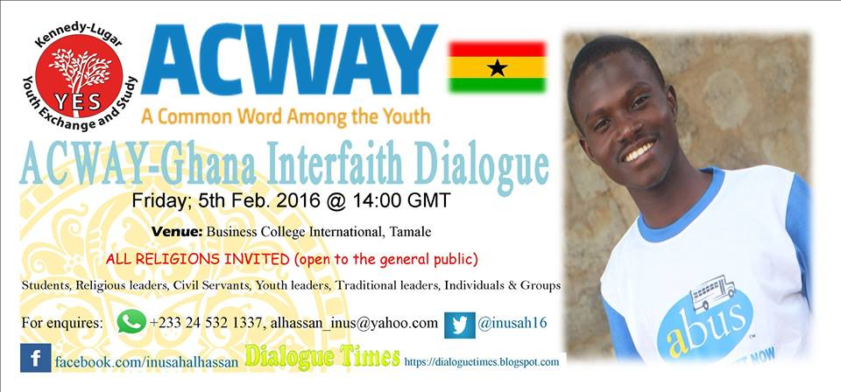
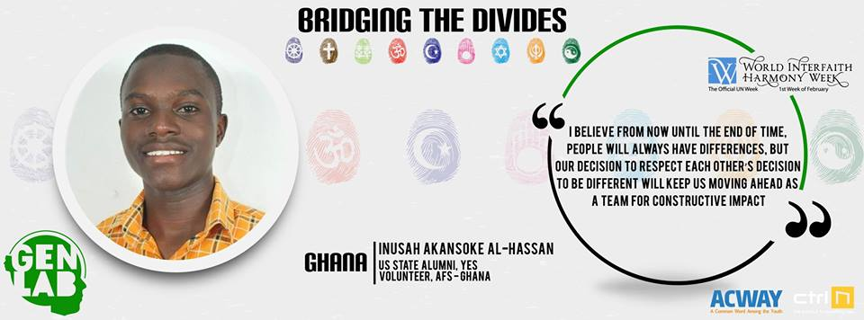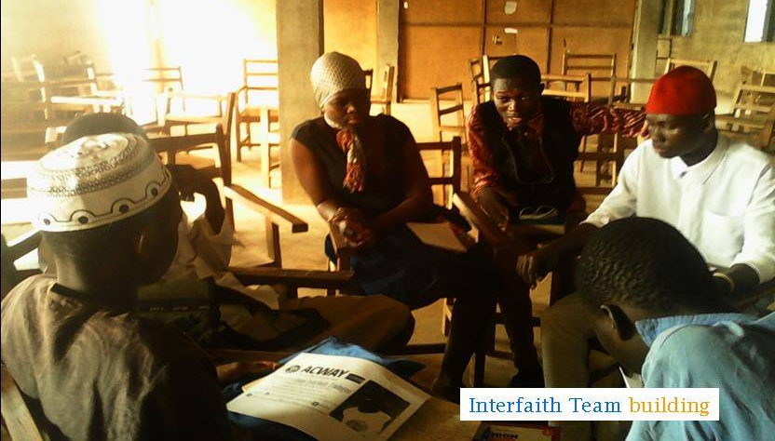
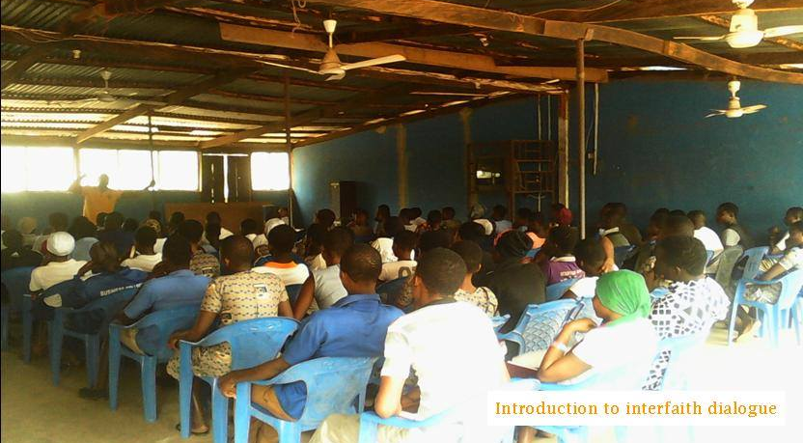

Breaking Barriers – Eliminating stereotyping through dialogue
