EXHIBITS
The Movie – Sitting at God’s Table
VIMEO - “Sitting at God’s Table” - ENTIRE FILM - 1 hr 15 min
https://vimeo.com/125337442
password: SAGTable

Bishop Curry’s interview of Ellen Shepard about “Sitting at God’s Table”
Click to view the Trailer Click to view the Interview
(https://www.youtube.com/watch?v=uXU4sWa8MVU) (https://vimeo.com/121935584)

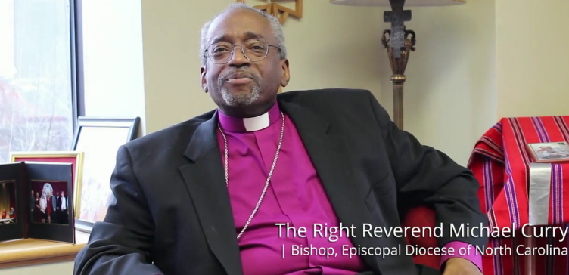
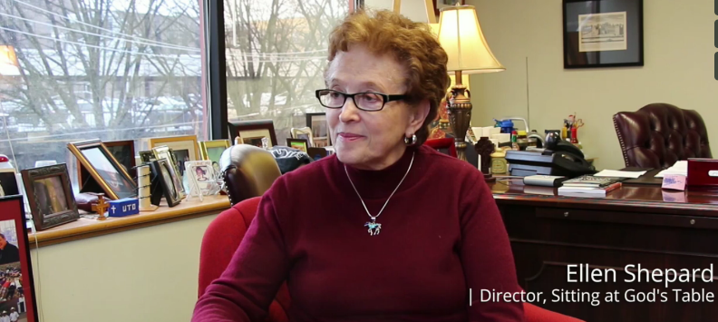
A priest, a rabbi and an imam sit down at God's table. They are joined by ministers from several denominations to discuss their vision of God; their ideas about sin, death and the afterlife, and their thoughts about contemporary social issues. The Right Reverend Michael Curry, Bishop of the Episcopal Diocese of North Carolina, interviews filmmaker Ellen Shepard about her new documentary, Sitting at God's Table.

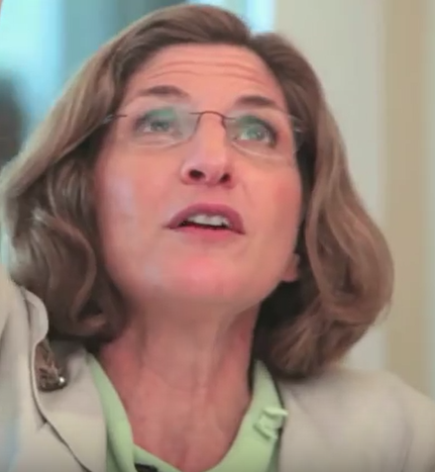
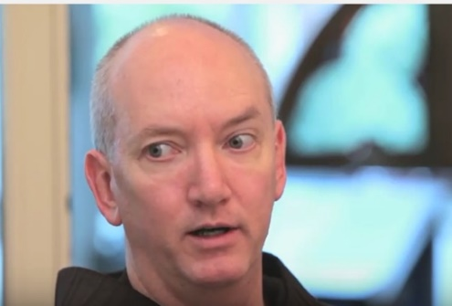
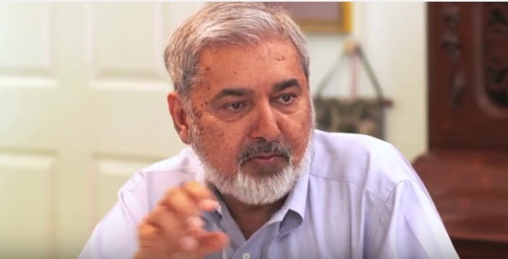
Rabbi Lucy Dinner
Temple Beth Or
Father Mark Reamer

Imam Shakil Ahmed
Islamic Association of Cary NC

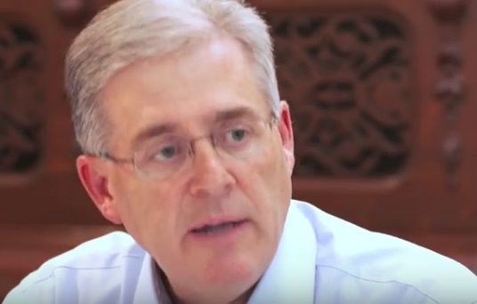
Pastor David Hailey
Hayes Barton Baptist Church

