Report on the observation of
United Nations World Interfaith Harmony Week 2016
At the Universal Peace Federation Peace Embassy Sydney
1st February 2016

The first Universal Peace Federation (UPF) Ambassadors for Peace bi-monthly meeting for the New Year of 2016 was held on 1st February at the UPF Peace Embassy in Sydney and featured the United Nations World Interfaith Harmony Week, observed each year during the first week of February.

UN Secretary-General Ban Ki-moon stated: "World Interfaith Harmony Week celebrates the principles of tolerance and respect for the other that are deeply rooted in the world’s major religions. The observance is also a summons to solidarity in the face of those who spread misunderstanding and mistrust."

This year the theme addressed by three speakers at the UPF event was “Interfaith in Action: Working Together for the Common Good.”

The Emcee for the evening, Ms Aila Willitts, President of the Women’s Federation for World Peace New South Wales, gave a warm welcome to around 60 UPF Ambassadors for Peace and friends who came along to the Oceania Peace Embassy in Sydney Australia to celebrate the occasion.

The first speaker was Mr Greg Stone, President of the Universal Peace Federation, Australia. He introduced the UN Interfaith Harmony Week, which was established in 2010 to promote dialogue among different faiths and religions and to enhance mutual understanding, harmony and cooperation among all people. He conveyed the appeal of UPF Founder, Rev Sun Myung Moon to religious people around the world:
“First, respect the traditions of other religions and do everything you can to prevent conflict and discord among religions.
Second, all religious communities should cooperate with each other to serve the world.
Third, the leaders of all religions should work together to develop a structure that will let us accomplish our mutual mission of establishing world peace.”

The second speaker was Mr Greg Johns, Vice Director of Soka Gakkai International Australia and manager of SGIA’s Peace, Culture and Education portfolio. He explained about the history and principles of SGIA and gave examples of their work in the community and world to promote harmony and understanding. Greg Johns shared the experience his organisation had as partners in an initiative with Latrobe University's Centre for Dialogue. They ran a program for Muslim Youth in South East Asia and Soka Gakkai hosted them as part of the program for a dialogue with their Buddhist youth at their centre. Based on that, Greg introduced a local Youth Dialogue Initiative to be launched in cooperation with the Auburn Interfaith Network, which will be held on a regular basis in Sydney.

The third speaker for the evening was Ms Anne Lanyon, Deputy Director of the Columban Mission Institute and coordinator of the Centre for Peace, Ecology and Justice and the Faith Ecology Network (FEN). Anne gave a very informative PowerPoint presentation on the work of the FEN with it’s aims to share mutual appreciation of religious traditions regarding ecological insights, to discern and foster religious reasons for environmental advocacy, and to strengthen the dialogue of science and religion between different faith groups, professionals and the community.

Through the presentations of the three speakers, the audience could see several practical examples of “Interfaith in Action and Working Together for the Common Good.”

It proved to be a highly informative meeting on the occasion of the 2016 UN Interfaith Harmony Week and a most fruitful opportunity for networking and cooperation among the various faith traditions represented.

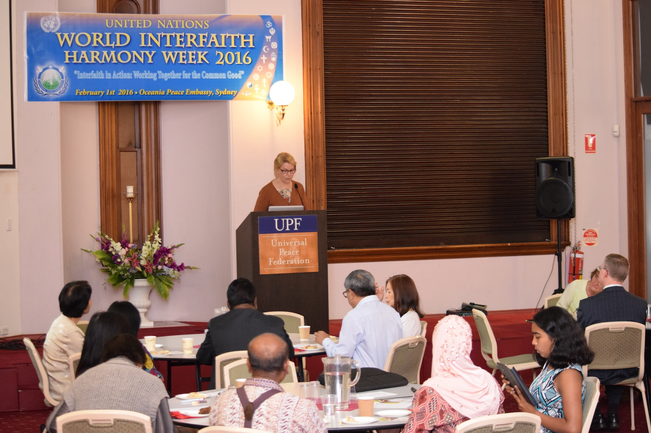
Figure 1 Emcee for the evening was Ms Aila Willitts, President of the Women's Federation for World Peace, New South Wales

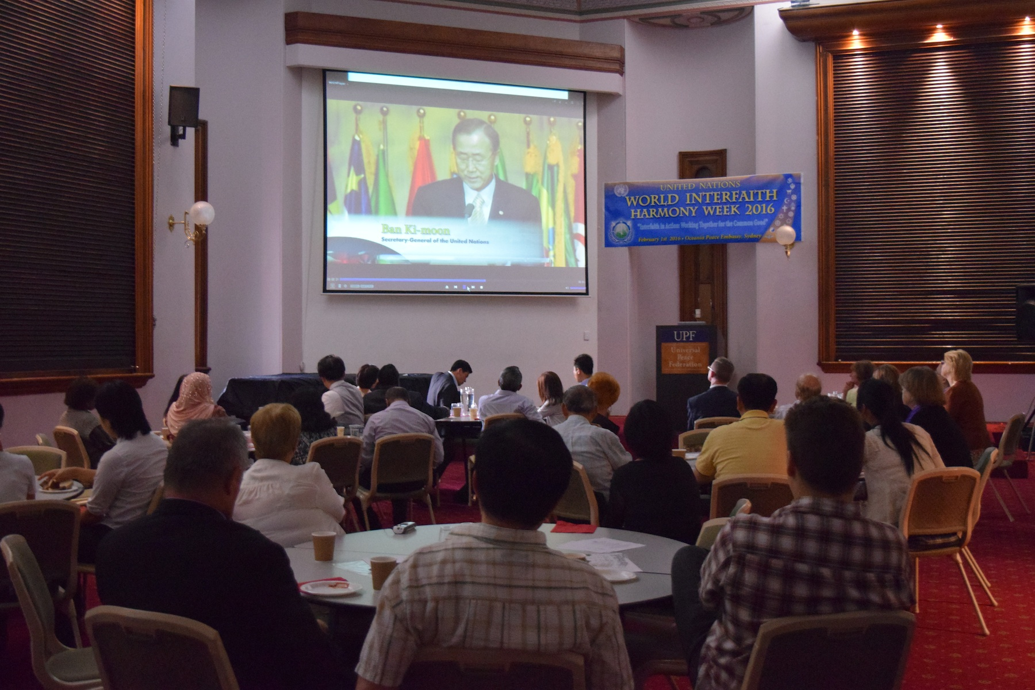
Figure 2 An introductory UPF video was shown at the commencement of the meeting
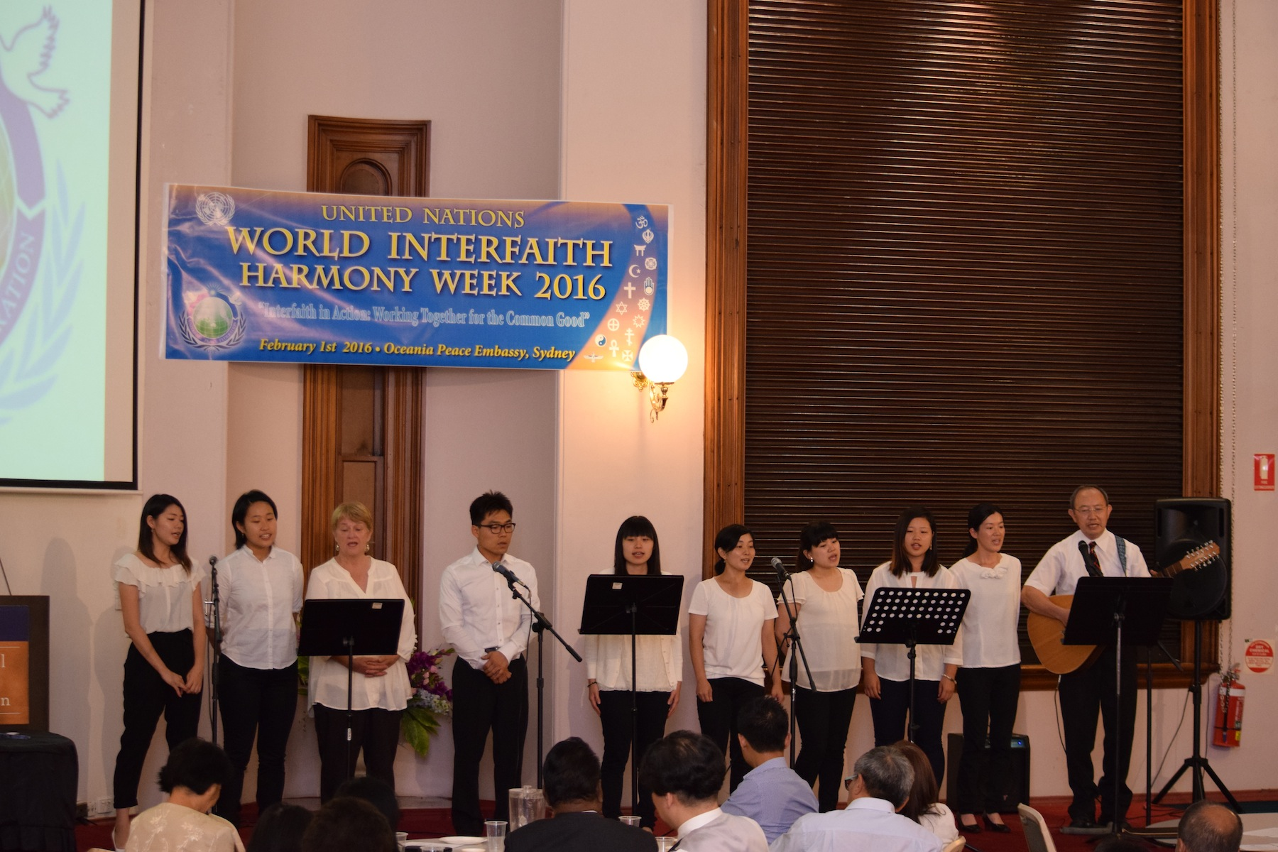
Figure 3 The UPF Youth Choir inspired the audience with two beautiful songs

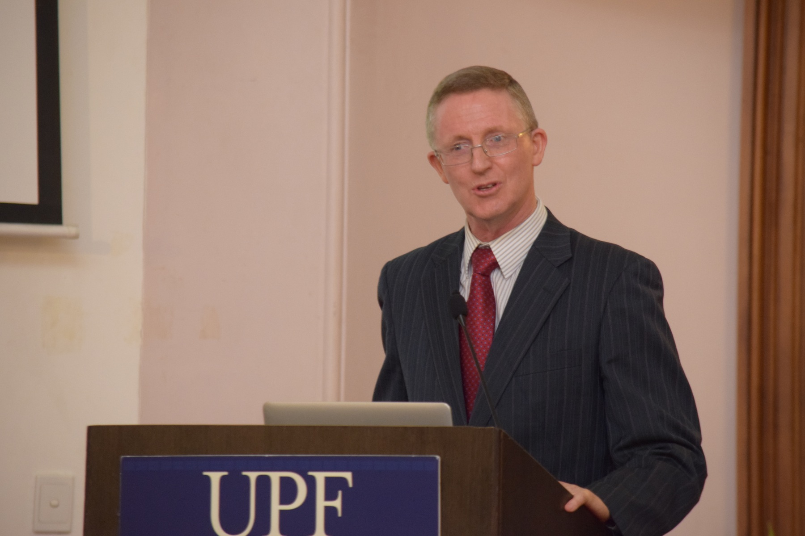
Figure 4 The first speaker was Mr Greg Stone, President of UPF Australia

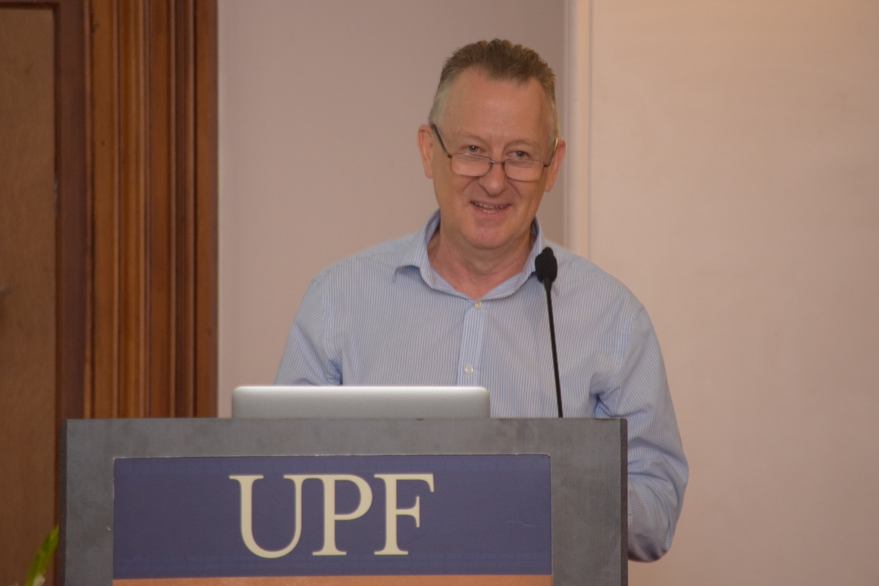
Figure 5 The second speaker was Mr Greg Johns, Vice Director of Soka Gakkai International Australia and manager of SGIA’s Peace, Culture and Education portfolio.

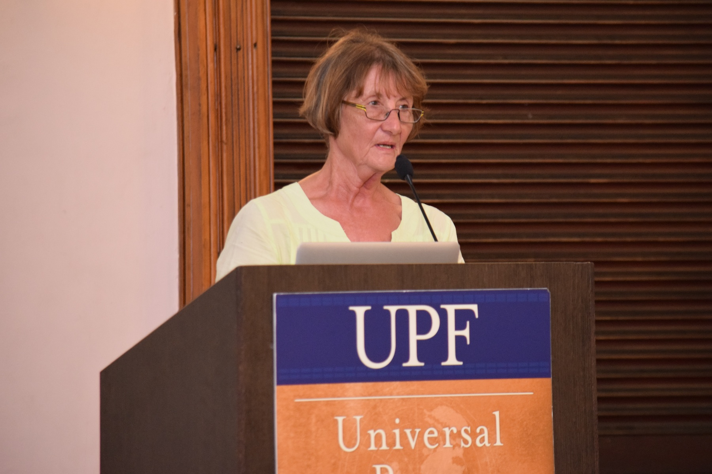
Figure 6 The third speaker for the evening was Ms Anne Lanyon, Deputy Director of the Columban Mission Institute and coordinator of the Centre for Peace, Ecology and Justice and the Faith Ecology Network (FEN).

