THE PEACE DRUMS INITIATIVE a project of Faiths Together.
Uganda as one of the countries in Africa is in a region which has varying tribes and religions. These differences amidst massive poverty among the population have caused a lot of stress among the population as they strive to seek a better life. This confusion has increased differences and war tendencies amongst the population as more people resort to crime, sports betting and addictions mostly in the youthful people.
Using the drum as Africa’s leading communication means, the Interfaith Harmony Peace Drums comes up to front the interfaith and religious tolerance. Through love for oneself and other, development is enhanced. God or Allah, Buddha (Most high) through various religions symbolizes acceptance of one another for social harmony.

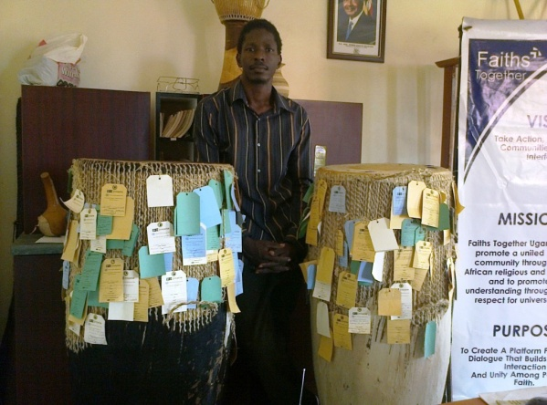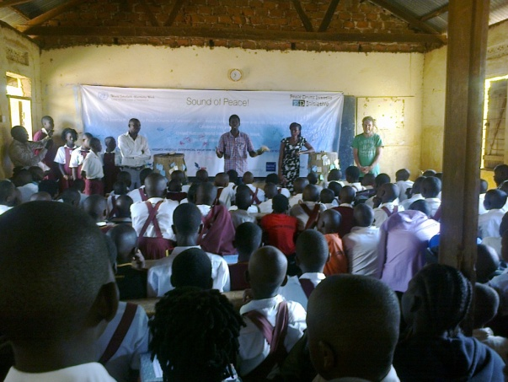
Mr Buyondo Micheal director of Faiths Together Uganda talking to young people about the World interfaith harmony week and why they need to focus on what unites

Through the peace drums initiative, we used two big drums as symbols of inter faith and inter cultural diversity. These include; a black and the other being white to represent the different races. The peace Drums’ Initiative uses art and music as an instrumental tool in bridging the gap among people of different religions. We believe that drums as a symbol of peace have reawakened the minds of young people in and out of these mult-religious school communities , The SOUND OF PEACE drive reached more than five thousand young people in a week in more than 14 schools Bishop East Primary School ,Bishop West Primary , Froebel Primary ,Mukono Kings High school ,Rhome Care Secondary School ,Light College Senior Secondary ,Seeta Christian School ,Seeta, Umah Primary School, Tripple ‘P” Primary School, Kampala School of Journalism (Seeta Mukono),Special Needs Education Centre Mukono ,St John’s Senior Secondary Mukono ,Bright Future Primary School Wakiso ,Naluse Primary School and in the other parts of the country.
All the schools and village communities we went to during this World Interfaith Harmony Week have drum sounds in their cultures thus, music being ideal for the world interfaith harmony drive.
PROJECT OUTREACH
Children with special needs.
We had the interfaith Harmony Peace drums reach several schools because often young people of special needs are left out in peace and development campaigns. Their voices need to be heard as well as they are taken as people who are less human. This is one of the reasons why we involved them in our interfaith harmony peace drums drive .They showed a great spirit of love for all and love for neighbour hence, challenging and inspiring many world wide
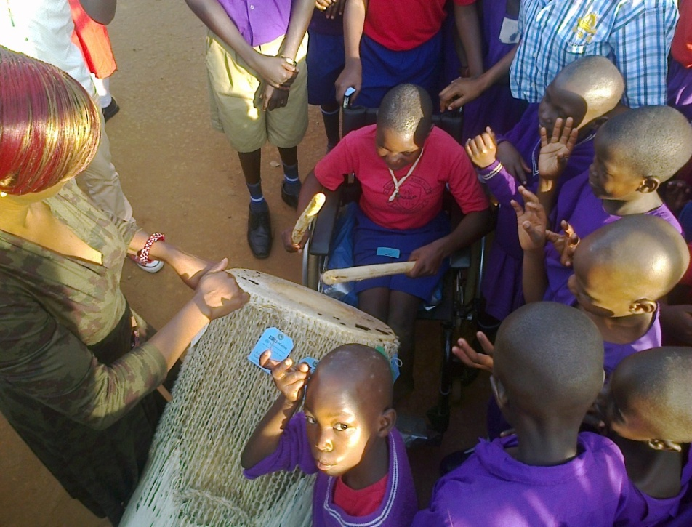
Naamala Blessing a child with special needs (on a wheel chair) joins the WIHW celebrations by sounding the peace drums
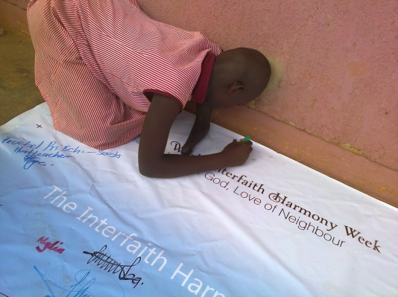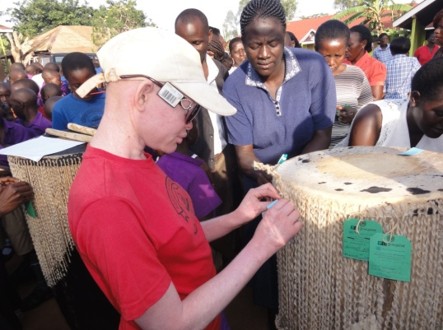
Left is Suzan appending her signature on the interfaith harmony declaration burner right is young albino fixing her tag on one of the Interfaith Harmony peace drum which reads what inspires you to sound the peace drums?

PROGRAM ACTIVITIES
One love music
Through Marco De Jong a music Intern At Faiths Together ,we believe that religion is love for one another By playing his acoustic guitar and singing along with the students and pupils songs that that bring people of different faiths together like ‘ Love is my religion, One love one heart “ by the legend Bob Marley . One can use art and music to build the spirit of oneness and harmony among people of different faiths .He shared his story and how hard it is for people of different religions working together at home in the Netherlands . 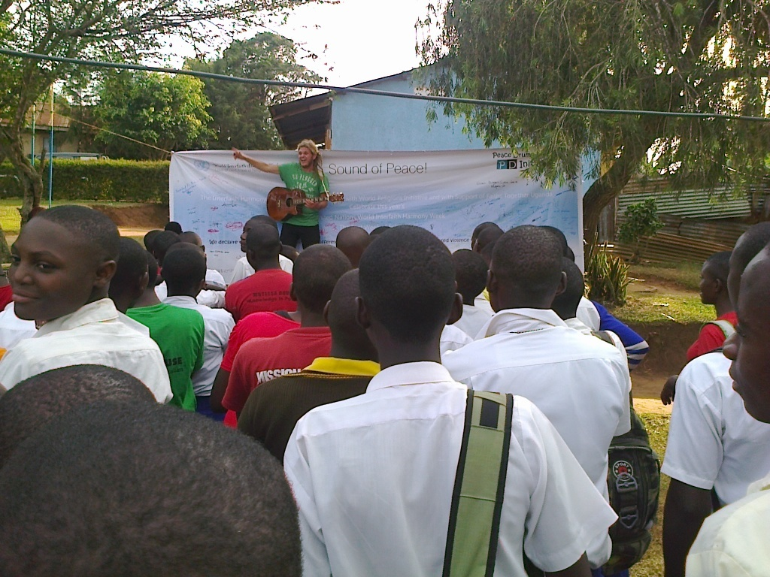
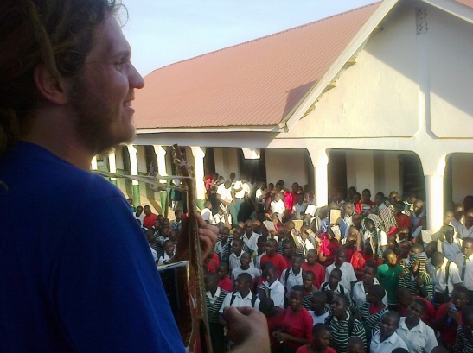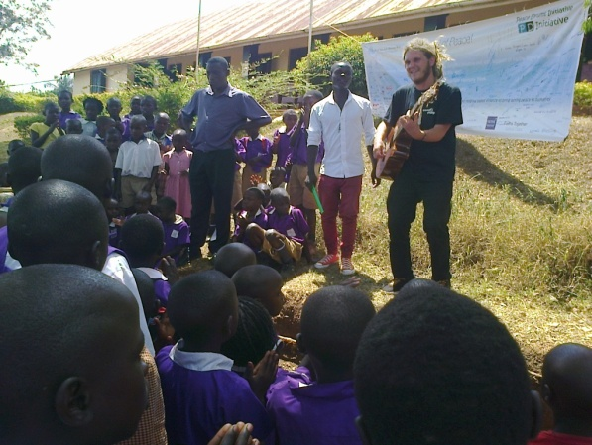
Above is Marco De Jong, a music Intern from Netherlands in a music moment with the students of Mukono Kings Sec School
Training Teachers and discussions
This is on how to set up interfaith /intercultural clubs in both primary and secondary schools by Mr. Buyondo Micheal .Just before the engaging the children we first talk to teachers about the need of people of different religions working together for peace and sustainable development. Then we engage the students after the 30 minutes teacher sensitization and training session.
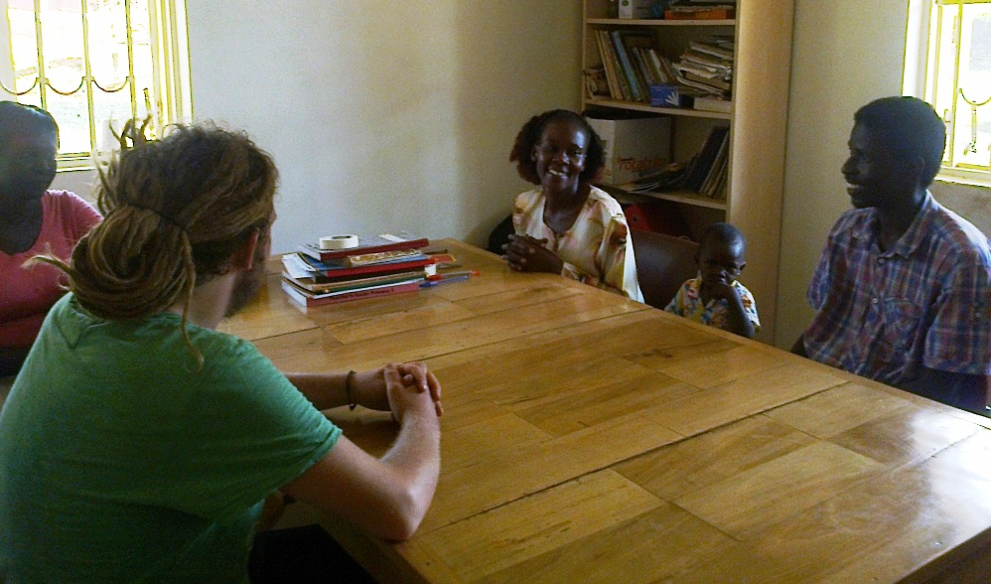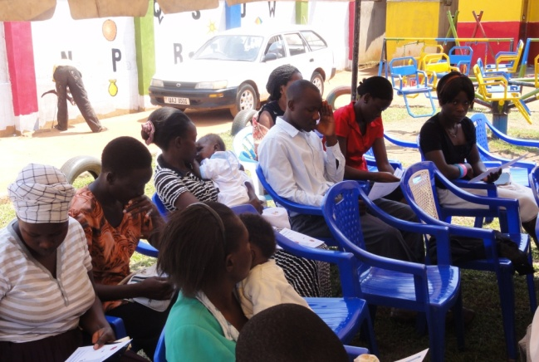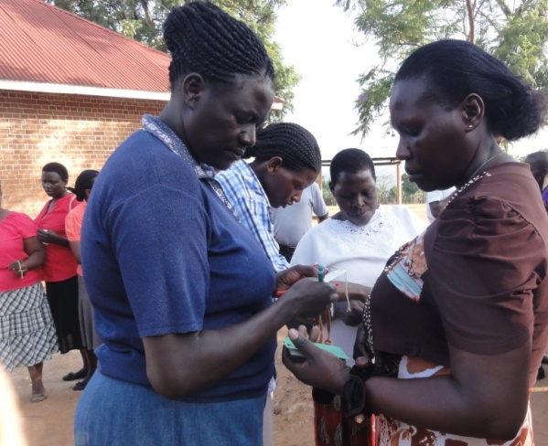

Sounding of the Interfaith Harmony Peace drums
The school administration calls out selected (primary) students religious leaders to represent the different faith communities in the schools, to do the symbolic sounding of the Unity drums. They also write their faith message on the hard paper tags then tie the tags on to the drums. This gesture is to make young faith leaders have a purpose in this endeavours of peace building and also celebrate the world interfaith harmony week
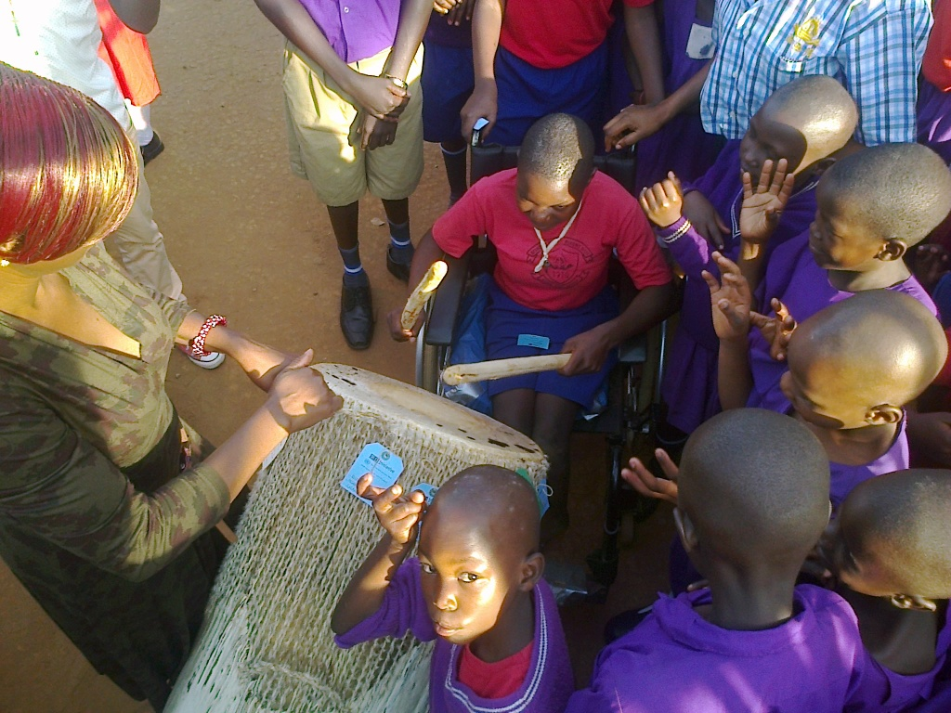
Naamala Blessing a child with special needs (on a wheel chair) joins the WIHW celebrations by sounding the peace drums
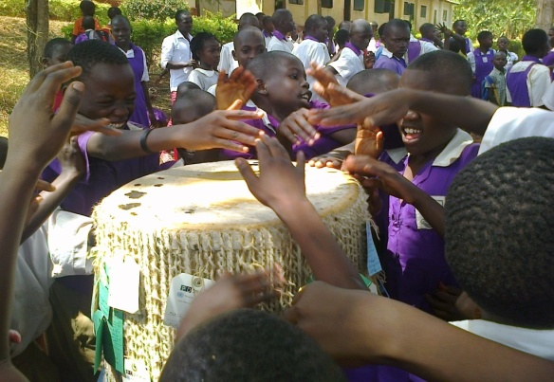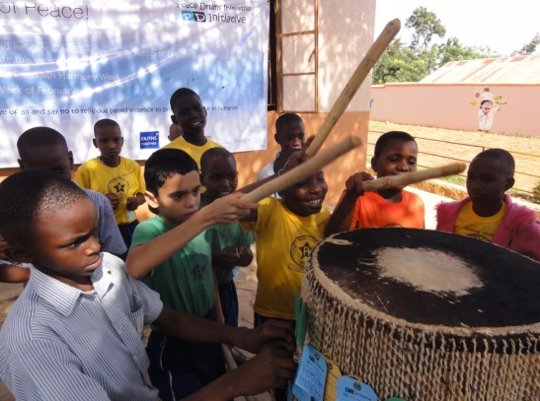
Above: pupils sounding the peace drums right : Vaibhar Gautam Indian sounding the peace drum.

Signing the declaration banner
A verbal open air declaration by all pupils, students and teachers was made reading the phrase on from the burner that read “:We Declare That we will live, respect Religious Differences ,Value love of all and say no to Religious Based Violence To Bring Lasting Peace To Humanity’ .Then signing of the ‘declaration banner ‘ by teachers and students religious leaders. Other non school going young people show their commitment towards global peace and a sustainable development by sounding the Interfaith Harmony Peace Drums and appending their signatures on the Declaration banner as well.
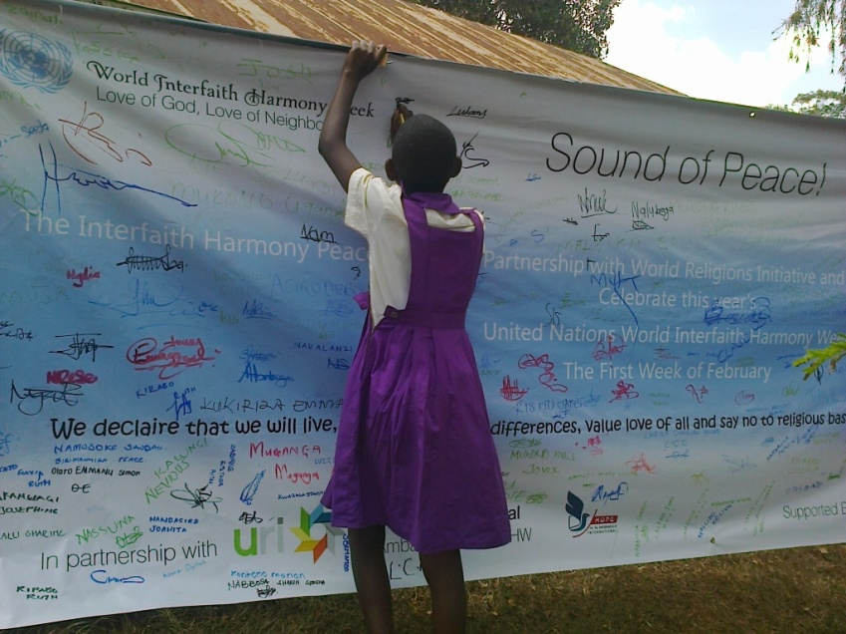
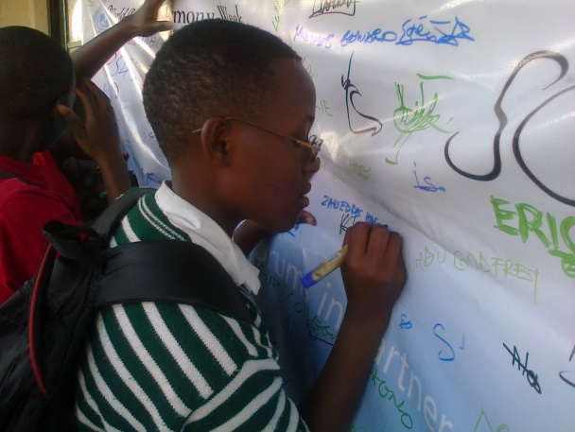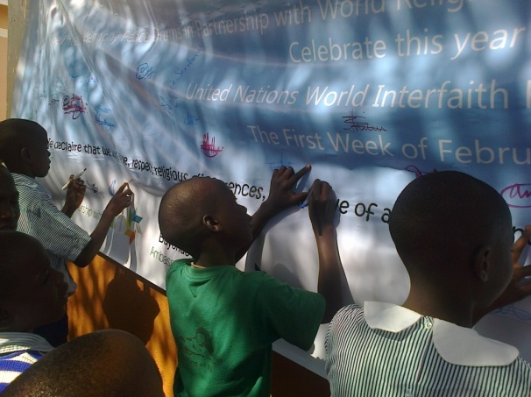
Above is Nyakayisiki Irene a senior four student of light college appending her signature on the declaration burner

Informal sector youths
These include; brick layers, welders, carpenters and builders who are young people who take one day at a time, vocational related jobs and brick laying is their source of income and in towns is where you find them. People often think of financial liberation as a key to better living forgetting the things that divide us as a people. Religion being a force that can be used for evil, we find it wise to have these young people join the rest in sounding these Interfaith harmony Peace drums
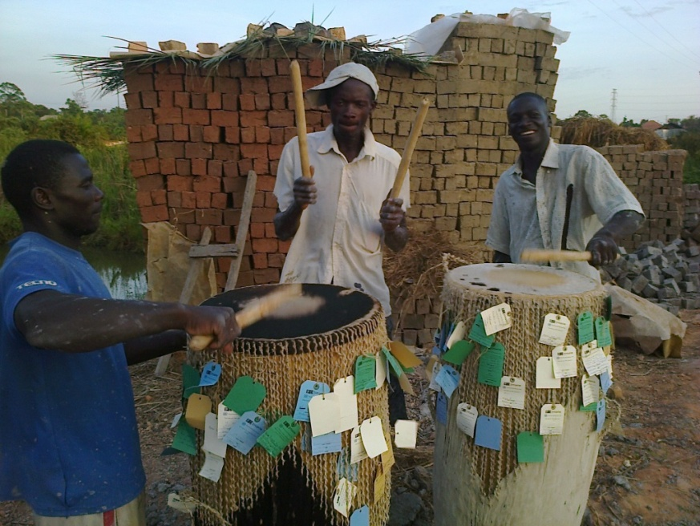
Conclusion
The peace drums initiative through schools and informal sector communities is to be rolled up to various locations as a key peace building initiative.
Links.

Video

https://www.youtube.com/watch?v=s1dh2XyycR0&feature=youtu.be&noredirect=1

One URI website
http://www.uri.org/the_latest/2015/02/world_interfaith_harmony_week_activities_2015

One travel for change Page
https://www.facebook.com/travel4change/posts/910759385634858

The Peace Drums Initiative (a project of Faiths Together)
Buyondo Micheal
michaelbti@gmail.com
+256 700 976 215
PO BOX 123 . Mukono, Seeta, BUZ/O42/B

