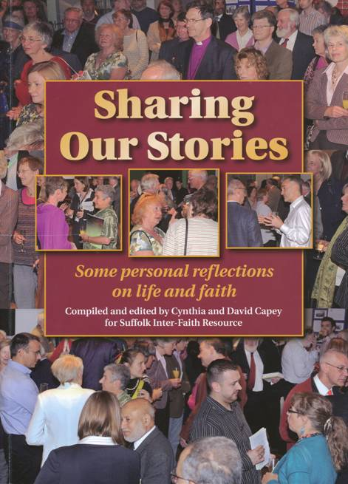

“SHARING OUR STORIES
SOME PERSONAL REFLECTIONS ON LIFE AND FAITH”
“Sharing our Stories’ is a collection of personal reflections about life from a diverse group of people. Although all have Suffolk connections, their stories highlight some of the challenges that face everyone wherever they live, including issues of gender, disability, race, persecution and displacement and the struggles individuals may have in maintaining their integrity with regard to their faith and spirituality.
People are often asked to state their religious affiliation and some are happy to be categorised in this way as Baha’is, Buddhists, Christians, Hindus, Humanists, Jains, Jews, Muslims, Pagans, Sikhs, Taoists and Zoroastrians (all represented in Suffolk). There are many others who see themselves as outside these boxes and their voices can also be heard through these stories.

A report on the launch of this book on 4th February 2015
“Sharing our Stories” a new book compiled for Suffolk Inter-Faith by Cynthia and David Capey, was officially launched on Wednesday 4th February at West Suffolk College in the presence of the Mayor of St. Edmundsbury, the Suffolk County Council Cabinet member responsible for Equalities and Inclusion and a group of people representing the faiths, the statutory bodies, the community and voluntary sectors and together with members of the general public. Local Radio and the local Press were in attendance.
There was an exhibition illustrating 25 years of inter-faith work in Suffolk and the guests were each given a booklet on this theme to take away. Light refreshments were provided.
The programme was opened by the Director of Higher Education at West Suffolk College who welcomed the guests. Representatives of the local United Nations Association then explained the origin and purpose of the UN World Interfaith Harmony Week.

Charles Croydon – Chairman of Ipswich and District United Nations Association
World Interfaith Harmony Week was first proposed at the UN General Assembly on 23 September 2010 by HM King Abdullah II of Jordan. Just under a month later, on 20 October 2010, it was unanimously agreed by the UN General assembly that the first week of February would be World Interfaith Harmony Week. It seeks to spread the message of harmony and tolerance among the followers of all the world’s religions and excludes no one. It also seeks to promote the common basis of “Love of God and Love of the Neighbour” or “Love of the Good and Love of the Neighbour” to safeguard world peace. Its message invites everyone, excludes no one, and is purely voluntary.

Brian Wesley – Secretary of United Nations Association, Eastern Region
For billions of people around the world, faith is an essential foundation of life. It provides strength in times of difficulty and an important sense of community. The vast majority of people of faith live in harmony with their neighbours, whatever their creed, but each religion also harbours a strident minority prepared to assert fundamentalist doctrines through bigotry and extreme violence.
These acts are an affront to the heritage and teachings of all major religions. They also contravene the Universal Declaration of Human Rights, which affirms the right of all to freedom of thought, conscience and religion. It is imperative that the moderate majority is empowered to stand firm against the forces of extremism. But, this can only be achieved through strong leadership. Whether on the world stage or in their communities, religious and cultural leaders have a responsibility to speak the language of tolerance and respect. This is a central message of World Interfaith Harmony Week.
We live in times of turmoil and transformation – economic, environmental, demographic and political. These transitions bring both hope and uncertainty. Our job is to ensure that hope wins, and our task will be made easier if the followers of all faiths collaborate in common cause. Let us never forget that what divides us is minuscule compared with what unites us. Working together, we can achieve all our goals for peace, prosperity and physical and spiritual well-being.
Extract from Ban Ki-moon’s message for UN World Interfaith Harmony Week 2014

Cynthia Capey then spoke on behalf of SIFRE and introduced the book.
“Why are we launching this book in Bury St Edmunds and not in Ipswich?
Ipswich is not the only significant town in Suffolk even though it is highly multi-cultural and multi-faith and our Inter-Faith Centre is there. Bury St. Edmunds is a thriving market town, once the County town of West Suffolk, and it successfully brings together the old and the new.
For example, Suffolk’s Cathedral is set here, rooted in the past but with its new tower – described by Prince Charles as “a beacon of hope for the new millennium.”
People from Ipswich travel to Bury St. Edmunds for leisure and to do their business as well as the other way round. For example, Prabjot Kaur, who is in this audience, lives in Ipswich but her husband Seva Singh is in Bury Market this afternoon and has come here every week for years to trade.
It is a place where the County and local District/ Borough Councils share a building and work together.
It is a place where ancient wrongs have been acknowledged and redeemed - where the massacre of local Jews in 1190 AD has been commemorated in the Garden of Remembrance in the Abbey gardens as well as victims of the Holocaust and of other genocides.
It is a town whose population at face value may seem quite monochrome – but take a closer look, especially in West Suffolk Hospital which is a place of great diversity, where, for example, a Muslim Doctor from Syria and a Coptic Christian from Egypt may be working side by side!
Last but not least, West Suffolk College which is hosting this event, is about to launch a new degree pathway in Religious Studies and Ethics.

The growth of interfaith activities in Suffolk
As the leaflets explain – the impetus for SIFRE came from two directions – through the initiative of the Ipswich mayors who had introduced Multi-faith Celebrations of the diversity of the town and also through the outreach of the Religious Studies courses that were then running in Suffolk College in Ipswich. So in 1991 an inter-faith network was launched in the presence of the then Mayor of Ipswich.
Two years later there was a further impetus. 1993 was designated a year of inter-religious understanding to mark the centenary of the 1st World Parliament of Religions and local groups were encouraged to make a special effort to bring people together. That led to our first two books “Faiths in Focus in Ipswich and Suffolk” and “Finding our Way and Sharing our Stories”. Through the coming together to compile these books strong friendships between people of different faiths were formed and many of these have lasted until today.
Meanwhile government agendas led us into an engagement with the statutory bodies and also the voluntary sector which have been fruitful, but it has highlighted how easy it is to become institutionalised and to spend most of one’s time networking in meetings. One recent government publication setting out principles of inter-faith engagement was entitled “Face to Face and Side by Side”, but that is not enough – it is imperative to be Heart to Heart! We have tried through SIFRE to be heart to heart in our interaction with individuals within these institutions as well as in our grassroots activities.
20 years later - 2003 seemed an appropriate moment to revisit the ground covered by our first two books. We tried to do it entirely electronically, combining general articles and personal stories. But the stories took on a life of their own. So we have both, an electronic resource which can be updated, and a book of individual reflections from a wide variety of people. This book of stories has become a story in its own right as those who read it draw in others to a ongoing conversation.
When HRH Prince Ghazi Bin Muhammad of Jordan, personal envoy of HM King Abdullah II to the UN, was commending the introduction of a UN World Interfaith Harmony Week, which had been proposed by the King of Jordan himself in 2010, he emphasised that he was not just talking about tolerance of the stance of others. He was referring to harmony in the Confucian sense which is a much richer concept. It does not merely describe a state of peace but also the “beautiful and dynamic interaction between different elements within a whole”. This is a goal towards which we must strive, and listening to each other’s stories is a basic component of our journey wherever we encounter each other.”
Cynthia then introduced selected passages from the book which were read aloud. These included the contribution from Dr Abdullah Mawas (Muslim) from West Suffolk Hospital in Bury St Edmunds and Betty Wells (Christian) from a Suffolk village.

Dr. ABDULLAH MAWAS A perspective on Syria
(He spoke of the need to deal with everyone as precious human beings whatever their race or faith. His is the first story in the book.)
“I am a doctor working in West Suffolk Hospital, but my place of origin is a village in northern Syria between Aleppo and the border with Turkey. In a recent talk which I gave to a SIFRE dialogue group meeting in the West Suffolk Hospital chapel, I shared my experience of living in the Middle East, in a country that used to have good inter-faith relations. For centuries the religious make-up of the population of Syria has been mixed.
Before the present conflict the percentages in Syria could be broken down as follows: Muslims 85%, of which 85% were Sunni, 10% Alwites and 5% Shias; Christians made up 10% and included the Greek Orthodox Church of Antioch, the Melkite Greek Catholic Church, the Oriental Syriac Orthodox Church, the Armenian Apostolic Church and Eastern Catholic Churches; Druze accounted for 3% and there were also Jews, mostly in Aleppo and Damascus, either dating back to Biblical times or originating as colonies of refugees fleeing the Spanish Inquisition. There were several thousand Yazidis and also people with folk spiritual beliefs.
Syria’s history has been one of invasion after invasion – by Egyptians, Phoenicians, Hebrews, Aramaeans, Assyrians, Babylonians, Persians, Greeks, Seleucids, Romans, Nabataeans, Byzantines, Muslim Arabs, European Christian Crusaders, Ottomans, Western Allied Forces and the French. However, Syria became independent on 11th April 1947 and until recently remained comparatively stable. The various communities lived together harmoniously.
In a Gallup poll taken in 2009, 87% of Syrians “agreed” or “strongly agreed” that they always treat members of other faiths with respect. 78% said they had a positive opinion of Christians and only 5% said they had a negative opinion.
In pre-conflict Syria, it was common for friends of other religions to attend each other’s weddings and funerals, to mind each other’s children and to give food to each other. It was considered rude to inquire into someone’s religious background. In my opinion the Sunni/Shia dimension of the Syrian conflict had a greater basis in international rivalries than on the ground realities.
My Syrian brothers and sisters are now endangered. Villages and cities have been partially or completely destroyed. Medical facilities have been deliberately targeted and Syria is among the worst examples of targeting medical care as a weapon of war, as said by Donna McKay, executive director of Physicians for Human Rights.
I now work as a member of a multi-racial, multi-faith medical and nursing team at West Suffolk Hospital, in a place where community relations are peaceful. The contrast between this context and my place of origin could not be greater. Please hold my broken country and its neighbours in your hearts.

BETTY WELLS Who is not my neighbour?
read by Kathleen Ben Rabha, Community Affairs Officer for the Anglican Diocese of St Edmundsbury and Ipswich
Mellis is an attractive village as it is blessed with a large common, one of the largest in Suffolk. The two owners, or Lords of the Manor, are the Suffolk Wildlife Trust and a private individual. This wonderful grazing common is renowned for its wild flowers, particularly orchids, and attracts the attention of those who enjoy the countryside. It is understandably a favourite stopping place for the travelling community, especially for those with horses to graze, and different groups have visited over the years.
I was thrilled to bits the first time I saw that people with two bow-topped wagons has stopped there. These first temporary neighbours were new age travellers and, although I felt a deep connection with them immediately and eventually made friends with them, my attitude was not shared by everyone in the village and a lot of tension was caused by their presence. I don’t understand why I felt so comfortable with them but the feeling was so strong that it made me wonder if I have any Gypsy ancestors, although I’m not aware of any. I do know, however, how much I have appreciated meeting most of those who have stayed over the years, including Irish travellers and Romany families as well as various new age travellers.
In a small village it can be very painful when there is dissent. Some of the ill will expressed by a few of our fellow villagers was based on bad experiences but much of it was blind prejudice. On the rare occasions when trash was left behind, the village bore the cost of clearing up. This made it difficult for traveller families who did behave well while here and for those of us who supported them.
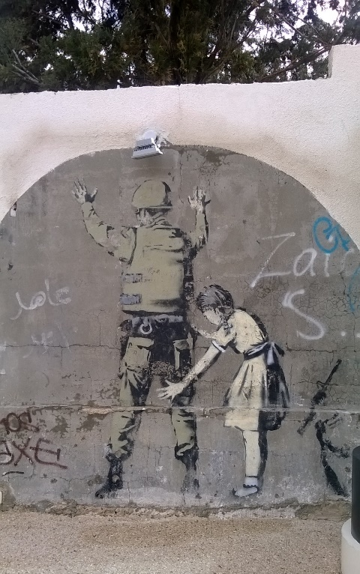
I have on one occasion been asked to lock the church when there were travellers in the area but I did not feel this was the right response. Fortunately both our parish clergy and our local police have been open-minded and wise in their dealings with these guests of ours.
The police have been able to allay fears about those travellers who will not cause trouble and the clergy have been prepared to extend pastoral care when needed. On one occasion we were privileged to hold a baptism actually on the common for a Gypsy baby and I am particularly privileged to be her Godmother. We brought the Paschal Candle from the church and used a mini Gypsy jack for the water. When the family moved on I lost contact for a while but I am glad to say that I am now back in touch with my little god-daughter, Louanna, and her family, and we exchange presents at Christmas. So these temporary neighbours of mine have brought me much pleasure and I have learnt a lot from them about their way of life. I am also the proud owner of my own traditional Gypsy bow-topped wagon!
I have also been on a steep learning curve as a result of various visits to the Holy Land, beginning in 2006. Initially we went on a Christian tour which was followed by courses at St. George’s College in Jerusalem and then by an independent arrangement which included a 4-day Green Olive tour during which we stayed with a Christian Palestinian family in Bethlehem. Since then we have been twice more, culminating this year with a conference in Bethlehem called Christ at the Checkpoint. As we actually stayed in Bethlehem we saw first-hand some of the horrors and humiliations suffered daily by innocent civilians including children. We have been amazed by the courage of the people we met and of their perseverance in trying to make a living and survive. Most pilgrims or tourists see only the Church of the Nativity, buy souvenirs and are then bussed quickly out again. They may barely notice the checkpoint or the Wall or the powerful messages painted on walls by the artist Banksy and by other people who have visited, looked about them and been outraged by what they saw there.
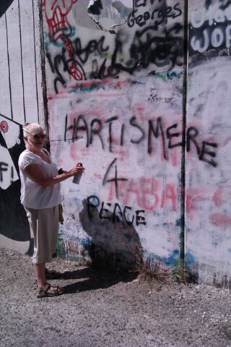
There are many times in the gospels when Jesus urges his contemporaries, especially the leaders, to open their eyes and not to remain in the dark and he called peacemakers “Children of God”. His message is still relevant today. Our eyes need to be open to what is happening to our neighbours, to those like the travelling community, who are marginalised in our own country, and those further away, like the peoples of the Middle East. We need to work for peace, wherever we can. But it is hard not to despair.

The event concluded with words of appreciation from Councillor Rebecca Hopfensperger and the Mayor of Bury St Edmunds, Councillor Robert Everritt.
Comments

This launch event was a moving and inspirational occasion: How fabulous yesterday was. Well done you!
Barbara
Thank you for inviting me - it was an interesting and memorable event. I will look forward to reading all the book and will try to promote it. Attached is the extract from the S-G's message that I read out.
Best wishes, Brian

PRESS REPORT
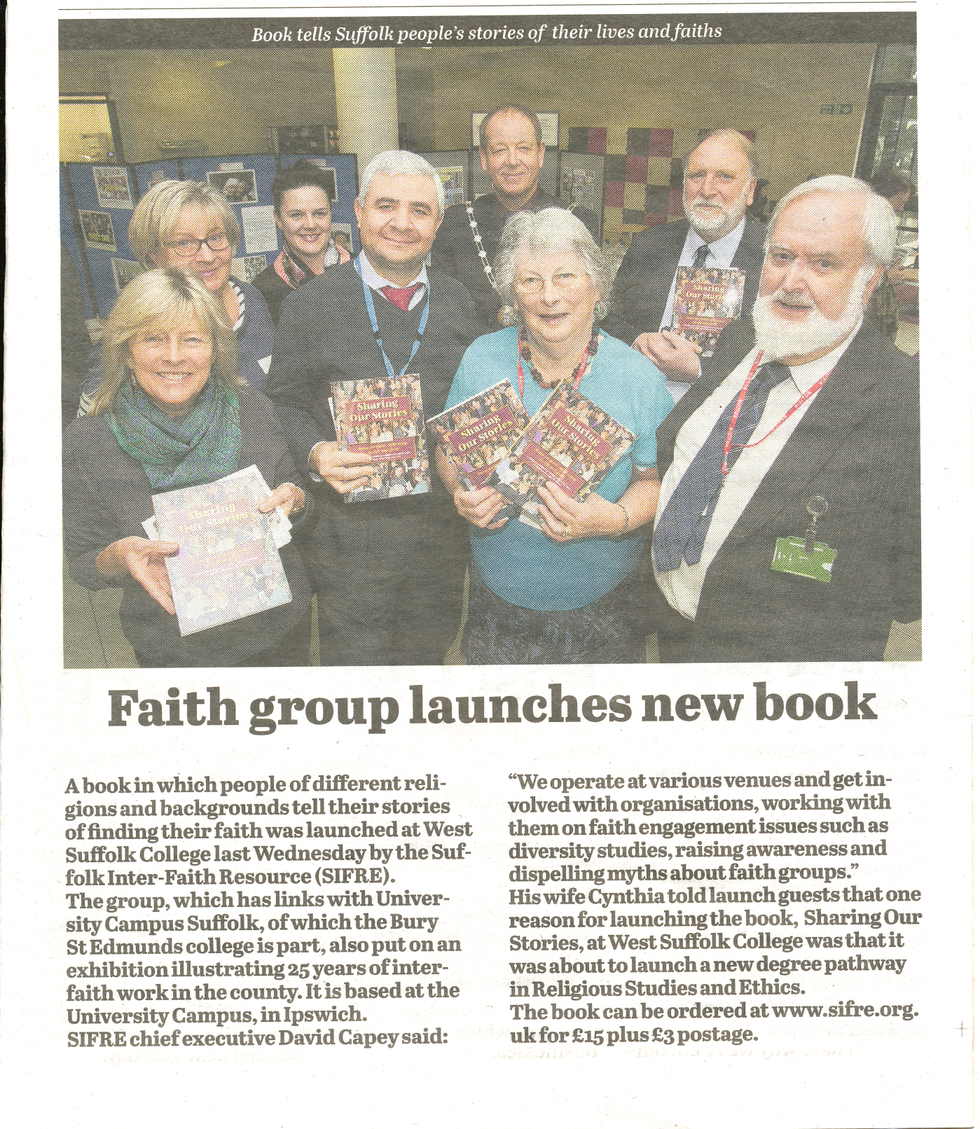

REVIEWS

New book about Suffolk people, their faiths and beliefs, including Humanism
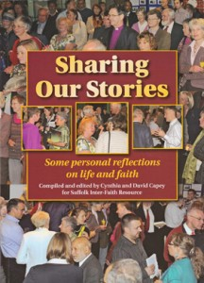
We’ve been affiliated to the Suffolk Inter-Faith Resource (SIFRE) since its inception in 1991, at about the same time that our group was founded. Among other things, it’s allowed us to contribute to educational activities in the county, in schools and other statutory and voluntary bodies, including local government. An off-shoot of SIFRE became the East o England Faiths Agency, which provides speakers for all of these organisations, and members of our group have been SIFRE and EEFA tutors.
SIFRE has published three books about the various faiths and beliefs in our area, including Humanism, and a board game called Diversity, which is used to teach people about faiths and beliefs. This latest publication, Sharing our Stories, is a collection of personal reflections about life from a diverse group of people. Some will make you smile and some are very moving, such as an account of growing up as a Jew in Nazi Germany. Four members of Suffolk Humanists and Secularists have contributed their stories, including Derek Mason, whose typically succinct reflection was read at his funeral last year.
We recommend that you put aside any prejudices you might have about religion and religious people, and buy the book. This is about how people live their lives, their experiences, their families and their communities. The book is £10, plus £3 P&P. Click here to go to the SIFRE website and order it. If you prefer to borrow a copy, we will be buying one to add to our small library.
from Margaret Nelson of Suffolk Humanists

‘Sharing Our Stories’ is a wonderful addition to the rich picture of Suffolk’s faith communities. The headlines for each religion are well known, but the lived experiences and perspectives less so. What is so powerful about this book is that the traditions are exemplified through the lived lives of Suffolk people. Their stories bring to life the tensions, the joys and the hopes for a life well lived. Many of the contributors have been involved in inter-faith work, often supported by Suffolk Interfaith Resource and their contributions to conversations about how to live are important and deserve to be read. This is an important resource for all living in Suffolk, and especially our young people who have the right to hear the rich, interesting and very moving testimonies of many of their neighbours.
This book needs to be in every school library and used as a resource in every RE department in Suffolk.
Mary Myatt
RE Adviser, Lead Inspector for Ofsted
and Servicing Officer for Suffolk SACRE
January 2015
I have received the WONDERFUL book: thank you so much! I have looked through it and very much look forward to reading it properly over the next few weeks. It's already given me a very different view of the population of Suffolk.
Isabelle Wen, Buddhist
"Suffolk Inter Faith Resource has, across the years, produced a series of excellent resources to promote inter faith understanding between people of different backgrounds in its area of England. With enormous commitment its small staff and volunteers have worked with local faith groups to provide opportunities for education about different faiths and opportunities for dialogue. They have also drawn together the stories of people of faith in their county. For 2015 World Interfaith Harmony Week they have launched a new compilation 'Sharing our Stories: Some Personal Reflections on Life and Faith'. Rather unusually for such compilations, it contains a wide range of stories from people of many different religious - and also non-religious - beliefs who speak candidly about their lives and their faith.
By turns moving, inspiring, fascinating and also shocking (some writers have lived through terrible experiences such as the Holocaust) and not uncontroversial in some views expressed, the book is a unique window into the lives of writers, each with much to tell us as fellow citizens of our multi faith country - and as global citizens seeking to live harmoniously in a multi faith world."
From Dr Harriet Crabtree, Director, Inter Faith Network for the UK,
2 Grosvenor Gardens, London SW1W 0DH

ABOUT THE COMPILERS

Dr David Capey, BSc, PhD, MRSC,
David studied chemistry at Birmingham University before becoming a member of staff at Essex University in 1965. A life-long Anglican, he became involved with the Anglican Chaplaincy there in 1974 and was a founder member of the Multifaith Chaplaincy. Since retirement in 1997, he has become a Trustee Director of Suffolk Inter-Faith Resource and is presently its Treasurer and Hon Executive Officer. Together with his wife, Cynthia, he was involved in the establishment of the East of England Faiths Agency in 2001 and is now its Company Secretary. He is also a Trustee of FBFE (Faith and Belief in Further Education). Though retired and living in a very rural part of Suffolk, David enjoys the voluntary inter-faith work he is involved in and rejoices in the fact that as he learns more of other faiths, the more he gains insights into his own faith.

Mrs Cynthia Capey MA Cantab. Cert.Ed.
Cynthia Capey studied Classic and Theology at Girton College, Cambridge and then trained as a teacher of Religious Education. After running an RE Department in a secondary school in Surrey, she spent most of her professional life as a member of staff at Suffolk College where she set up a Department for Religious Studies, and laid the foundations for Suffolk Inter-Faith Resource (SIFRE). Since she retired from the College 18 years ago she has been working for SIFRE in a voluntary capacity, and is now also an Interfaith Consultant and Diversity trainer for the East of England faiths Agency (EEFA)l. She has co-authored and edited many of SIFRE’s publications, including its popular Handbook of Faiths and she conceived of and developed the internationally acclaimed game Diversity. In 2006 Cynthia was awarded the Muslim News Annemarie Schimmel award and was the non-Muslim member on the panel of judges for the 2010 awards. She is married to David with whom she has raised a family of 8 children including an adopted Indian daughter and an African-Caribbean son.

