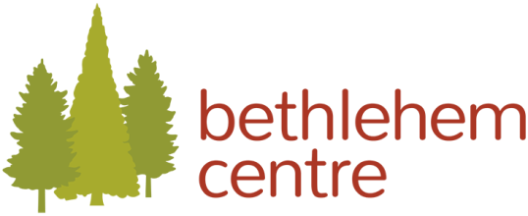

The Art of Chanting
An Exploration of Chanting from Christian, Jewish,
Muslim and Hindu Faith Traditions
January 26-28, 2018
In January 2018 the Bethlehem Centre offered the community a peaceful day of chanting by donation hosted by Gabriola Island’s sensational musical group Trio Sayso. The weekend workshop took place Friday, January 26th until 1:00 PM on Sunday, January 28th at 2371 Arbot Rdand offered chanting workshops from global cultures.
The weekend commenced with Trio Sayso offering contemporary ecstatic chant. The next day calming Hindu chanting with Pandit Tejomaya started the day. Teyjomaya is a priest of the Himalayan Yoga Tradition and was raised as a Roman Catholic. Teyjomaya introduced a union with infinite divinity.
This was followed by mystical Gregorian chanting with organist Peter Orme. Orme enjoyed 30 years of parish ministry in the Anglican Church and leads the VOX ensemble performing music from the Medieval and Renaissance periods to contemporary repertoire. On Saturday afternoon we experienced chanting based upon the Jewish tradition with Vancouver School of Theology’s Director of inter-religious studies Laura Duhan Kaplan with her husband musician Charles Kaplan. Laura is a Rabbi, writer, researcher and an award-winning educator and religious leader. Finally we Delved into the fine art of traditional Sufi chanting with Seemi Ghazi and friends. Ghazi is a University of BC instructor in Islamic literature and the arts. She introduced us to profound Islamic lyricism and its spellbinding rhythms. That evening we continued with our contemporary program with Trio Say So. On Sunday we wrapped up the weekend with a collaborative chant offering from 10 am-12 noon and the entire community was invited! At the final event our Director spoke of the connection to World Interfaith Harmony Week and how important this work is in our community and to the mission of the Bethlehem Centre.

This event was so well received that we intend to offer it at the same time in 2019. Perhaps it will become our annual celebration of World Interfaith Harmony Week!

